Game Design Document

Fill up the Following document

1. Write the title of your project.

Among us

1. What is the goal of the game?

The goal of this game is to complete the missions that are assigned to the players in this game before they are killed

1. Write a brief story of your game?

This game will have 5 players who are assigned to do some work and among those players there will be a bad guy who will kill other 4 people before they complete their assigned work .The main aim of that guy who will kill others will be to not allow those other 4 player to complete their work ….. This game will actually look like a game called Among us

1. Which are the playing characters of this game?

* Playing characters are the ones which respond to the user based on the input from the user
* Cars, monkeys, dinos, wizards etc, are the playing characters in the game.

|  |  |  |
| --- | --- | --- |
| Number | Character Name | What can this character do? |
| 1 | Crew mate 1 | This character will do the work that is assigned to him/her |
| 2 | Crew mate 2 | This character will do the work that is assigned to him/her |
| 3 | Crew mate 3 | This character will do the work that is assigned to him/her |
| 4 | Crew mate 4 | This character will do the work that is assigned to him/her |
| 5 | Bad guy | This character will kill other crew mates |
| 6 |  |  |
| 7 |  |  |
| 8 |  |  |

1. Which are the Non Playing Characters of this game?

* Non Playing characters are the ones which don't have an action or a behaviour when the user interacts with the game.
* Hurdles, stones, bananas, coins, etc are non playing characters in the game.

|  |  |  |
| --- | --- | --- |
| Number | Character Name | What can this character do? |
| 1 |  |  |
| 2 |  |  |
| 3 |  |  |
| 4 |  |  |
| 5 |  |  |
| 6 |  |  |
| 7 |  |  |
| 8 |  |  |

Draw your imagination of this game. What does this game look like?

* Draw the game either on your computer or on paper,
* Add images of scenes of the game to show each of the playing and non-playing characters at least once.

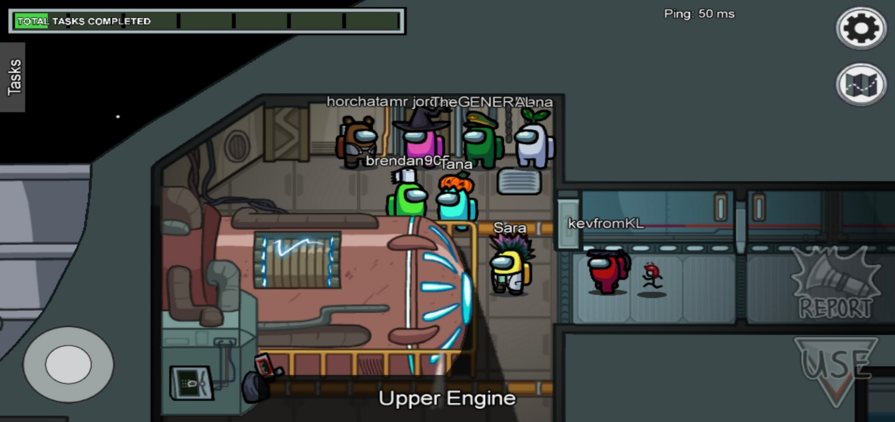

How do you plan to make your game engaging?

Players will have to do the task that is assigned to them before getting killed