# Installation

* + Indexing Server runs by default at port 40000
    1. Install mysql.
    2. Update the DB_Setup.c file with the root username/password
    3. Run “gcc DB_Setup.c –o DB_Setup” to setup the required tables
    4. Run “./DB_Setup.c”
    5. Run “gcc Server_Main.c –o ServerMain”
    6. Run “./ServerMain” to start the server
  + Peer runs by default on port 18000 and 18002

1. Run “gcc ClientUI.c –o FndFl”
2. Run “mkdir Test1 Test2 Test3”
3. Copy the FndFl object file to the folder [Test1], [Test2], [Test3]
4. Copy any files you want to share into the folders [Test1], [Test2], [Test3]
5. Run “cd Test1”
6. Run “./FndFl 127.0.0.1 18000”
7. Run “cd ..”
8. Run “cd Test2”
9. Create a file Test2.txt with some content
10. Run “./FndFl 127.0.0.1 19000”
11. Run “cd ..”
12. Run “cd Test3”
13. Run “./FndFl 127.0.0.1 20000”

# Testing Searching files

1. On the third console window which is listening at port 20000, enter “Test2.txt”
2. Check status messages reporting success

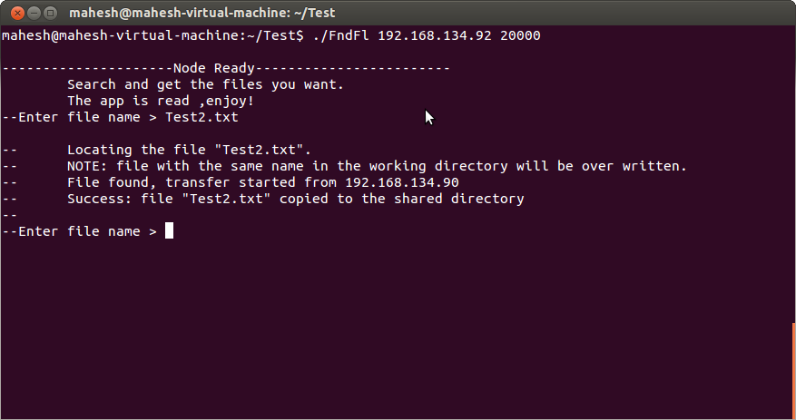

1. Check folder Test3.
2. The file “Test2.txt” is present in the folder [Test3]