UNIT I

BASIC STRUCTURE OF COMPUTERS

1.1 Functional Units
1.2 Basic Operational Concepts
1.3 Bus Structures
1.4 Software Performance
1.5 Memory Location and Addresses
1.6 Memory Operations
1.7 Instructions and instruction sequencing
1.8 Addressing modes
1.9 Assembly Language

BASIC STRUCTURE OF COMPUTERS

Computer Organization:
It refers to the operational units and their interconnections that realize the Architectural specifications.
It describes the function of and design of the various units of digital computer that store and process information.
Computer hardware:
It consists of electronic circuits, displays, magnetic and optical storage media, Electro mechanical equipments and communication facilities.
Computer Architecture:
It is concerned with the structure and behavior of the computer. It includes the information formats, the instruction set and techniques for addressing memory.
1.1 FUNCTIONAL UNITS
A computer consists of 5 main parts.
- Input
- Memory
- Arithmetic and logic
- Output
- Control Units
Functional Units of a Computer
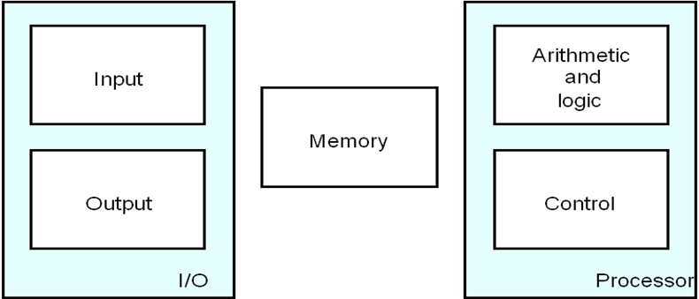
Fig 1.1 Basic Functional Units of Computer
- Input unit accepts coded information from human operators, from electromechanical devices such as keyboards, or from other computers over digital communication lines.
- The information received is either stored in the computer’s memory for later reference or immediately used by the arithmetic and logic circuitry to perform the desired operations.
- The processing steps are determined by a program stored in the memory.
- Finally the results are sent back to the outside world through the output unit.
- All of these actions are coordinated by the control unit.
- The list of instructions that performs a task is called a program.
- Usually the program is stored in the memory.
- The processor then fetches the instructions that make up the program from the memory one after another and performs the desire operations.
Input Unit:
- Computers accept coded information through input units, which read the data.
- Whenever a Key is pressed, the corresponding digit or letter is automatically translated into its corresponding binary code and transmitted over a cable to either the memory or the processor
Some input devices are
- Joysticks
- Trackballs
- Mouse
- Microphones (Capture audio input and it is sampled & it is converted into digital codes for storage and processing).
Memory Unit:
It stores the programs and data. There are 2 types of storage classes
- Primary Storage
- Secondary Storage
Primary Storage:
- It is a fast memory that operates at electronic speeds.
- Programs must be stored in the memory while they are being executed.
- The memory contains large no of semiconductor storage cells.
- Each cell carries 1 bit of information.
- The Cells are processed in a group of fixed size called Words.
- To provide easy access to any word in a memory, a distinct address is associated with each word location.
- Addresses are numbers that identify successive locations.
- The number of bits in each word is called the word length.
- The word length ranges from 16 to 64 bits.
There are 3 types of memory. They are
- RAM (Random Access Memory)
- Cache memory
- Main Memory
RAM:
Memory in which any location can be reached in short and fixed amount of time after specifying its address is called RAM. Time required to access 1 word is called Memory Access Time.
Cache Memory:
The small, fast, RAM units are called Cache. They are tightly coupled with processor to achieve high performance.
Main Memory:
The largest and the slowest unit is called the main memory.
Arithmetic Logic Unit:
Most computer operations are executed in ALU of the Processor.
Consider an example,
Suppose 2 numbers located in memory are to be added. They are brought into the processor and the actual addition is carried out by the ALU. The sum may then be stored in the memory or retained in the processor for immediate use. Access time to registers is faster than access time to the fastest cache unit in memory.

Output Unit:
Its function is to send the processed results to the outside world.
Example: Printer
Printers are capable of printing 10000 lines per minute but its speed is comparatively slower than the processor.
Control Unit:
The operations of Input unit, output unit, ALU are co-ordinate by the control unit. The control unit is the Nerve centre that sends control signals to other units and senses their states. Data transfers between the processor and the memory are also controlled by the control unit through timing signals.
The operations of computer are,
- The computer accepts information in the form of programs and data through an input unit and stores it in the memory.
- Information stored in the memory is fetched, under program control into an arithmetic and logic unit, where it is processed.
- Processed information leaves the computer through an output unit.
- All activities inside the machine are directed by the control unit.
1.2 BASIC OPERATIONAL CONCEPTS
The data/operands are stored in memory. The individual instructions are brought from the memory to the processor, which executes the specified operation.
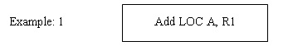
Instructions are fetched from memory and the operand at LOC A is fetched. It is then added to the contents of R0, the resulting sum is stored in Register R0.
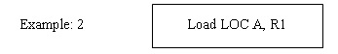
Transfer the contents of memory location A to the register R1.
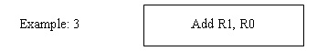
Add the contents of Register R1 & R0 and places the sum into R0.
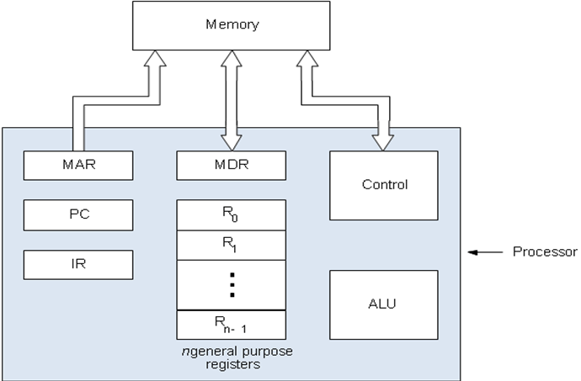
Fig 1.2 Connection between Processor and Main Memory
- Instruction Register (IR)
- Program Counter (PC)
- Memory Address Register (MAR)
- Memory Data Register (MDR)
Instruction Register (IR):
- It holds the instruction that is currently being executed.
- It generates the timing signals.
Program Counter (PC):
- It contains the memory address of the next instruction to be fetched for execution.
Memory Address Register (MAR):
- It holds the address of the location to be accessed.
Memory Data Register (MDR):
- It contains the data to written into or read out of the address location.
- MAR and MDR facilitates the communication with memory.
Operation Steps:
- The program resides in memory. The execution starts when PC is point to the first instruction of the program.
- MAR read the control signal.
- The Memory loads the address word into MDR.
- The contents are transferred to Instruction register.
- The instruction is ready to be decoded & executed.
Interrupt:
- Normal execution of the program may be pre-empted if some device requires urgent servicing.
E.g. Monitoring Device in a computer controlled industrial process may detect a
Dangerous conditions.
- In order to deal with the situation immediately, the normal execution of the current program may be interrupted & the device raises an interrupt signal.
- The processor provides the requested service called the Interrupt Service Routine (ISR).
- ISR save the internal state of the processor in memory before servicing the interrupt because interrupt may alter the state of the processor.
- When ISR is completed, the state of the processor is restored and the interrupted program may continue its execution.
1.3 BUS STRUCTURES
A group of lines that serves as the connection path to several devices is called a Bus. A Bus may be lines or wires or one bit per line. The lines carry data or address or control signal.
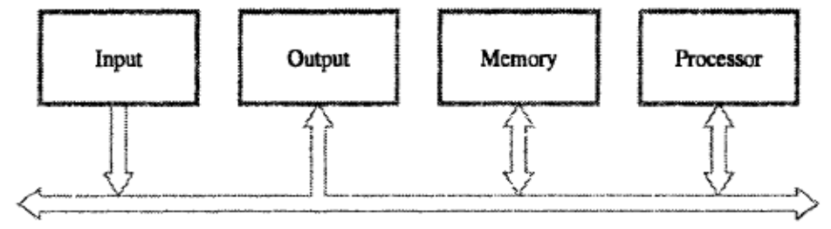
Fig 1.3 Single Bus Structure
There are 2 types of Bus structures. They are
- Single Bus Structure
- Multiple Bus Structure
Single Bus Structure:
- It allows only one transfer at a time.
- It costs low.
- It is flexible for attaching peripheral devices.
- Its Performance is low.
Multiple Bus Structure:
- It allows two or more transfer at a time.
- It costs high.
- It provides concurrency in operation.
- Its Performance is high.
Devices Connected with Bus | Speed
Electro-mechanical devices (Keyboard, printer)  Magnetic / optical disk  Memory & processing units | Slow  High  Very High
The Buffer Register when connected with the bus carries the information during transfer. The Buffer Register prevents the high speed processor from being locked to a slow I/O device during a sequence of data transfer.
1.4 SOFTWARE PERFORMANCE
System Software is a collection of programs that are executed as needed to perform
Function such as,
- Receiving & Interpreting user commands.
- Entering & editing application program and storing them as files in secondary Storage devices.
- Managing the storage and retrieval of files in Secondary Storage devices.
- Running the standard application such as word processor, games, and spreadsheets with data supplied by the user.
- Controlling I/O units to receive input information and produce output results.
- Translating programs from source form prepared by the user into object form.
- Linking and running user-written application programs with existing standard library routines.
Software is of 2 types. They are
- Application program
- System program
Application Program:
It is written in high level programming language(C, C++, Java, FORTRAN) the programmer using high level language need not know the details of machine program instruction.
System Program :( Compiler, Text Editor, File)
Compiler - It translates the high level language program into the machine language program.
Text Editor - It is used for entering & editing the application program.
System software Component ->OS (OPERATING SYSTEM)
Operating System - It is a large program or a collection of routines that is used to control the sharing of and interaction among various computer units.
Functions of OS:
- Assign resources to individual application program.
- Assign memory and magnetic disk space to program and data files.
- Move the data between the memory and disk units.
- Handles the I/O operation.
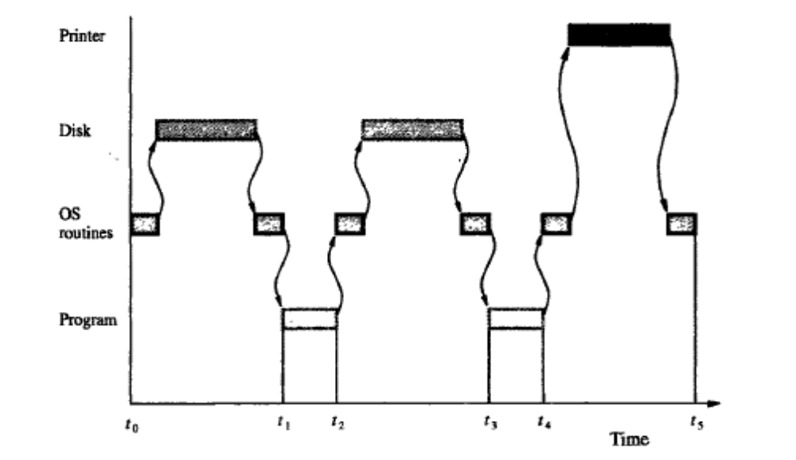
Fig 1.4 (a) User Program and OS routine sharing of the process
Steps:
- The first step is to transfer the file into memory.
- When the transfer is completed, the execution of the program starts.
- During time period “t0” to “t1”, an OS routine initiates loading the application program from disk to memory, wait until the transfer is complete and then passes the execution control to the application program & print the results.
- Similar action takes place during “t2” to” t3” and “t4” to “t5”.
- At “t5”, Operating System may load and execute another application program.
- Similarly during “t0” to”t1”, the Operating System can arrange to print the previous programs results while the current program is being executed.
- The pattern of managing the concurrent execution of the several application programs to make the best possible use of computer resources is called the multi- programming or multi-tasking.
Performance:
The most important measure of the performance of a computer is how quickly it can execute programs. The speed with which a computer executes programs is affected by the design of its hardware and its machine language instructions. For best performance, it is necessary to design the compiler, machine instruction set and hardware in a co-ordinate way.
Elapsed Time - The total time required to execute the program is called the elapsed time. It depends on all the units in computer system.
Processor Time - The period in which the processor is active is called the processor time. It depends on hardware involved in the execution of the instruction
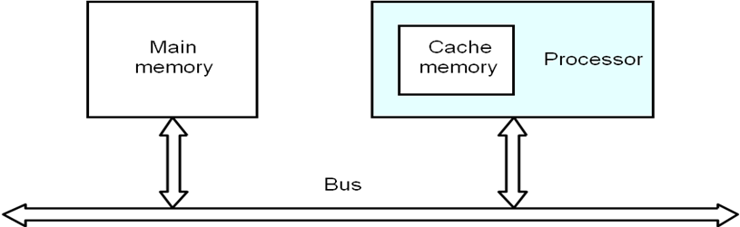
Fig 1.4 (b) Processor Cache
A Program will be executed faster if the movement of instruction and data between the main memory and the processor is minimized, which is achieved by using the Cache.
Processor Clock:
Clock - The Processor circuits are controlled by a timing signal called a clock.
Clock Cycle - The cycle defines a regular time interval called clock cycle.
Clock Rate, R =1/P
Where, P = Length of one clock cycle.
Basic Performance Equation:
T = (N*S)/R
Where, T = Performance Parameter
R = Clock Rate in cycles/sec
N = Actual number of instruction execution
S = Average number of basic steps needed to execute one machine instruction.
To achieve high performance N,S<R
Pipelining and Superscalar operation:
Pipelining - A Substantial improvement in performance can be achieved by overlapping
the execution of successive instruction using a technique called pipelining.
Superscalar Execution - It is possible to start the execution of several instructions in every clock cycles (i.e) several instructions can be executed in parallel by creating parallel paths. This mode of operation is called the Superscalar execution.
Clock Rate:
There are 2 possibilities to increase the clock rate(R).They are,
- Improving the integrated Chip(IC) technology makes logical circuits faster.
- Reduce the amount of processing done in one basic step also helps to reduce the clock period P.
Instruction Set: - CISC AND RISC:
- The Complex instruction combined with pipelining would achieve the best performance.
- It is much easier to implement the efficient pipelining in processor with simple instruction set.
- Tradeoff between N and S
- A key consideration is the use of pipelining
- S is close to 1 even though the number of basic steps per instruction may be considerably larger
- It is much easier to implement efficient pipelining in processor with simple instruction sets
- Reduced Instruction Set Computers (RISC)
- Complex Instruction Set Computers (CISC)
Simple Instruction Set
RISC
CISC
(Reduced Instruction Set Computer)
It is the design of the instruction set of a processor with simple instruction
(Complex Instruction Set Computer) It is the design of the instruction set of a processor with complex instruction.
Compiler
- A compiler translates a high-level language program into a sequence of machine instructions.
- To reduce N, we need a suitable machine instruction set and a compiler that makes good use of it.
- Goal – reduce N×S
- A compiler may not be designed for a specific processor; however, a high-quality compiler is usually designed for, and with, a specific processor.
High level Language Program
Machine
Instruction
Compiler

Functions of Compiler:
- The compiler re-arranges the program instruction to achieve better performance.
- The high quality compiler must be closely linked to the processor architecture to reduce the total number of clock cycles.
Performance Measurement
- The Performance Measure is the time it takes a computer to execute a given benchmark.
- T is difficult to compute.
- Measure computer performance using benchmark programs.
- System Performance Evaluation Corporation (SPEC) selects and publishes representative application programs for different application domains, together with test results for many commercially available computers.
- Compile and run (no simulation)
- Reference computer
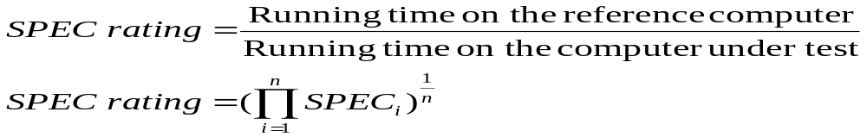
1.5 MEMORY LOCATION AND ADDRESSES
- Memory consists of many millions of storage cells, each of which can store 1 bit.
- Data is usually accessed in n-bit groups. n is called word length.
- The Memory of a computer can be schematically represented as a collection of words
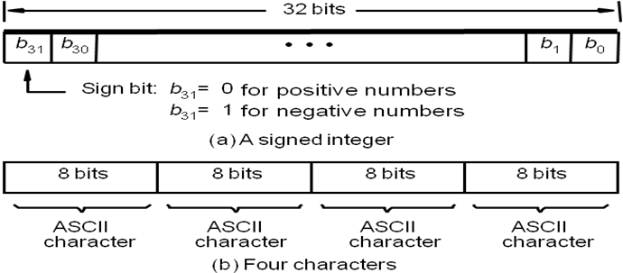
Fig 1.5 Encoded Information in a 32 bit word

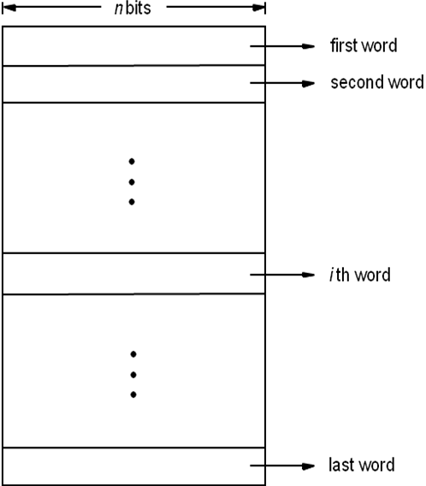
Fig 1.6 Memory Words
Byte Addressability:
- To retrieve information from memory, either for one word or one byte (8-bit), addresses for each location is needed.
- A k-bit address memory has 2^{k} memory locations, namely 0 – 2^{k}-1, called memory space.
- 24-bit memory: 2²⁴ = 16,777,216 = 16M (1M=2²⁰)
- 32-bit memory: 2³² = 4G (1G=2³⁰)
- 1K(kilo)=2¹⁰
- 1T(tera)=2⁴⁰
Big-Endian and Little-Endian Assignments
- Big-Endian: lower byte addresses are used for the most significant bytes of the word
- Little-Endian: opposite ordering. lower byte addresses are used for the less significant bytes of the word
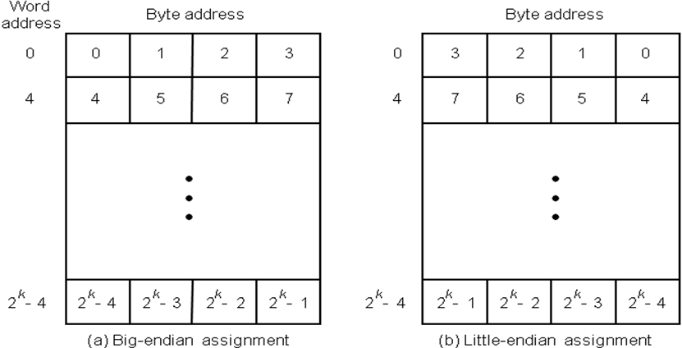
Fig 1.7 Byte and Word Addressing
Word alignment:
- Words are said to be aligned in memory if they begin at a byte address. That is a multiple of the num of bytes in a word.
    - 16-bit word: word addresses: 0, 2, 4,….
    - 32-bit word: word addresses: 0, 4, 8,….
    - 64-bit word: word addresses: 0, 8,16,….
- Accessing Numbers, Characters and Character Strings:
- A Number usually occupies one word
- It can be accessed in the memory by specifying its word address
- Individual Characters can be accessed by their byte address.
- In many applications it is necessary to handle character strings of variable length
- The beginning of the string is indicated by giving the address of the byte containing its first character
- Successive byte location contain successive character of the string
1.6 MEMORY OPERATIONS
- Load (or Read or Fetch)
- Copy the content. The memory content doesn’t change.
- Address – Load
- Registers can be used
- Store (or Write)
- Overwrite the content in memory
- Address and Data – Store
- Registers can be used
1.7 INSTRUCTION AND INSTRUCTION SEQUENCING
A computer must have instruction capable of performing the following operations.
- Data transfer between memory and processor register.
- Arithmetic and logical operations on data.
- Program sequencing and control.
- I/O transfer.
Register Transfer Notation:
The possible locations in which transfer of information occurs are,
- Memory Location
- Processor register
- Registers in I/O sub-system.
- Identify a location by a symbolic name standing for its hardware binary address (LOC, R0,…)
- Contents of a location are denoted by placing square brackets around the name of the location (R1←[LOC], R3 ←[R1]+[R2])
- Register Transfer Notation (RTN)
Location | Hardware Binary Address | Example | Description
Memory | LOC,PLACE,A,VAR2 | R1←[LOC] | The contents of memory  Location is transferred to. the processor register.
Processor | R0, R1, …. | [R3]←[R1]+[R2] | Add the contents of register R1 &R2 and places .their sum into register R3.It is .called Register Transfer Notation.
I/O Registers | DATAIN,DATAOUT | Provides Status information | I/O Registers
Assembly Language Notation:
- Represent machine instructions and programs.
Assembly Language Format | Description
Move LOC,R1 | Transfers the contents of memory location to the processor register R1.
Add R1,R2,R3 | Add the contents of register R1 & R2 and places their sum into register R3.
Basic Instruction Types:
Instruction Type | Syntax | Example | Description
Three Address | Operation Source1,Source2,Destination | Add A,B,C | Add values of variable A ,B & place the result into c.
Two Address | Operation Source, Destination | Add A,B | Add the values of A,B & place the result into B.
One Address | Operation Operand | Add B | Content of accumulator add with content of B.
Instruction Execution and Straight–line Sequencing:
Instruction Execution:
There are 2 phases for Instruction Execution. They are,
- Instruction Fetch
- Instruction Execution
Instruction Fetch:
- The instruction is fetched from the memory location whose address is in Program Counter (PC). This is placed in Instruction Register (IR).
Instruction Execution:
- Instruction in IR is examined to determine whose operation is to be performed.
Program execution Steps:
- To begin executing a program, the address of first instruction must be placed in PC.
- The processor control circuits use the information in the PC to fetch & execute instructions one at a time in the order of increasing order.
- This is called Straight line sequencing. During the execution of each instruction, the PC is incremented by 4 to point the address of next instruction.
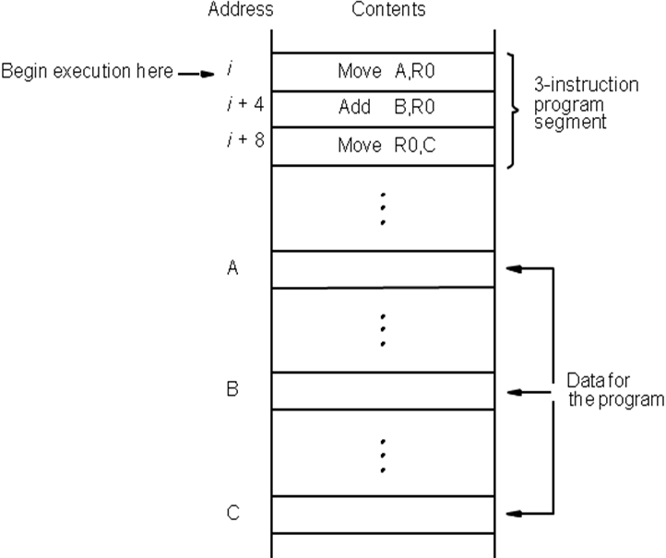
Fig 1.8 Program for C ← [A] + [B]

Branching:
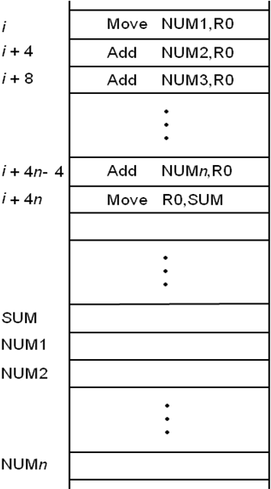
Fig 1.9 Straight Line Sequencing Program for adding ‘n’ numbers
- The Address of the memory locations containing the n numbers are symbolically given as NUM1, NUM2…..NUM_{n}.
- Separate Add instruction is used to add each number to the contents of register R0.
- After all the numbers have been added, the result is placed in memory location SUM.
Using loop to add ‘n’ numbers:
- Number of entries in the list „n‟ is stored in memory location M. Register R1 is used as a counter to determine the number of times the loop is executed.
- Content location M is loaded into register R1 at the beginning of the program.
- It starts at location Loop and ends at the instruction. Branch>0.During each pass, the address of the next list entry is determined and the entry is fetched and added to R0.
Decrement R1
- It reduces the contents of R1 by 1 each time through the loop.
Branch >0 Loop
- A conditional branch instruction causes a branch only if a specified condition is satisfied.
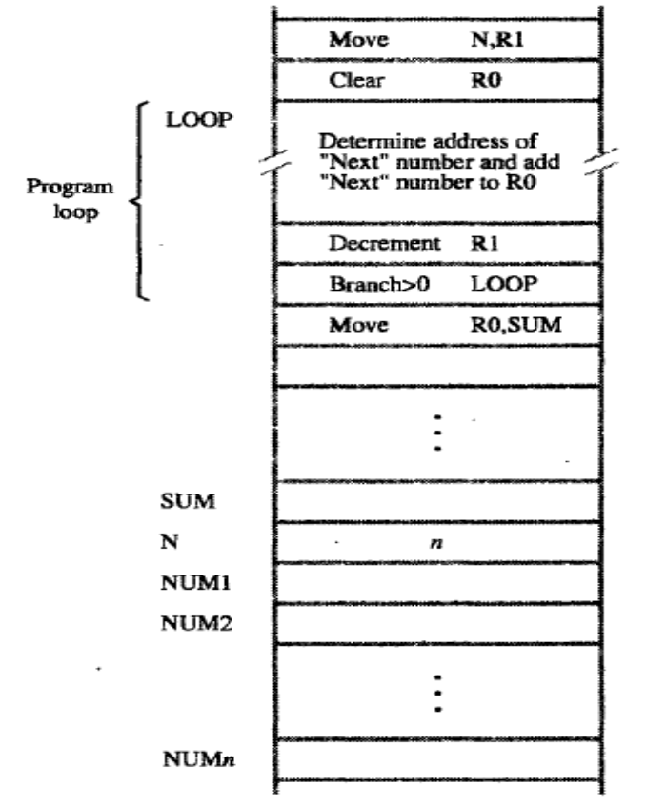
Fig 1.10 Using loop to add ‘n’ numbers
Conditional Codes:
- Result of various operation for user by subsequent conditional branch instruction is accomplished by recording the required information in individual bits often called Condition code Flags.
Commonly used flags:
- N (Negative) - set to 1 if the result is –ve, otherwise cleared to 0.
- Z (Zero) - set to 1 if the result is 0, otherwise cleared to 0.
- V (Overflow) - set to 1 if arithmetic overflow occurs, otherwise cleared to 0.
- C (Carry) - set to 1 if carry and results from the operation, otherwise cleared to 0.
1.8 ADDRESSING MODES
- The different ways in which the location of an operand is specified in an instruction is called as Addressing mode.
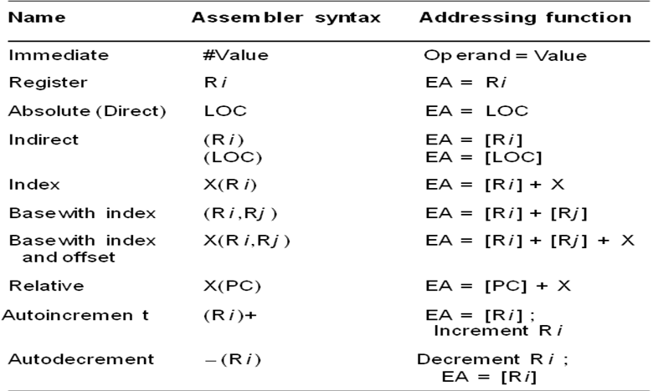
Fig 1.11 Generic Addressing Modes
Implementation of Variables and Constants:
Variables:
- The value can be changed as needed using the appropriate instructions.
- There are 2 accessing modes to access the variables. They are
- Register Mode
- Absolute Mode
Register Mode:
- The operand is the contents of the processor register.
- The name (address) of the register is given in the instruction.
Absolute Mode (Direct Mode):
- The operand is in new location.
- The address of this location is given explicitly in the instruction.
Example: MOVE LOC, R2
- The above instruction uses the register and absolute mode.
- The processor register is the temporary storage where the data in the register are accessed using register mode.
- The absolute mode can represent global variables in the program.
Mode Assembler Syntax Addressing Function
- Register mode Ri EA=Ri
- Absolute mode LOC EA=LOC
Where EA-Effective Address
Constants:
- Address and data constants can be represented in assembly language using Immediate Mode.
Immediate Mode:
- The operand is given explicitly in the instruction.
Example: Move 200 immediate, R0
- It places the value 200 in the register R0.The immediate mode used to specify the value of source operand.
- In assembly language, the immediate subscript is not appropriate so # symbol is used.
- It can be re-written as
Move #200, R0
Assembly Syntax: Addressing Function
Immediate #value Operand =value
Indirection and Pointers:
- Instruction does not give the operand or its address explicitly. Instead it provides information from which the new address of the operand can be determined. This address is called effective Address (EA) of the operand.
Indirect Mode:
- The effective address of the operand is the contents of a register.
- We denote the indirection by the name of the register or new address given in the instruction.
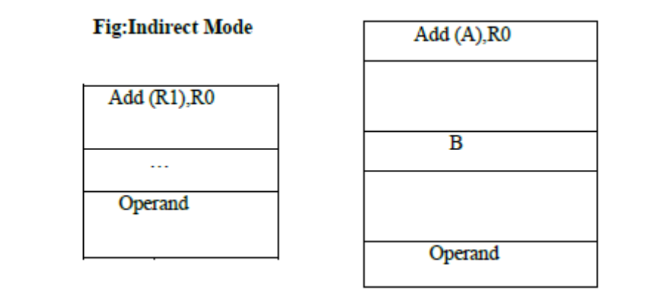
Fig 1.12 Indirect Mode
- Address of an operand (B) is stored into R1 register. If we want this operand, we can get it through register R1 (indirection).
- The register or new location that contains the address of an operand is called the pointer.
Mode Assembler Syntax Addressing Function:
Indirect Ri, LOC EA=[Ri] or EA=[LOC]
Indexing and Arrays:
Index Mode:
- The effective address of an operand is generated by adding a constant value to the contents of a register.
- The constant value uses either special purpose or general purpose register.
We indicate the index mode symbolically as,
X(Ri)
Where
X – Denotes the constant value contained in the instruction
Ri – It is the name of the register involved.
The Effective Address of the operand is,
EA=X + [Ri]
- The index register R1 contains the address of a new location and the value of X defines an offset (also called a displacement).
To find operand,
- First go to Reg R1 (using address)-read the content from R1-1000
- Add the content 1000 with offset 20 get the result.
- 1000+20=1020
- Here the constant X refers to the new address and the contents of index register define the offset to the operand.
- The sum of two values is given explicitly in the instruction and the other is stored in register.
Example: Add 20(R1), R2 (or) EA=>1000+20=1020
Index Mode | Assembler Syntax | Addressing Function
Index | X(Ri) | EA=[Ri]+X
Base with Index | (Ri,Rj) | EA=[Ri]+[Rj]
Base with Index and offset | X(Ri,Rj) | EA=[Ri]+[Rj] +X
Relative Addressing:
- It is same as index mode. The difference is, instead of general purpose register, here we can use program counter (PC).
Relative Mode:
- The Effective Address is determined by the Index mode using the PC in place of the general purpose register (gpr).
- This mode can be used to access the data operand. But its most common use is to specify the target address in branch instruction. Example: Branch>0 Loop
- It causes the program execution to goto the branch target location. It is identified by the name loop if the branch condition is satisfied.
Mode Assembler Syntax Addressing Function
Relative X (PC) EA=[PC]+X
Additional Modes:
There are two additional modes. They are
- Auto-increment mode
- Auto-decrement mode

Auto-increment mode:
- The Effective Address of the operand is the contents of a register in the instruction.
- After accessing the operand, the contents of this register is automatically incremented to point to the next item in the list.
Mode Assembler syntax Addressing Function
Auto-increment (Ri) + EA=[Ri];
Increment Ri
Auto-decrement mode:
- The Effective Address of the operand is the contents of a register in the instruction.
- After accessing the operand, the contents of this register is automatically decremented to point to the next item in the list.
Mode Assembler Syntax Addressing Function
Auto-decrement -(Ri) EA=[Ri];
Decrement Ri
1.9 ASSEMBLY LANGUAGE
- A Complete set of symbolic names and rules form their use constitute a programming language, generally referred as Assembly Language
- The set of rules for using the mnemonics in the specification of complete instructions and program called the syntax of the language
- Programs written in an assembly language can be automatically translated into a sequence of machine instructions by a program called an Assembler.
- The Assembly language is not case sensitive
Mnemonics in assembly language:
Name | Mnemonic | Name | Mnemonic
Load | LD | Increment | INC
Store | ST | Decrement | DEC
Move | MOV | Add | ADD
Exchange | XCH | Subtract | SUB
Input | IN | Multiply | MUL
Output | OUT | Divide | DIV
Push | PUSH | Add with carry | ADDC
Pop | POP | Subtract with borrow | SUBB
Clear | CLR | Negate | NEG
Complement | COM | Logical shift right | SHR
AND | AND | Logical shift left | SHL
OR | OR | Arithmetic shift right | SHRA
Exclusive-OR | XOR | Arithmetic shift left | SHLA
Clear carry | CLRC | Rotate right | ROR
Set carry | SETC | Rotate left | ROL
Complement carry | COMC | Rotate right through carry | RORC
Enable interrupt | EI | Rotate left through carry | ROLC
Disable interrupt | DI
Example:
ADD #5, R3
- Adds the number 5 to the contents of the register R3 and puts the results back into the register R3.
Assembler Directives:
- In addition to providing a mechanism for representing instructions in a program, the assembly language allows the programmer to specify other information needed to translate the source program to object program
- We need to assign numerical values to any names used in a program.
Example:
SUM EQU 200
- SUM is used to represent the value 200; It simply informs the assembler that the name SUM should be replaced by the value 200 whenever it appears in the program.
- Such statements are called as Assembler Directives, which are used by the assembler while it translates a source program into an object program
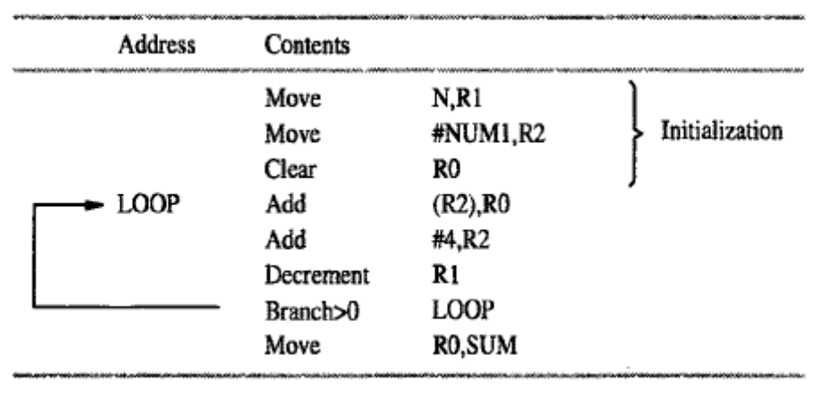
Fig 1.13 Program with Indirect Addressing
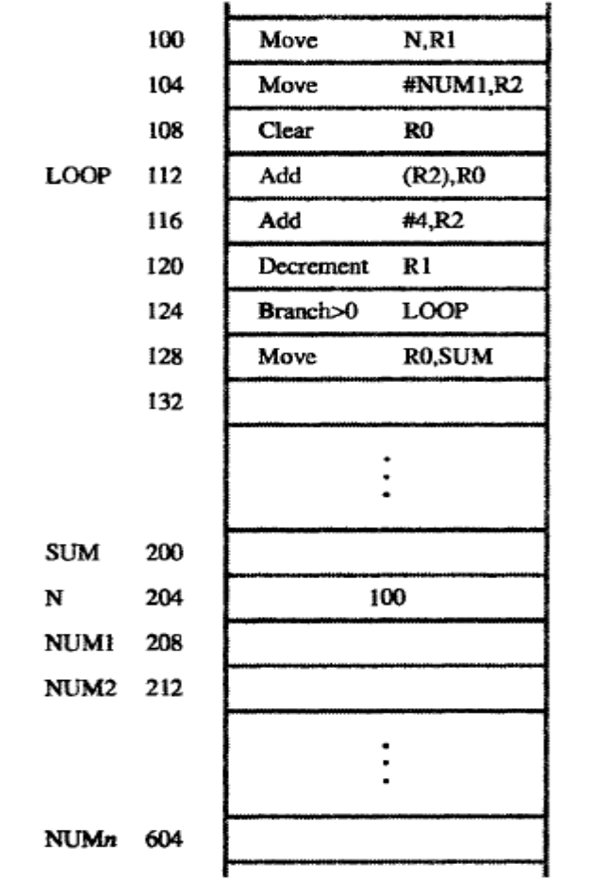
Fig 1.14 Memory Arrangements for the Program
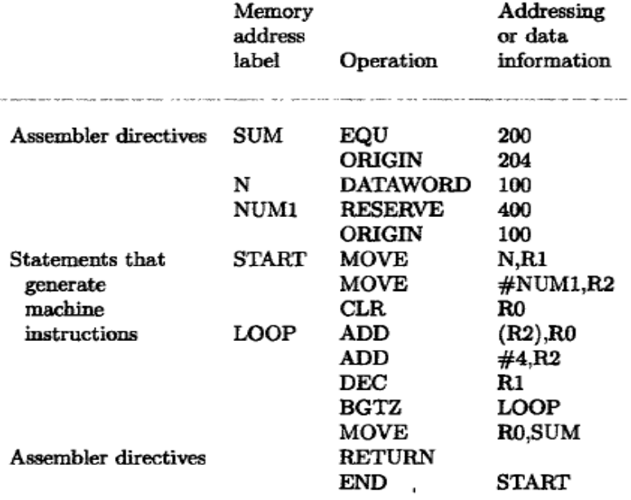
Fig 1.15 Assembly Language Representation for the Program
Assembly and Execution of Programs:
- A Source program written in an assembly language must be assembled into a machine language object program before it can be executed.
- This is done by the assembler program, which replaces all symbols denoting operations and addressing modes with the binary codes used in machine instructions, and replaces all names and labels with their actual values.
- The Assembler computes the branch offset which is the distance to the target, and puts it into the machine instruction.
- The Assembler goes through the source program a second time and substitutes values for all names from the symbol table. Such assembler is called two-pass assembler.
- The Loader loads the object program in the magnetic disk into the Main Memory before executing.
- The Debugger program enables the user to stop the execution of the object program at some point of interest and to examine the contents of various processor registers and memory locations.

