Saif Sattar
S1313176
Computer Games (Software Development)
Year 3
Graphics Programming Report

I confirm that the code contained in this file (other than that provided or authorised) is all my own work and has not been submitted elsewhere in fulfilment of this or any other award.
S.Sattar

Contents

1 Code Explanation 3
1.1 Audio 3
1.2 Mesh 3
1.3 Display 4
1.4 Shaders 4
1.5 Main Game 5

2 References 5

1 Code Explanation

  - Audio

Firstly, in the header files two methods created to handle data: isBigEndian () and convertInt (). convertInt () is used to simply convert a character array to an integer array as some of the sound data is stored as character data and Open AL uses integers as parameters.
Other methods created in the header file for loading audio, deleting audio, playing audio, stopping audio and setting audio listener.
loadSoundWAV () is used to read in a WAV file in a way that allows for playback using Open AL. loadSound () takes in a file from a pathway and load it and from there works out the type of audio data, sample rate, mono/stereo, etc. then saves the data in a buffer ready for use. playSound () plays a sound by calling the integer handler and the 3d position that the sound will play from whereas stopSound () stops the sound. setAudioListener () sets the position of the audio listener and where the listener is looking.

  - Mesh

The methods that were created were draw (), init (), loadModel (), startModel () and updateSphereData ().
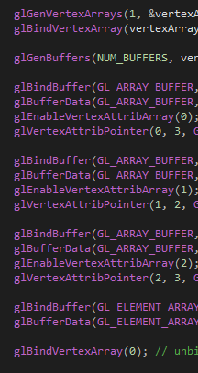
Open GL is used in the initModel () method.

A vertex array was generated and stored in the vertex array object. The vertex array object is then bound using glBindVertexArray. glGenBuffers generates the buffers based on the array of data/buffers. Open GL is told what type of data the buffer is and passes the data. The data is moved to the GPU. At the end the vertex array object is unbound.

  - Display

Methods are created for staring the display, swapping the buffer and clearing the display. Float variables to hold the screen width and screen height were also created.

  - Shader

In the Start () method is the Shader class the shader program is created which openGL saves as a reference number. Then the vertex shader and fragment shader are created.

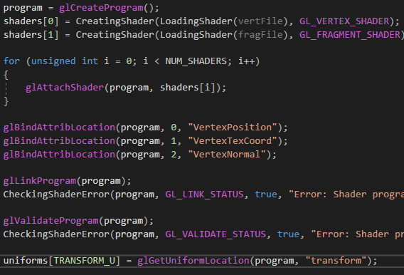

An array is then used to add all the created shaders to the shader program named “shaders.”

glLinkProgram(program) creates executables that will run on the GPU shaders and glValidateProgram(program) checks that the entire program is valid.

  - Main Game

Methods were created for starting systems, processing inputs, the main game loop, the game drawing and playing audio. A Boolean was created for collision. The meshes were referenced for the three game objects as well as the camera being referenced.
In the drawingGame () method each model was drawn. Each model’s position, rotation and scale was set. The shader methods (shadeRimToon.Binding() and settingRimToon () etc.) were called here. Each model’s mesh is drawn here.

- References

Space ship model - https://www.turbosquid.com/FullPreview/Index.cfm/ID/1063711

Skull model - https://www.turbosquid.com/3d-models/free-skull-3d-model/269706

Monkey model – GCU Learn

