Ex.no: 5 Date: ____________
CREATE A CD PIPELINE IN JENKINS
Aim:
To create a Jenkins pipeline that automatically checks out, builds, and tests an application, and sends an email notification with the result of each build.
Procedure:
1. Run sudo systemctl start jenkins in Ubuntu, then open http://172.19.68.232:8080 in your browser.

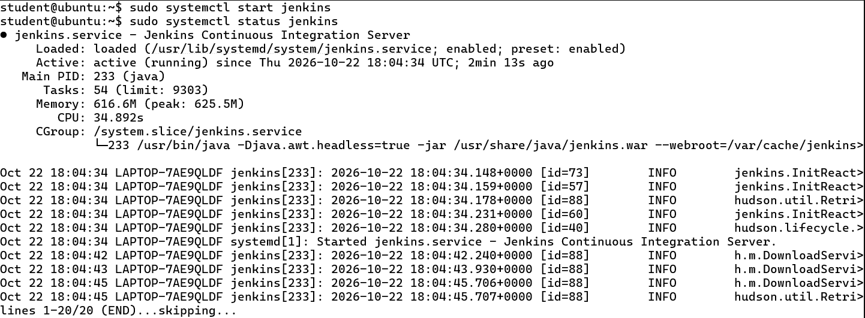
2. Open http://172.19.68.232:8080 in a browser and log in with administrator credentials to access the Jenkins dashboard.

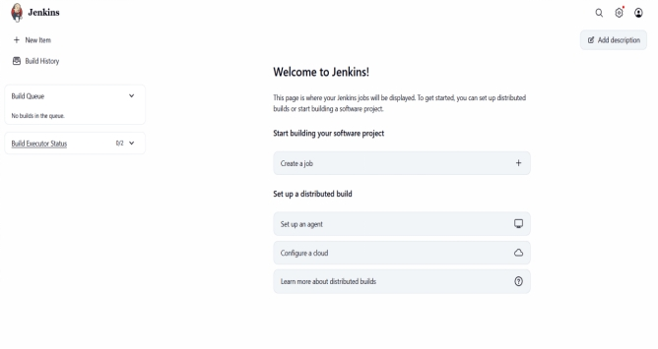
3. Go to Manage Jenkins -> Manage Plugins, search for Email Extension Plugin in the Available tab, and install it if not already installed.

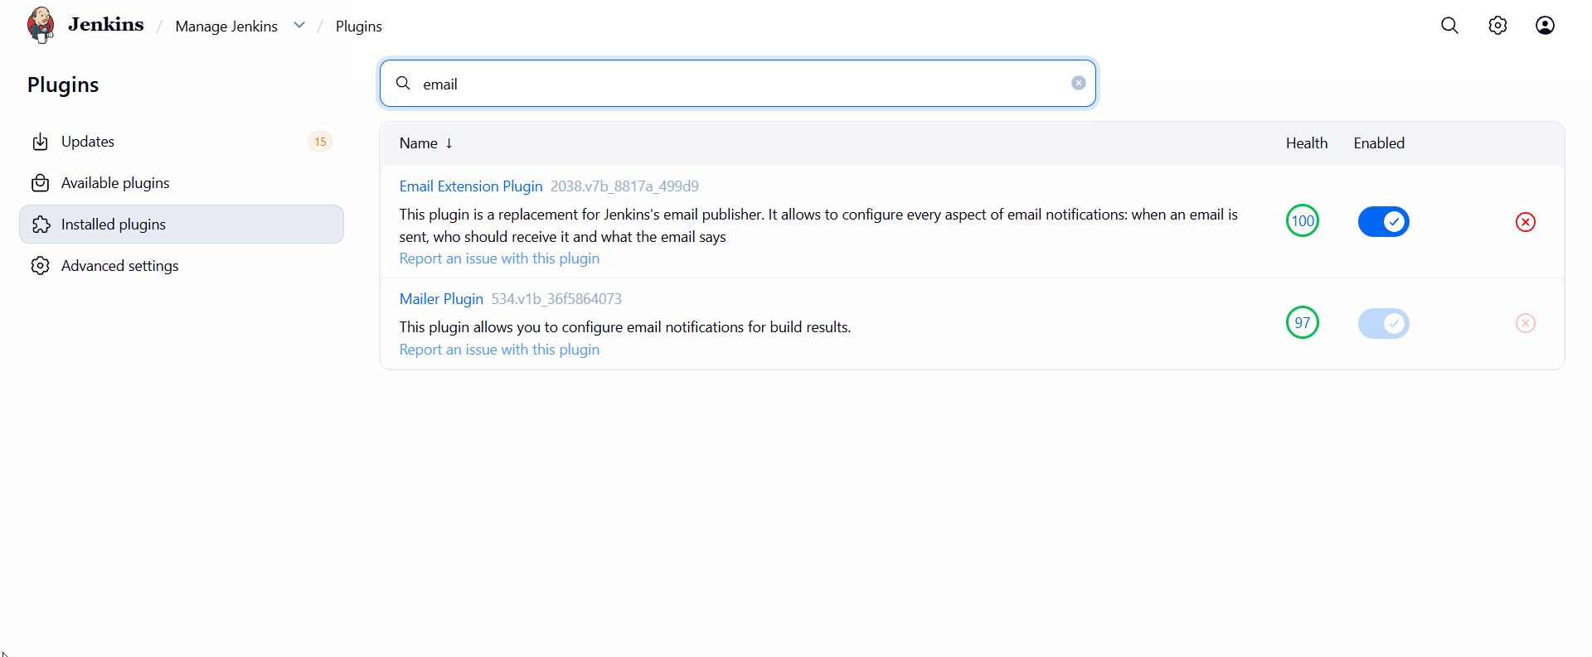
4. Go to Manage Jenkins -> System -> E-mail Notification, enter localhost as the SMTP server, click Advanced, untick Use SMTP Authentication and Use SSL, set the SMTP port to 1025, then click Apply and Save.

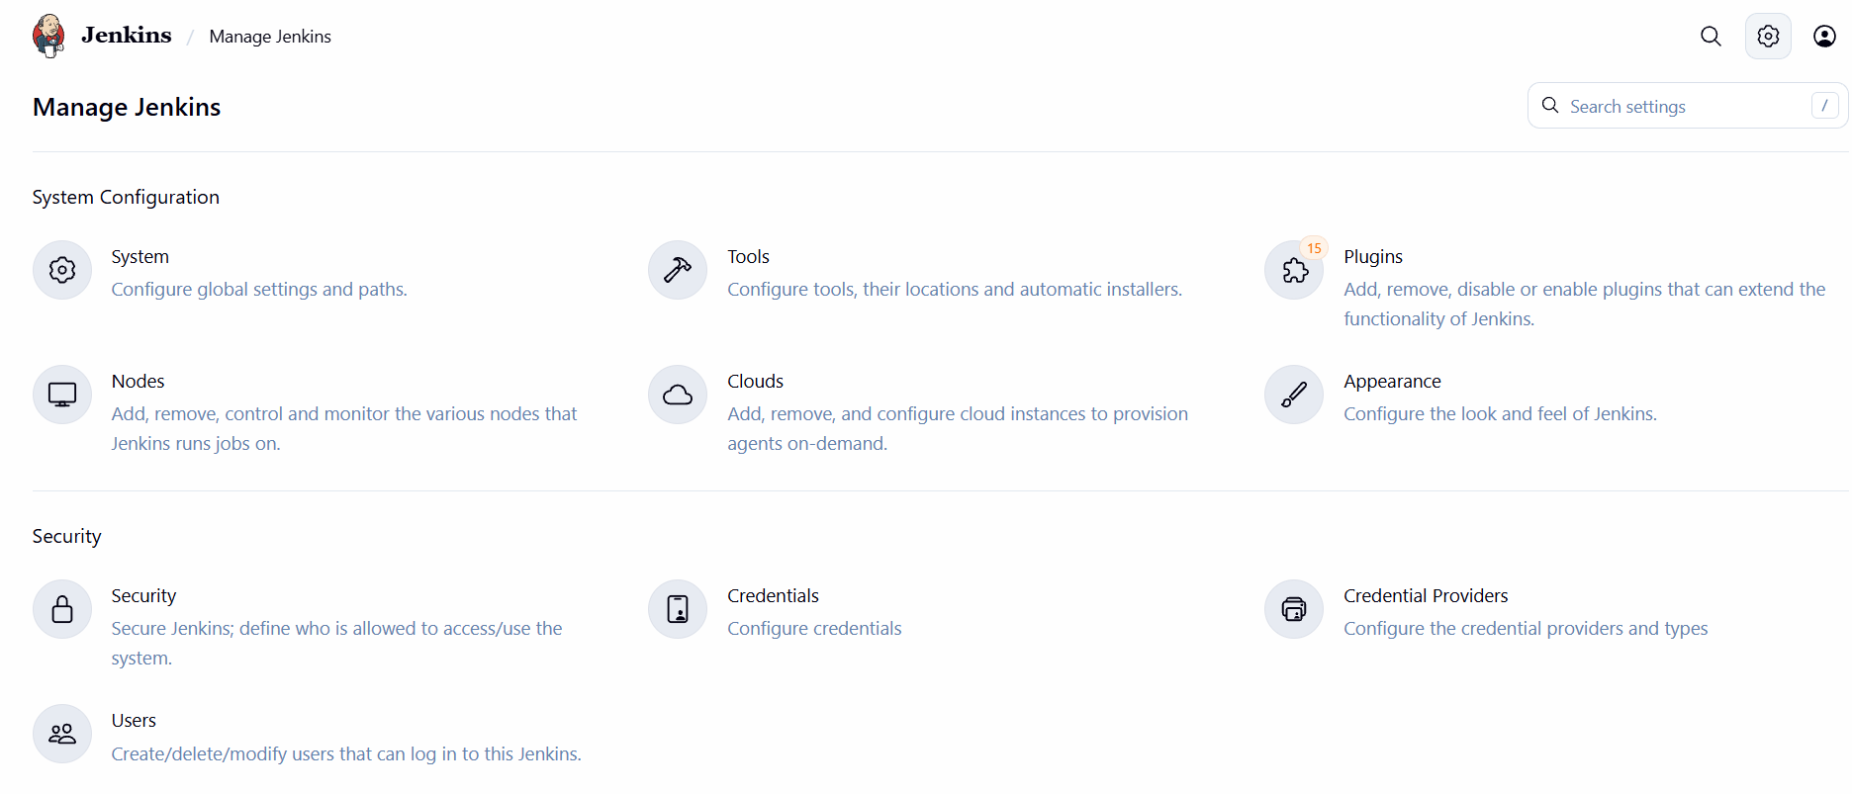
5. Create Jenkins Pipeline Job: Now go to Jenkins homepage and create a new job. Name the job with whatever name that you want and select pipeline. Click on OK. Now in the pipeline section type the following code.

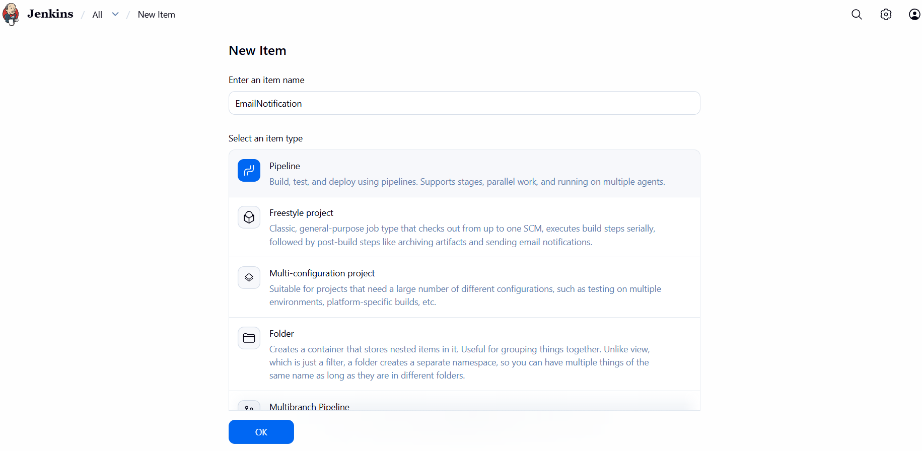
Pipeline Script:
pipeline {
agent any
stages {
stage('Checkout') {
steps {
echo 'Checking out source code...'
git branch: 'main', url: 'https://github.com/SSBHARATHKUMAR-13/Jenkins-CD-Demo.git'
}
}
stage('Build') {
steps {
echo 'Building the application...'
sh 'echo Build completed'
}
}
stage('Test') {
steps {
echo 'Running tests...'
sh 'echo Tests passed'
}
}
}
post {
success {
mail to: 'ssbharathkumar03@gmail.com',
subject: "Build #${env.BUILD_NUMBER} SUCCESS - ${env.JOB_NAME}",
body: "The pipeline ${env.JOB_NAME} (build #${env.BUILD_NUMBER}) completed successfully. Details: ${env.BUILD_URL}"
}
failure {
mail to: 'ssbharathkumar03@gmail.com',
subject: "Build #${env.BUILD_NUMBER} FAILED - ${env.JOB_NAME}",
body: "The pipeline ${env.JOB_NAME} (build #${env.BUILD_NUMBER}) failed. Check the console: ${env.BUILD_URL}console"
}
}
}

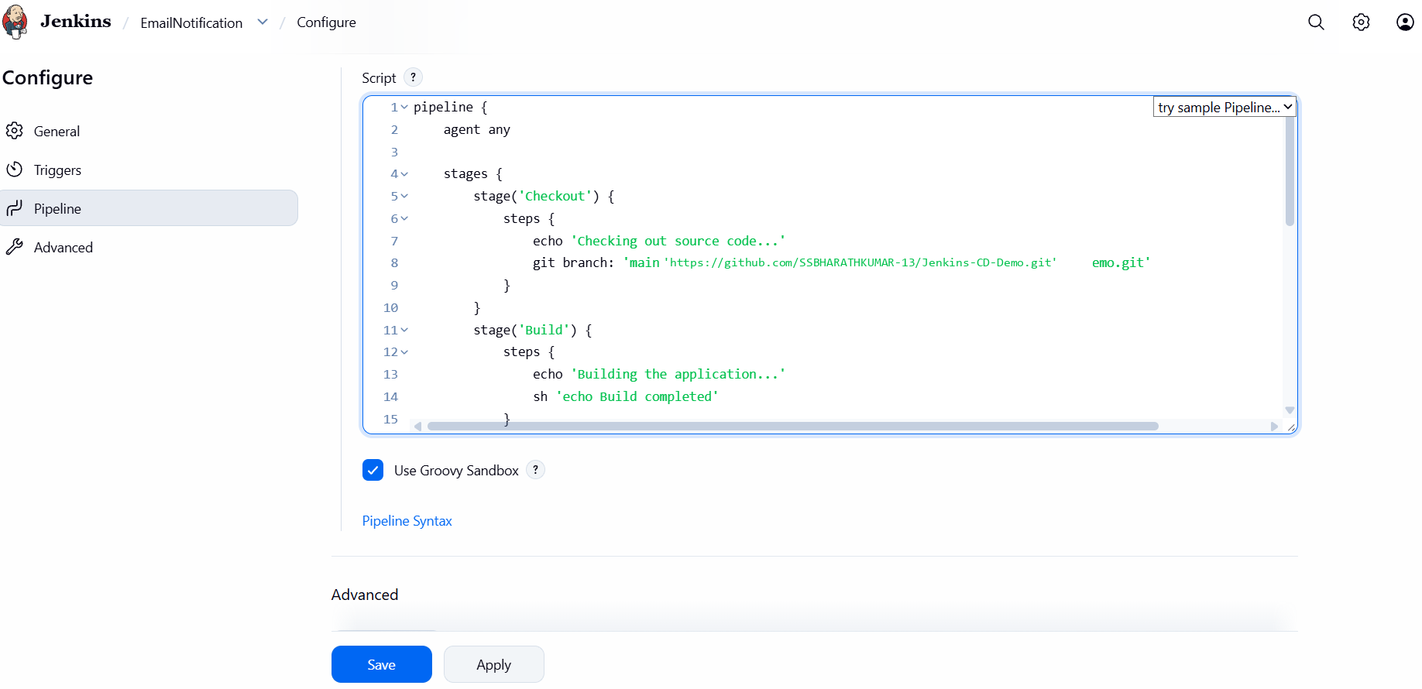
6. Run sudo docker run -d -p 1025:1025 -p 8025:8025 mailhog/mailhog in a terminal to start the local mail server, then open http://localhost:8025 in a browser to see its empty inbox.

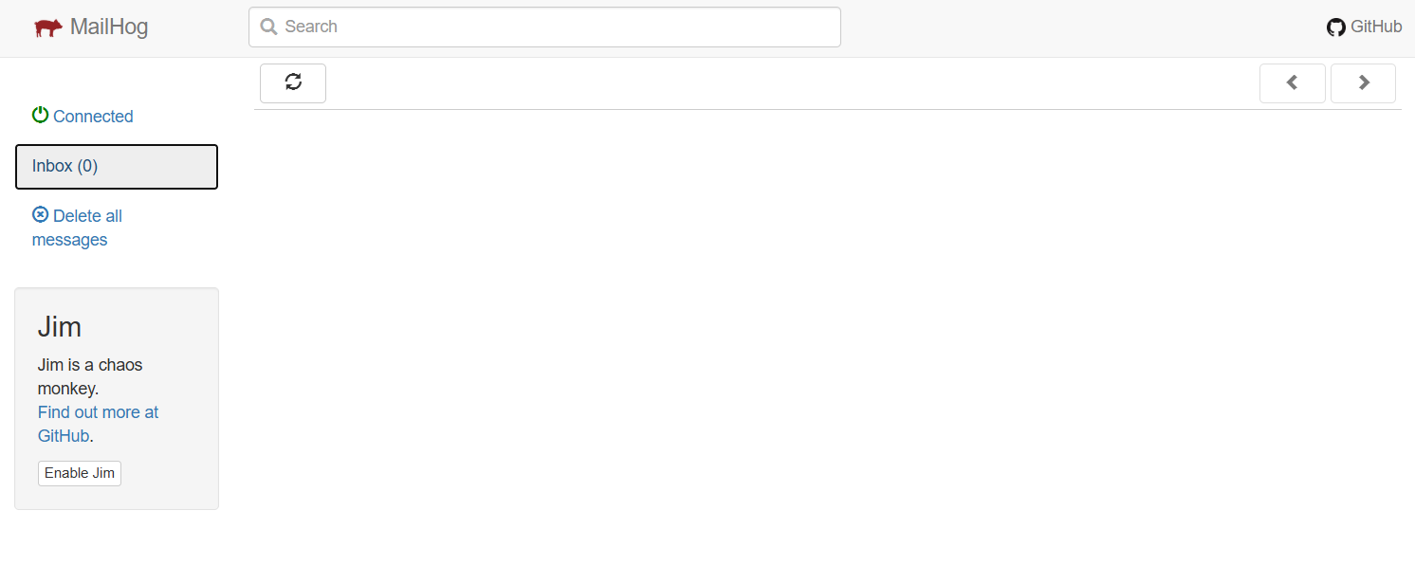
7. Execute the Jenkins pipeline and verify that all stages-Checkout, Build, Test, and Post Actions-complete successfully, with the email notification step executed.

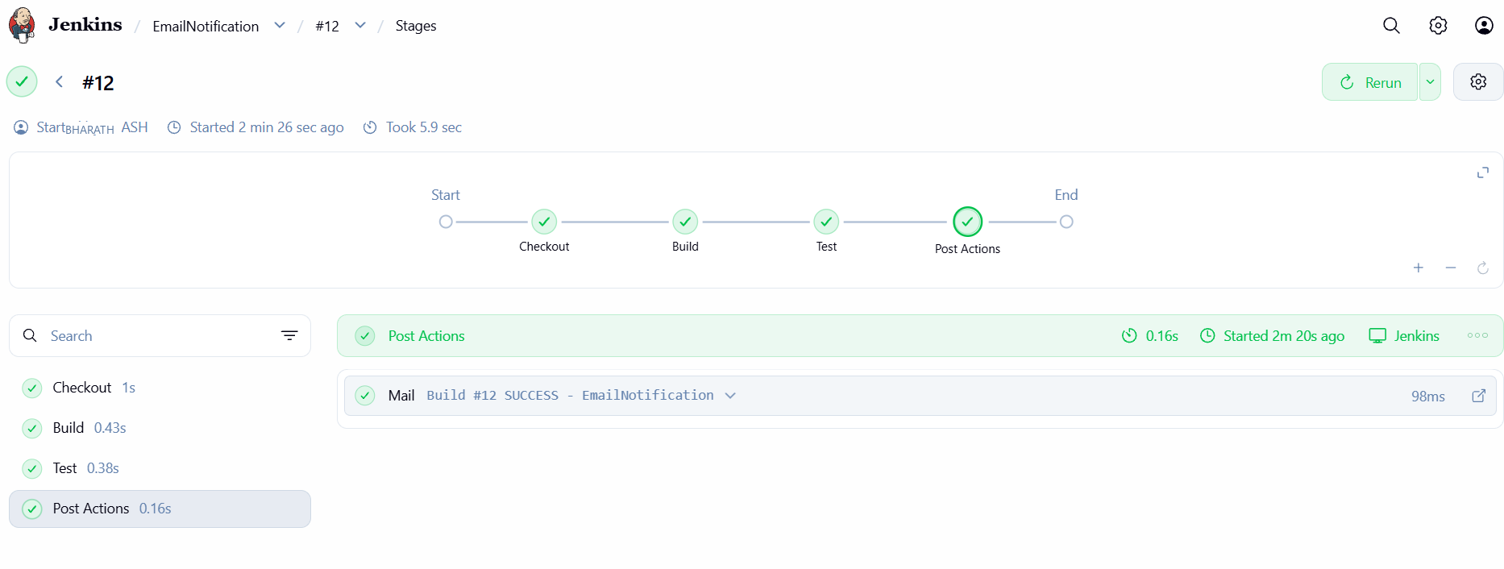
8. After the Jenkins pipeline completes successfully, open the MailHog inbox at http://localhost:8025. The email notification with the subject "Build #12 SUCCESS - EmailNotification" confirms that the Build, Test, and Deploy stages have completed successfully.

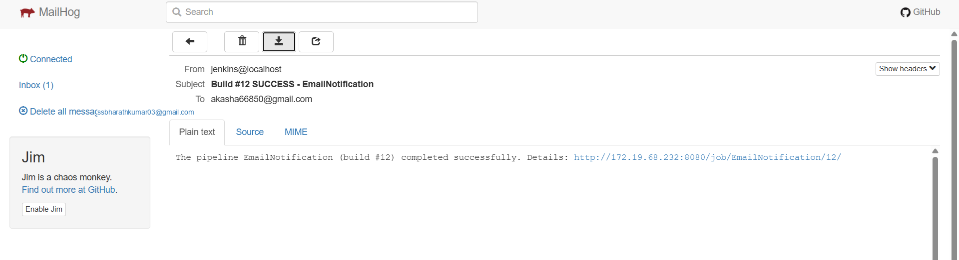

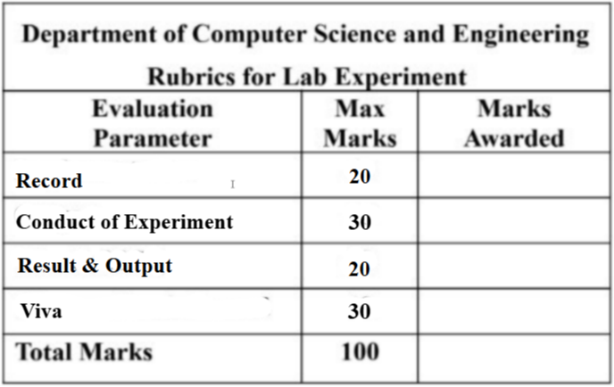
Result:
The CD pipeline was executed successfully in Jenkins, and an email notification confirmed successful deployment.

