**Education Center Staff Nisenan Class: School items**

**Review sheet for Monday, September 18, 2023**

In today’s class, we reviewed some language for talking about “having” different school items:

1. Names for some school items (e.g. ‘tape’ ‘pen/pencil’).
2. How to ask “Do you have _____?” and respond.
3. How to say “Take it” and “Give it to me”.

**School items**

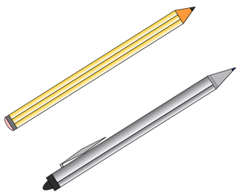

*boonóyu* ‘pen/pencil’ *papél* ‘paper’ *sɨk’ə́lyu* ‘scissors’

*inpaayutíyu* ‘stapler’ *wac’adaktíyu* ‘tape’

**Talking about “having”**

Today we learned some language that we can use to talk about having different school items. For example, you can ask whether someone has something by saying:

*_____-pébe mi?* ‘Do you have _____?’

*Boonoyupébe mi?* ‘Do you have boonóyu?’ (pen/pencil)

*Papelpébe mi?* ‘Do you have papél?’ (paper)

*Inpaayutiyupébe mi?* ‘Do you have inpaayutíyu?’ (stapler)

*Sɨk’ǝlyupébe mi?* ‘Do you have sɨk’ə́lyu?’ (scissors)

*Wac’adaktiyupébe mi?*  ‘Do you have wac’adaktíyu?’ (tape)

In response, you can use some of the following language:

*Haan!* ‘Yes!’

*Wiin!* ‘No!’

You can also tell someone to take the item, or give it to you:

*Meep mɨyé.* ‘Take it.’

*Mey nik mɨyé.* ‘Give it to me.’

Please reach out to the Language Department at [Language@ssband.org](mailto:Language@ssband.org) with any questions.