StatMek and importance sampling
- Entropy and energy
$$\frac{S}{k_{B}}=-\sum_{i}{p_{i}\ln\left(p_{i}\right)}$$
$p_{i}$ the probability to be in state $i$ in phase space.
- Micro and canonical ensembles
Microcanonical ensemble: Sepcified energy E
Canonical ensemble: System connected to reservoir. $P_{i}=\frac{1}{Z}e^{-βϵ_{i}}$, $Z=\sum_{i}{e^{-βϵ_{i}}}=e^{-βF}$
Minimise $F=\left\langle E\right\rangle -TS$
Example: Paramagnet:

All in steady state
- Monte-Carlo method
Find expectation values $\left\langle A\right\rangle =\frac{1}{Z}\sum_{i}{A_{i}e^{-βϵ_{i}}}$ by importance sampling in phase space. Visit states based on probability. Transition porb $w_{l→m}≡w_{lm}$
$$P_{l}\left(t+1\right)=P_{l}\left(t\right)\left(1-\sum_{m≠l}{w_{lm}}\right)+\sum_{m≠l}{P_{m}\left(t\right)w_{ml}}=\sum_{m}{P_{m}\left(t\right)w_{ml}}$$
Steady state implies
$$P_{l}\left(t+1\right)-P_{l}\left(t\right)=\sum_{m}{\left(P_{m}\left(t\right)w_{ml}-P_{l}\left(t\right)w_{lm}\right)}$$
$$=\sum_{m}{\left(P_{m}^{eq}w_{ml}-P_{l}^{eq}w_{lm}\right)}=0$$
- Detailed balance: $P_{m}^{eq}w_{ml}-P_{l}^{eq}w_{lm}=0$, flux is time reversible.
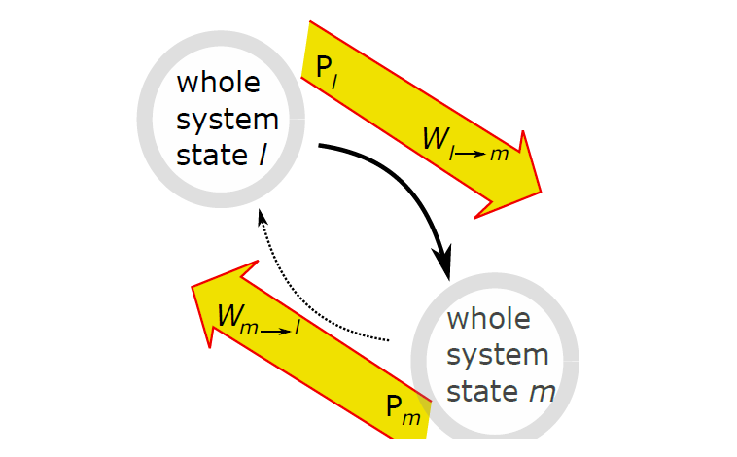
Look at transition $l→m$. This obeys
$$ΔE≡E_{m}-E_{l}$$
$$\frac{w_{lm}}{w_{ml}}=e^{-βΔE}$$
We looked at the particular scheme called Metropolis algorithm:
$$\frac{w_{lm}}{w_{ml}}=\frac{F\left(e^{-βΔE}\right)}{F\left(\frac{1}{e^{-βΔE}}\right)}=e^{-βΔE}$$
Solved by $w_{lm}^{\left(metropolis\right)}=\min\left(1,e^{-βΔE}\right)$.
Algoritme for Ising-type model:
Set temperature and some Hamiltonian. Start with array of spins.
Flip one spin and calculate $ΔE$: If $ΔE<0$ transition. Else if $ΔE>0$ transition with $P=e^{-βΔE}$.
Sample some variable $A$ after $n_{0}$ steps. $\left\langle A\right\rangle =\frac{1}{n_{max}-n_{0}}\sum_{n>n_{0}}{A_{n}}$

Phase transitions and criticality
- Ising: 1D, 2D
- Mean-field
- Monte-Carlo
- Universality
Phase transition: Sudden change in order parameter (1st) or derivative of OP (2nd). Critical point at $T_{c}$.
Example: 2D Ising ($h∼0$) from $M≠0$ to $M=0$; $M∝\sum{s_{i}}$

Percolation and fractals
- Power laws
- Percolation on Bethe lattice
- Fractal dimension
Scale-free behaviour: No typical size. Large deviations have high probability (compared with scaled distributions). $P\left(k\right)=\frac{1}{k^{γ}}→P\left(>k\right)∝\frac{1}{k^{γ-1}}$
Ziph distribution, $γ=2$ is special (cut-off depedent vs cut off independent
$$\left\langle s\right\rangle =\int_{1}^{M}{ds^{'}\frac{s^{'}}{{s^{'}}^{τ}}}=\frac{1}{2-τ}\left(M^{2-τ}-1\right)∼\left\{\begin{aligned}M^{2-τ}, τ<2 \\ 1, τ>2\end{aligned}\right.$$
Percolation:
Clusters of connected sites with active $p$.Critical $p_{c}$: From many similar size clusters to one large (system spanning) cluster (the system percolates/transmits). Easy to simulate, hard to calculate.
Bethe lattice: Simple, properties can be calculated. Network of nodes with connectivity $z$ (=3) and no loops (one directed path for any pair of nodes). Infinite. Z-1 branches per site. Nodes within distance x:
$$N\left(≤x\right)=1+3\left(\sum_{i}^{x-1}{2^{i}}\right)=1+3·\frac{1-2^{x}}{1-2}=3·2^{x}-3∝x^{D}→D=∞$$
Critical branching: Any active site (p) connects on average to 1 active site (not counting back-propagation):
$$\#active site =p_{c}·\left(z-1\right)=1→p_{c}=\frac{1}{2}$$
Look at z=3 from now on. We can now calculate critical exponents. Some cahrectaristics are
Mean cluster size $S\left(p\right)∝{\left|p_{c}-p\right|}^{-γ}$ for $p<p_{c}$:
Cluster size distribution:

SOC
https://en.wikipedia.org/wiki/Self-organized_criticality
- Critical Attractor?
- Random walk: $t^{-\frac{3}{2}}$
- Sandpile (random walk)
Counterexample: For Ising critical point is reached by tuning $T$ in steady state. If SOC, this is reached by dynamic models by some transient.
Random walk:
Walk with $x\left(\frac{t}{τ}+1\right)=x\left(\frac{t}{τ}\right)+η$, $η=±l$. Satisfies, when steps uncorrelated:
$\left\langle x\right\rangle =0$, $\left\langle x^{2}\right\rangle =Var\left(x\right)=\sum_{i=0}^{\frac{t}{τ}}{l^{2}}=2Dt$, so $width=σ∝\sqrt{t}$
Destributon of walkers at $t$ given by
$$ρ\left(x,t\right)=\frac{1}{2\sqrt{πDt}}\exp\left(-\frac{x^{2}}{4Dt}\right)$$
First returns: We look at distribution of first returns $P_{First}(t)$ for walker returning to $x=0$.
Heuristic argument:
Assume power law $P_{First}\left(t\right)∝\frac{1}{t^{τ}}$. Total time must be the number of intervals (between returns) times the average length of these intervals. Number of intervals is given by $\frac{number of points along x}{width of these points}∝\frac{t}{\sqrt{t}}$
$$t∼\frac{t}{\sqrt{t}}\int_{1}^{t}{dt^{'}\frac{t^{'}}{{t^{'}}^{τ}}}→τ=\frac{3}{2}$$
A special exponent.
Questions:
How stringent is lower bound? How is $\frac{t}{\sqrt{t}}$ derived? (Perhaps not important): P(max excursion in [0; t] > x) should have $≥$ instead?
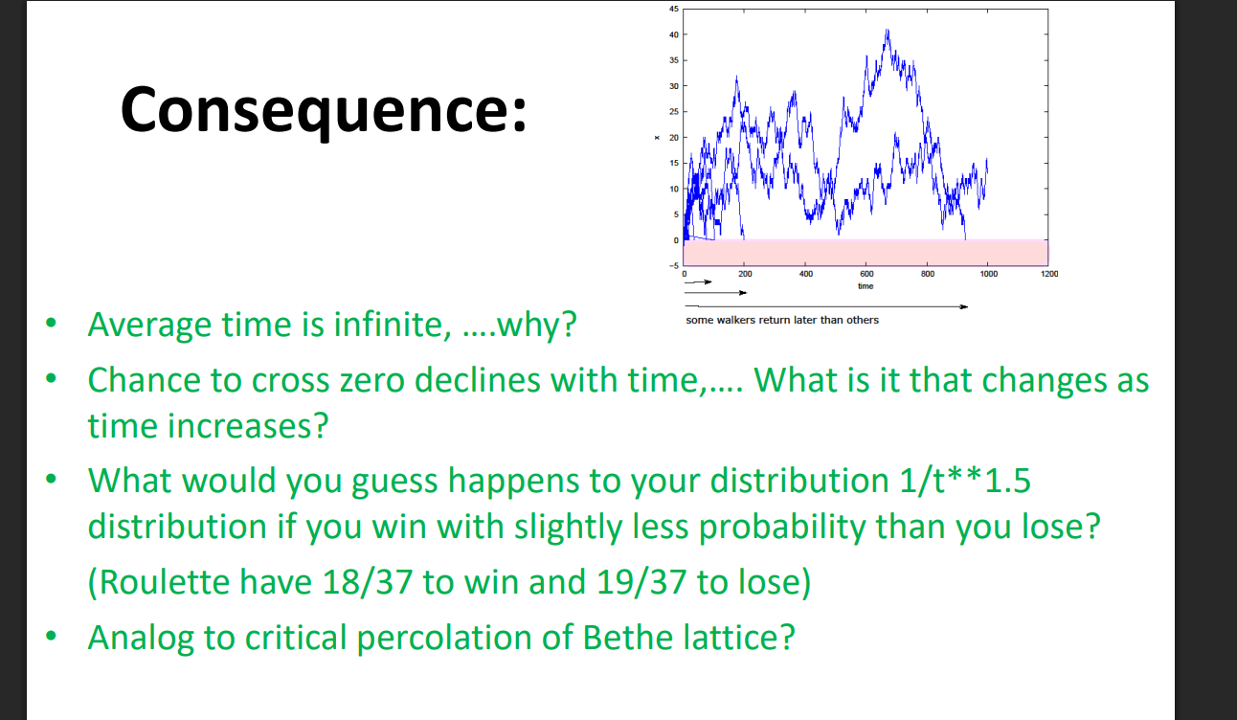
Use of random walks in self organised criticality:
Critical branching prcoss:
Each branch has 50/50 to produce 0 or 2 branches.
Sandpile:

Stochastic dynamics
- Gillespie
- Agent-based models
- SIR
Event based vs agent based: Event based has every part following their own set of rules (e.g. creation, death). Agent based has the parts of the system interact and adapt to input from eachother.
Simulate system by randomness of discrete entities/agents as system components.
We start with event based modelling and the Gillespie algorithm:
Randomness in continuous equations like
$$\frac{d\left\langle x\right\rangle }{dt}=\left\langle x\right\rangle$$
Interpreting $xΔt$ as the probability for $x→x+1$ in time step $Δt$. Interpretation as ABM: $x$ agents replicate
Independently.
$$\frac{d\left\langle x\right\rangle }{dt}=\left\langle x\right\rangle -\left\langle x\right\rangle =0$$
Random walk-like. Reaction like
$$\frac{d\left\langle x\right\rangle }{dt}=Q-\frac{\left\langle x\right\rangle }{τ}, Q>0$$
$$x\left(t+Δt\right)-x\left(t\right)=QΔt-\frac{x}{τ}Δt$$
Agents are produced at a constant rate and die at a rate prop to their number; like radioactive process. Have to ensure $QΔt$ and $\frac{x}{τ}Δt≪1$. Not effective constraint.
Gillespie:
When simulating time series (like the evolution model from SOC), often long periods of calm are interrupted by short bursts of activity. We wish to reduce wasted time.
Focus on change. Instead of $p(Δt)$ from $Δt$, find $Δt$ from $p(Δt)$, ensuring something always happens at each time step. Consider Poisson process (memory-less system), i.e., independent with fixed mean $λ=r_{i}Δt$:
$$p\left(n_{i}\right)=\frac{e^{-λ}λ^{n_{i}}}{n_{i}!}→p\left(event after Δt\right)=p\left(n_{i}=0,Δt\right)=e^{-r_{i}Δt}$$
Now generate the probability as $P_{i}=ran_{i}∈\left[0,1\right]$ and then have
$$t_{next process}=\min\left(t+Δt_{i}\right)=\min\left(t-\frac{\ln\left(ran_{i}\right)}{r_{i}}\right)$$
With the next process also decided by $\min\left(t+Δt_{i}\right)$. Then reset and do again for next timestep. If $r_{i}$ small, event happens often, as it should. If change different than 1 ($Δ_{i}$), $Δt_{i}→Δ_{i}Δt_{i}$. One can then find the average as
$$\left\langle x\right\rangle =\frac{\sum_{i}{Δt_{i}x_{i-1}}}{\sum_{i}{Δt_{i}}}$$
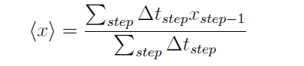
What is $x_{i-1}$?
Agent based models:
Exemplified with the voter model (Ising-like but not equilibrium):
3-state: -1,0,+1. Change if selecting two neighbours with same sign but opposite yours.
OR: Randomly change state of one agent with probability $β$ (temperature).
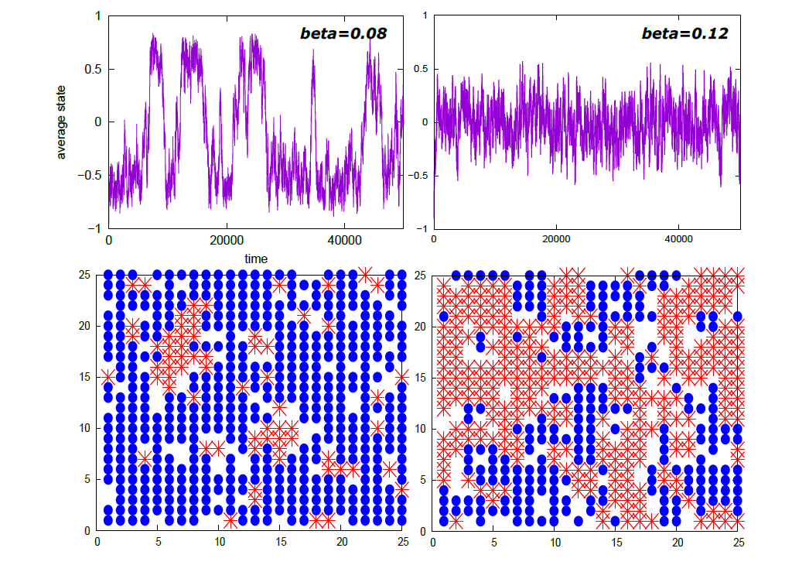
2-state: Have to meat two neighbours of opposite sign to change.
Can be solved by mean-field.
Epidemics (SIR and agent-based):
At least 3 populations: Susceptible (S), infected (I) and recovered (R).
Solve by event-based (mean field). Recovered can never be infected.
$\frac{dS}{dt}=-λIS$, $\frac{dI}{dt}=λIS-γI$, $\frac{dR}{dt}=γI$
In the beninging, $I∼1$

Networks

Econophysics
- Hurst exponent

Wiki:
https://en.wikipedia.org/wiki/Critical_phenomena
https://en.wikipedia.org/wiki/Self-organized_criticality
https://en.wikipedia.org/wiki/Detailed_balance
Questions:
Factor $\frac{t}{\sqrt{t}}$ for first returns in RW.

