[HBase-4400](https://www.google.com/url?q=https://issues.apache.org/jira/browse/HBASE-4400&sa=D&source=editors&ust=1751362891434861&usg=AOvVaw3wKNH9F74qfJtF6AFiw_nj)

.META. getting stuck if RS hosting it is dead and znode state is in RS_ZK_REGION_OPENED

**(1)  Log information**

**(1.1) Roles in this case**

RS2 goes down while it is processing the assignment for META region

HMaster   recovers the META region which was on RS2 from   ZK

**(1.2) Symptoms**

“Start 2 RegionServers. The META is being hosted by RS2 but while processing it goes down.

Now restart the master and RS1. Master gets the RS name from the znode in RS_ZK_REGION_OPENED. But as RS2 is not online still the master is not able to process the META at all.”

The following logs are from HMaster, after HMaster restarts:

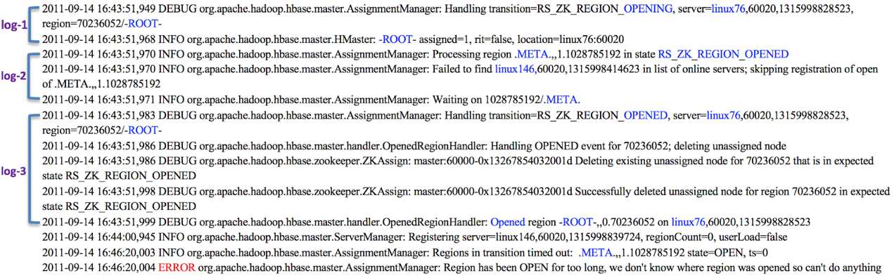

log-1 and log-3 show the assignment for ROOT              log-2 shows the assignment for META

After the HMaster prints this ERROR, the HMaster will hang due to the META region getting stuck. As a result, the system will also hang.

2011-09-14 16:43:51,949 DEBUG org.apache.hadoop.hbase.master.AssignmentManager: Handling transition=RS_ZK_REGION_OPENING, server=linux76,60020,1315998828523, region=70236052/-ROOT-

2011-09-14 16:43:51,968 INFO org.apache.hadoop.hbase.master.HMaster: -ROOT- assigned=1, rit=false, location=linux76:60020

2011-09-14 16:43:51,970 INFO org.apache.hadoop.hbase.master.AssignmentManager: Processing region .META.,,1.1028785192 in state RS_ZK_REGION_OPENED

2011-09-14 16:43:51,970 INFO org.apache.hadoop.hbase.master.AssignmentManager: Failed to find linux146,60020,1315998414623 in list of online servers; skipping registration of open of .META.,,1.1028785192

2011-09-14 16:43:51,971 INFO org.apache.hadoop.hbase.master.AssignmentManager: Waiting on 1028785192/.META.

2011-09-14 16:43:51,983 DEBUG org.apache.hadoop.hbase.master.AssignmentManager: Handling transition=RS_ZK_REGION_OPENED, server=linux76,60020,1315998828523, region=70236052/-ROOT-

2011-09-14 16:43:51,986 DEBUG org.apache.hadoop.hbase.master.handler.OpenedRegionHandler: Handling OPENED event for 70236052; deleting unassigned node

2011-09-14 16:43:51,986 DEBUG org.apache.hadoop.hbase.zookeeper.ZKAssign: master:60000-0x13267854032001d Deleting existing unassigned node for 70236052 that is in expected state RS_ZK_REGION_OPENED

2011-09-14 16:43:51,998 DEBUG org.apache.hadoop.hbase.zookeeper.ZKAssign: master:60000-0x13267854032001d Successfully deleted unassigned node for region 70236052 in expected state RS_ZK_REGION_OPENED

2011-09-14 16:43:51,999 DEBUG org.apache.hadoop.hbase.master.handler.OpenedRegionHandler: Opened region -ROOT-,,0.70236052 on linux76,60020,1315998828523

2011-09-14 16:44:00,945 INFO org.apache.hadoop.hbase.master.ServerManager: Registering server=linux146,60020,1315998839724, regionCount=0, userLoad=false

2011-09-14 16:46:20,003 INFO org.apache.hadoop.hbase.master.AssignmentManager: Regions in transition timed out: .META.,,1.1028785192 state=OPEN, ts=0

2011-09-14 16:46:20,004 ERROR org.apache.hadoop.hbase.master.AssignmentManager: Region has been OPEN for too long, we don't know where region was opened so can't do anything