[HBase-4792](https://www.google.com/url?q=https://issues.apache.org/jira/browse/HBASE-4792&sa=D&source=editors&ust=1751359852701173&usg=AOvVaw1GmzgiNJM75ltunnCqhsfO)

SplitRegionHandler doesn't care if it deletes the znode or not, leaves the parent region stuck offline

**(1)  Log information**

**(1.1) Roles in this case**

RegionServer is waiting for HMaster to delete the ZNode

**(1.2) Symptoms**

HMaster log:

2011-11-15 22:28:57,900 DEBUG org.apache.hadoop.hbase.master.handler.SplitRegionHandler: Handling SPLIT event for e5be6551c8584a6a1065466e520faf4e; deleting node

2011-11-15 22:28:57,900 DEBUG org.apache.hadoop.hbase.zookeeper.ZKAssign: master:62003-0x132f043bbde08c1 Deleting existing unassigned node for e5be6551c8584a6a1065466e520faf4e that is in expected state RS_ZK_REGION_SPLIT

2011-11-15 22:28:57,975 WARN org.apache.hadoop.hbase.zookeeper.ZKAssign: master:62003-0x132f043bbde08c1 Attempting to delete unassigned node in RS_ZK_REGION_SPLIT state but after verifying state, we got a version mismatch         When this WARN is printed, ZKUtil.*deleteNode*() fails and returns*FALSE.*

2011-11-15 22:28:57,975 INFO org.apache.hadoop.hbase.master.handler.SplitRegionHandler: Handled SPLIT report); parent=TestTable,0001355346,1321396080924.e5be6551c8584a6a1065466e520faf4e. daughter a=TestTable,0001355346,1321396132414.df9b549eb594a1f8728608a2a431224a.daughter b=TestTable,0001368082,1321396132414.de861596db4337dc341138f26b9c8bc2.

2011-11-15 22:28:58,052 DEBUG org.apache.hadoop.hbase.master.AssignmentManager: Handling transition=RS_ZK_REGION_SPLIT, server=sv4r28s44,62023,1321395865619, region=e5be6551c8584a6a1065466e520faf4e

2011-11-15 22:28:58,052 WARN org.apache.hadoop.hbase.master.AssignmentManager: Region e5be6551c8584a6a1065466e520faf4e not found on server sv4r28s44,62023,1321395865619; failed processing

2011-11-15 22:28:58,052 WARN org.apache.hadoop.hbase.master.AssignmentManager: Received SPLIT for region e5be6551c8584a6a1065466e520faf4e from server sv4r28s44,62023,1321395865619 but it doesn't exist anymore, probably already processed its split

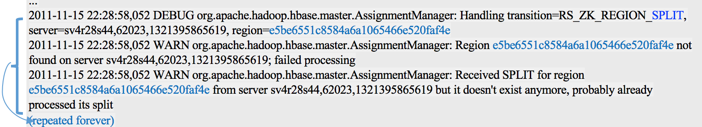

“The master processes the split but when it calls ZKAssign.deleteNode it doesn't check the boolean that's returned. In this case it was false. So for the master the split was completed, but for the region server it's another story:”

 (RS log)

2011-11-15 22:28:57,661 DEBUG org.apache.hadoop.hbase.zookeeper.ZKAssign: regionserver:62023-0x132f043bbde08d3 Attempting to transition node e5be6551c8584a6a1065466e520faf4e from RS_ZK_REGION_SPLITTING to RS_ZK_REGION_SPLIT

2011-11-15 22:28:57,775 DEBUG org.apache.hadoop.hbase.zookeeper.ZKAssign: regionserver:62023-0x132f043bbde08d3 Successfully transitioned node e5be6551c8584a6a1065466e520faf4e from RS_ZK_REGION_SPLITTING to RS_ZK_REGION_SPLIT

2011-11-15 22:28:57,775 INFO org.apache.hadoop.hbase.regionserver.SplitTransaction: Still waiting on the master to process the split for e5be6551c8584a6a1065466e520faf4e

2011-11-15 22:28:57,876 DEBUG org.apache.hadoop.hbase.zookeeper.ZKAssign: regionserver:62023-0x132f043bbde08d3 Attempting to transition node e5be6551c8584a6a1065466e520faf4e from RS_ZK_REGION_SPLIT to RS_ZK_REGION_SPLIT

2011-11-15 22:28:57,967 DEBUG org.apache.hadoop.hbase.zookeeper.ZKAssign: regionserver:62023-0x132f043bbde08d3 Successfully transitioned node e5be6551c8584a6a1065466e520faf4e from RS_ZK_REGION_SPLIT to RS_ZK_REGION_SPLIT

