[HBase-9387](https://www.google.com/url?q=https://issues.apache.org/jira/browse/HBASE-9387&sa=D&source=editors&ust=1751363076964869&usg=AOvVaw1dmKoXBwi6_LTnxMmUImqd)

**Region could get lost during assignment**

**(1)  Log information**

**(1.1) Roles in this case**

HMaster         sends RPC_OPEN to        RegionServer

RegionServer  sends eventHandler to   ZooKeeper                             ZooKeeper  notifies  HMaster

**(1.2) Symptoms**

“Looks like region state for 1588230740 became inconsistent between master and the surviving region server:”

2013-08-29 22:15:34,180 INFO  [AM.ZK.Worker-pool2-t4] master.RegionStates(299): Onlined 1588230740 on kiyo.gq1.ygridcore.net,57016,1377814510039         The META region state in HMaster is opened in the specific RS “kiyo.gq1.ygridcore.net,57016,1377814510039”

...

2013-08-29 22:15:34,587 DEBUG [Thread-221] client.HConnectionManager$HConnectionImplementation(1269): locateRegionInMeta parentTable=hbase:meta, metaLocation={region=hbase:meta,,1.1588230740, hostname=kiyo.gq1.ygridcore.net,57016,1377814510039, seqNum=0}, attempt=2 of 35 failed; retrying after sleep of 302 because: org.apache.hadoop.hbase.exceptions.RegionOpeningException: Region is being opened: 1588230740

            at org.apache.hadoop.hbase.regionserver.HRegionServer.getRegionByEncodedName(HRegionServer.java:2574)

            at org.apache.hadoop.hbase.regionserver.HRegionServer.getRegion(HRegionServer.java:3949)

            at org.apache.hadoop.hbase.regionserver.HRegionServer.get(HRegionServer.java:2733)

            at org.apache.hadoop.hbase.protobuf.generated.ClientProtos$ClientService$2.callBlockingMethod(ClientProtos.java:26965)

            at org.apache.hadoop.hbase.ipc.RpcServer.call(RpcServer.java:2063)

            at org.apache.hadoop.hbase.ipc.RpcServer$CallRunner.run(RpcServer.java:1800)

            at org.apache.hadoop.hbase.ipc.SimpleRpcScheduler.consumerLoop(SimpleRpcScheduler.java:165)

            at org.apache.hadoop.hbase.ipc.SimpleRpcScheduler.access$000(SimpleRpcScheduler.java:41)

2013-08-29 22:15:29,978 DEBUG [RS_OPEN_META-kiyo:57016-0] zookeeper.ZKAssign(786): regionserver:57016-0x140cc24e86a0003 Transitioning 1588230740 from RS_ZK_REGION_OPENING to RS_ZK_REGION_OPENED

...

2013-08-29 22:15:32,746 WARN [RS_OPEN_META-kiyo:57016-0] zookeeper.RecoverableZooKeeper(258): Possibly transient ZooKeeper, quorum=localhost:61251, exception=org.apache.zookeeper.KeeperException$ConnectionLossException: KeeperErrorCode = ConnectionLoss for /hbase/region-in-transition/1588230740

2013-08-29 22:15:32,746 INFO [RS_OPEN_META-kiyo:57016-0] util.RetryCounter(54): Sleeping 2000ms before retry #1...

...

2013-08-29 22:15:34,148 DEBUG [AM.ZK.Worker-pool2-t4] master.AssignmentManager(801): Handling transition=RS_ZK_REGION_OPENED, server=kiyo.gq1.ygridcore.net,57016,1377814510039, region=1588230740, current state from region state map ={1588230740 state=OPENING, ts=1377814529578, server=kiyo.gq1.ygridcore.net,57016,1377814510039}

...

2013-08-29 22:15:34,149 DEBUG [AM.ZK.Worker-pool2-t4] zookeeper.ZKAssign(405): master:44745-0x140cc24e86a0001-0x140cc24e86a0001 Deleting existing unassigned node 1588230740 in expected state RS_ZK_REGION_OPENED

2013-08-29 22:15:34,179 DEBUG [pool-1-thread-1-EventThread] zookeeper.ZooKeeperWatcher(312): master:44745-0x140cc24e86a0001-0x140cc24e86a0001 Received ZooKeeper Event, type=NodeDeleted, state=SyncConnected, path=/hbase/region-in-transition/1588230740

...

2013-08-29 22:15:34,760 WARN [RS_OPEN_META-kiyo:57016-0] zookeeper.ZKAssign(866): regionserver:57016-0x140cc24e86a0003-0x140cc24e86a0003 Attempt to transition the unassigned node for 1588230740 from RS_ZK_REGION_OPENING to RS_ZK_REGION_OPENED failed, the node existed and was in the expected state but then when setting data it no longer existed

2013-08-29 22:15:34,761 WARN [RS_OPEN_META-kiyo:57016-0] handler.OpenRegionHandler(370): Completed the OPEN of region hbase:meta,,1.1588230740 but when transitioning from OPENING to OPENED got a version mismatch, someone else clashed so now unassigning -- closing region on server: kiyo.gq1.ygridcore.net,57016,1377814510039

2013-08-29 22:15:34,761 DEBUG [RS_OPEN_META-kiyo:57016-0] regionserver.HRegion(950): Closing hbase:meta,,1.1588230740: disabling compactions & flushes

2013-08-29 22:15:34,761 DEBUG [RS_OPEN_META-kiyo:57016-0] regionserver.HRegion(972): Updates disabled for region hbase:meta,,1.1588230740

2013-08-29 22:15:34,762 INFO [StoreCloserThread-hbase:meta,,1.1588230740-1] regionserver.HStore(668): Closed info

2013-08-29 22:15:34,762 INFO [RS_OPEN_META-kiyo:57016-0] regionserver.HRegion(1030): Closed hbase:meta,,1.1588230740

2013-08-29 22:15:34,763 INFO [RS_OPEN_META-kiyo:57016-0] handler.OpenRegionHandler(396): Opening of region {ENCODED => 1588230740, NAME => 'hbase:meta,,1', STARTKEY => '', ENDKEY => ''} failed, transitioning from OPENING to FAILED_OPEN in ZK, expecting version 1

2013-08-29 22:15:34,763 DEBUG [RS_OPEN_META-kiyo:57016-0] zookeeper.ZKAssign(786): regionserver:57016-0x140cc24e86a0003-0x140cc24e86a0003 Transitioning 1588230740 from RS_ZK_REGION_OPENING to RS_ZK_REGION_FAILED_OPEN

2013-08-29 22:15:34,765 DEBUG [RS_OPEN_META-kiyo:57016-0] zookeeper.ZKUtil(784): regionserver:57016-0x140cc24e86a0003-0x140cc24e86a0003 Unable to get data of znode /hbase/region-in-transition/1588230740 because node does not exist (not necessarily an error)

2013-08-29 22:15:34,765 WARN [RS_OPEN_META-kiyo:57016-0] handler.OpenRegionHandler(404): Unable to mark region {ENCODED => 1588230740, NAME => 'hbase:meta,,1', STARTKEY => '', ENDKEY => ''} as FAILED_OPEN. It's likely that the master already timed out this open attempt, and thus another RS already has the region.

From the symptom, we can locate the related source code based on the messages.

RegionOpeningException occurs in the following function. The exception occurs because region 1588230740 is not in the current RS’s onlineRegions, but it is in regionsInTransitionInRS.

It seems that even in this RS, there is a conflict within the META region state.

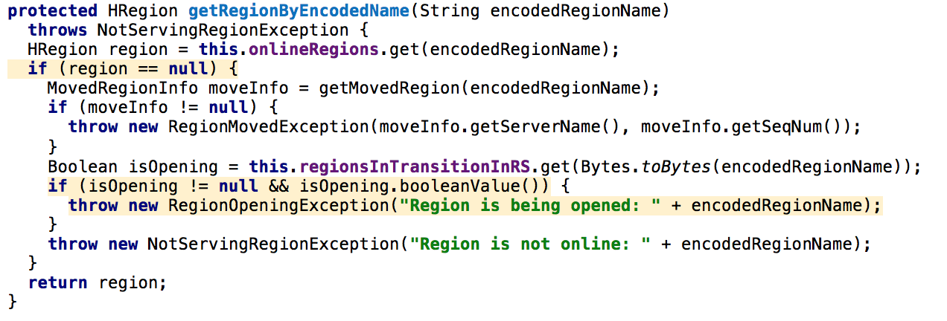

When the Client wants to locate a certain region in META through RPC call, it fails due to the conflict in the RS which hosting META region.

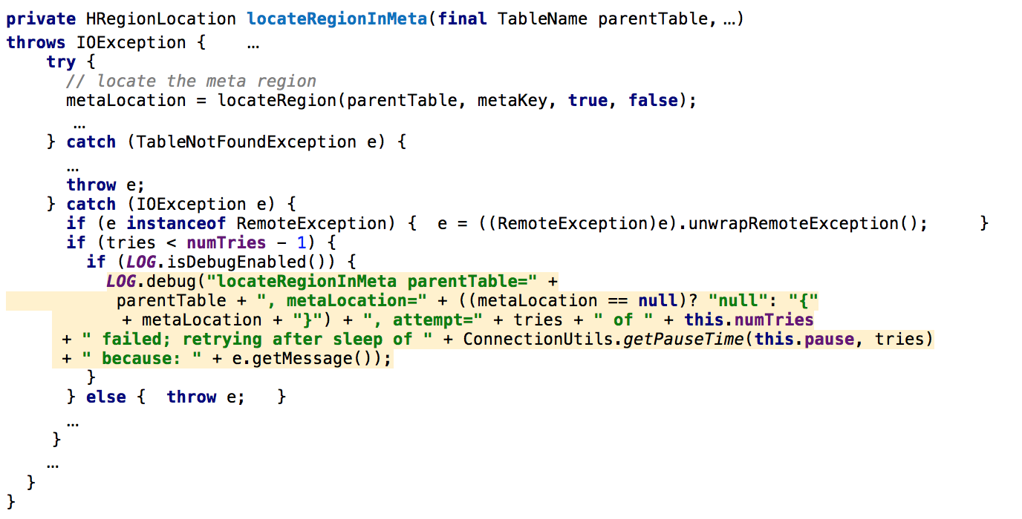

However, the region state in HMaster is onlined, so the reporter says “Looks like region state for 1588230740 became inconsistent between master and the surviving region server”.