# MAXIM Tutorial

Zhen Ji

Department of Radiation Oncology

Washington University in St. Louis

1. Software interface - Graphic User Interface (GUI)

The main GUI is shown in Fig. 1

Slice slider

Image panel

Contrast bar

Image tools (zoom, pan, pixel info)

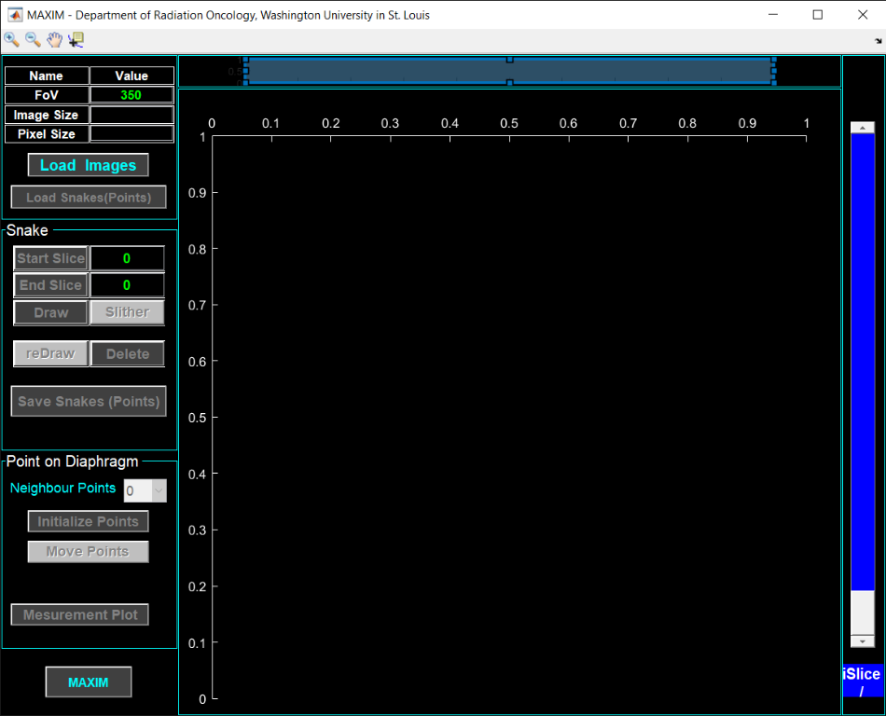

About MAXIM

Point panel

Snake panel

Image info. panel

Figure. 1 Main GUI

1. Loading image file

Before loading any images, enter the value of Field of View (‘FoV Value’ Image info. Panel). The unit is mm.

To load images, click ‘Load Images’ button in ‘Image info. Panel’, then navigate and doble click the image file (.mat) on harddrive. The image file contains a stack of MR image slices with contours on each slice as shown in ‘Image panel’ in GUI (Fig. 2). Image slices can be flipped through using the ‘Slice slider’ bar. Image information is shown in the ‘Image Info. panel’, while slice numbers are shown on the bottom of the ‘Slice slider’ bar.

There are 3 types of contours with different colors, red for reference, green for tracking, and blue for gating. Every slice has a reference (red) contour. Most slices should have either a tracking (blue) or a gating (blue) contour, and some slices with bad image quality only have reference contour. When an image set is being loaded in, all the contours are also processed and shown in ‘Contour panel’ on ‘Measurement plot’ (a separate figure window) as shown in Fig. 3. Contour plot has all contours overlaid as shown in red, blue, and green. It also has all contours as binary image mark overlaid. The ‘profile line’ in the ‘Contour panel’ is a cross line across the overlaid contour plot, while the profile plot shown in ‘Profile panel’ is the overlaid binary image intensity value along the profile line. The red vertical lines in ‘Profile panel’ correspond to the reference contour (red) in ‘Contour panel’, while the numbers are the measured values for uprise and fall of the intensity profile across the profile line.

The profile line is an interactive object, which can be moved/stretched by holding the line’s body/ends using mouse. The profile plot in ‘Profile panel’ will respond the change of the profile line change in real time. The radio buttons in ‘Contour panel’ can be used to turn on and off ‘binary overlay’ and contours, while the pushbuttons ‘hProfile’ and ‘vProfile’ are for setting the profile line to ‘horizontal’ and ‘vertical’ position, respectively. The ‘Save Data’ button in ‘Contour panel’ will save the measurement data as ‘.mat’ file on harddrive.

The ‘Measurement plot’ can be hidden by click the close icon ‘x’, and be restored later by click the ‘Measurement Plot’ button in ‘Point panel’ on the main GUI.

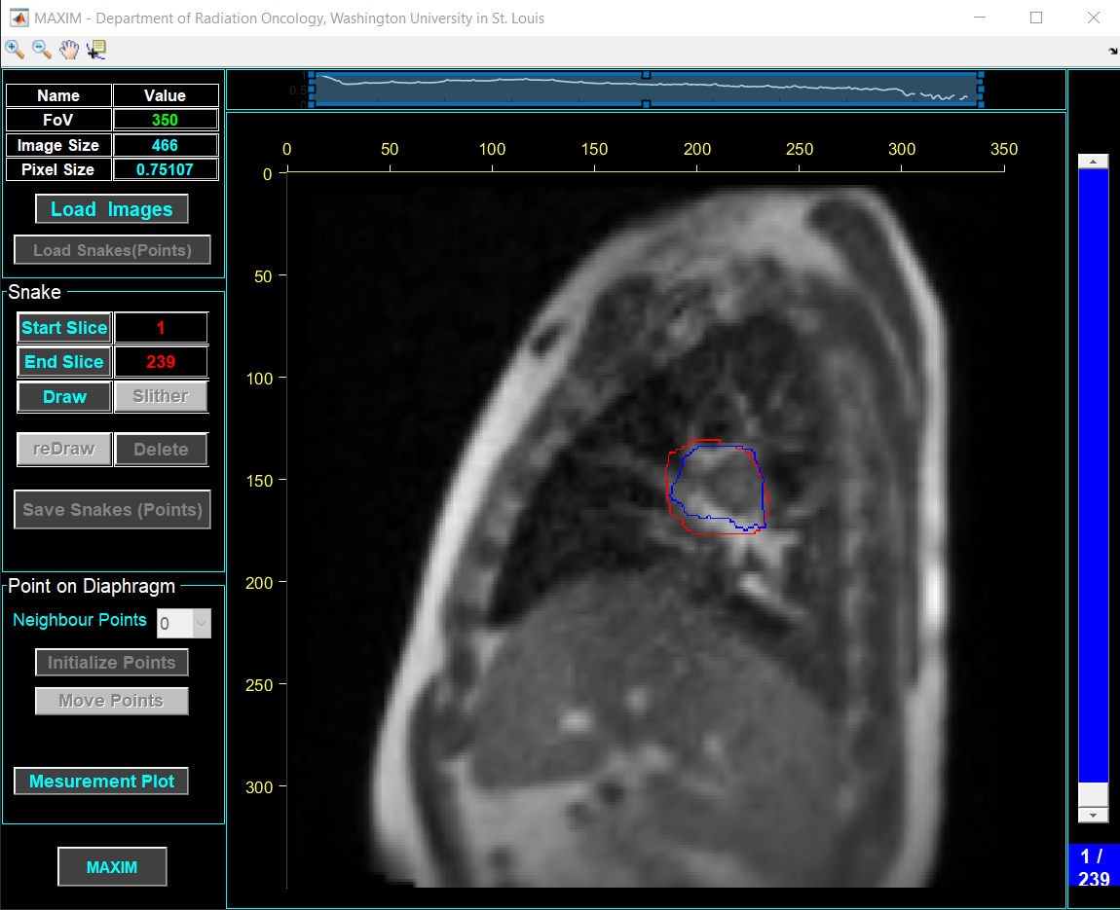

Figure. 2 GUI with an image file loaded

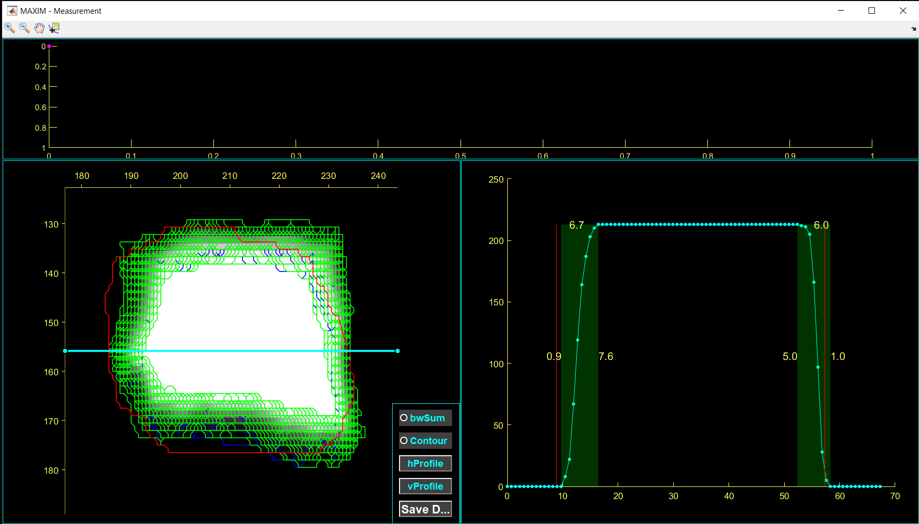

Point plot panel­

Profile line

Contour panel­

Profile panel­

Figure. 3 Measurement plot

1. Snake

One major functionality of this software is to find diaphragm on MR images. First, a guided hand-drawn curve (snake) will be placed along the diaphragm on an image. Then the program will automatically find diaphragm on other image slices. The algorithm is based on Active Contour Model, also called Snake. The process is as following.

* 1. Click ‘Draw’ button on ‘Snake panel’, then use mouse to draw a curve by clicking along diaphragm. Right-click the mouse when finishing the drawing as shown in Fig. 4. The curve can be drawn on any slices with a tracking (green) or gating (blue) contour.
  2. Click ‘Slither’ button to let the snake slithers (finding diaphragms) on other images as shown in Fig. 5. The ‘Slice slider’ shows the whole progress during ‘slithering’.
  3. The ‘Slithering’ process can be stopped by click the red ‘Stop’ button. Then the above steps need to be repeated to slither over all images.

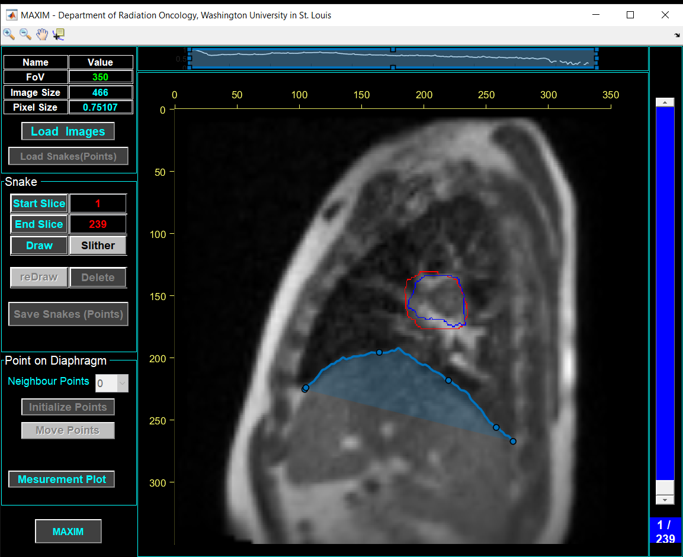

Figure. 4 Drawing a snake as a start point

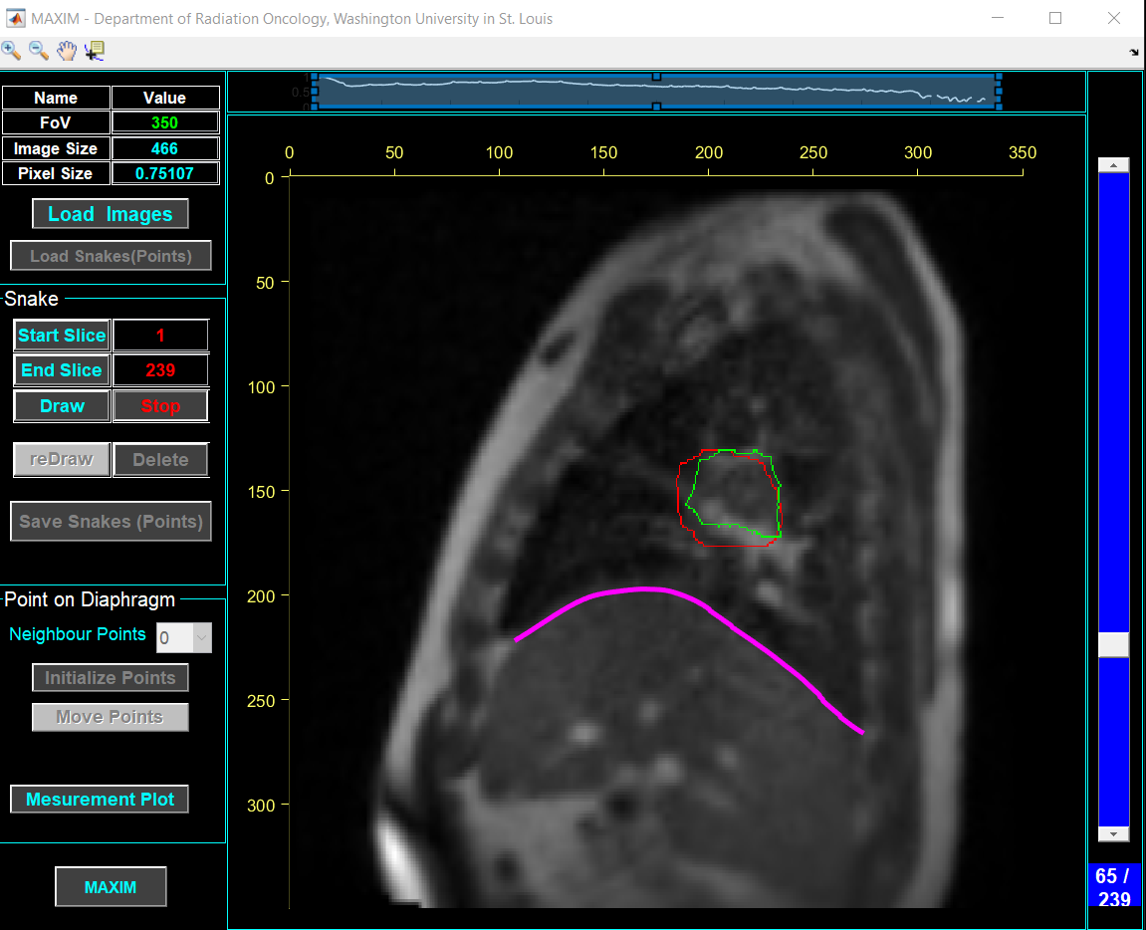

Figure. 5 Snake slithering

1. Points on diaphragms

To find points on diaphragms, the number of neighbour points (on each side) needs to be defined on ‘Point panel’ first. The purpose of this is later to calculate the average coordinates. For example, if 3 is picked for ‘Neighbour Points’, then later the average coordinates will be calculated over 7 points.

After picking the number of neighbour points, click the ‘Initialize Points’ button to get starting points on each snake. Fig. 6 shows a zoom-in of initialized points on diaphragm with 3 neighbour points on each side. Once the initialization is done, ‘Point plot panel’ (see Fig. 3) will show point data as shown in Fig. 7. The horizontal axis is slice number, and the vertical axis is averaged y-coordinates of all points.

To put points at desired location, simply click the ‘Move Points’ button, then click on the image and use left/right arrow on keyboard to move the points on snake. When the points are being moved along a diaphragm, point data are also being updated in ‘Point plot panel’. There are some slices having neither tracking (green) nor gating (blue) contours, there are also no snakes on those slices, so no points on diaphragm. Therefore, there are some ‘missed’ points in ‘Point plot panel’. When the ‘Move Points’ button is clicked, the button will change to ‘Done’, which needs to click when points moving are done.

1. Save snakes (diaphragm, points) data

To save snakes, diaphragm and points data, just click the ‘Save Snakes (Points)’ button in ‘Snake panel’. Table 1. lists all the saved data files, as well as measured data as shown later. Fig. 7. Shows how the files look like on hard drive with different extensions.

|  |  |  |
| --- | --- | --- |
| **File Name Extension** | **Format** | **Information** |
| _ImgInfo | .mat | 2D MR image information for MAXIM II |
| _measureData | .mat | Measured data such as tumor profile |
| _measureDataFig | .jpg | Image snap shot associated with measured data |
| _PointData | .csv | Tumor contour center and the point on diaphragm x, y coordinates |
| _PointOnSnake | .mat | All point data (including neighbors) |
| _Snake | .mat | All diaphragm curve data |
| _SnakePoints | .csv | All diaphragm x, y coordinates |
| _SnakePointsMatrix | .csv | All diaphragm y coordinates with same x coordinates |
| _Tumor | .mat | Tumor contours, including masks |
| _TumorCenter | .mat | Coordinates of tumor center |
| _TumorContourPoints | .csv | Tumor contour coordinates |
|  |  |  |
|  |  |  |
|  |  |  |
|  |  |  |

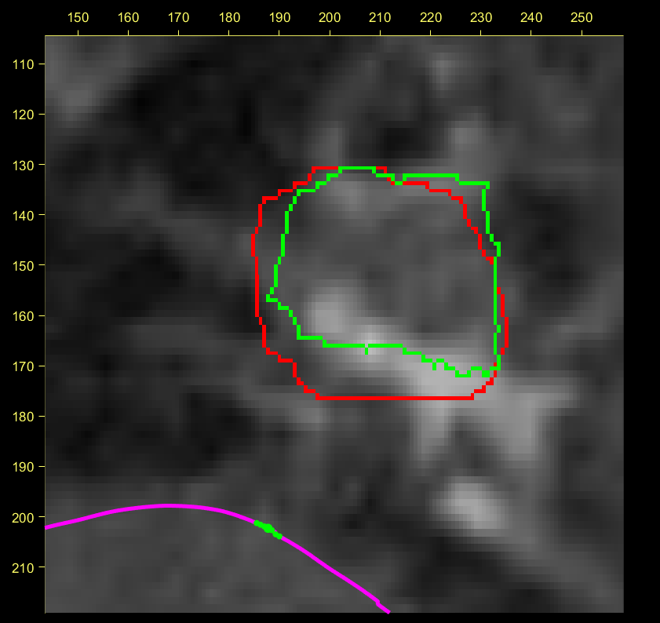

Figure. 6 Points on disphragm

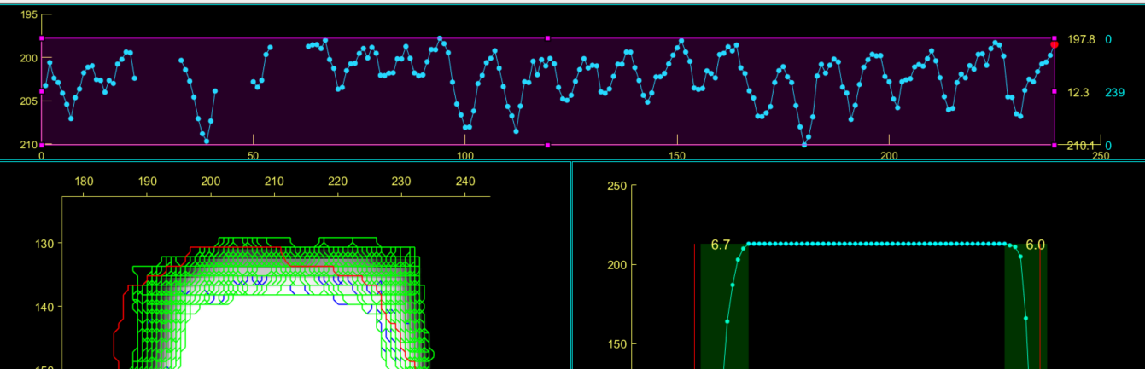

Figure. 7 Point plot.

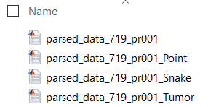

Figure. 8 Saved data files.

1. Re-snake

In case some snakes are considered not match diaphragm very well, the ‘slithering’ process can be carried out on selected image slices. To select a range of consecutive slices, use the ‘Slice slider’ to go to the first slice, then click ‘Start Slice’ button in ‘Snake panel’. Do the same thing for the last slice by going to the last slice and clicking the ‘End Slice’ button. Then draw snake on any slices in the range, and ‘slither’. This process will update snakes in the selected slice range, as well as the points on diaphragms. Should other slices need to re-snake, just repeat the above process. Save updated snake and point data by clicking ‘Save Snakes (Points)’. Data saving can be done at any time, and old data will be overwritten by new data.

If a snake needs to be removed from an image slice, simply click ‘Delete’ button in ‘Snake panel’.

1. Load previously saved snake/point data

When main GUI is started with an image data set, and corresponding snake/point data were saved previously, the ‘Load Snake (Point)’ button in ‘Image Info. panel’ will be enabled, and the snake/point data can be loaded in by just clicking the button.

1. Measurement

In the ‘Point plot panel’, the upper and lower pink lines are interactive objects, which can be dragged by mouse to move vertically. The yellow texts on the left are the upper line vertically coordinate, gap width, and lower line coordinates, respectively. The blue texts are number of points (slices) above the upper line, between both lines, and below the lower line. The ‘Contour panel’ and ‘Profile panel’ also show the corresponding results for the slices (points) between upper and lower lines, excluding the slices above the upper line and below the lower lines.

1. Save measured data

To save measurement data, just click the ‘Save Data’ button in the ‘Contour panel’. The measurement data will be saved as .mat/.csv file for later use.