**Check point No: 1**

***Capstone project No 3: Candidate Renege_ Data Description***

***Capstone project No: 3***

***Batch Name: E***

***Group No:3***

***Group members:***

***1. Pradyumna Bopanna***

***2. Ravi Guntakala***

***3. Harsha Vardhan Etcherla***

***4. Hema Sri Gandi***

***5. Swarna Deepika Gurivindapudi***

**Task 1.2 (SQL-Oracle)**

**Stage 1:**

Construct an ER-Diagram for the above-mentioned Requirement

2.Construct Tables as per the ER-Diagram

create table joining_status(

candidate_ref number(38) not null,

status VARCHAR2(26)

);

create table interview_dates(

candidate_ref number(38) not null,

date_of_interview date

);

create table domicile_master(

domicile_id VARCHAR2(26),

domicile_name VARCHAR2(26));

create table HR_Hiring_details_transaction(

Sno number(38),

Candidate_Ref number(38),

DOJ_Extended varchar2(26),

Duration_to_accept_offer number(38),

Notice_Period number(38),

Offered_Band varchar2(26),

Percent_hike_expected_in_CTC number(38,2),

Percent_hike_offered_in_CTC number(38,2),

Percent_difference_CTC number(38,2),

Joining_Bonus varchar2(26),

Candidate_relocate_actual varchar2(26),

Gender varchar2(26),

Candidate_Source varchar2(26),

Rex_in_Yrs number(38),

Location_ID varchar2(26),

Postal_Code number(38),

Age number(38),

LOB_Id number(38),

Domicile_ID varchar2(26)

);

create table location_master(

location_id varchar2(26),

region_id varchar2(26),

location varchar2(26)

);

create table lob_master(

lob_id number(38),

lob varchar2(26)

);

create table region_master(

region_id varchar2(26),

region_name varchar2(26)

);

Note:

we are directly imported the data into database from Excel sheets, so it will automatically creates the tables. but just for reference we added the table creation queries here.

3.Identify the relationships between tables and use appropriate standards for the same where applicable.

**/* DOMICILE_MASTER*/**

ALTER TABLE DOMICILE_MASTER

ADD PRIMARY KEY (DOMICILE_ID);

**/* INTERVIEW_DATES*/**

ALTER TABLE INTERVIEW_DATES

ADD FOREIGN KEY (CANDIDATE_REF) REFERENCES JOINING_STATUS(CANDIDATE_REF)

ADD PRIMARY KEY (CANDIDATE_REF);

**/* JOINING_STATUS*/**

ALTER TABLE JOINING_STATUS

ADD PRIMARY KEY (CANDIDATE_REF)

**/* LOB_MASTER*/**

ALTER TABLE LOB_MASTER

ADD PRIMARY KEY (LOB_ID);

**/* LOCATION_MAS*/**

ALTER TABLE LOCATION_MAS

ADD FOREIGN KEY (REGION_ID) REFERENCES REGION_MASTER(REGION_ID);

ADD PRIMARY KEY (LOCATION_ID)

**/* REGION_MASTER*/**

ALTER TABLE REGION_MASTER

ADD PRIMARY KEY (REGION_ID);

**/* HR_HIRING_DETAILS_TRANSACTION*/**

ALTER TABLE HR_HIRING_DETAILS_TRANSACTION

ADD FOREIGN KEY (LOCATION_ID) REFERENCES LOCATION_MASTER(LOCATION_ID)

ADD FOREIGN KEY (DOMICILE_ID) REFERENCES DOMICILE_MASTER(DOMICILE_ID)

ADD FOREIGN KEY (CANDIDATE_REF) REFERENCES INTERVIEW_DATES(CANDIDATE_REF)

ADD FOREIGN KEY (LOCATION_ID) REFERENCES LOCATION_MASTER(LOCATION_ID);

ADD FOREIGN KEY (LOB_ID) REFERENCES LOB_MASTER(LOB_ID)

ADD PRIMARY KEY (SNO);

**Relationship schema**

4.Insert the appropriate data into the identified tables from the sample dataset provided

1.Domicile_master

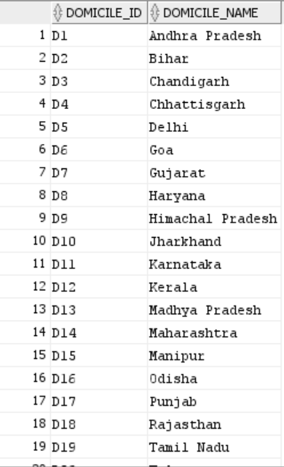

2.HR_HIRING_DETAILS_TRANSACTION

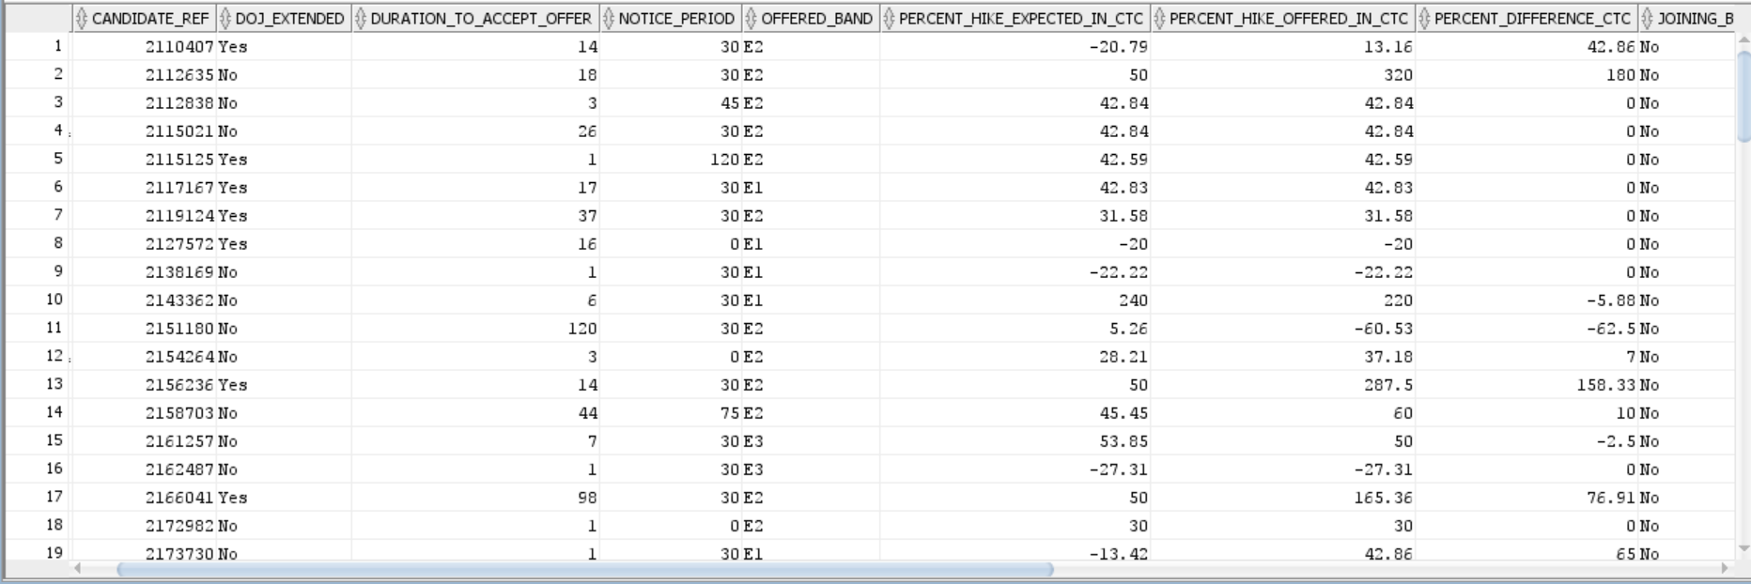

3.JOINING STATUS

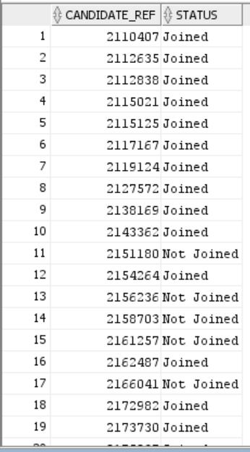

4.INTERVIEW_DATES

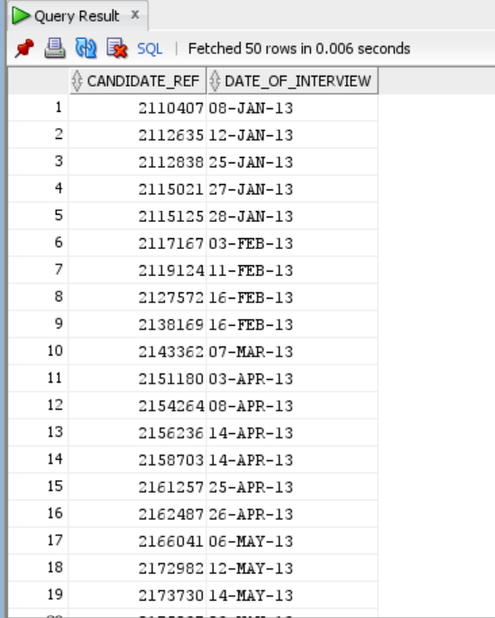

5.LOB_MASTER

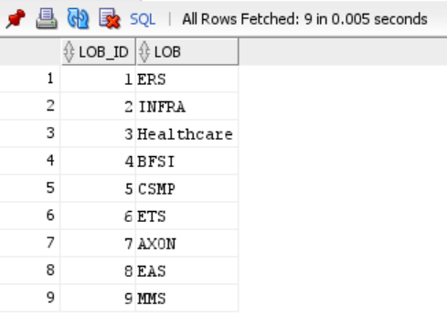

6.LOCATION_MASTER

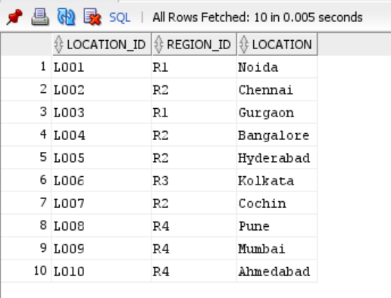

7.REGION_MASTER

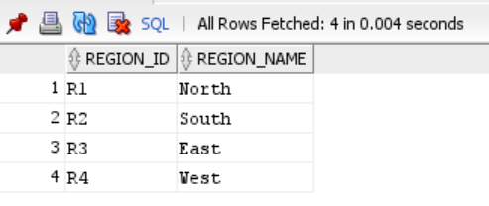

Note:

We are having very large dataset around 9000 rows in each dataset, so it is not possible to insert the data manually. So, we are imported the data into oracle database.

**Stage 2:**

1. Generate Info those candidates who have accepted offer and joining time is less then 30 days and candidates who are ready to re-locate.

select * from HR_HIRING_DETAILS_TRANSACTION HR

LEFT join JOINING_STATUS J ON HR.Candidate_Ref = J.Candidate_Ref

where Notice_Period<30 and Candidate_relocate_actual='Yes' and status='Joined'

**Output:**

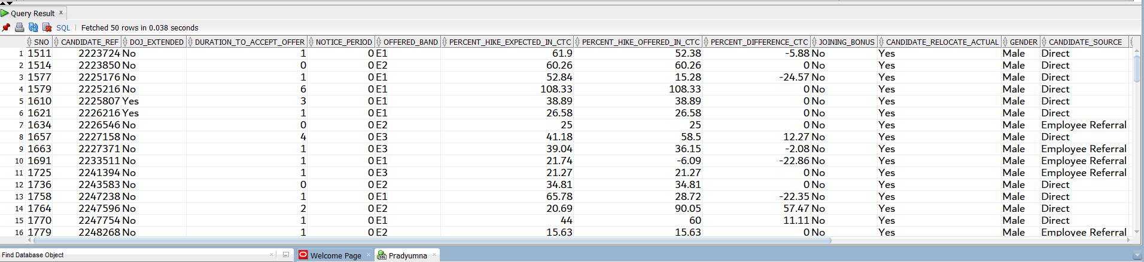

**Explanation:**

Displayed the info of candidates where notice period is less than 30 days, ready to relocate

2. Generate Info those candidates who have accepted offer and also display list the candidates who have been offered and yet to accept the offer within 10 days.

select * from HR_HIRING_DETAILS_TRANSACTION HR

LEFT join JOINING_STATUS J ON HR.Candidate_Ref = J.Candidate_Ref

where Duration_to_accept_offer >10 and status='Joined'

**Output:**

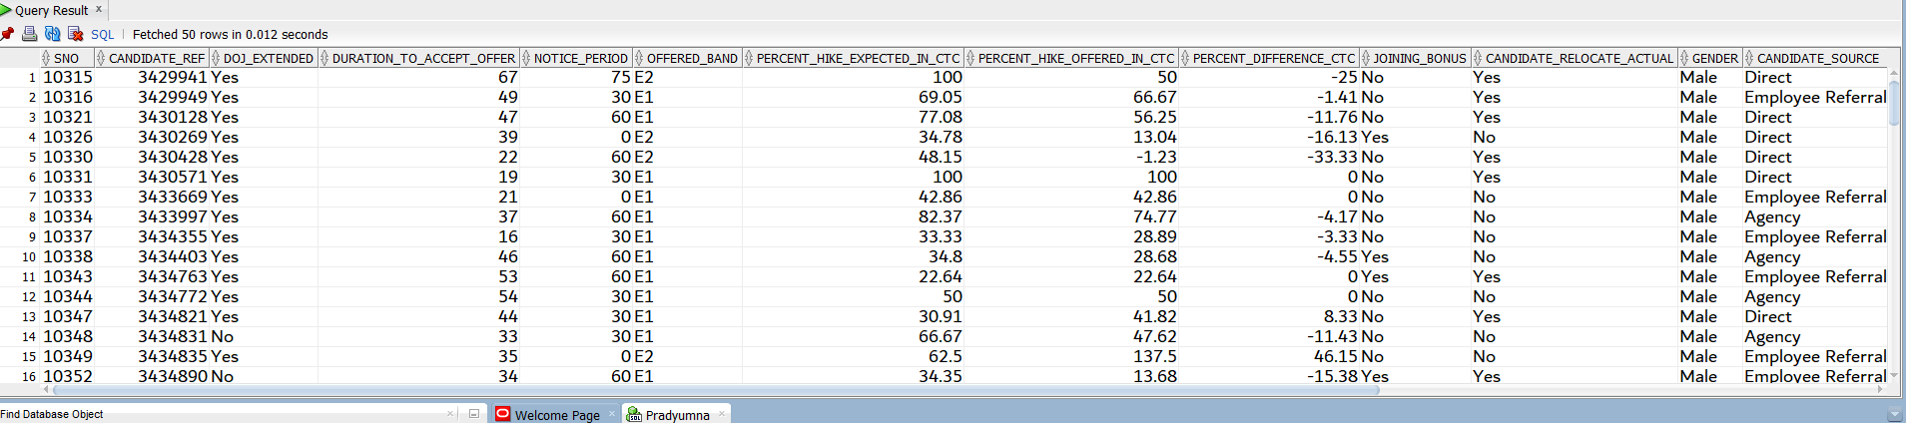

**Explanation:**

Displayed info of candidates where duration to accept offer greater than 10 days and joining status joined

3. Generate Info those candidates who are willing to join and the ECTC is 25% hike from their CTC

select * from HR_HIRING_DETAILS_TRANSACTION HR

LEFT join JOINING_STATUS J ON HR.Candidate_Ref = J.Candidate_Ref

where DOJ_Extended= 'Yes' and status='Joined' and Percent_hike_expected_in_CTC=25

**Output:**

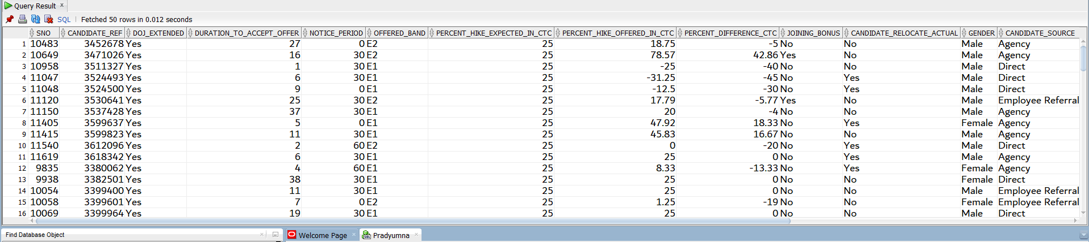

**Explanation:**

Displayed info of candidates whose doj is extended, joining status joined and percentage of ECTC IS 25%

4. Generate Info those candidates who are willing to join and the ECTC is 25% hike from their CTC joining time is less then 30 days and candidates who are ready to re-locate and joining bonus is offered.

select * from HR_HIRING_DETAILS_TRANSACTION HR

LEFT join JOINING_STATUS J ON HR.Candidate_Ref = J.Candidate_Ref

where DOJ_Extended= 'Yes' and status='Joined' and Percent_hike_expected_in_CTC=25 and

Notice_Period<=30 AND Candidate_relocate_actual='Yes' and Joining_Bonus='Yes'

**Output:**

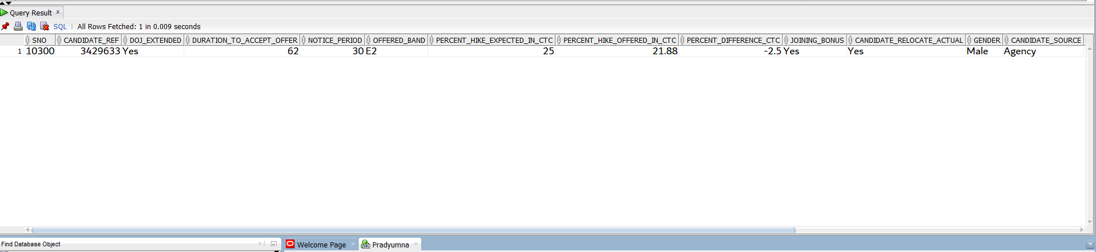

**Explanation:**

Displayed info of candidates who have joined and the ECTC is 25% hike from their CTC joining time is less than 30 days and candidates who are ready to re-locate and joining bonus is offered.

5. Generate the count of the candidates who are hired through what source and also who have joined and declined the offer.

select Candidate_Source,count(HR.Candidate_Ref) from HR_HIRING_DETAILS_TRANSACTION HR LEFT join JOINING_STATUS J ON HR.Candidate_Ref = J.Candidate_Ref

where status='Joined' group by Candidate_Source

**Output:**

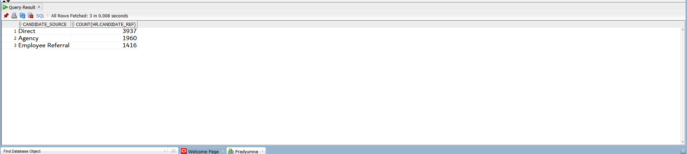

**Explanation:**

Displayed count of the candidates who are hired through what source

6. Generate the count of the candidates who are hired through what source and also who have declined the offer.

select * from HR_HIRING_DETAILS_TRANSACTION HR

LEFT join JOINING_STATUS J ON HR.Candidate_Ref = J.Candidate_Ref

where status='Not Joined'

**Output:**

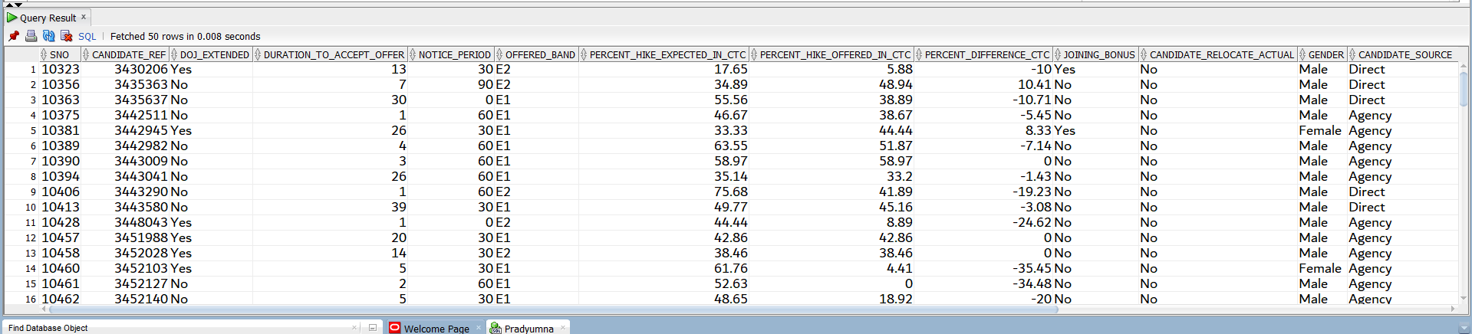

**Explanation:**

Displayed info of candidates whose joining status is not joined.