MAI LAB CA-2

MINI PROJECT REPORT

“GeoFusion: Multimodal Road Condition Intelligence and GIS-Based Maintenance Prioritization”

BACHELOR OF TECHNOLOGY IN ARTIFICIAL INTELLIGENCE & MACHINE LEARNING

Submitted By
GROUP 19
Priyanshi Faldu 23070126042
Shreyans Gadekar 23070126043
Lakshya Joshi 23070126065
Aryan Revankar 24070126502

UNDER THE GUIDANCE OF
Dr. Nivedita Mishra


Pune – 412115, Maharashtra State, India
https://www.sitpune.edu.in/
DEPARTMENT OF ARTIFICIAL INTELLIGENCE & MACHINE LEARNING
AY 2026-27

1. Project Scope and Current Data Position
GeoFusion should provide a capability to transform the observations collected by a mobile device on roads into an evaluation of the presence of anomalies and maintenance priority based on GIS. The end goal of the system still stays the same—it should allow collecting road information through the vehicle-mounted smartphone, processing of inertial motion and location, estimation of anomalies/severity, and mapping of the result onto a road section.
The chosen dataset allows the integration of data from sensors, location, elevation, and weather fields of the smartphone. However, the raw data itself is stored separately due to limitations in memory and contains additional annotation files, folders with cameras, and links to video files located in Google Drive. Thus, IMU and GIS data can be processed right away while video has to be downloaded separately.

2 Description of the Selected Dataset
The provided archive comprises combined CSV records at the event level that have GIS and weather information, pure sensor records, and a GIS archive having route elevation data. The performed EDA has made use of combined CSV records for sensor analysis and pure annotation files for event-level analysis.
Dataset characteristic | Observed value
Analysed recordings | 102 CSV recordings
Raw session folders available | 102 folders in the supplied Raw Data copy
Sensor observations | 616,870 rows
Fields per combined recording | 45
Road-anomaly recordings | 97
Normal-road recordings | 5
Median sampling rate | 100 Hz
Median recording duration | 29.09 seconds
Observed latitude range | 24.361684 to 24.532970
Observed longitude range | 88.522954 to 88.839153
Auxiliary GIS file | Route elevation CSV with latitude, longitude and elevation
External video links found | 21 Google Drive link files in the available Raw Data copy

Every combined event record has elapsed time; accelerometer and gyroscope readings are both calibrated and uncalibrated; readings of gravity, orientation, magnetometer, compass, and barometer; latitude and longitude of GPS records; GIS elevation; and temperature, humidity, cloudiness, and wind speed. The class assignment for this dataset comes from the provided folders in the source archive and not the almost empty annotation-text column.

3 Modalities Selected for the Initial Model
Modality | Available fields | Role in GeoFusion
Inertial sensing | Three-axis total acceleration and gyroscope signals at 100 Hz | Primary signal for road-impact and vibration pattern detection.
Geospatial context | GPS latitude, GPS longitude and GIS elevation | Location, map matching, elevation context and later road-segment aggregation.
Weather context | Temperature, humidity, cloud cover and wind speed | Contextual features for robustness analysis; not treated as the primary anomaly signal.
Visual road imagery | Google Drive links referenced by session camera folders; videos are not stored locally | Visual validation and later RGB plus IMU fusion after selected videos are accessed and temporally aligned.

In the case of this particular dataset, the multimodal format consists of inertial sensing with geospatial context, where weather is kept as auxiliary context. This setup is a valid one since the IMU senses the motion of the vehicle and GIS gives physical/geographical context information. Video is now confirmed as one of the available external modalities. It is to be included only after proper verification of required recordings and their timestamp annotations.

4. Exploratory Data Analysis
Data profiling was done in two stages. Record-level profiling was done on the basis of file count, row count, duration, estimated sample rate, missingness, and geographic representation. Sensor level profiling was done on the basis of calculation of total acceleration and gyroscope vector magnitudes to evaluate the range and variability of inertial data. Coverage of GPS data and GIS/weather fields was also ensured.
Measure | Road anomaly recordings | Normal-road recordings
Number of recordings | 97 | 5
Median rows per recording | 2,695 | 6,144
Median duration | 27.15 s | 61.43 s
Median estimated sample rate | 100 Hz | 100 Hz
Mean acceleration magnitude | 9.769 m/s² | 9.832 m/s²
Mean gyroscope magnitude | 0.150 rad/s | 0.128 rad/s
Median missing-cell percentage | 8.91% | 3.75%

The recordings have a stable median sampling rate of 100 Hz, which is appropriate for window-based time series analysis. The magnitude of acceleration in both classes is close to the value of gravitational acceleration since total acceleration already has the gravity component. Therefore, relevant discriminant information can be obtained from variability, peak, spectral energy, and orientation-normalized motions, not from the mean itself.
The major problem with the data is imbalance between classes: 97 anomaly recordings vs. 5 normal recordings, or almost 19.4 to 1. An initial anomaly model cannot use ordinary accuracy as its major result. Stratum-based evaluation where possible, a class-weighted loss function, precision-recall analysis, balanced accuracy, and F1 score will be employed. Normal class should also be increased through additional collection of data before making claims about deployment.
A data quality screen further found one anomaly file that had only four observations and no useful duration. It would be advisable to leave this file out of window generation unless the raw acquisition is recovered. Missing GPS latitude/longitude data at the record summary level is found in a few files, and these instances should be resolved using missing location codes rather than creating false coordinates.
Raw annotation result | Observed value
Valid annotated events | 688
Bump annotations | 396
Pothole annotations | 292
Sessions containing bump or pothole annotations | 97
Median bump press duration | 83.5 ms
Median pothole press duration | 83.0 ms

The raw annotations give the event type and elapsed time required for the construction of sensor windows appropriately labeled. The button press duration in the annotation is saved as metadata but is not considered as road defect severity.
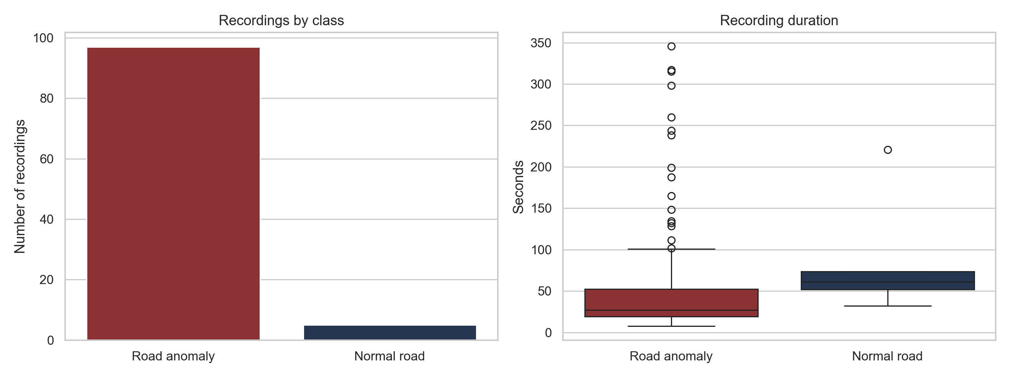
Figure 1. Recording count and recording-duration distribution by source class.
Interpretation: Class distribution of anomalies is very skewed in the record-level classes. Furthermore, recording durations differ widely, especially among the anomalies, and hence, the modelling unit needs to be fixed duration windows.
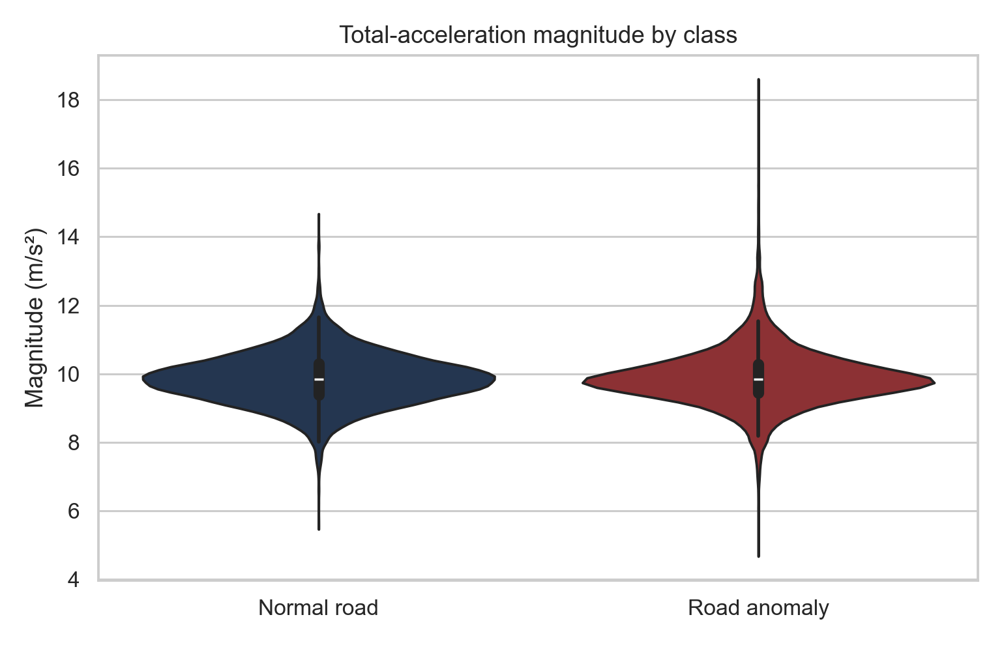
Figure 2. Total-acceleration magnitude distribution by source class.
Interpretation: Both distributions are centered near gravitational acceleration since total acceleration includes gravity. The evident overlap demonstrates that a magnitude-based average cannot be used for classification. It is important to check window-level maxima, variance, jerk, spectral energy, and orientation-dependent characteristics.
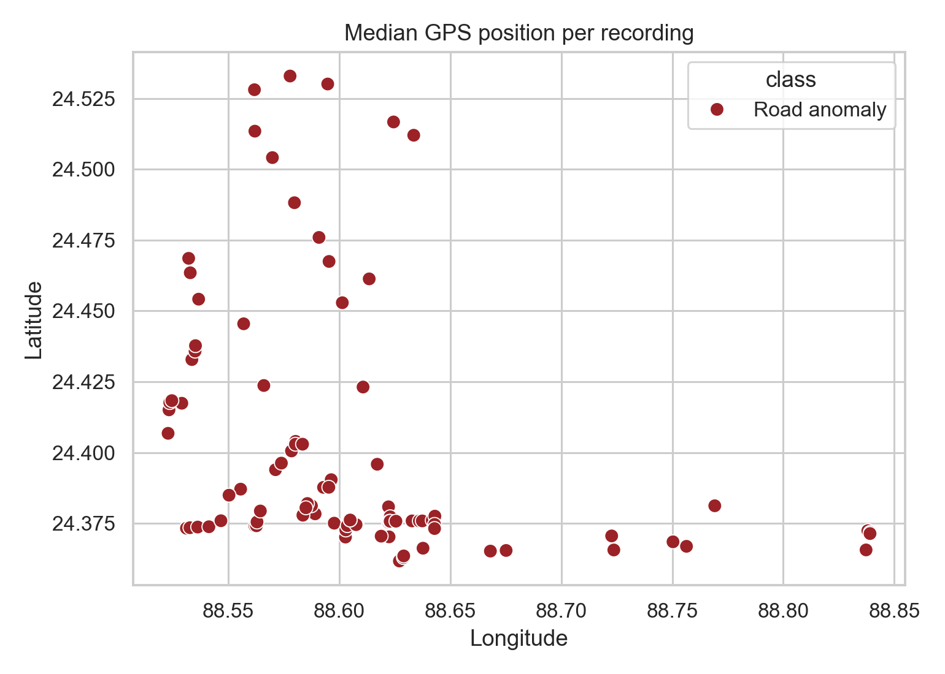
Figure 3. Median GPS position for each recording with valid coordinates.
Interpretation: The samples contain measurements from various route points and thus prove the need for geospatial information. Median coordinates can be considered an initial indicator of coverage; however, the actual deployment should involve the whole GPS trajectory and map-matching, not just one coordinate per session.
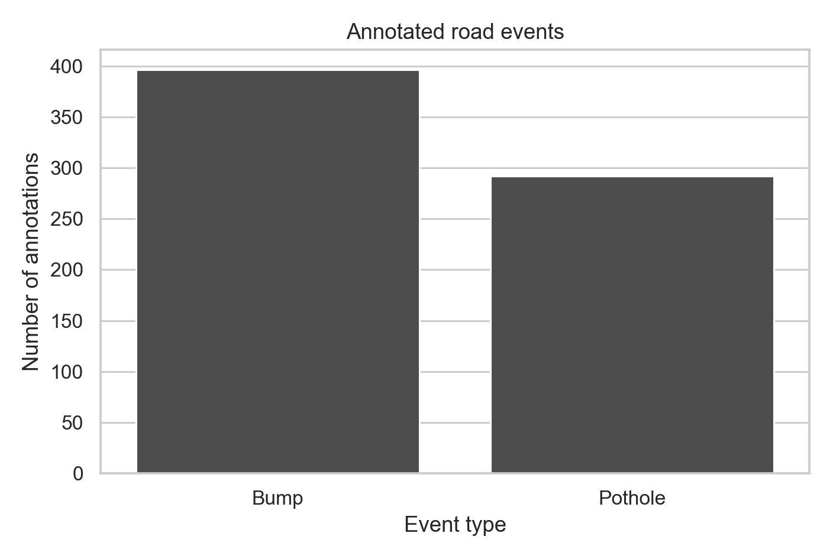
Figure 4. Counts of bump and pothole annotations from the raw session files.
Interpretation: There are two types of anomalies represented in the annotations, and there are more annotations of the bump type than of the pothole type. Thus, a three-class definition of normal road, bump, and pothole can be used later on if normal windows are enlarged and divided per session.
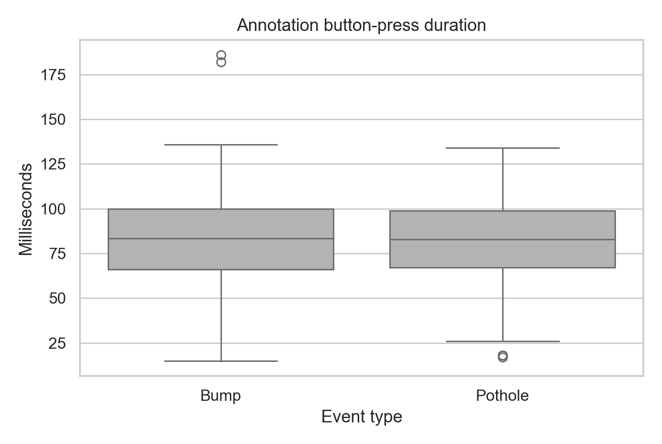
Figure 5. Distribution of annotation button-press duration by anomaly type.
Interpretation: Two events have nearly identical median annotation durations, which equal 83 milliseconds. This feature refers to the process of manual annotation itself and not the intensity of defects; therefore, it is intended to be used for quality assessment.

5 Video Data Exploration and Sensor Video Alignment
Raw Data folders were examined on the spot at Raw Data. This step revealed 81 MP4 files locally on the session camera folders. There is a session-level Annotation.csv file corresponding to each video, and all the 402 bump or pothole annotations in these sessions with videos are within the video duration. The manifest was created in a light-weight way to store the path to videos, the event type, sensor timestamp, target video frame, and video metadata without making copies of the MP4 files into the project workspace.
Video EDA measure | Observed value
Local MP4 recordings | 81
Video-backed annotated events | 402
Video-backed bump events | 232
Video-backed pothole events | 170
Events within video bounds | 402 of 402
Video resolution | 4K; 3840 x 2160 or 2160 x 3840
Orientation by session | 56 portrait and 25 landscape
Observed frame-rate range | 27.49 to 30.02 frames per second
Frame-quality audit | 16 balanced annotated frames read successfully

The video filename contains the epoch at which the video starts to record in milliseconds. Checking this against the annotation timestamp and seconds elapsed gave that event time can be converted to a target frame. This makes the connection between the two key data sets necessary for the multimodal pipeline proposed: a small video clip around the event and an IMU clip around the same event.
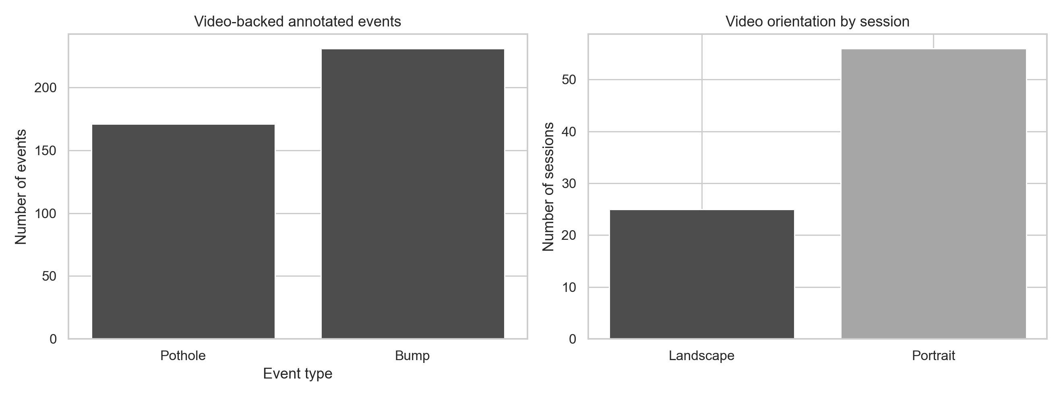
Figure 6. Video-backed event count and recording orientation across the available local MP4 sessions.
Interpretation: The local video dataset is made up of both classes of anomalies, but the bumps are more common. The majority of videos in this dataset are in portrait orientation, and thus it becomes important for the visual preprocessing pipeline to correctly identify orientation and rotate the frames before training the image models.
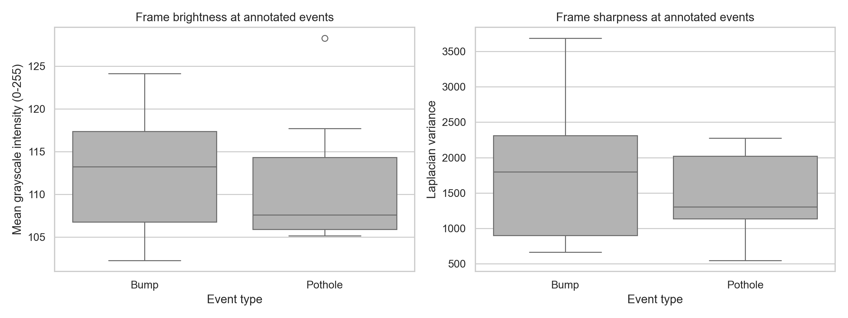
Figure 7. Brightness and sharpness measures for a balanced 16-frame visual-audit sample.
Interpretation: This is not a classification but a quality check on the data. This example shows that the labelled frames can be interpreted directly from the MP4 files. The lighting and the sharpness are different depending on the driving conditions, and therefore color normalization and image augmentation should be included in the visual model.
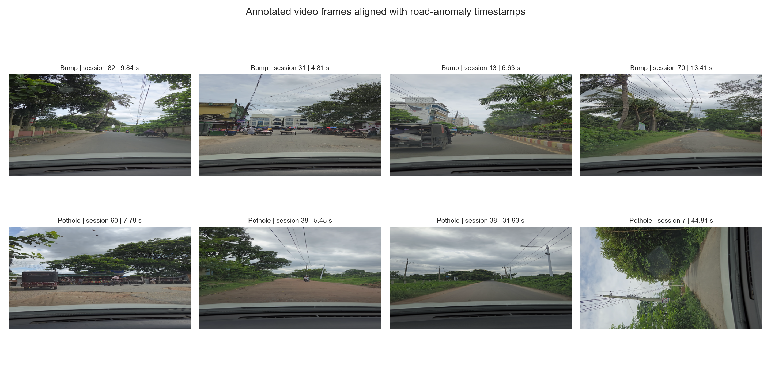
Figure 8. Sample frames extracted at annotation-aligned bump and pothole timestamps.
Interpretation: The contact sheet proves that there is road-facing visual evidence tied to the sensor labels in the project. Anomalies in the road can be small or occluded and may not be very prominent in just one frame. Therefore, the model should include a few consecutive frames alongside the IMU window.

6 Resource Allocation
Work package | Resources | Deliverable
Data preparation | Python, pandas, NumPy; local project storage; version-controlled preprocessing scripts | Clean event windows, quality flags, class labels and train-validation-test splits.
EDA and feature engineering | Matplotlib or Seaborn; IMU time-series utilities | Signal magnitude, peak, variance, frequency-domain and GPS-derived features.
Model development | PyTorch or TensorFlow; CPU for baselines and optional GPU for deep time-series models | IMU baseline, GIS-context fusion model and calibrated evaluation.
GIS and decision support | GeoPandas or QGIS; map data and road-segment layer | Map matching, segment aggregation and maintenance-priority score.
Mobile deployment | Android smartphone with camera, IMU and GPS; TensorFlow Lite or ONNX Runtime Mobile | On-device sensing and inference prototype with map-oriented output.

Currently, the dataset is small enough to process on a regular developer's laptop for training. Initial training can be done using engineered time-window features with a simple 1D CNN or time-based model. This way, the development process will be reproducible, and no cloud computation resources will be wasted until a working baseline and testing process are established.

7 Risk Analysis and Mitigation
Risk | Effect on project | Mitigation
Severe class imbalance | A model may learn to label most windows as anomalies or may fail to represent normal driving. | Collect or obtain additional normal-road recordings; use class weights; report F1, balanced accuracy and precision-recall measures.
Externally linked video availability | Video is not stored locally and the supplied Raw Data copy contains only a subset of session link files. | Use the derived link index to select and verify videos; retain sensor-only baselines; document the exact sessions for which video is accessible.
Short or incomplete recordings | Unreliable time windows and distorted feature distributions. | Apply minimum-duration checks, remove the four-row file from model input, and retain an auditable exclusion log.
GPS gaps or low location precision | Incorrect map matching and road-segment prioritization. | Use accuracy fields and missing-coordinate flags; perform map matching only when location quality is sufficient.
Device and vehicle variation | A model may not generalize across phones, mounts, vehicles or speeds. | Normalize signals, capture metadata, use augmentation and evaluate by route, device and vehicle where possible.
Mobile compute and battery constraints | A large model may be unsuitable for real-time operation. | Use windowed inference, a lightweight model, quantization and periodic rather than continuous map uploads.

8 Immediate Development Plan and Mobile Deployment Path
The next step in development involves turning the recording into fixed-length windows, determining quality flags, and creating a reproducible split that will not allow similar windows to leak between train and test datasets. After that, a simple IMU model will be compared to a combined IMU with a GIS and weather context fusion model.
For the implementation, the mobile application will capture camera frames along with IMU (accelerometer, gyroscope) and GPS measurements. For the first iteration of the app, the trained IMU and GIS model will be implemented on-device and utilized to identify possible road problems. GPS coordinates will be stored only for identified and validated events and uploaded for map matching and segmentation of road sections. Videos from the external source will be used for validation and developing the vision part of the project. The final dashboard will rank road segments according to the number of events, severity, and location data.

9. Conclusion
The chosen dataset is appropriate for launching GeoFusion as it includes inertial measurements at a high frequency, GPS data, elevation data, weather conditions and linked videos per each session. The EDA showed that the dataset has a stable nominal sampling rate, good geospatial coverage and 688 raw event annotations but, at the same time, it lacks normal roads and is not always complete with local video links. The proper scope of the project is an IMU and GIS based anomaly detection prototype followed by videos retrieval and synchronization.

