|  |  |
| --- | --- |
| **Country Name** | **Forest Percent Cover 2005 (FORPC05)** |
| Burundi | 5.9 |
| Kenya | 6.2 |
| Uganda | 18.4 |
| Rwanda | 19.5 |
| Tanzania | 39.9 |
| Angola | 47.4 |
| Zambia | 57.1 |
| Congo DR | 58.9 |
| Congo | 65.8 |
| Gabon | 84.5 |

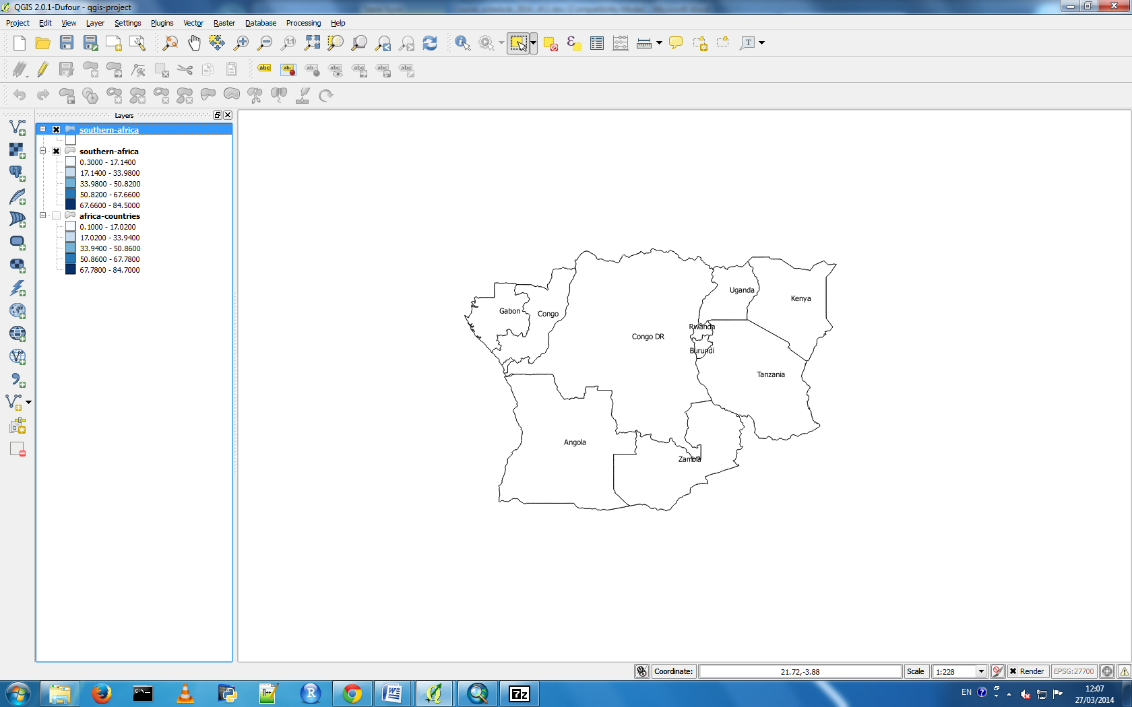

Using the values in the table, colour in the countries in this central part of sub-Saharan Africa according to the percent of forest cover in 2005. Also remember to indicate in the table which colours represent which values.