**Making Maps for Publication (using QGIS)**

|  |  |  |
| --- | --- | --- |
| **Learning outcomes:** |  | **Tools used:** |
| Designing and producing a publication-ready map in QGIS (p. 1) |  | Symbolising data (p. 2) |
| Saving/exporting your maps as image files (p. 6) |  | Print composer (p. 3) |

**1. Introduction**

This practical focuses on aspects of map design and symbolisation in QGIS. In particular, it will build upon the skills from the previous practical to look at how QGIS can be used to produce publication quality maps of critical habitats for tiger conservation in India. An example is provided at the end of this handout.

If you haven’t done so already open Documents\GIS and create a new folder named prac2

Please follow the link (bit.ly/2qqhQlr) to download the data for this practical, which you need to extract to the prac2 folder as previously.

## **2. Mapping proposed tiger conservation habitats in India**

QGIS has a powerful tool called Print Composer (accessed via **Project > New Print Composer**) that allows you to create maps. In this part of the practical we show you how to create the Tiger map that’s attached to the end of this handout. We will create the map from scratch and add elements such as north arrow, legends and scale bars. Remember to  **Save** your work as you go.

Start QGIS by clicking on **Start**, then type **QGIS** and select **QGIS Desktop 2.18**.

We now need to add our data layers to the map. Click the  **Add Vector Layer** button and then the **Browse** button. Make sure ESRI Shapefiles(*.shp *.SHP) is selected in the drop down file type menu.

Select all four Shapefiles (countries.shp, india.shp, reserves_clip.shp and tcu_clip.shp) and click **Open**, click **Open** once more.

The layers will be added in a random order, so rearrange the layers in the layers window with the tcu_clip layer at the top, followed by reserves_clip, india and countries.

You should now have four layers added to the map display. The colours used by default are not particularly helpful so let’s change these to something a little more meaningful.

Double-click the countries layer (or the colour swab next to the layer name), select **Style** (from the left panel) and choose an appropriate colour from the **Color** swab (perhaps choose the lightest brown)

Click the **General** tab and change the **Layer** name to Other countries, press **OK**

Repeat this process to change the colour of the india layer and its name to India

Change the colour of the reserves_clip layer and change its name to Wildlife reserves

Change the name of tcu_clip to Tiger conservation units. Click on the **Style** tab and select **Categorized ** from the top dropdown box. Ensure that LEVEL_ is selected in the Column dropdown box

Click on **New color ramp** from the dropdown box next to **Color ramp** (you might have to scroll down to the bottom of the list). An error might appear saying **The selected color ramp is not available**, if it does, just click **OK**. Then a window prompt named **Color ramp type** will open. Ensure that Gradient is selected and click **OK**

We now need to select two colours to create our colour ramp. Change Color 1 to your first colour (perhaps yellow) and repeat for Color 2 (perhaps red). Click **OK** and, when prompted for a name, enter TCU ramp. Now click **OK**.

Finally, click **Classify** to add all the values from the LEVEL_ column field to the symbol window

Now we need to assign labels, do this according to the table below by double-clicking each entry underneath **Legend**:

|  |  |
| --- | --- |
| **Old label name** | **New label name** |
| 1 | To be surveyed |
| 2 | Low priority |
| 3 | Medium priority |
| 4 | High priority |

When you’re done, select the last value in the list (the one without a label) and choose **Delete** (this row represents blank values, it is added by default and we don’t need it)

If you wish, choose appropriate colours for each of the labels by clicking on the colour swab under Symbol (changing the symbol of the To be surveyed label might be sensible given that it is not part of the high/medium/low categorisation). Once finished, your view might look something like the screenshot:

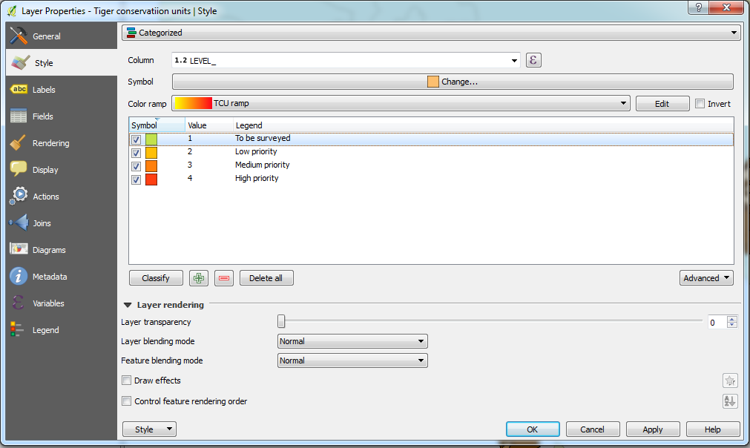

Finally, click on Value in the header bar to sort the values in descending order (i.e. High priority is at the top of the list)

Choose **OK** once you are happy with your labels and colours

Now that we have set up our layers we can start to create our map.

Go to **Project > New Print Composer** and the Composer title prompt will open. Enter Practical2 as the title and click **OK**, the Print Composer window will now open with a blank page

We need to tell the composer where on the page we would like our map to be positioned. Click the  **Add new map** button and draw a rectangle on the canvas that fills around a quarter of page

Alongside the main map view you should see tabs labelled Composition and Item properties (if you do not see these right-click the top bar and make sure that there is a cross in the checkbox  for Composition and Item properties)

In the **Item properties** tab change the **Scale** to 20000000.

Expand the **Position and size** properties and change the Width to 140, Height to 125.

Use the  **Move item content** button to position India within the centre of the frame. Note: if the scale changes simply correct the value back to 20000000 and click **Update preview** to update the display

Ensure that the checkbox  is checked next to **Frame**

To move the different elements around on the map, make sure you select the **Select/Move item** tool.

You should notice that the data layers that we have on display in the Print Composer are the same as that in our QGIS project (i.e. the two displays are linked). At the moment we have all of the layers viewable but for this part of the figure we don’t want to display the Tiger conservation units layer (we’ll display this in another map on the same page in a minute).

Switch windows back to the QGIS project (i.e. not the Print Composer window) and make sure there is *not* a tick next to the Tiger conservation units layer. Now switch back to the Print Composer window and you’ll see that this layer is now not displayed (if the map in the Print Composer window hasn’t updated, you may need to click **Update preview**). Your map should display the India, Other countries and Wildlife reserves layers and look something like the screenshot below (ask if you need help)



Before we create another map next to that of the wildlife reserves map we need to tell QGIS to not update the map we’ve created in the Print Composer. To do this check the checkbox next to  **Lock layers**. This will mean that the map will not update as we check layers on/off

Now is also a good time to save our work, use the  **Save** button to do this.

Right, we can now create an identical map in the top right corner to display our Tiger conservation units layer.

Go back to the QGIS project window and switch on the Tiger conservation units layer and switch off the Wildlife reserves layer

Go back to the Print Composer and once again click the  **Add new map** button. Draw a rectangle approximately the same size as the one you already have and a new map will be added to the display

Once again, change the values for Scale, Height and Width to match our other map

Use the  **Move item content** button to position India within the centre of the frame

Use the **Select/Move item** 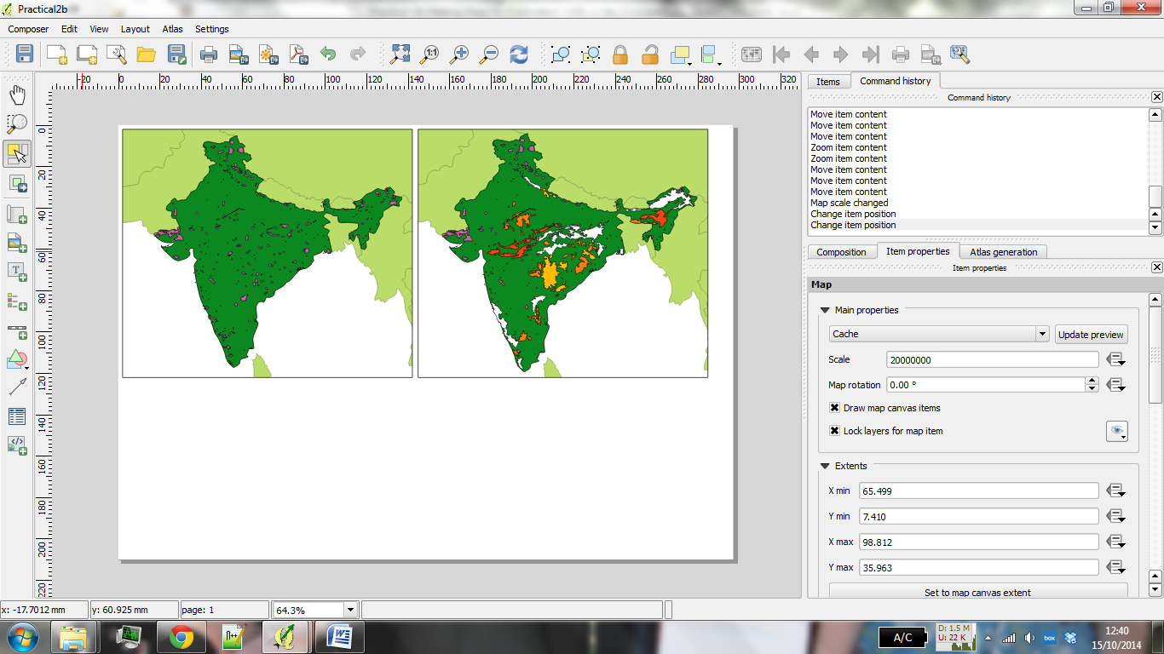 button to position the two maps closely together but with a small gap. If the scale changes, change it back to the correct value

Ensure that the checkbox  is checked next to **Frame**

In **Item Properties** check the checkbox next to  **Lock layers** before moving on.

We now need to add a map of the World to the figure to help give viewers some context.

Leaving just the Other countries layers visible create another map at the bottom of the figure. Play around with moving the Other countries layer into the frame and adjust the scale accordingly until it fills the frame (a scale of 350000000 should just about do it but feel free to choose your own).

Ensure that the checkbox  next to **Frame** is checked. Your current map should now look something like this below:



Now that we have all of our maps in position we need to add a title.

From the top menu select **Layout > Add Label** click somewhere along the top of the map. The **Item Properties** box should become visible and the words QGIS added to the map display

In **Item Properties** change the words to Tiger Conservation

Click on **Font** and change the **Font Style** to Bold and the **Size** to 28 (you might need to drag out the box in the map display to fit the text)

Under **Vertical Alignment** select the radio button named Left and set the **Horizontal Alignment** button to Center

Check the checkbox  next to Frame

You should save your work regularly as you go through this practical. Do save what you have done in the Print Composer window, either click the **Save** button in the top-left corner Screen Shot 2014-11-13 at 13 or click **Composer > Save Project**. Let’s add some more details:

Under **Item Properties** find the **Background** property and change the colour to a light grey.

Drag the grey frame to align with the other maps in the figure.



We’ll now add a small subtitle to the Tiger Conservation title.

* Add another label in the same way but change the text to Size *18* and Font Style to *Italic*
* Change the words to read: an assessment of critical habitat in India and expand the box so that the words are all visible
* Finally, position the subtitle next to the title.

We now need to add legends, scalebars and a north arrow to our maps so that the user has a sense of scale and so that they can easily distinguish what each of the colours mean.

To add a legend:

* Make sure that you have the **Select/Move item ** tool selected and click on the top left map
* With the top left map selected go to **Layout > Add Legend** and click on the map and a legend will appear
* Under **Item Properties** go to **Main Properties** and remove the title (it’s not necessary to have a title for the legend, or key, in this map but it might be in other situations)
* The legend includes all the items in the QGIS project window. To remove some of the unnecessary items go to **Item Properties > Legend items** and untick **Auto** update. From this you can select items and remove Tiger conservation units from the legend
* Make sure that you have the **Select/Move item ** tool selected and position the legend in the bottom right of the Wildlife reserves map
* Check the checkbox  next to Frame to add a border, change the thickness to 0.10
* Repeat this process to add another legend containing all of the layers that are visible in the top right (Tiger conservation units) map. You can change the order of items that appear in the legend under **Item Properties > Legend items** and by using the up  and down  arrows. Feel free to play around with the various legend settings to create custom legends.

To add a north arrow:

* Click on **Layout > Add Arrow** from the top menu bar and draw the arrow in a suitable position on the map (the top right in each of the two top maps would be appropriate)

To add a scalebar:

* Select the **Select/Move item ** tool and click on the top left map
* Click on **Layout > Add Scalebar** and click on the map. A scalebar will now be added to the map (its style will depend upon the last settings that you used so may differ slightly here). Under **Item properties > Scalebar** make sure that the correct corresponding Map is selected from the dropdown box (in my case the top left map is Map 0 so this should be selected here). Change this value to match the name of your top left (wildlife reserves) map and change the Style to Single Box
* Change **Scalebar units** to Map units
* Set **Label unit multiplier** to 0.01 (as our data is in the WGS 84 datum which is decimal degrees – one decimal degree is roughly 111.111 metres which equates to 0.01 map units)
* Change **Label for units** to km.
* Make sure **Segments** is set to left 0 and right 3
* Select **Fixed width** and set this to 2.5 units
* Feel free to change any of the other settings such as Font or Colour before moving on
* Place the scalebar in a suitable place on the map
* Repeat the process for the top right (Tiger conservation units) map using the same values.

**To add an overview to the world map:**

*This will show on the world map the area that the India map shows. Although it is fair to say we probably all know where India is in the world, this technique can be very useful to highlight where a study area is in a country or region.*

* Select the map window which has the world map in it and expand the **Overviews** section in the **Item properties** tab.
* Click the green + button and a new overview will be added. Change the **Map frame** entry to **Map 0** (or whichever map you wish to highlight the area of) and you should see the overview shown in the world map. *It may not be very obvious at first – try adjusting the style to improve this. I tend to use a coloured outline with a clear fill.*

**Other map layout changes (optional exercise)**

Laying out a map can be a complex exercise, particularly where the map consists of a number of different elements, as this one does. Experiment with different layout options, and see if you can improve on the layout you have so far. Text (such as the title in this case) can be rotated, so one option is to try rotating the title and sub-title 90 degrees anti-clockwise and locating it on the left hand edge of the page. Another option would be to combine the legend entries, and/or moving the scale bar to a different location.

Our map is almost finished. Annoyingly, we have a large white space in the bottom right hand corner of the map. What can we fill this with? Conveniently, we have an image of a Tiger in the data files!



* To add the image of the Tiger, go to **Layout > Add Image** and draw a box on the map
* Under **Item Properties > Main properties** click on the button next to **Image Source** and navigate to the prac2 folder. Select the Tigerpic.jpg image and position it in the bottom right hand corner of the map

To export a copy of your map

* Go to **Composer > Export as PDF**, choose a location and a filename to save your map.

## **3. Mapping other data (optional exercises)**

## Now you have seen the process of creating a publication quality map, let’s make it a bit more challenging and get you to make a different sort of map, using the skills you have learnt today.

## **A. Mapping age structure in the North West using 2011 Census data**

There are a number of spatial data repositories, like the CDRC Data Store ([http://data.cdrc.ac.uk](http://data.cdrc.ac.uk/)) which provide nicely packaged spatial data, with the attribute data and the spatial data already linked together. However this is not always the case. I have provided some age structure data for the North West of England; the count and percentage of people ages in a number of different age groups for each LSOA (liverpool-age-data.zip). Create a map of one (or more) age categories for the North West using this data. You will need to join the data together, and then symbolise the map appropriately.

## **B. Mapping population change in India using 2011 and 2011 Census data**

Your task is to make a map of population and/or population change in India. It should be a map of publishable quality, like the one we created for the Tiger Conservation areas. How you lay the map out, and whether you show population or population change, or both, is up to you.

These are the data you will need:

* The Indian state (level 1) spatial boundaries, which can be downloaded from [www.gadm.org](http://www.gadm.org/). Make sure you download the shapefile version.
* The Indian population data from the 2011 and 2001 Census. You can download this from [http://censusindia.gov.in](http://censusindia.gov.in/), but you need to register so I have downloaded this data for you (india_2001.xlsx and india_2011.xlsx).

I have done some of the data processing for the Indian Census data (included in the practical zip file), but you will need to do some as well. You will need to join the census data to the boundaries, calculate the population change, and then map the data. Remember to reference the data sources. Good luck!

## **C. Mapping your own data**

If you’ve brought some of your own data along, try getting that into QGIS and seeing what you can do with it. I will be available to chat to you on a one-to-one basis, so I can provide help with this.



*Written and tested using QGIS 2.18 on 10/05/2017 by Nick Bearman.*

*This work is licensed under the Creative Commons Attribution-ShareAlike 4.0 International License. To view a copy of this license, visit http://creativecommons.org/licenses/by-sa/4.0/deed.en.*

