
Overview
The goal of this competitive analysis is to help Nimble Signals research their competitors’ current positions, products, and processes in order to figure out how to stand out from the rest. Use this section to direct the company’s sales and marketing team in how they should conduct this competitive analysis.

Add a caption here
Competitors
Get to know the company’s competitors. List the top competitors of Nimble Signals and conduct primary or secondary market research.
Direct competitors still dominate the tech and networking sector
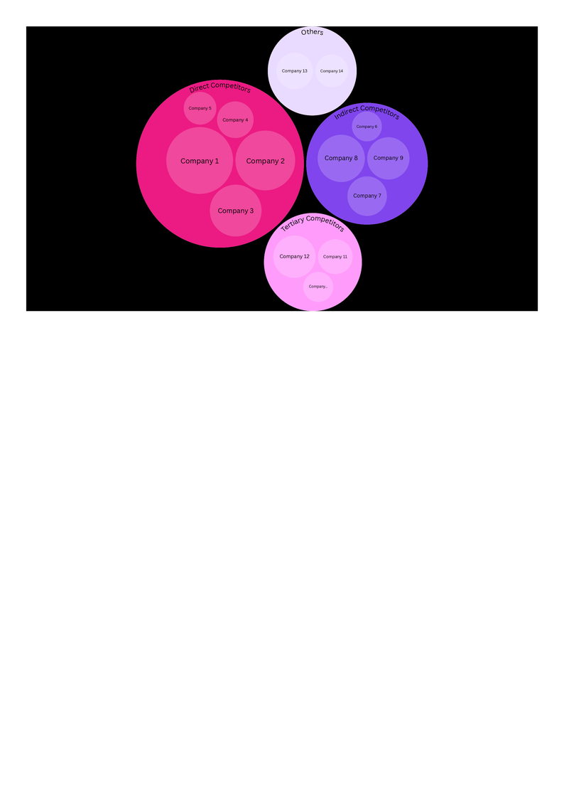
Company 1 and Company 2 remain the top direct competitors of Nimble Signals within the immediate market sector

List down all the information about the top competitors in the table below.
 | Direct Competitor | Indirect Competitor | Tertiary Competitor
Unique Value Proposition | What is the selling point of this competitor?
Product Positioning | How do customers perceive this competitor’s products?
Target Market | Which specific groups of customers are being catered to by this competitor?
Market Share | What is this competitor’s percentage of total revenue in the industry?

Products or Services
In this section, take note of the competitors’ product or service features and compare them with Nimble Signals’ own offerings.
 | Your  Company | Direct Competitor | Indirect Competitor | Tertiary Competitor
Products or Services | What are the company’s offered products or services? |   Add images as needed
Pricing | What is the pricing model used by the company?
Features | What are the unique features of the products?
Ease of Use | Do customers find the products easy to use and satisfying?
Quality | Are the products up to industry standards?

Sales Strategies
After comparing Nimble Signals’ and its competitors’ products, the next step is to analyze how those products are reaching each company’s customer base.
Your Company
Overview: Briefly introduce all the sales strategies and channels that the company is implementing.
- Personal Selling - explain how the company leverages this specific sales channel.
- Retail - elaborate as needed.
- Wholesale
Competitors
Overview: Briefly introduce all the sales strategies and channels that the company is implementing.
- Direct Marketing - explain how the company leverages this specific sales channel.
- Automated Retail - elaborate as needed.
- Add another sales channel

SWOT Analysis
Create SWOT tables per company to build awareness about all the factors that impact each of them.
Your Company
Strengths | Weaknesses | Opportunities | Threats
What sets the company apart? | Where does the company need to improve? | Which external trends can the company capitalize on? | What external factors may be detrimental to the company?
Competitors
Strengths | Weaknesses | Opportunities | Threats
List down the necessary attributes here | Write here | Write here | Write here

