ENTEROHEPATIC BILE ACID DYNAMICS REPORT
Longitudinal Crossover Analysis of Fasting vs. Postprandial States across 15 Bile Acids
Statistical Method: Batch-corrected Linear Mixed-effects Model (LMM)
Date Generated: 2026-05-20

1. Executive Summary & Research Context
Bile acids (BAs) are critical amphipathic sterol molecules synthesized from cholesterol in hepatocytes, acting as essential detergents for emulsification and absorption of dietary lipids in the small intestine. Beyond their physical detergent properties, bile acids function as potent signaling ligands that bind to nuclear receptors, such as the farnesoid X receptor (FXR), and G-protein coupled receptors, like TGR5. These actions regulate lipid, glucose, energy, and xenobiotic metabolism throughout the enterohepatic circulation pathway. This report presents a rigorous longitudinal analysis of 15 primary, secondary, and tertiary bile acids to characterize baseline levels, prolonged fasting trajectories, and postprandial (after meal) physiological response.

2. Detailed Statistical & Preprocessing Methodology
To ensure chemical and biological validity, a multi-stage statistical pipeline was developed and executed:

2.1 Technical Plate-to-Plate Batch Effect Normalization
Because the biological subjects are fully nested within individual plates (e.g., all 5 timepoints for a single subject are processed on one plate), simple biological median centering would confound real biological subject variation with plate-level technical bias. To resolve this, technical batch correction was achieved using identical pooled Long-Term Reference (LTR) samples run repeatedly across all three plates (SRVp008, SRVp009, SRVp010). For each compound, a plate-specific adjustment factor was calculated as the ratio of the global LTR median to the plate-specific LTR median. This technical adjustment was applied to all sample concentrations to normalize technical plate bias while fully preserving individual biological baselines and crossover profiles.

2.2 Longitudinal Linear Mixed-effects Modeling (LMM)
A major statistical error in longitudinal or crossover data analysis is treating repeated measurements on the same subject as independent observations (using standard ANOVA or simple linear models). This violates the core independence assumption, inflates type-I error rates, and miscalculates p-values. Here, we implemented a Linear Mixed-effects Model (LMM) in R using the lmerTest package. The model is formulated as:
Value_log ~ Timepoint + (1 | Subject)
where Timepoint is a categorical fixed effect (levels: 2 = Baseline, 18 = NS4 Fasting, 26 = RTDS Fasting, 23 = NS4 After-Meal) and (1 | Subject) is the random effect modeling a subject-specific intercept. The random intercept mathematically models the unique baseline of each individual and successfully accounts for intra-subject covariance due to repeated measures.

2.3 Log-Transformation and Model Validity
Plasma concentrations of bile acids are strictly non-negative and highly skewed, naturally spanning multiple orders of magnitude. Analyzing raw concentrations directly in an LMM would severely violate the core assumptions of residual normality and homoscedasticity. Therefore, a natural log-transformation was applied to all adjusted values prior to fitting the mixed models, ensuring variance stabilization and residual normality.

2.4 Post-hoc Pairwise Comparisons & FDR Correction
Post-hoc pairwise comparisons were conducted using the emmeans package in R. Pairwise contrasts were specifically targeted to compare the postprandial state (Timepoint 23) against each of the three fasting states: Baseline (Timepoint 2), NS4 Fasting (Timepoint 18), and RTDS Fasting (Timepoint 26). P-values were calculated using Satterthwaite's approximation for degrees of freedom. To control the false discovery rate (FDR) arising from multiple testing across all 15 bile acids (45 pairwise tests), Benjamini-Hochberg (BH) correction was applied. Statistical significance is determined based on FDR-corrected q-values (q < 0.05) and annotated using standard stars (*q < 0.05, **q < 0.01, ***q < 0.001, ns = non-significant). Individual trajectory plots display unadjusted p-values for reference; all summary tables and interpretive text use FDR-corrected q-values.

3. Comprehensive Statistical Summary Table (Master Table)
The following table provides a complete, publication-ready overview of the statistical comparisons for all 15 individual bile acids and 4 aggregate classes (Total Bile Acids, Glycine-Conjugated, Taurine-Conjugated, and Unconjugated pools). Log Fold Changes (LFC) are reported on the natural log scale as estimated by the Linear Mixed-effects Models (LMM). Both raw p-values (Satterthwaite) and FDR-corrected q-values (Benjamini-Hochberg) are reported. Statistical significance is determined by FDR q-values and highlighted in bold dark red for all contrasts yielding q < 0.05 (*q < 0.05, **q < 0.01, ***q < 0.001, ns = non-significant).

 |  | Postprandial (23) vs. Baseline (2) |  |  | Postprandial (23) vs. NS4 Fasting (18) |  |  | Postprandial (23) vs. RTDS Fasting (26)
Bile Acid | Class / Category | LFC | p (raw) | FDR q | LFC | p (raw) | FDR q | LFC | p (raw) | FDR q
GCA | Primary Conj | 0.505 | < 0.001 | 0.002 (**) | 0.312 | 0.025 | 0.071 (ns) | -0.004 | 0.978 | 0.988 (ns)
TCA | Primary Conj | 0.654 | < 0.001 | < 0.001 (***) | 0.360 | 0.016 | 0.048 (*) | 0.042 | 0.777 | 0.871 (ns)
GCDCA | Primary Conj | 0.494 | < 0.001 | 0.002 (**) | 0.201 | 0.123 | 0.240 (ns) | 0.002 | 0.988 | 0.988 (ns)
TCDCA | Primary Conj | 0.814 | < 0.001 | < 0.001 (***) | 0.393 | 0.011 | 0.040 (*) | 0.162 | 0.297 | 0.477 (ns)
CA | Primary Unconj | 0.429 | 0.101 | 0.228 (ns) | -0.347 | 0.184 | 0.331 (ns) | -0.089 | 0.736 | 0.850 (ns)
CDCA | Primary Unconj | 0.071 | 0.794 | 0.871 (ns) | -0.277 | 0.311 | 0.481 (ns) | -0.014 | 0.960 | 0.988 (ns)
GDCA | Secondary Conj | 0.154 | 0.321 | 0.481 (ns) | 0.178 | 0.252 | 0.436 (ns) | 0.108 | 0.485 | 0.624 (ns)
TDCA | Secondary Conj | 0.600 | < 0.001 | 0.002 (**) | 0.458 | 0.006 | 0.026 (*) | 0.267 | 0.111 | 0.238 (ns)
GLCA | Secondary Conj | 0.611 | < 0.001 | < 0.001 (***) | 0.606 | < 0.001 | < 0.001 (***) | 0.770 | < 0.001 | < 0.001 (***)
TLCA | Secondary Conj | 0.465 | 0.012 | 0.040 (*) | 0.579 | 0.002 | 0.007 (**) | 0.317 | 0.089 | 0.211 (ns)
DCA | Secondary Unconj | -0.334 | 0.053 | 0.141 (ns) | -0.136 | 0.427 | 0.565 (ns) | 0.166 | 0.333 | 0.484 (ns)
LCA | Secondary Unconj | -0.100 | 0.281 | 0.469 (ns) | 0.229 | 0.016 | 0.048 (*) | 0.396 | < 0.001 | < 0.001 (***)
UDCA | Tertiary / Microbial | -0.184 | 0.412 | 0.561 (ns) | -0.192 | 0.382 | 0.538 (ns) | -0.090 | 0.692 | 0.819 (ns)
GUDCA | Tertiary / Microbial | -0.077 | 0.516 | 0.645 (ns) | -0.062 | 0.602 | 0.732 (ns) | -0.192 | 0.116 | 0.238 (ns)
TUDCA | Tertiary / Microbial | 0.194 | 0.171 | 0.321 (ns) | 0.252 | 0.074 | 0.184 (ns) | 0.009 | 0.950 | 0.988 (ns)
Total_BA | Total Pool | 0.424 | 0.069 | 0.207 (ns) | 0.085 | 0.713 | 0.778 (ns) | 0.333 | 0.155 | 0.310 (ns)
Glycine_Conjugated | Gly Conjugates | 0.414 | 0.056 | 0.207 (ns) | 0.217 | 0.312 | 0.416 (ns) | 0.255 | 0.240 | 0.412 (ns)
Taurine_Conjugated | Tau Conjugates | 0.706 | < 0.001 | 0.001 (**) | 0.386 | 0.030 | 0.181 (ns) | 0.296 | 0.098 | 0.236 (ns)
Unconjugated | Unconjugated Pool | 0.046 | 0.871 | 0.871 (ns) | -0.254 | 0.367 | 0.440 (ns) | 0.293 | 0.301 | 0.416 (ns)

4. Detailed Bile Acid Trajectory Analysis & Interpretations

4. 1 - Glycocholic Acid (GCA)
Bile Acid Classification: Primary Conjugated Bile Acid

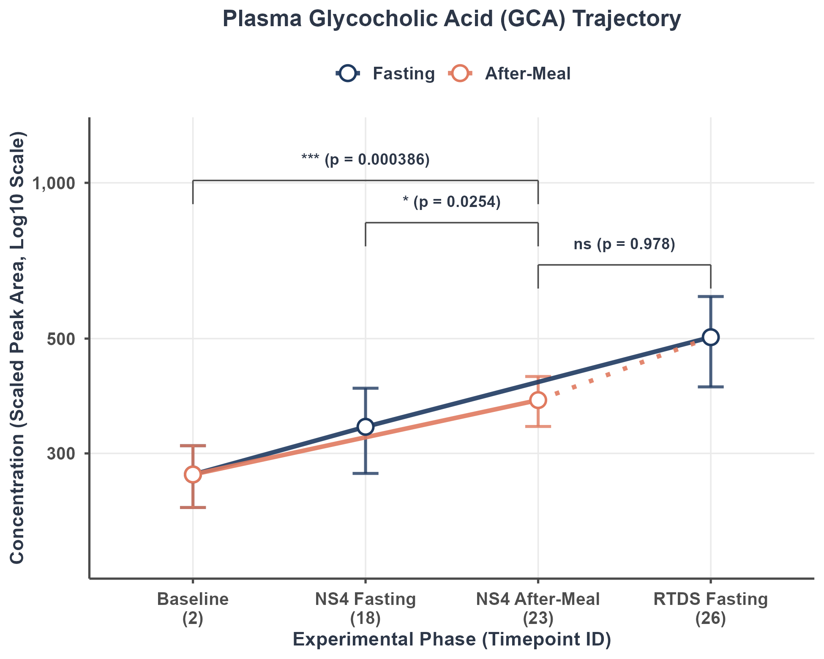
Figure Caption: Mean concentration trajectory (Scaled Peak Area, log10 scale) showing the Fasting trajectory (Baseline [2] -> NS4 Fasting [18] -> RTDS Fasting [26], blue line) and the Meal trajectory (overlapping fasting, and extending to NS4 After-Meal [23], orange line). Error bars represent mean ± SEM. Statistical brackets show unadjusted p-values from longitudinal crossover Linear Mixed-effects Models (LMM). FDR-corrected q-values are reported in the statistical table and interpretive text. *p < 0.05, **p < 0.01, ***p < 0.001, ns = non-significant.

Statistical Contrast Results Table:
Contrast Comparison | Log Fold Change (LFC) | Std Error (SE) | p-value (raw) | FDR q-value | Signif
Postprandial (23) vs. Baseline (2) | 0.5052 | 0.1371 | 0.0003863 | 0.002173 | **
Postprandial (23) vs. NS4 Fasting (18) | 0.3116 | 0.1371 | 0.0253685 | 0.071349 | ns
Postprandial (23) vs. RTDS Fasting (26) | -0.0039 | 0.1399 | 0.9780019 | 0.988089 | ns

Statistical Relevance & Biological Interpretation:
Glycocholic Acid (GCA) is a major primary conjugated bile acid synthesized in hepatocytes by the conjugation of cholic acid with glycine. Secreted actively into bile, GCA is released into the duodenum following meal ingestion via cholecystokinin (CCK)-mediated gallbladder contraction. GCA's enterohepatic recovery is facilitated by active transport via the ASBT transporter in the ileum. The LMM analysis reveals statistically significant postprandial changes at Timepoint 23 vs. Baseline (FDR q = 0.00217, **, elevated). The contrast(s) vs. NS4 Fasting and RTDS Fasting did not reach significance after FDR correction.

4. 2 - Taurocholic Acid (TCA)
Bile Acid Classification: Primary Conjugated Bile Acid

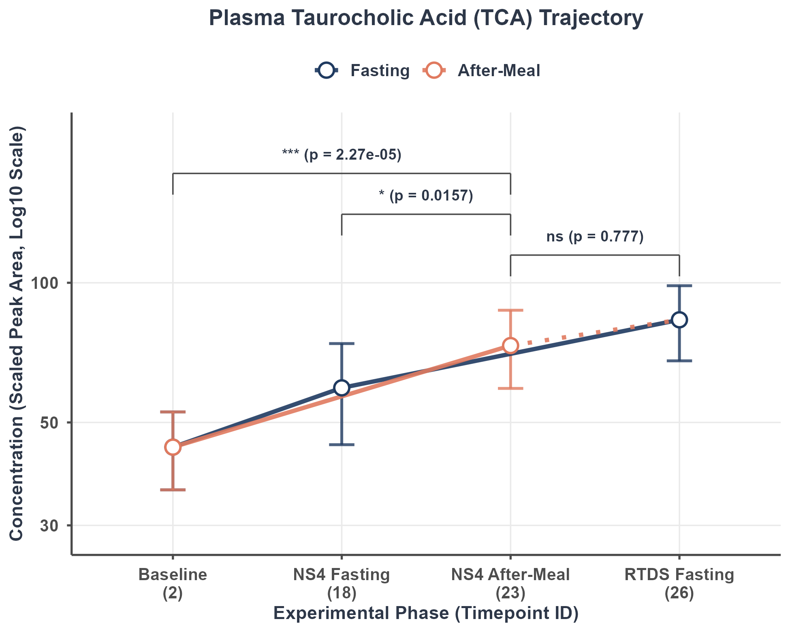
Figure Caption: Mean concentration trajectory (Scaled Peak Area, log10 scale) showing the Fasting trajectory (Baseline [2] -> NS4 Fasting [18] -> RTDS Fasting [26], blue line) and the Meal trajectory (overlapping fasting, and extending to NS4 After-Meal [23], orange line). Error bars represent mean ± SEM. Statistical brackets show unadjusted p-values from longitudinal crossover Linear Mixed-effects Models (LMM). FDR-corrected q-values are reported in the statistical table and interpretive text. *p < 0.05, **p < 0.01, ***p < 0.001, ns = non-significant.

Statistical Contrast Results Table:
Contrast Comparison | Log Fold Change (LFC) | Std Error (SE) | p-value (raw) | FDR q-value | Signif
Postprandial (23) vs. Baseline (2) | 0.6543 | 0.1464 | 2.265e-05 | 0.0002144 | ***
Postprandial (23) vs. NS4 Fasting (18) | 0.3605 | 0.1464 | 0.01572 | 0.0475770 | *
Postprandial (23) vs. RTDS Fasting (26) | 0.0425 | 0.1496 | 0.77698 | 0.8713892 | ns

Statistical Relevance & Biological Interpretation:
Taurocholic Acid (TCA) is a primary taurine-conjugated bile acid synthesized in hepatocytes. Because taurine conjugation provides a highly polar structure, TCA is restricted to the intestinal lumen until it reaches the active transport systems of the terminal ileum. During fasting, systemic TCA concentrations remain extremely low, reflecting quiescent enterohepatic circulation between meals. The LMM analysis reveals statistically significant postprandial changes at Timepoint 23 vs. Baseline (FDR q = 0.000214, ***, elevated); vs. NS4 Fasting (FDR q = 0.0476, *, elevated). The contrast(s) vs. RTDS Fasting did not reach significance after FDR correction.

4. 3 - Glycochenodeoxycholic Acid (GCDCA)
Bile Acid Classification: Primary Conjugated Bile Acid

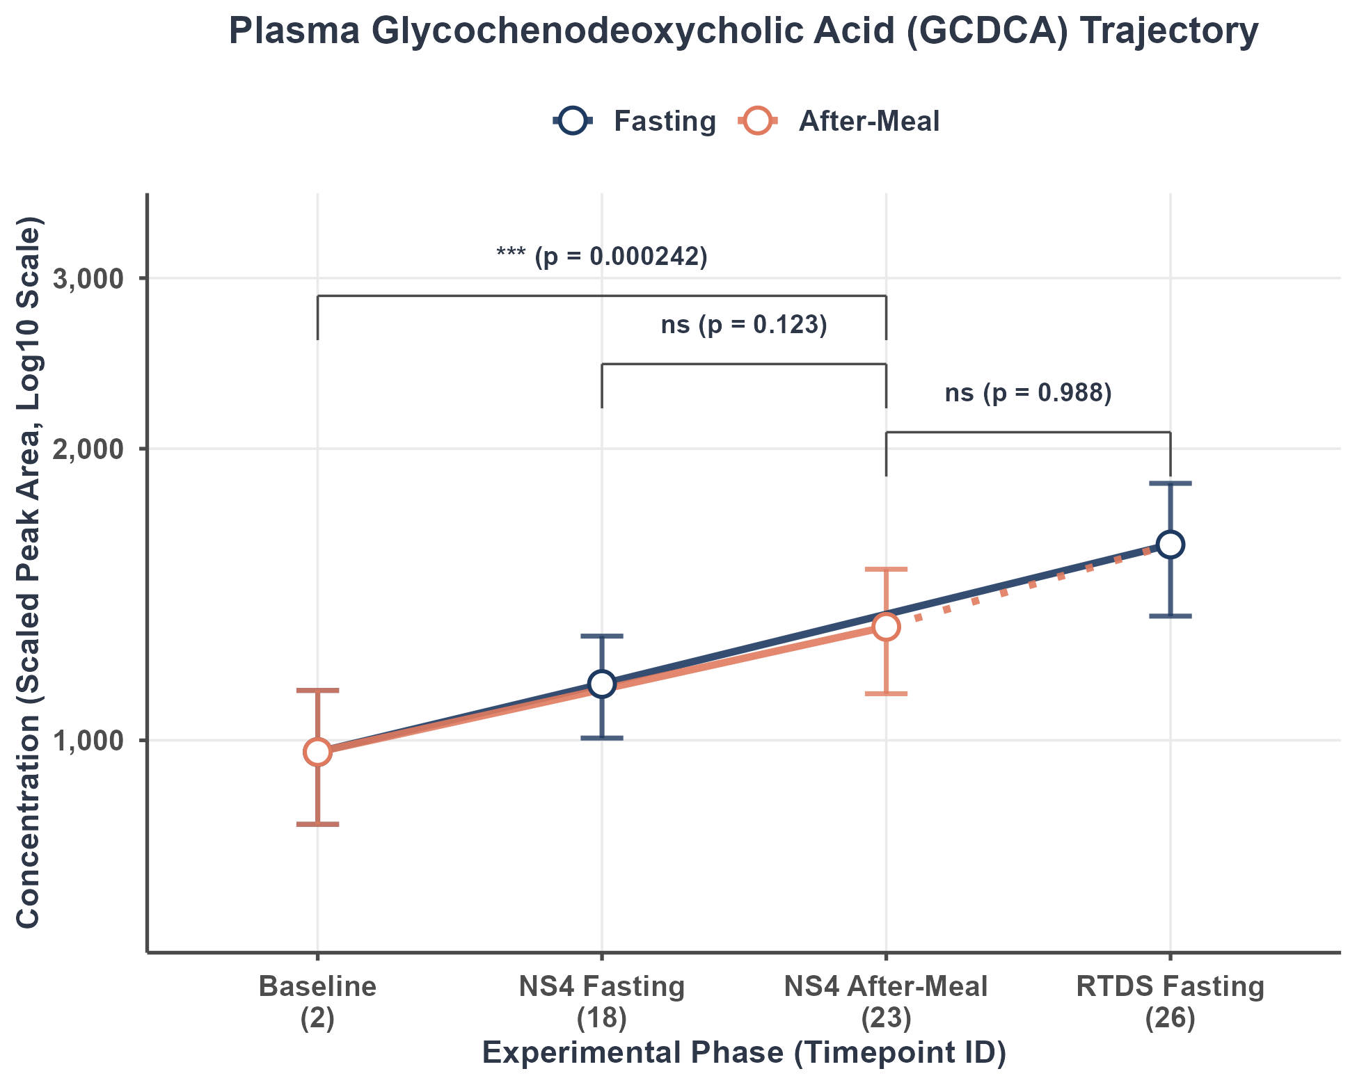
Figure Caption: Mean concentration trajectory (Scaled Peak Area, log10 scale) showing the Fasting trajectory (Baseline [2] -> NS4 Fasting [18] -> RTDS Fasting [26], blue line) and the Meal trajectory (overlapping fasting, and extending to NS4 After-Meal [23], orange line). Error bars represent mean ± SEM. Statistical brackets show unadjusted p-values from longitudinal crossover Linear Mixed-effects Models (LMM). FDR-corrected q-values are reported in the statistical table and interpretive text. *p < 0.05, **p < 0.01, ***p < 0.001, ns = non-significant.

Statistical Contrast Results Table:
Contrast Comparison | Log Fold Change (LFC) | Std Error (SE) | p-value (raw) | FDR q-value | Signif
Postprandial (23) vs. Baseline (2) | 0.4941 | 0.1293 | 0.0002417 | 0.001554 | **
Postprandial (23) vs. NS4 Fasting (18) | 0.2013 | 0.1293 | 0.1228447 | 0.240348 | ns
Postprandial (23) vs. RTDS Fasting (26) | 0.0020 | 0.1320 | 0.9880892 | 0.988089 | ns

Statistical Relevance & Biological Interpretation:
Glycochenodeoxycholic Acid (GCDCA) is the glycine conjugate of chenodeoxycholic acid and represents one of the most abundant bile acids in human bile. GCDCA plays a central role in postprandial fat emulsification and is actively reabsorbed via ileal transporters during enterohepatic circulation. The LMM analysis reveals statistically significant postprandial changes at Timepoint 23 vs. Baseline (FDR q = 0.00155, **, elevated). The contrast(s) vs. NS4 Fasting and RTDS Fasting did not reach significance after FDR correction.

4. 4 - Taurochenodeoxycholic Acid (TCDCA)
Bile Acid Classification: Primary Conjugated Bile Acid

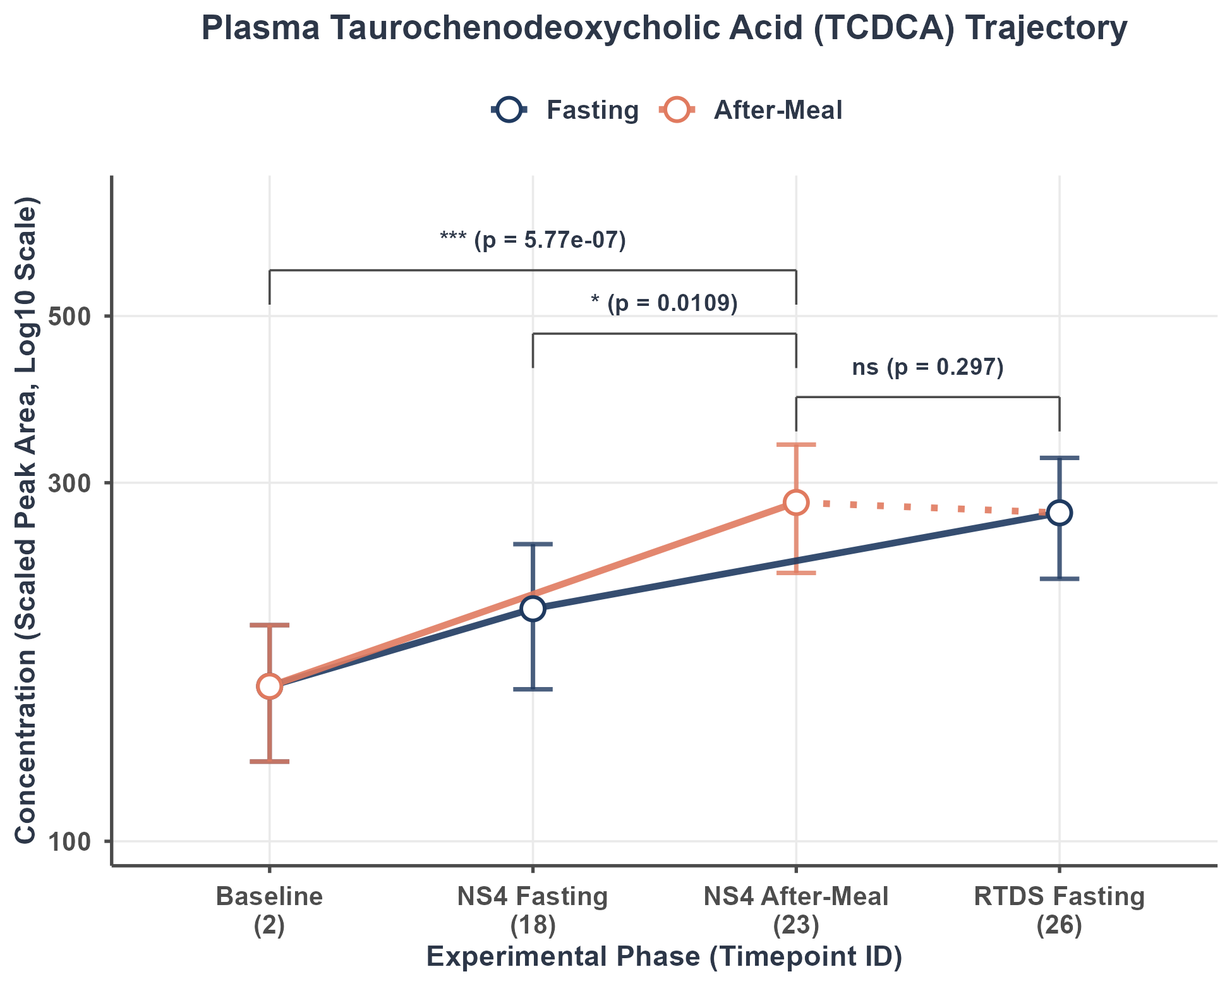
Figure Caption: Mean concentration trajectory (Scaled Peak Area, log10 scale) showing the Fasting trajectory (Baseline [2] -> NS4 Fasting [18] -> RTDS Fasting [26], blue line) and the Meal trajectory (overlapping fasting, and extending to NS4 After-Meal [23], orange line). Error bars represent mean ± SEM. Statistical brackets show unadjusted p-values from longitudinal crossover Linear Mixed-effects Models (LMM). FDR-corrected q-values are reported in the statistical table and interpretive text. *p < 0.05, **p < 0.01, ***p < 0.001, ns = non-significant.

Statistical Contrast Results Table:
Contrast Comparison | Log Fold Change (LFC) | Std Error (SE) | p-value (raw) | FDR q-value | Signif
Postprandial (23) vs. Baseline (2) | 0.8137 | 0.1513 | 5.774e-07 | 1.299e-05 | ***
Postprandial (23) vs. NS4 Fasting (18) | 0.3930 | 0.1513 | 0.01094 | 0.04017 | *
Postprandial (23) vs. RTDS Fasting (26) | 0.1620 | 0.1545 | 0.29697 | 0.47728 | ns

Statistical Relevance & Biological Interpretation:
Taurochenodeoxycholic Acid (TCDCA) is the taurine conjugate of chenodeoxycholic acid. TCDCA is a major signaling ligand for the nuclear farnesoid X receptor (FXR). Postprandial surges of TCDCA are crucial for triggering hepatic FXR signaling to suppress de novo bile acid synthesis via FGF15/19 feedback. The LMM analysis reveals statistically significant postprandial changes at Timepoint 23 vs. Baseline (FDR q = 1.3e-05, ***, elevated); vs. NS4 Fasting (FDR q = 0.0402, *, elevated). The contrast(s) vs. RTDS Fasting did not reach significance after FDR correction.

4. 5 - Cholic Acid (CA)
Bile Acid Classification: Primary Unconjugated Bile Acid

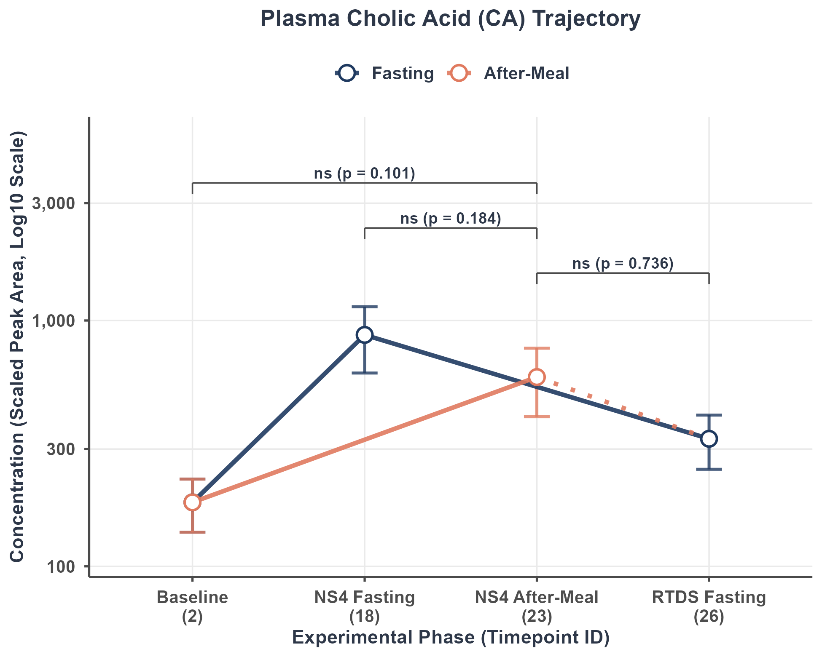
Figure Caption: Mean concentration trajectory (Scaled Peak Area, log10 scale) showing the Fasting trajectory (Baseline [2] -> NS4 Fasting [18] -> RTDS Fasting [26], blue line) and the Meal trajectory (overlapping fasting, and extending to NS4 After-Meal [23], orange line). Error bars represent mean ± SEM. Statistical brackets show unadjusted p-values from longitudinal crossover Linear Mixed-effects Models (LMM). FDR-corrected q-values are reported in the statistical table and interpretive text. *p < 0.05, **p < 0.01, ***p < 0.001, ns = non-significant.

Statistical Contrast Results Table:
Contrast Comparison | Log Fold Change (LFC) | Std Error (SE) | p-value (raw) | FDR q-value | Signif
Postprandial (23) vs. Baseline (2) | 0.4293 | 0.2595 | 0.1015 | 0.2283 | ns
Postprandial (23) vs. NS4 Fasting (18) | -0.3474 | 0.2595 | 0.1839 | 0.3311 | ns
Postprandial (23) vs. RTDS Fasting (26) | -0.0895 | 0.2649 | 0.7363 | 0.8496 | ns

Statistical Relevance & Biological Interpretation:
Cholic Acid (CA) is an unconjugated primary bile acid synthesized directly from cholesterol via the classical pathway in hepatocytes. Unlike its conjugated forms GCA and TCA, CA is less polar and can undergo passive absorption in the jejunum and colon, though active transport in the ileum is still dominant. A portion of the circulating CA pool arises from microbial deconjugation of GCA and TCA in the distal gut. The LMM analysis did not reveal statistically significant postprandial changes at Timepoint 23 relative to any of the three fasting states after FDR correction (all q > 0.05). This indicates that systemic concentrations of this bile acid remain relatively stable across meal and fasting conditions in this cohort (N = 32 subjects).

4. 6 - Chenodeoxycholic Acid (CDCA)
Bile Acid Classification: Primary Unconjugated Bile Acid

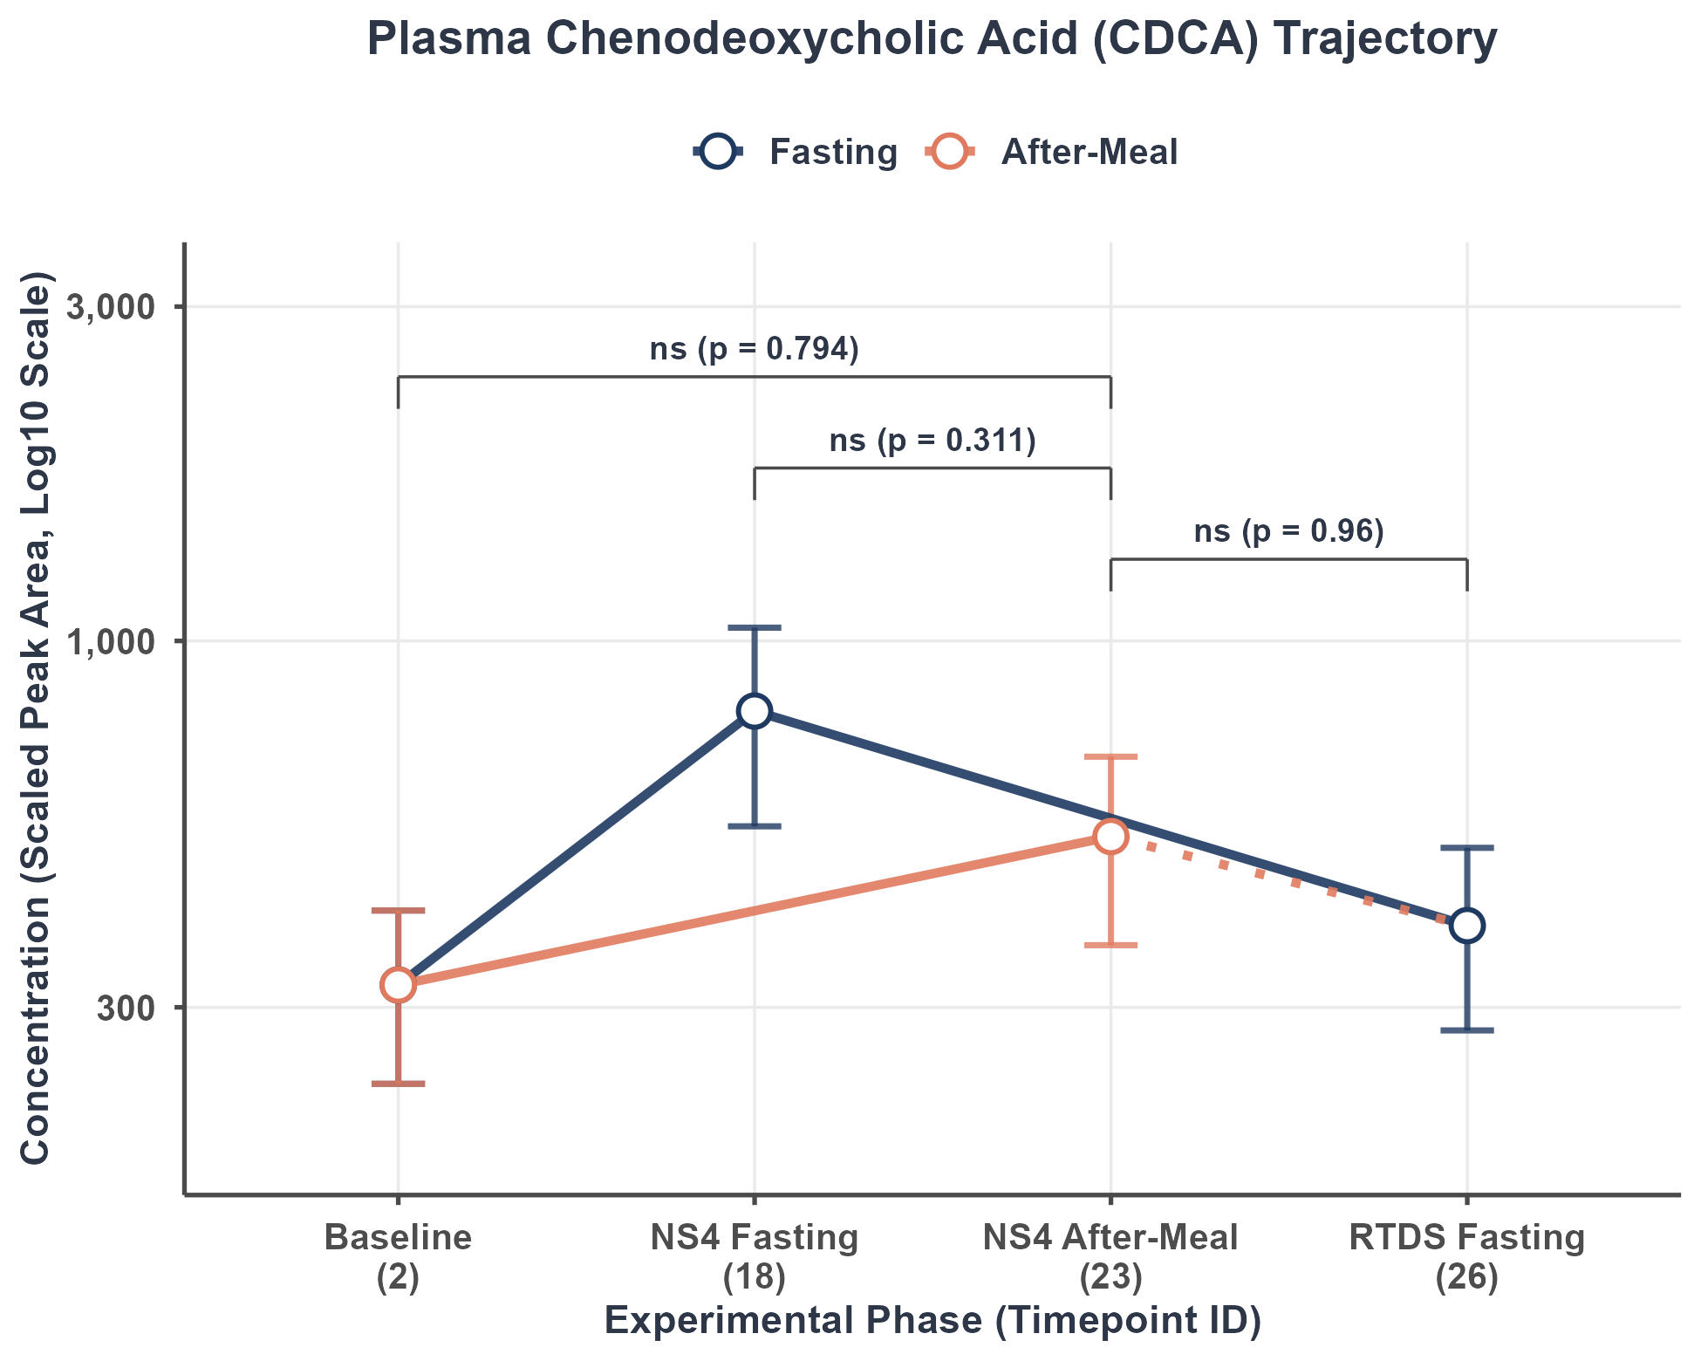
Figure Caption: Mean concentration trajectory (Scaled Peak Area, log10 scale) showing the Fasting trajectory (Baseline [2] -> NS4 Fasting [18] -> RTDS Fasting [26], blue line) and the Meal trajectory (overlapping fasting, and extending to NS4 After-Meal [23], orange line). Error bars represent mean ± SEM. Statistical brackets show unadjusted p-values from longitudinal crossover Linear Mixed-effects Models (LMM). FDR-corrected q-values are reported in the statistical table and interpretive text. *p < 0.05, **p < 0.01, ***p < 0.001, ns = non-significant.

Statistical Contrast Results Table:
Contrast Comparison | Log Fold Change (LFC) | Std Error (SE) | p-value (raw) | FDR q-value | Signif
Postprandial (23) vs. Baseline (2) | 0.0711 | 0.2716 | 0.7939 | 0.8714 | ns
Postprandial (23) vs. NS4 Fasting (18) | -0.2766 | 0.2716 | 0.3111 | 0.4809 | ns
Postprandial (23) vs. RTDS Fasting (26) | -0.0140 | 0.2772 | 0.9599 | 0.9881 | ns

Statistical Relevance & Biological Interpretation:
Chenodeoxycholic Acid (CDCA) is an unconjugated primary bile acid and the most potent endogenous agonist for the farnesoid X receptor (FXR), playing a foundational role in metabolic regulation. Since CDCA is highly lipophilic, it is easily absorbed passively in the intestine. The LMM analysis did not reveal statistically significant postprandial changes at Timepoint 23 relative to any of the three fasting states after FDR correction (all q > 0.05). This indicates that systemic concentrations of this bile acid remain relatively stable across meal and fasting conditions in this cohort (N = 32 subjects).

4. 7 - Glycodeoxycholic Acid (GDCA)
Bile Acid Classification: Secondary Conjugated Bile Acid

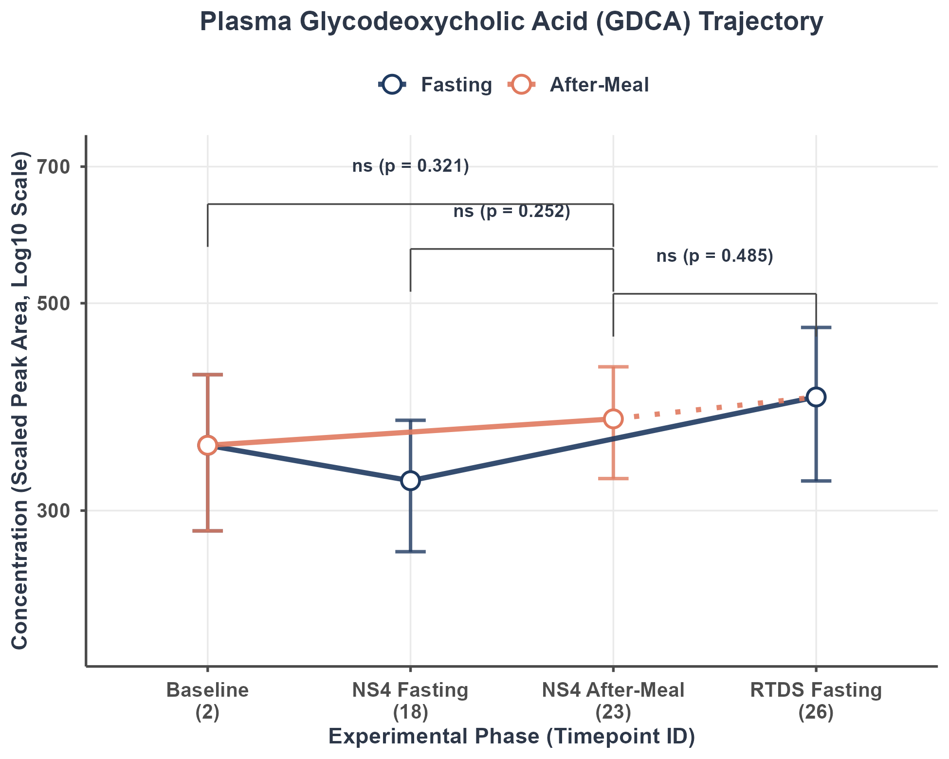
Figure Caption: Mean concentration trajectory (Scaled Peak Area, log10 scale) showing the Fasting trajectory (Baseline [2] -> NS4 Fasting [18] -> RTDS Fasting [26], blue line) and the Meal trajectory (overlapping fasting, and extending to NS4 After-Meal [23], orange line). Error bars represent mean ± SEM. Statistical brackets show unadjusted p-values from longitudinal crossover Linear Mixed-effects Models (LMM). FDR-corrected q-values are reported in the statistical table and interpretive text. *p < 0.05, **p < 0.01, ***p < 0.001, ns = non-significant.

Statistical Contrast Results Table:
Contrast Comparison | Log Fold Change (LFC) | Std Error (SE) | p-value (raw) | FDR q-value | Signif
Postprandial (23) vs. Baseline (2) | 0.1544 | 0.1546 | 0.3206 | 0.4809 | ns
Postprandial (23) vs. NS4 Fasting (18) | 0.1783 | 0.1546 | 0.2519 | 0.4360 | ns
Postprandial (23) vs. RTDS Fasting (26) | 0.1083 | 0.1544 | 0.4850 | 0.6236 | ns

Statistical Relevance & Biological Interpretation:
Glycodeoxycholic Acid (GDCA) is a secondary conjugated bile acid formed when gut bacteria dehydroxylate cholic acid derivatives in the colon, which are then conjugated with glycine, reabsorbed, and recirculated through enterohepatic cycling. The LMM analysis did not reveal statistically significant postprandial changes at Timepoint 23 relative to any of the three fasting states after FDR correction (all q > 0.05). This indicates that systemic concentrations of this bile acid remain relatively stable across meal and fasting conditions in this cohort (N = 32 subjects).

4. 8 - Taurodeoxycholic Acid (TDCA)
Bile Acid Classification: Secondary Conjugated Bile Acid

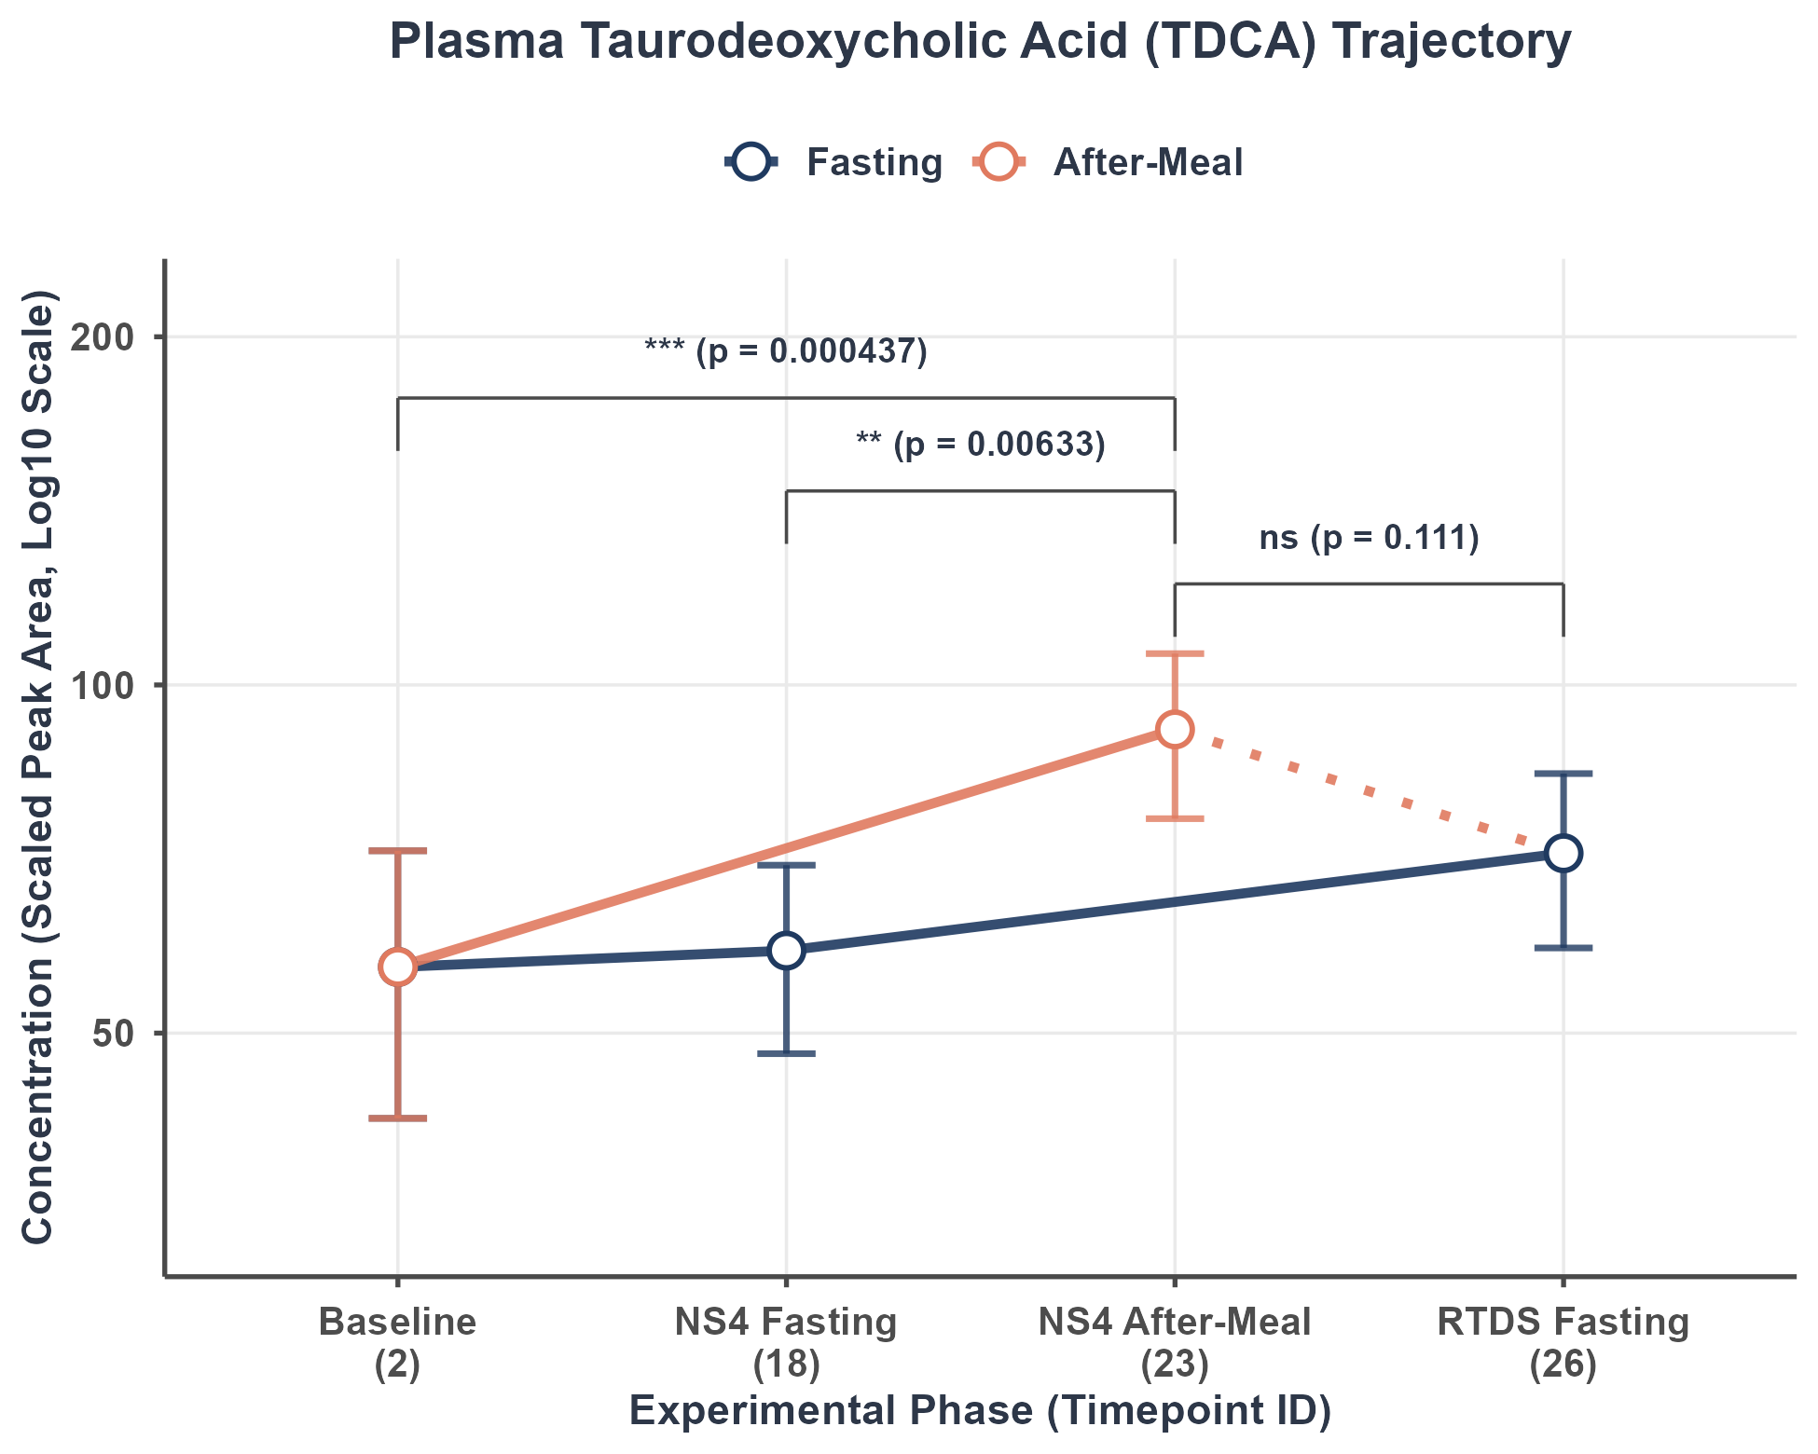
Figure Caption: Mean concentration trajectory (Scaled Peak Area, log10 scale) showing the Fasting trajectory (Baseline [2] -> NS4 Fasting [18] -> RTDS Fasting [26], blue line) and the Meal trajectory (overlapping fasting, and extending to NS4 After-Meal [23], orange line). Error bars represent mean ± SEM. Statistical brackets show unadjusted p-values from longitudinal crossover Linear Mixed-effects Models (LMM). FDR-corrected q-values are reported in the statistical table and interpretive text. *p < 0.05, **p < 0.01, ***p < 0.001, ns = non-significant.

Statistical Contrast Results Table:
Contrast Comparison | Log Fold Change (LFC) | Std Error (SE) | p-value (raw) | FDR q-value | Signif
Postprandial (23) vs. Baseline (2) | 0.6003 | 0.1641 | 0.0004374 | 0.002187 | **
Postprandial (23) vs. NS4 Fasting (18) | 0.4584 | 0.1638 | 0.0063345 | 0.025914 | *
Postprandial (23) vs. RTDS Fasting (26) | 0.2671 | 0.1660 | 0.1112247 | 0.237741 | ns

Statistical Relevance & Biological Interpretation:
Taurodeoxycholic Acid (TDCA) is the taurine conjugate of the secondary bile acid deoxycholic acid. Formed via microbial dehydroxylation and subsequent hepatic taurine conjugation, TDCA actively participates in enterohepatic recirculation. As a potent TGR5 receptor agonist, systemic TDCA can stimulate GLP-1 release from intestinal L-cells to optimize glucose-stimulated insulin secretion. The LMM analysis reveals statistically significant postprandial changes at Timepoint 23 vs. Baseline (FDR q = 0.00219, **, elevated); vs. NS4 Fasting (FDR q = 0.0259, *, elevated). The contrast(s) vs. RTDS Fasting did not reach significance after FDR correction.

4. 9 - Glycolithocholic Acid (GLCA)
Bile Acid Classification: Secondary Conjugated Bile Acid

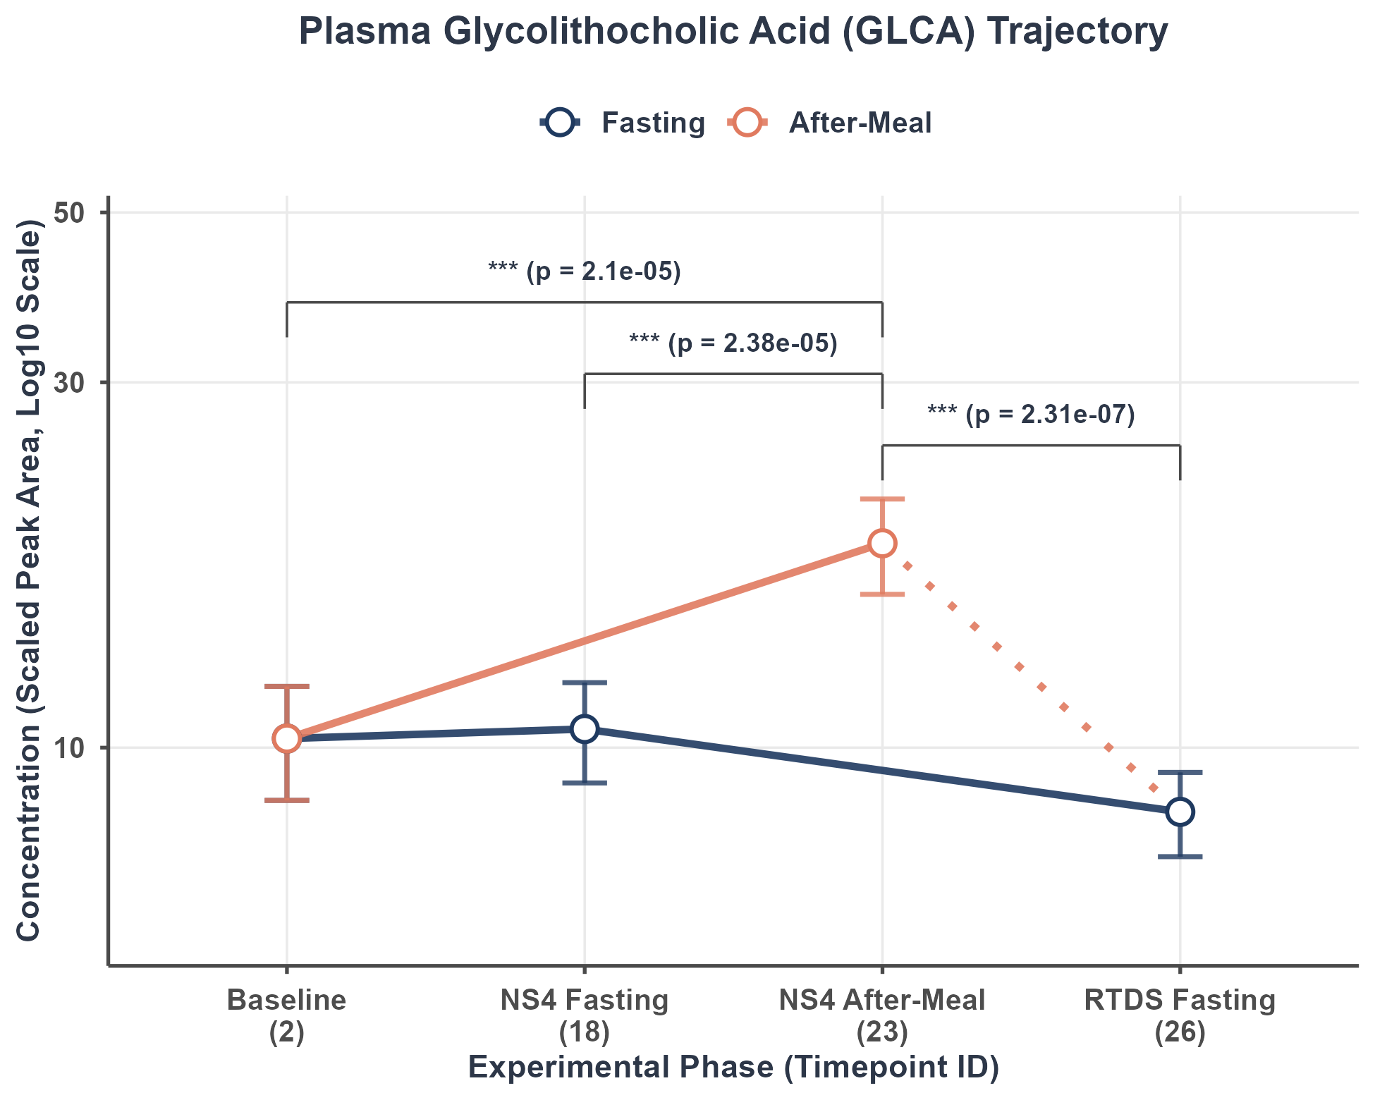
Figure Caption: Mean concentration trajectory (Scaled Peak Area, log10 scale) showing the Fasting trajectory (Baseline [2] -> NS4 Fasting [18] -> RTDS Fasting [26], blue line) and the Meal trajectory (overlapping fasting, and extending to NS4 After-Meal [23], orange line). Error bars represent mean ± SEM. Statistical brackets show unadjusted p-values from longitudinal crossover Linear Mixed-effects Models (LMM). FDR-corrected q-values are reported in the statistical table and interpretive text. *p < 0.05, **p < 0.01, ***p < 0.001, ns = non-significant.

Statistical Contrast Results Table:
Contrast Comparison | Log Fold Change (LFC) | Std Error (SE) | p-value (raw) | FDR q-value | Signif
Postprandial (23) vs. Baseline (2) | 0.6110 | 0.1360 | 2.098e-05 | 0.0002144 | ***
Postprandial (23) vs. NS4 Fasting (18) | 0.6065 | 0.1360 | 2.382e-05 | 0.0002144 | ***
Postprandial (23) vs. RTDS Fasting (26) | 0.7703 | 0.1375 | 2.309e-07 | 1.039e-05 | ***

Statistical Relevance & Biological Interpretation:
Glycolithocholic Acid (GLCA) is a glycine-conjugated secondary bile acid derived from lithocholic acid (LCA), which is highly hepatotoxic. To prevent toxicity, the liver efficiently sulfates and conjugates LCA. Systemic concentrations of GLCA are very low because the LCA pool is kept extremely small via rapid fecal excretion and sulfation. The LMM analysis reveals statistically significant postprandial changes at Timepoint 23 vs. Baseline (FDR q = 0.000214, ***, elevated); vs. NS4 Fasting (FDR q = 0.000214, ***, elevated); vs. RTDS Fasting (FDR q = 1.04e-05, ***, elevated).

4. 10 - Taurolithocholic Acid (TLCA)
Bile Acid Classification: Secondary Conjugated Bile Acid

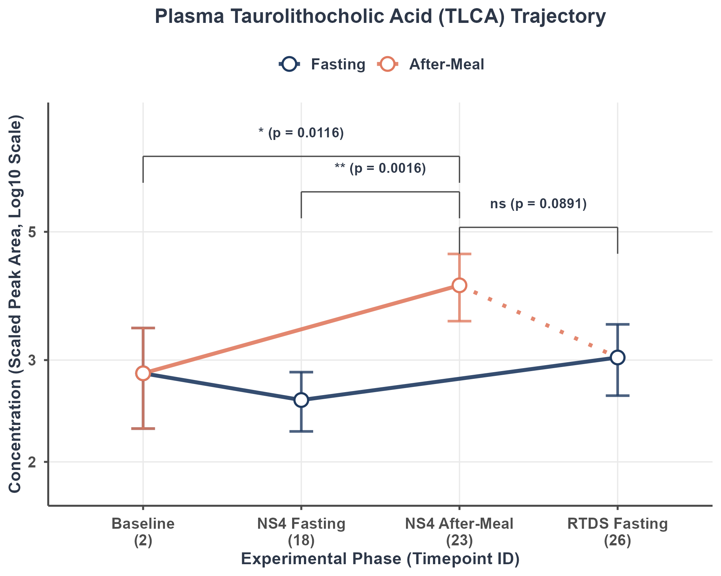
Figure Caption: Mean concentration trajectory (Scaled Peak Area, log10 scale) showing the Fasting trajectory (Baseline [2] -> NS4 Fasting [18] -> RTDS Fasting [26], blue line) and the Meal trajectory (overlapping fasting, and extending to NS4 After-Meal [23], orange line). Error bars represent mean ± SEM. Statistical brackets show unadjusted p-values from longitudinal crossover Linear Mixed-effects Models (LMM). FDR-corrected q-values are reported in the statistical table and interpretive text. *p < 0.05, **p < 0.01, ***p < 0.001, ns = non-significant.

Statistical Contrast Results Table:
Contrast Comparison | Log Fold Change (LFC) | Std Error (SE) | p-value (raw) | FDR q-value | Signif
Postprandial (23) vs. Baseline (2) | 0.4655 | 0.1805 | 0.01161 | 0.040175 | *
Postprandial (23) vs. NS4 Fasting (18) | 0.5789 | 0.1777 | 0.00160 | 0.007198 | **
Postprandial (23) vs. RTDS Fasting (26) | 0.3169 | 0.1843 | 0.08908 | 0.210988 | ns

Statistical Relevance & Biological Interpretation:
Taurolithocholic Acid (TLCA) is the taurine conjugate of the secondary bile acid lithocholic acid. Like GLCA, it is highly hydrophobic and potentially toxic, requiring tight regulation. Systemic circulation of TLCA is minimal. The LMM analysis reveals statistically significant postprandial changes at Timepoint 23 vs. Baseline (FDR q = 0.0402, *, elevated); vs. NS4 Fasting (FDR q = 0.0072, **, elevated). The contrast(s) vs. RTDS Fasting did not reach significance after FDR correction.

4. 11 - Deoxycholic Acid (DCA)
Bile Acid Classification: Secondary Unconjugated Bile Acid

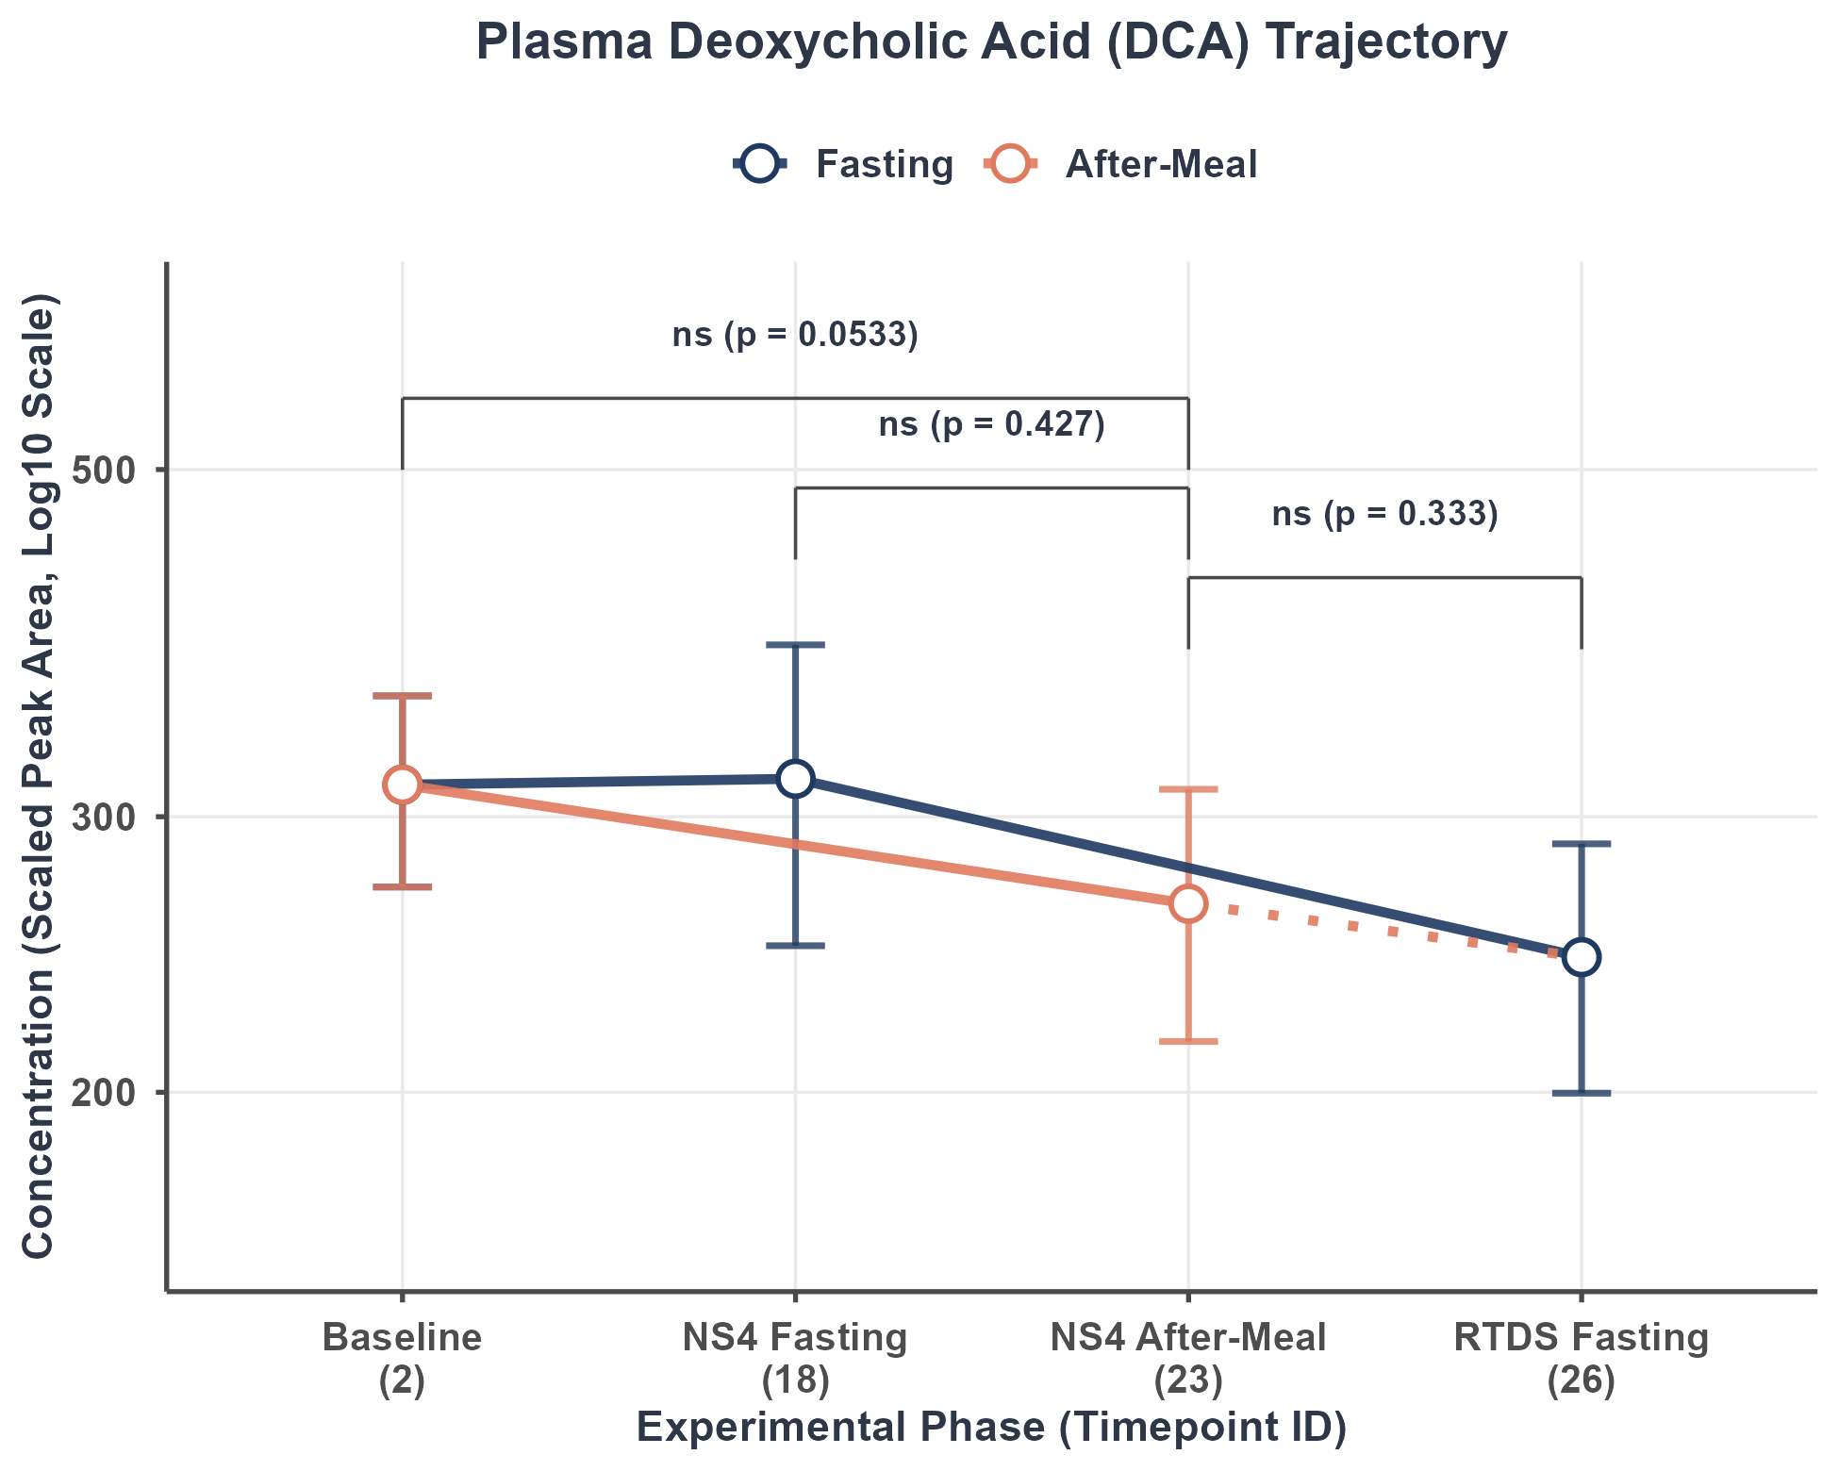
Figure Caption: Mean concentration trajectory (Scaled Peak Area, log10 scale) showing the Fasting trajectory (Baseline [2] -> NS4 Fasting [18] -> RTDS Fasting [26], blue line) and the Meal trajectory (overlapping fasting, and extending to NS4 After-Meal [23], orange line). Error bars represent mean ± SEM. Statistical brackets show unadjusted p-values from longitudinal crossover Linear Mixed-effects Models (LMM). FDR-corrected q-values are reported in the statistical table and interpretive text. *p < 0.05, **p < 0.01, ***p < 0.001, ns = non-significant.

Statistical Contrast Results Table:
Contrast Comparison | Log Fold Change (LFC) | Std Error (SE) | p-value (raw) | FDR q-value | Signif
Postprandial (23) vs. Baseline (2) | -0.3345 | 0.1707 | 0.05331 | 0.1411 | ns
Postprandial (23) vs. NS4 Fasting (18) | -0.1363 | 0.1707 | 0.42688 | 0.5650 | ns
Postprandial (23) vs. RTDS Fasting (26) | 0.1660 | 0.1705 | 0.33321 | 0.4837 | ns

Statistical Relevance & Biological Interpretation:
Deoxycholic Acid (DCA) is a major unconjugated secondary bile acid produced via microbial 7-alpha-dehydroxylation of cholic acid in the large intestine. Unconjugated BAs typically require microbial deconjugation and show slower absorption kinetics than conjugated forms. The LMM analysis did not reveal statistically significant postprandial changes at Timepoint 23 relative to any of the three fasting states after FDR correction (all q > 0.05). This indicates that systemic concentrations of this bile acid remain relatively stable across meal and fasting conditions in this cohort (N = 32 subjects).

4. 12 - Lithocholic Acid (LCA)
Bile Acid Classification: Secondary Unconjugated Bile Acid

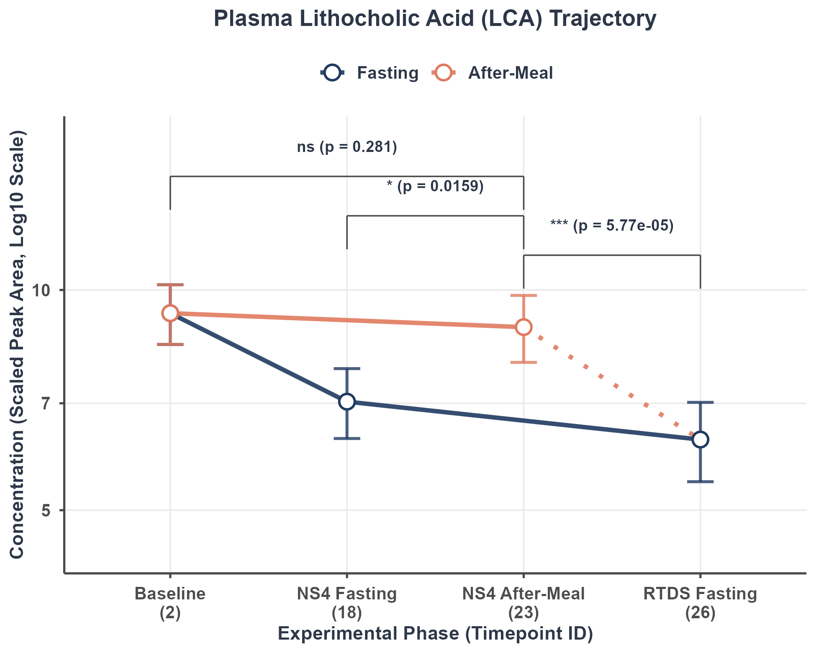
Figure Caption: Mean concentration trajectory (Scaled Peak Area, log10 scale) showing the Fasting trajectory (Baseline [2] -> NS4 Fasting [18] -> RTDS Fasting [26], blue line) and the Meal trajectory (overlapping fasting, and extending to NS4 After-Meal [23], orange line). Error bars represent mean ± SEM. Statistical brackets show unadjusted p-values from longitudinal crossover Linear Mixed-effects Models (LMM). FDR-corrected q-values are reported in the statistical table and interpretive text. *p < 0.05, **p < 0.01, ***p < 0.001, ns = non-significant.

Statistical Contrast Results Table:
Contrast Comparison | Log Fold Change (LFC) | Std Error (SE) | p-value (raw) | FDR q-value | Signif
Postprandial (23) vs. Baseline (2) | -0.0998 | 0.0921 | 0.28132 | 0.4688604 | ns
Postprandial (23) vs. NS4 Fasting (18) | 0.2292 | 0.0931 | 0.01586 | 0.0475770 | *
Postprandial (23) vs. RTDS Fasting (26) | 0.3961 | 0.0936 | 5.771e-05 | 0.0004328 | ***

Statistical Relevance & Biological Interpretation:
Lithocholic Acid (LCA) is an unconjugated secondary bile acid formed by bacterial 7-alpha-dehydroxylation of CDCA in the colon. Extremely hydrophobic and potentially toxic, LCA is mostly excreted in feces or sulfated in hepatocytes. Systemic concentrations are extremely low. The LMM analysis reveals statistically significant postprandial changes at Timepoint 23 vs. NS4 Fasting (FDR q = 0.0476, *, elevated); vs. RTDS Fasting (FDR q = 0.000433, ***, elevated). The contrast(s) vs. Baseline did not reach significance after FDR correction.

4. 13 - Ursodeoxycholic Acid (UDCA)
Bile Acid Classification: Tertiary / Microbial-derived Bile Acid

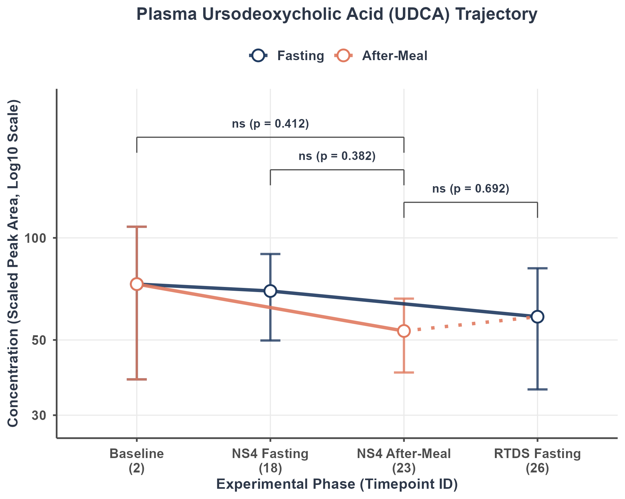
Figure Caption: Mean concentration trajectory (Scaled Peak Area, log10 scale) showing the Fasting trajectory (Baseline [2] -> NS4 Fasting [18] -> RTDS Fasting [26], blue line) and the Meal trajectory (overlapping fasting, and extending to NS4 After-Meal [23], orange line). Error bars represent mean ± SEM. Statistical brackets show unadjusted p-values from longitudinal crossover Linear Mixed-effects Models (LMM). FDR-corrected q-values are reported in the statistical table and interpretive text. *p < 0.05, **p < 0.01, ***p < 0.001, ns = non-significant.

Statistical Contrast Results Table:
Contrast Comparison | Log Fold Change (LFC) | Std Error (SE) | p-value (raw) | FDR q-value | Signif
Postprandial (23) vs. Baseline (2) | -0.1840 | 0.2227 | 0.4115 | 0.5611 | ns
Postprandial (23) vs. NS4 Fasting (18) | -0.1916 | 0.2180 | 0.3825 | 0.5379 | ns
Postprandial (23) vs. RTDS Fasting (26) | -0.0895 | 0.2248 | 0.6916 | 0.8190 | ns

Statistical Relevance & Biological Interpretation:
Ursodeoxycholic Acid (UDCA) is an unconjugated tertiary bile acid formed via bacterial epimerization of CDCA. UDCA has well-known hydrophilic, cytoprotective properties and its presence helps buffer the cytolytic potential of hydrophobic secondary bile acids. The LMM analysis did not reveal statistically significant postprandial changes at Timepoint 23 relative to any of the three fasting states after FDR correction (all q > 0.05). This indicates that systemic concentrations of this bile acid remain relatively stable across meal and fasting conditions in this cohort (N = 32 subjects).

4. 14 - Glycoursodeoxycholic Acid (GUDCA)
Bile Acid Classification: Tertiary / Microbial-derived Bile Acid

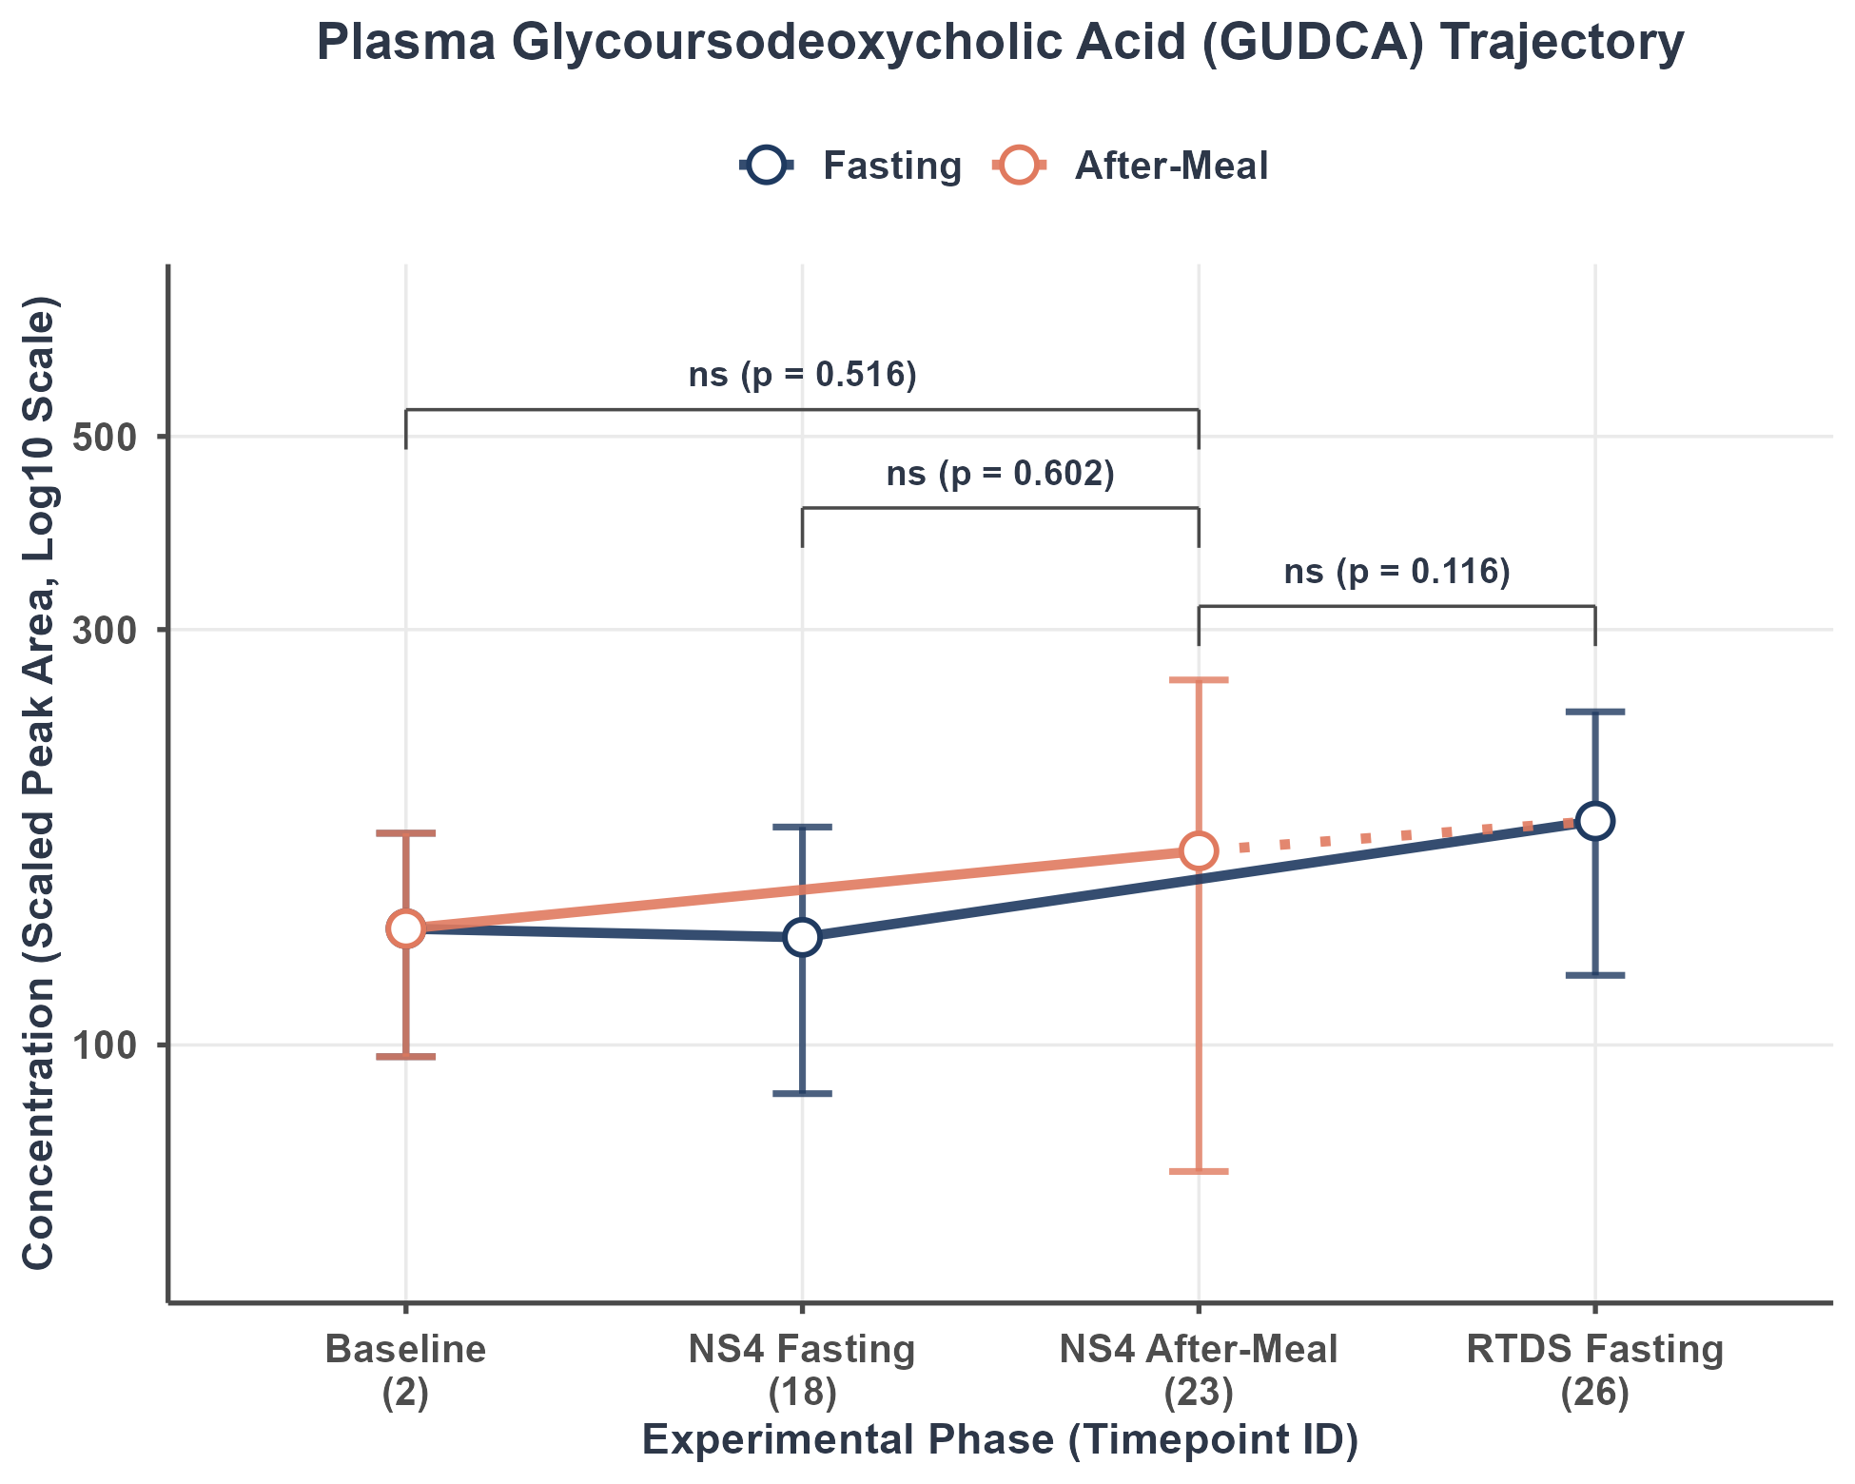
Figure Caption: Mean concentration trajectory (Scaled Peak Area, log10 scale) showing the Fasting trajectory (Baseline [2] -> NS4 Fasting [18] -> RTDS Fasting [26], blue line) and the Meal trajectory (overlapping fasting, and extending to NS4 After-Meal [23], orange line). Error bars represent mean ± SEM. Statistical brackets show unadjusted p-values from longitudinal crossover Linear Mixed-effects Models (LMM). FDR-corrected q-values are reported in the statistical table and interpretive text. *p < 0.05, **p < 0.01, ***p < 0.001, ns = non-significant.

Statistical Contrast Results Table:
Contrast Comparison | Log Fold Change (LFC) | Std Error (SE) | p-value (raw) | FDR q-value | Signif
Postprandial (23) vs. Baseline (2) | -0.0772 | 0.1185 | 0.5163 | 0.6453 | ns
Postprandial (23) vs. NS4 Fasting (18) | -0.0620 | 0.1185 | 0.6018 | 0.7319 | ns
Postprandial (23) vs. RTDS Fasting (26) | -0.1919 | 0.1210 | 0.1162 | 0.2377 | ns

Statistical Relevance & Biological Interpretation:
Glycoursodeoxycholic Acid (GUDCA) is the glycine conjugate of the tertiary bile acid ursodeoxycholic acid. Known for its highly hydrophilic and FXR-antagonistic or cytoprotective properties, GUDCA contributes to the hydrophilic, protective bile acid pool. The LMM analysis did not reveal statistically significant postprandial changes at Timepoint 23 relative to any of the three fasting states after FDR correction (all q > 0.05). This indicates that systemic concentrations of this bile acid remain relatively stable across meal and fasting conditions in this cohort (N = 32 subjects).

4. 15 - Tauroursodeoxycholic Acid (TUDCA)
Bile Acid Classification: Tertiary / Microbial-derived Bile Acid

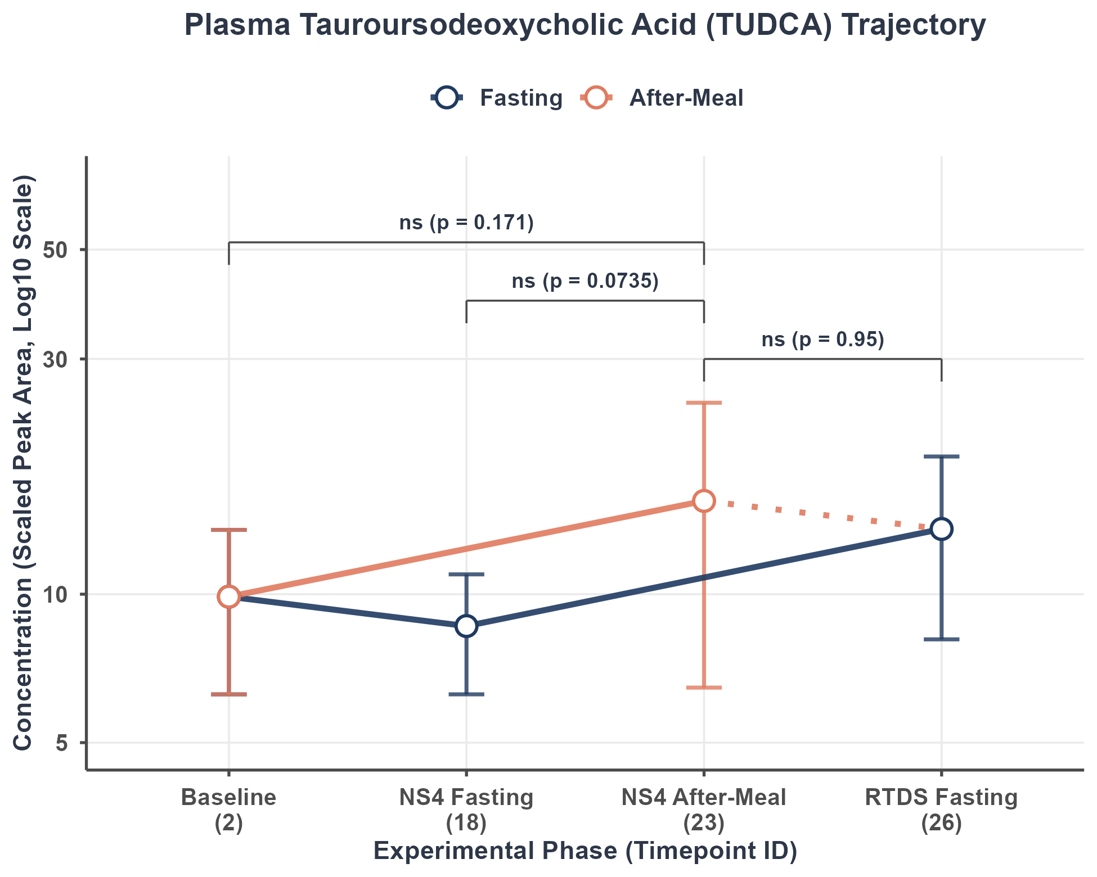
Figure Caption: Mean concentration trajectory (Scaled Peak Area, log10 scale) showing the Fasting trajectory (Baseline [2] -> NS4 Fasting [18] -> RTDS Fasting [26], blue line) and the Meal trajectory (overlapping fasting, and extending to NS4 After-Meal [23], orange line). Error bars represent mean ± SEM. Statistical brackets show unadjusted p-values from longitudinal crossover Linear Mixed-effects Models (LMM). FDR-corrected q-values are reported in the statistical table and interpretive text. *p < 0.05, **p < 0.01, ***p < 0.001, ns = non-significant.

Statistical Contrast Results Table:
Contrast Comparison | Log Fold Change (LFC) | Std Error (SE) | p-value (raw) | FDR q-value | Signif
Postprandial (23) vs. Baseline (2) | 0.1937 | 0.1404 | 0.17107 | 0.3207 | ns
Postprandial (23) vs. NS4 Fasting (18) | 0.2516 | 0.1389 | 0.07353 | 0.1838 | ns
Postprandial (23) vs. RTDS Fasting (26) | 0.0089 | 0.1419 | 0.95009 | 0.9881 | ns

Statistical Relevance & Biological Interpretation:
Tauroursodeoxycholic Acid (TUDCA) is the taurine conjugate of the tertiary bile acid ursodeoxycholic acid. TUDCA is highly hydrophilic and acts as a molecular chaperone, reducing endoplasmic reticulum (ER) stress in hepatocytes. The LMM analysis did not reveal statistically significant postprandial changes at Timepoint 23 relative to any of the three fasting states after FDR correction (all q > 0.05). This indicates that systemic concentrations of this bile acid remain relatively stable across meal and fasting conditions in this cohort (N = 32 subjects).

5. Aggregate Bile Acid Class Trajectory Analysis & Interpretations
This section provides a high-level physiological analysis of the four major bile acid pool classes: Total Bile Acids, Glycine-Conjugated Bile Acids, Taurine-Conjugated Bile Acids, and Unconjugated Bile Acids. Evaluating these broad chemical classes offers a comprehensive overview of enterohepatic circulation capacity, conjugation preferences, active transport efficacy, and the metabolic influence of gut microbial biotransformations.

5.1 Aggregate Classes 2x2 Trajectory Grid
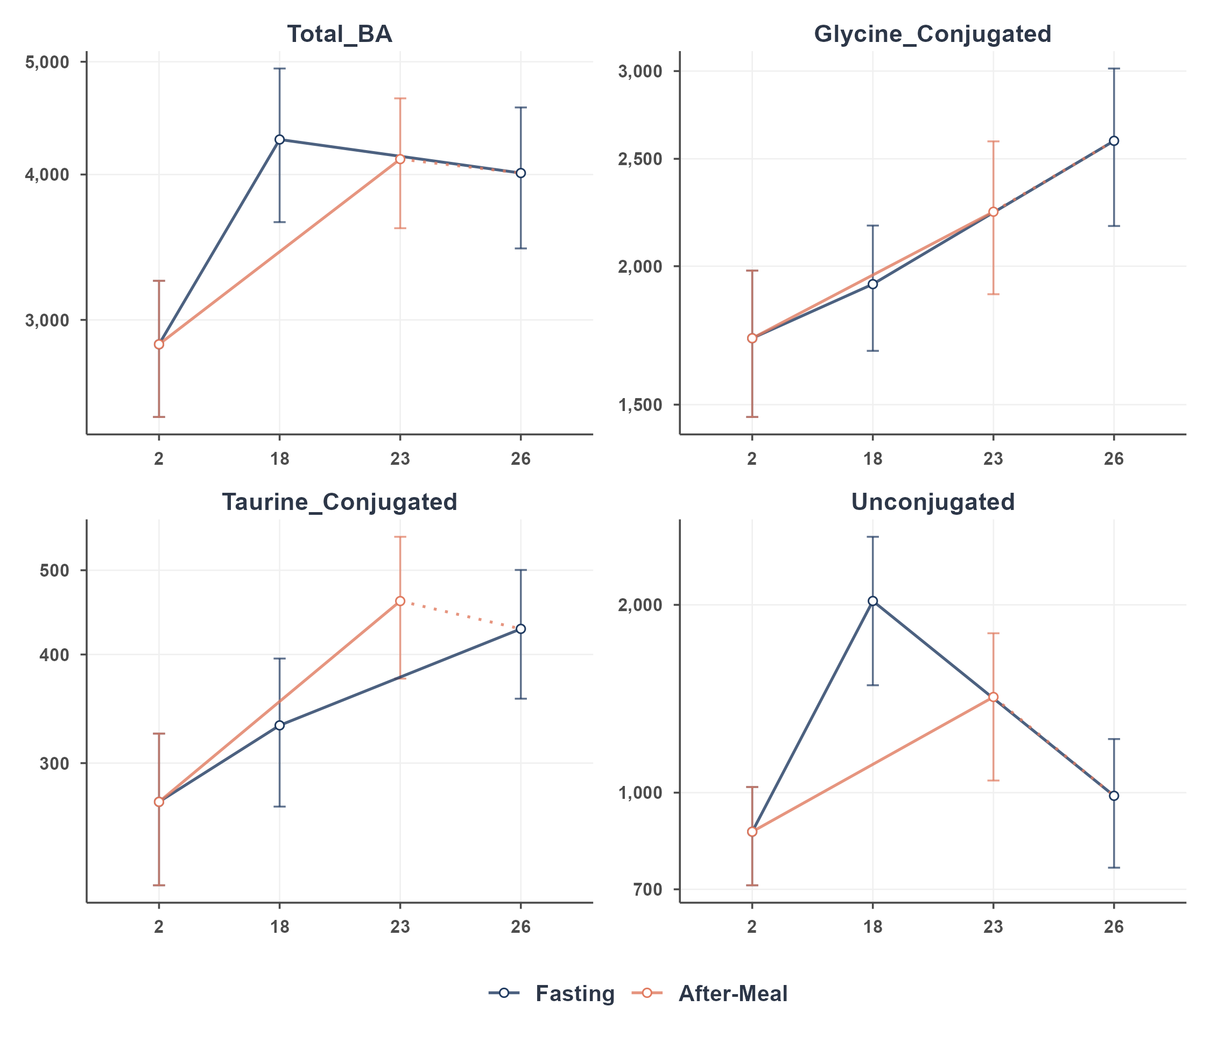
Figure Caption: 2x2 composite trajectory grid of the four aggregate bile acid classes showing the Fasting trajectory (Baseline [2] -> NS4 Fasting [18] -> RTDS Fasting [26], blue line) and the Meal trajectory (starts at Baseline [2] and connects directly to NS4 After-Meal [23], orange line, with a dotted line connecting to RTDS Fasting [26]). Error bars represent mean ± SEM. Values are in Scaled Peak Area, log10 scale.

5. 2 - Total Bile Acids (Total_BA)
Bile Acid Classification: Aggregate Total Bile Acid Pool

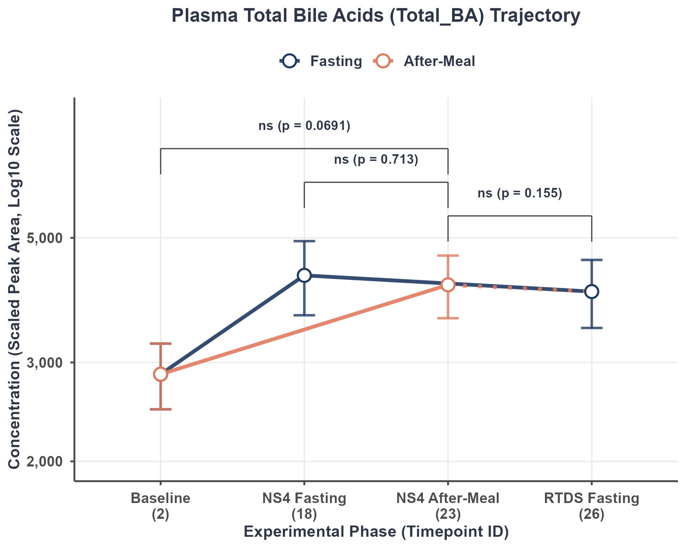
Figure Caption: Mean class concentration trajectory (Scaled Peak Area, log10 scale) showing the Fasting trajectory (Baseline [2] -> NS4 Fasting [18] -> RTDS Fasting [26], blue line) and the Meal trajectory (starts at Baseline [2] and connects directly to NS4 After-Meal [23], orange line, with a dotted recovery line connecting to RTDS Fasting [26]). Error bars represent mean ± SEM. Statistical brackets show unadjusted p-values from longitudinal crossover Linear Mixed-effects Models (LMM). FDR-corrected q-values are reported in the statistical table and interpretive text. *p < 0.05, **p < 0.01, ***p < 0.001, ns = non-significant.

Statistical Contrast Results Table:
Contrast Comparison | Log Fold Change (LFC) | Std Error (SE) | p-value (raw) | FDR q-value | Signif
Postprandial (23) vs. Baseline (2) | 0.4236 | 0.2303 | 0.06909 | 0.2073 | ns
Postprandial (23) vs. NS4 Fasting (18) | 0.0851 | 0.2303 | 0.71273 | 0.7775 | ns
Postprandial (23) vs. RTDS Fasting (26) | 0.3332 | 0.2324 | 0.15504 | 0.3101 | ns

Statistical Relevance & Biological Interpretation:
The Total Bile Acid pool is a vital physiological biomarker representing the overall capacity of enterohepatic circulation. Meal-induced gallbladder contraction, mediated by cholecystokinin (CCK), triggers release of the total pool into the duodenum, followed by active reabsorption in the terminal ileum. The LMM analysis did not reveal statistically significant postprandial changes at Timepoint 23 relative to any of the three fasting states after FDR correction (all q > 0.05). This indicates that systemic concentrations of this bile acid remain relatively stable across meal and fasting conditions in this cohort (N = 32 subjects).

5. 3 - Glycine-Conjugated Bile Acids
Bile Acid Classification: Aggregate Conjugated Bile Acids (Glycine Class)

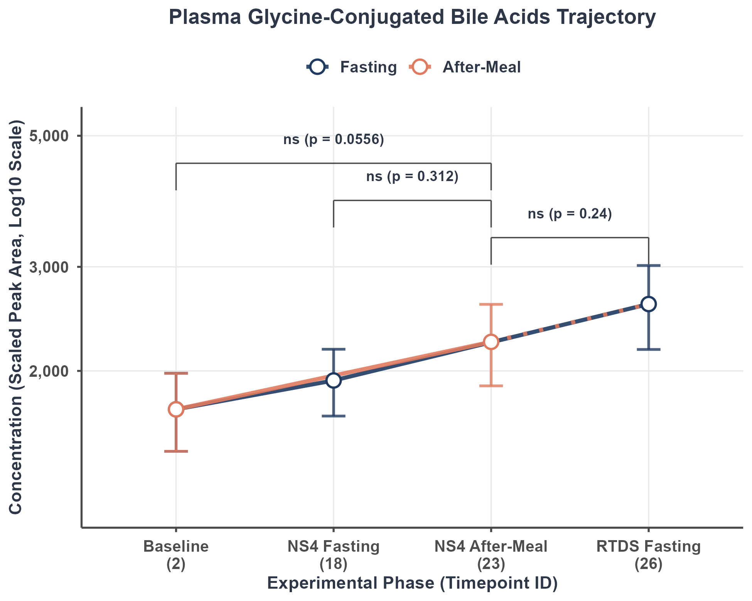
Figure Caption: Mean class concentration trajectory (Scaled Peak Area, log10 scale) showing the Fasting trajectory (Baseline [2] -> NS4 Fasting [18] -> RTDS Fasting [26], blue line) and the Meal trajectory (starts at Baseline [2] and connects directly to NS4 After-Meal [23], orange line, with a dotted recovery line connecting to RTDS Fasting [26]). Error bars represent mean ± SEM. Statistical brackets show unadjusted p-values from longitudinal crossover Linear Mixed-effects Models (LMM). FDR-corrected q-values are reported in the statistical table and interpretive text. *p < 0.05, **p < 0.01, ***p < 0.001, ns = non-significant.

Statistical Contrast Results Table:
Contrast Comparison | Log Fold Change (LFC) | Std Error (SE) | p-value (raw) | FDR q-value | Signif
Postprandial (23) vs. Baseline (2) | 0.4141 | 0.2136 | 0.05556 | 0.2073 | ns
Postprandial (23) vs. NS4 Fasting (18) | 0.2170 | 0.2136 | 0.31222 | 0.4163 | ns
Postprandial (23) vs. RTDS Fasting (26) | 0.2548 | 0.2156 | 0.24030 | 0.4119 | ns

Statistical Relevance & Biological Interpretation:
Glycine conjugation is the predominant pathway for bile acid conjugation in humans. Conjugated bile acids are fully ionized at physiological intestinal pH, restricting passive diffusion across cell membranes and confining them to the intestinal lumen until they reach the active transporters in the terminal ileum. The LMM analysis did not reveal statistically significant postprandial changes at Timepoint 23 relative to any of the three fasting states after FDR correction (all q > 0.05). This indicates that systemic concentrations of this bile acid remain relatively stable across meal and fasting conditions in this cohort (N = 32 subjects).

5. 4 - Taurine-Conjugated Bile Acids
Bile Acid Classification: Aggregate Conjugated Bile Acids (Taurine Class)

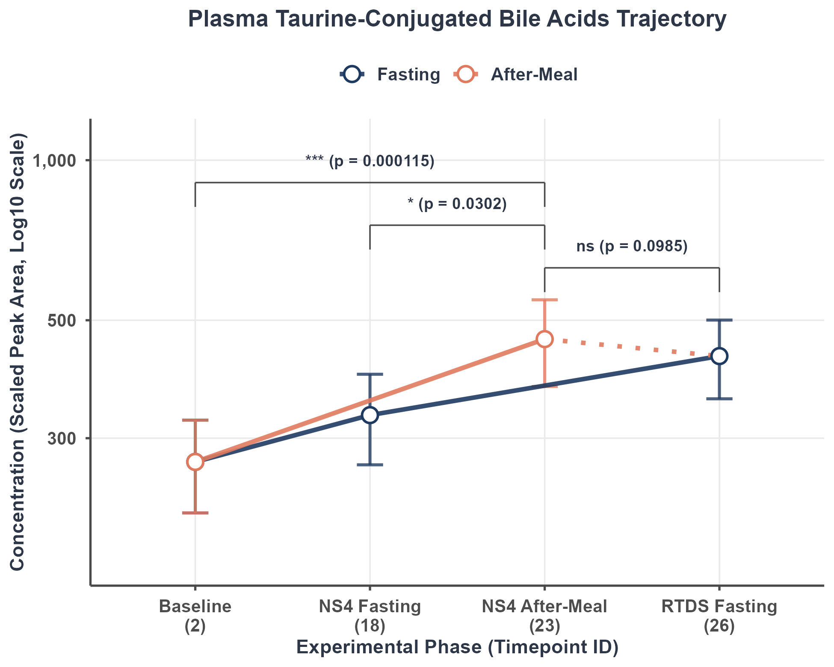
Figure Caption: Mean class concentration trajectory (Scaled Peak Area, log10 scale) showing the Fasting trajectory (Baseline [2] -> NS4 Fasting [18] -> RTDS Fasting [26], blue line) and the Meal trajectory (starts at Baseline [2] and connects directly to NS4 After-Meal [23], orange line, with a dotted recovery line connecting to RTDS Fasting [26]). Error bars represent mean ± SEM. Statistical brackets show unadjusted p-values from longitudinal crossover Linear Mixed-effects Models (LMM). FDR-corrected q-values are reported in the statistical table and interpretive text. *p < 0.05, **p < 0.01, ***p < 0.001, ns = non-significant.

Statistical Contrast Results Table:
Contrast Comparison | Log Fold Change (LFC) | Std Error (SE) | p-value (raw) | FDR q-value | Signif
Postprandial (23) vs. Baseline (2) | 0.7063 | 0.1753 | 0.0001152 | 0.001382 | **
Postprandial (23) vs. NS4 Fasting (18) | 0.3858 | 0.1753 | 0.0302383 | 0.181430 | ns
Postprandial (23) vs. RTDS Fasting (26) | 0.2955 | 0.1771 | 0.0984884 | 0.236372 | ns

Statistical Relevance & Biological Interpretation:
Taurine conjugation is a highly polar conjugation pathway. Due to their ultra-low pKa (~1.5), taurine conjugates remain fully negatively charged throughout the entire small intestine, preventing passive absorption and making them dependent on active sodium-coupled transporters (ASBT) in the terminal ileum. As potent agonists of the TGR5 receptor, postprandial taurine conjugate surges serve as systemic signaling cues to trigger GLP-1 release and regulate energy expenditure. The LMM analysis reveals statistically significant postprandial changes at Timepoint 23 vs. Baseline (FDR q = 0.00138, **, elevated). The contrast(s) vs. NS4 Fasting and RTDS Fasting did not reach significance after FDR correction.

5. 5 - Unconjugated Bile Acids
Bile Acid Classification: Aggregate Unconjugated Bile Acids

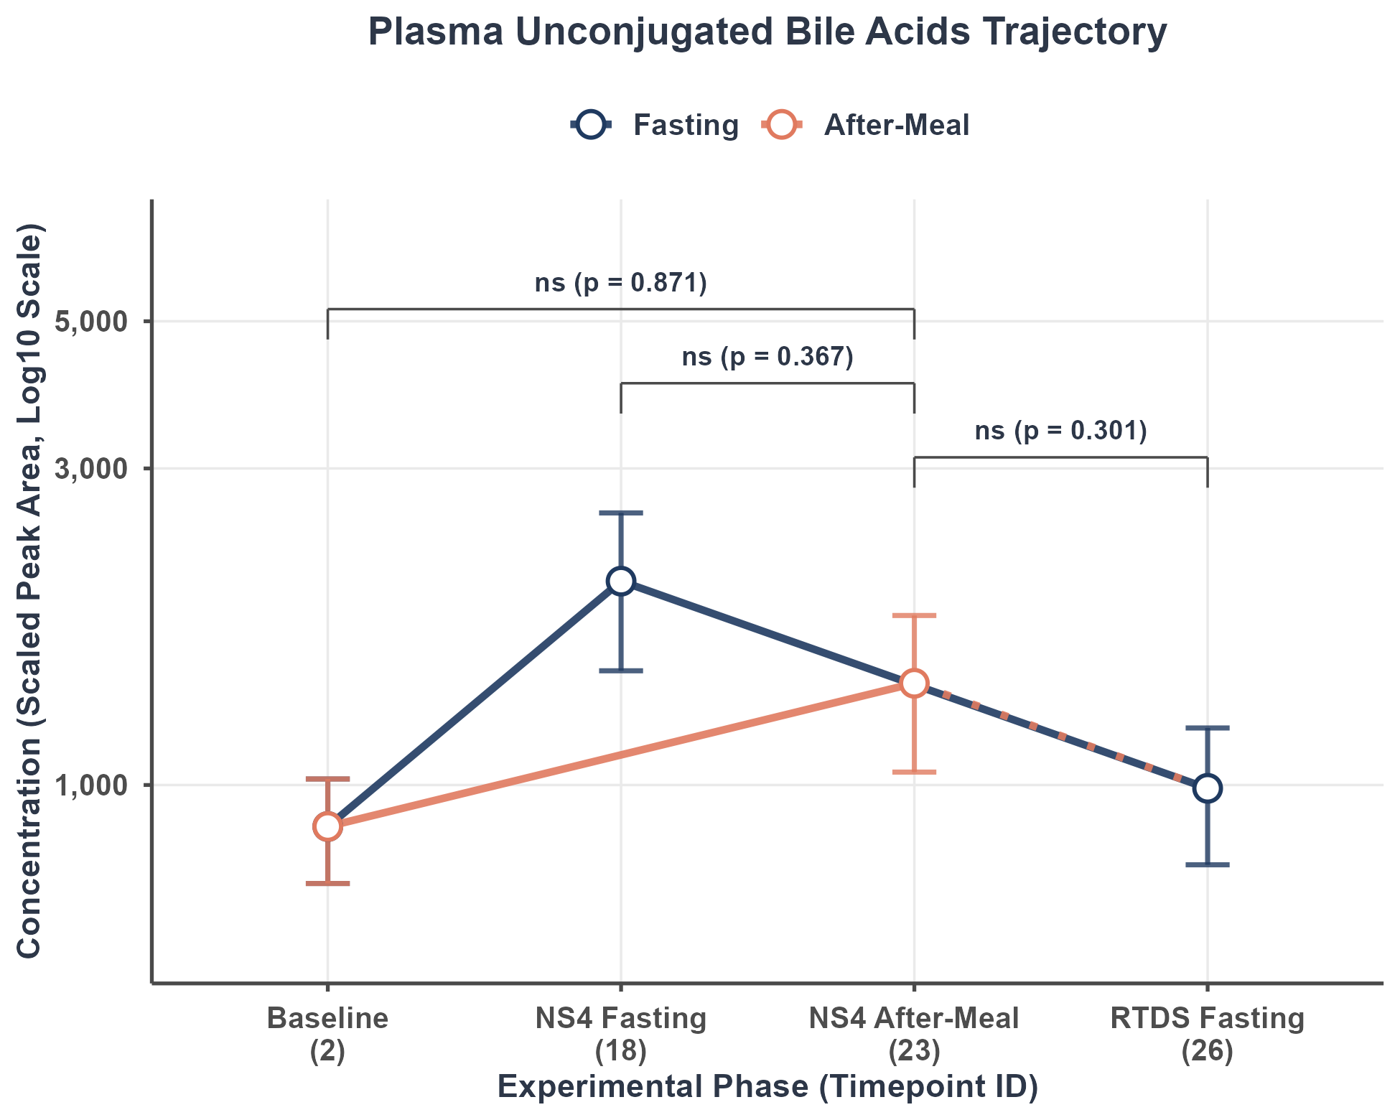
Figure Caption: Mean class concentration trajectory (Scaled Peak Area, log10 scale) showing the Fasting trajectory (Baseline [2] -> NS4 Fasting [18] -> RTDS Fasting [26], blue line) and the Meal trajectory (starts at Baseline [2] and connects directly to NS4 After-Meal [23], orange line, with a dotted recovery line connecting to RTDS Fasting [26]). Error bars represent mean ± SEM. Statistical brackets show unadjusted p-values from longitudinal crossover Linear Mixed-effects Models (LMM). FDR-corrected q-values are reported in the statistical table and interpretive text. *p < 0.05, **p < 0.01, ***p < 0.001, ns = non-significant.

Statistical Contrast Results Table:
Contrast Comparison | Log Fold Change (LFC) | Std Error (SE) | p-value (raw) | FDR q-value | Signif
Postprandial (23) vs. Baseline (2) | 0.0456 | 0.2797 | 0.8708 | 0.8708 | ns
Postprandial (23) vs. NS4 Fasting (18) | -0.2535 | 0.2797 | 0.3671 | 0.4405 | ns
Postprandial (23) vs. RTDS Fasting (26) | 0.2935 | 0.2824 | 0.3013 | 0.4163 | ns

Statistical Relevance & Biological Interpretation:
Unconjugated bile acids (CA, CDCA, DCA, LCA, UDCA) are formed when primary conjugated bile acids undergo deconjugation by gut bacterial bile salt hydrolases (BSH) in the distal ileum and colon. Unconjugated bile acids are highly lipophilic and can be absorbed via passive non-ionic diffusion throughout the intestine, though their appearance in plasma is partially delayed due to the necessity of microbial BSH action. The LMM analysis did not reveal statistically significant postprandial changes at Timepoint 23 relative to any of the three fasting states after FDR correction (all q > 0.05). This indicates that systemic concentrations of this bile acid remain relatively stable across meal and fasting conditions in this cohort (N = 32 subjects).

6. Comprehensive Bile Acid Trajectory Grid (All 15 Compounds)
The following grid combines the longitudinal trajectories of all 15 bile acids in a single comprehensive page. This overview facilitates comparative analysis of baseline levels, prolonged fasting trajectories, and postprandial responses across primary, secondary, and tertiary bile acid families. The X-axis timepoint IDs represent Baseline (2), NS4 Fasting (18), NS4 After-Meal (23), and RTDS Fasting (26).

