Saad Sarfaraz Khan

Tests in TDD:

Control Flow Graph

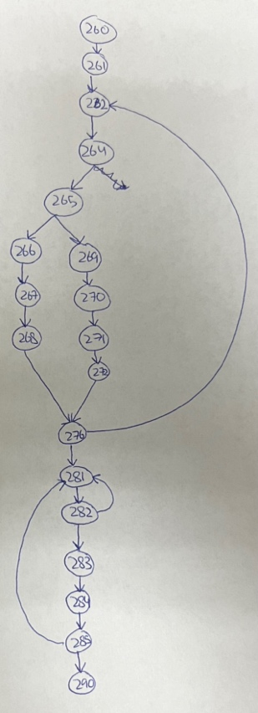

To get complete edge coverage we need nodes 260, 261, 262, 264, 265, 269, 270, 271, 272, 276, 281, 282, 283, 284, 285, 290.

To get complete node coverage, we need 2 sequences.

1. 260, 261, 262, 264, 265, 269, 270, 271, 272, 276, 281, 282, 283, 284, 285, 290.
2. 260, 261, 262, 264, 265, 266, 267, 268, 276, 281, 282, 283, 284, 285, 290.

After writing all my tests for gameplay in WhiteBox, I feel they adequately cover everything because I tested most, if not all, possible options during gameplay.

JacocoTestReport:

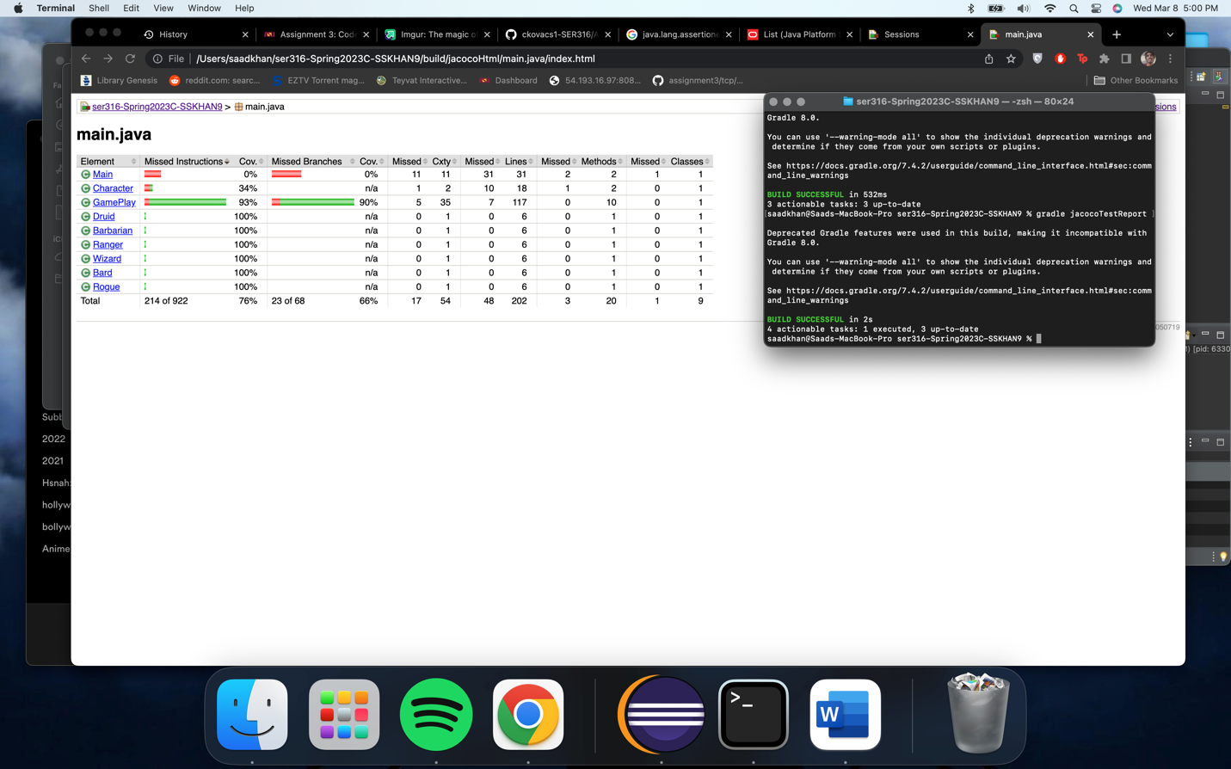

Questions:

1. What is the overall code coverage for the whole Java source code (excluding Main)?

The Test Report only shows us code coverage for main. According to EclEmma in eclipse, the code coverage for the entire src is 40.9%.

1. What is the code coverage for GamePlay.java with all your tests?

93%.

