Black LDPE Bags for Metal Wrapping Applications

1. Introduction
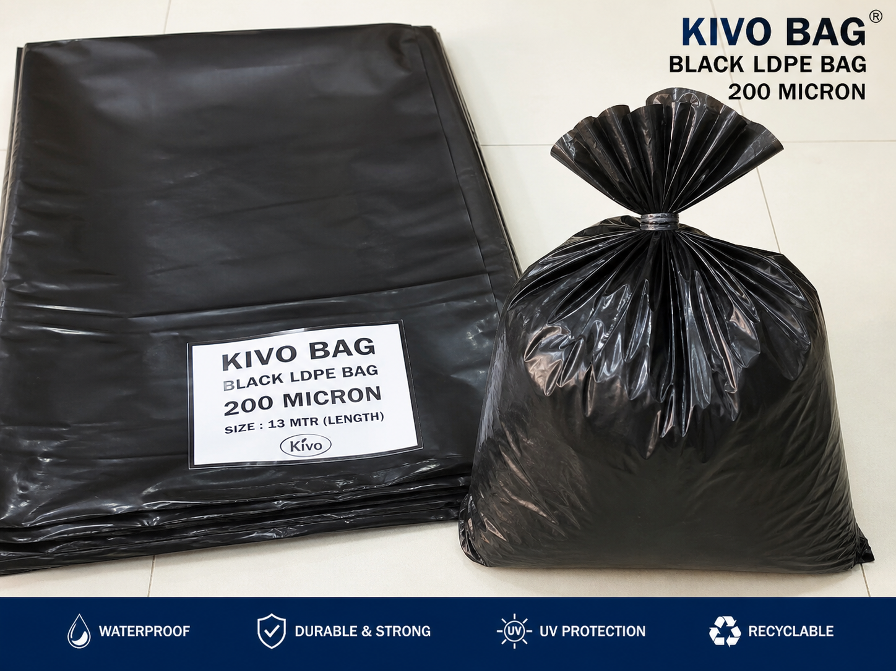
Picture 1 : Black LDPE bags ( taken from chatgpt)
Black Low-Density Polyethylene (LDPE) bags are widely used in industrial packaging, especially for protecting metal products during storage and transportation. These bags are known for their flexibility, durability, and resistance to moisture, making them a reliable solution for preventing environmental damage.
In metal applications such as pipes, rods, sheets, and fabricated components, black LDPE bags are often used with heat shrink methods. When heat is applied, the material shrinks and tightly conforms to the product, forming a protective outer layer. This ensures better coverage and improved protection compared to loose or manual wrapping methods.

2. Size Availability in the Market
Black LDPE bags are available in a wide range of sizes and specifications to meet different industrial requirements. Both standard and custom-made options are commonly offered.
Typical availability includes:
a. Thickness: 100 to 300+ microns
b. Width: From small sizes to several meters for large items
c. Length: Rolls or pre-cut bags, including long lengths such as 13 meters or more
d. Formats: Lay-flat bags, gusseted bags, and tubular rolls
This variety allows the packaging of small components as well as large and heavy metal bundles.

3. Advantages
Black LDPE bags provide several important benefits:
a. Moisture Protection: Acts as a barrier against water, dust, and contaminants
b. UV Resistance: Black color protects against sunlight exposure
c. Flexibility: Easily wraps around irregular shapes
d. Strength: Offers good resistance to tearing when properly handled
e. Uniform Shrink: Provides tight and even coverage when heat is applied
f. Cost-Effective: Economical compared to other packaging methods

4. Why It Is Effective for Wrapping Systems
Black LDPE bags are highly effective in wrapping systems due to their ability to tightly conform to the shape of the product. The heat shrink process eliminates air gaps and creates a secure, continuous protective layer.
For heavy loads, including multi-ton metal products, the bag acts as a protective covering rather than carrying weight. When combined with pallets, strapping, and edge protection, it improves load stability and reduces exposure to environmental factors.
Its ease of use and adaptability make it a preferred solution in industrial packaging.

5. Recycling and Environmental Considerations
LDPE is a recyclable material, which makes black LDPE bags a more sustainable option when disposed of properly.
- Can be recycled into new plastic products
- Can be reused in some cases
- Helps reduce waste when proper recycling systems are used
Recycling depends on local facilities and proper waste handling practices.

6. Conclusion
Black LDPE bags offer a practical, reliable, and cost-effective solution for protecting metal products. Their availability in different sizes and thicknesses allows them to meet a wide range of packaging needs.
With benefits such as moisture resistance, UV protection, and strong shrink performance, they are well suited for both transportation and storage. When used correctly, they help maintain product quality and reduce damage risks.
Overall, black LDPE bags remain a trusted and widely used packaging solution in the metal industry.

