PROJECT REPORT
Telecom Churn Risk Model
A cost-aware, calibrated and explainable machine-learning model for a fictional Chennai telecom operator
Prepared by | S Keerthana
Programme | B.E. Artificial Intelligence & Data Science, M. S. Ramaiah Institute of Technology, Bengaluru
Dataset | Public Telco Customer Churn data (7,043 customers, 21 columns)
Tooling | Python, pandas, scikit-learn, SHAP; Google Colab notebook (Telecom_Churn_Risk_Model.ipynb)

0.846  held-out ROC AUC |  | 2.47x  lift, top two deciles |  | 49%  churners in top 20% |  | 67%  expected cost saving

Contents
1 Executive summary
2 Business problem and objectives
3 Data and quality audit
4 Methodology and leak-free pipeline
5 Feature engineering and ablation
6 Model training, tuning and comparison
7 Calibration and the cost-based threshold
8 Final held-out evaluation and lift
9 Explainability with SHAP
10 Retention segments and actions
11 Limitations and next steps
12 Deliverables and reproducibility
Appendix A Tuned hyper-parameters
Appendix B Two-page summary: churn drivers and recommended actions

1 Executive summary
A fictional Chennai telecom operator is losing prepaid and postpaid customers and wants a churn model that its retention team can act on. Using a public telecom churn dataset of 7,043 customers, this project builds a leak-free scikit-learn pipeline, engineers 13 behavioural features, tunes three model families with stratified five-fold cross-validation, calibrates the probabilities, selects a decision threshold from a cost matrix in which a missed churner costs five times a wasted offer, and explains the result with SHAP.
Result. The selected Gradient Boosting model reaches a held-out ROC AUC of 0.8464 (target: at least 0.84) and PR AUC of 0.658 against a 26.5% churn base rate. The top two risk deciles churn at 65.6%, a lift of 2.47x over random targeting, and contain 49.5% of all churners.
Decision value. At the cost-optimal threshold of 0.17, expected cost on the test set falls from 1,870 (contact nobody) to 617, a 67.0% saving, and 40.4% less than contacting everyone.

Key findings
- Three very different models reach the same accuracy. Logistic regression, random forest and gradient boosting are within 0.001 ROC AUC in cross-validation (0.8469, 0.8471, 0.8476). The signal in this dataset is largely captured by a handful of contract, tenure and service variables.
- Engineered features help modestly and honestly. All 13 features together add +0.0022 ROC AUC and +0.0022 PR AUC in repeated cross-validation; almost all of the gain comes from the tenure-lifecycle group.
- The threshold matters more than the algorithm. Moving from the default 0.50 to the cost-optimal 0.17 cuts expected cost by 35.1% (950 to 617).
- Churn is explained by a short list of drivers: month-to-month contracts, the first year of tenure, fibre internet without tech support, manual (electronic-check) payment and a high bill per bundled service. These define three actionable retention segments.
- Uncertainty is stated. The 95% bootstrap interval for test ROC AUC is 0.824 to 0.867, so the 0.84 target is met by the point estimate and by cross-validation (0.8476 ± 0.0120) but sits inside the interval's range rather than far above it.

2 Business problem and objectives
The retention team has a limited budget for save offers. Contacting a customer who would have stayed wastes an offer; failing to contact a customer who leaves loses all future revenue. The model therefore has to do three things: rank customers by risk, output trustworthy probabilities, and support a defensible yes/no decision. The table maps each requirement of the brief to where and how it was met.
# | Requirement | How it was addressed | Result
1 | Churn model the retention team can act on | Calibrated probabilities, cost-based threshold, ranked list, segments with actions | Sections 7, 10
2 | Public dataset (~7,000 customers); blanks, inconsistent labels, imbalance, leakage | Cleaning rules, leakage audit, stratified splits | 7,043 rows; 11 blanks fixed
3 | pandas + scikit-learn pipeline with column transformers; no leakage | Pipeline: feature engineering, ColumnTransformer (imputer, scaler, one-hot) inside every CV fold | Section 4
4 | At least eight engineered features, tested by ablation | 13 features in 5 groups; add-one and leave-one-out ablation | +0.0022 ROC AUC
5 | Logistic regression, random forest, gradient boosting; stratified 5-fold tuning; class weights or resampling | RandomizedSearchCV, StratifiedKFold(5), class_weight tuned for each model | Section 6
6 | Compare precision, recall, ROC AUC, PR AUC; calibrate; cost-based threshold (FN = 5 x FP) | Comparison table, CalibratedClassifierCV, cost curve | Threshold 0.17
7 | Stretch: SHAP global and individual; three retention segments | TreeExplainer, beeswarm, waterfall plots, rule-based segments | Sections 9, 10
8-9 | Held-out ROC AUC of at least 0.84; clear lift in top two deciles | Single evaluation on 20% held-out test set with bootstrap intervals | 0.846; 2.47x lift
10 | Notebook, saved model, comparison table, lift chart, two-page summary | All delivered (Section 12 and Appendix B) | Complete
Table 1. Requirement traceability.

3 Data and quality audit
The public Telco Customer Churn dataset contains 7,043 customers and 21 columns: demographics, account information (tenure, contract, payment method), subscribed services, monthly and total charges, and the churn label. 26.5% of customers churned (1,869 of 7,043, about one in 3.8). The table lists the data problems named in the brief and how each was handled.
Issue | What was found | Treatment
Blank TotalCharges | 11 rows contained a blank string (0.16%); every one has tenure = 0 | Converted to numeric; blanks set to 0 because nothing has been billed yet (business rule, not an estimate). A median imputer inside the pipeline guards against any other gap.
Inconsistent category labels | "No internet service" and "No phone service" duplicate "No" across 7 columns (MultipleLines plus six add-on services); case and whitespace variants handled generically | Merged into "No" because the real information lives in InternetService and PhoneService; a generic routine unifies spelling and case variants.
Class imbalance | 26.5% churners | Stratified train/test split and CV folds; class weights tuned as a hyper-parameter; PR AUC reported; cost-based threshold; probability calibration.
Identifier | customerID is unique per row and carries no behaviour | Dropped.
Features that could leak the future | Single-feature audit: strongest single column is tenure with CV ROC AUC 0.740; 0 columns exceed the 0.90 alarm level. TotalCharges is almost exactly tenure x MonthlyCharges (correlation 0.9996). | Guard list drops post-churn columns if present (Churn Label/Score/Reason/Category/Value, CLTV, Customer Status, Satisfaction Score); none exist in this file. TotalCharges is kept because it is known at scoring time; its redundancy with tenure is tested in the ablation study.
Learned preprocessing | Imputation, scaling and one-hot encoding learn statistics from data | All inside the sklearn Pipeline so they are fitted on training folds only, never on validation or test rows.
Table 2. Data quality issues and treatments.
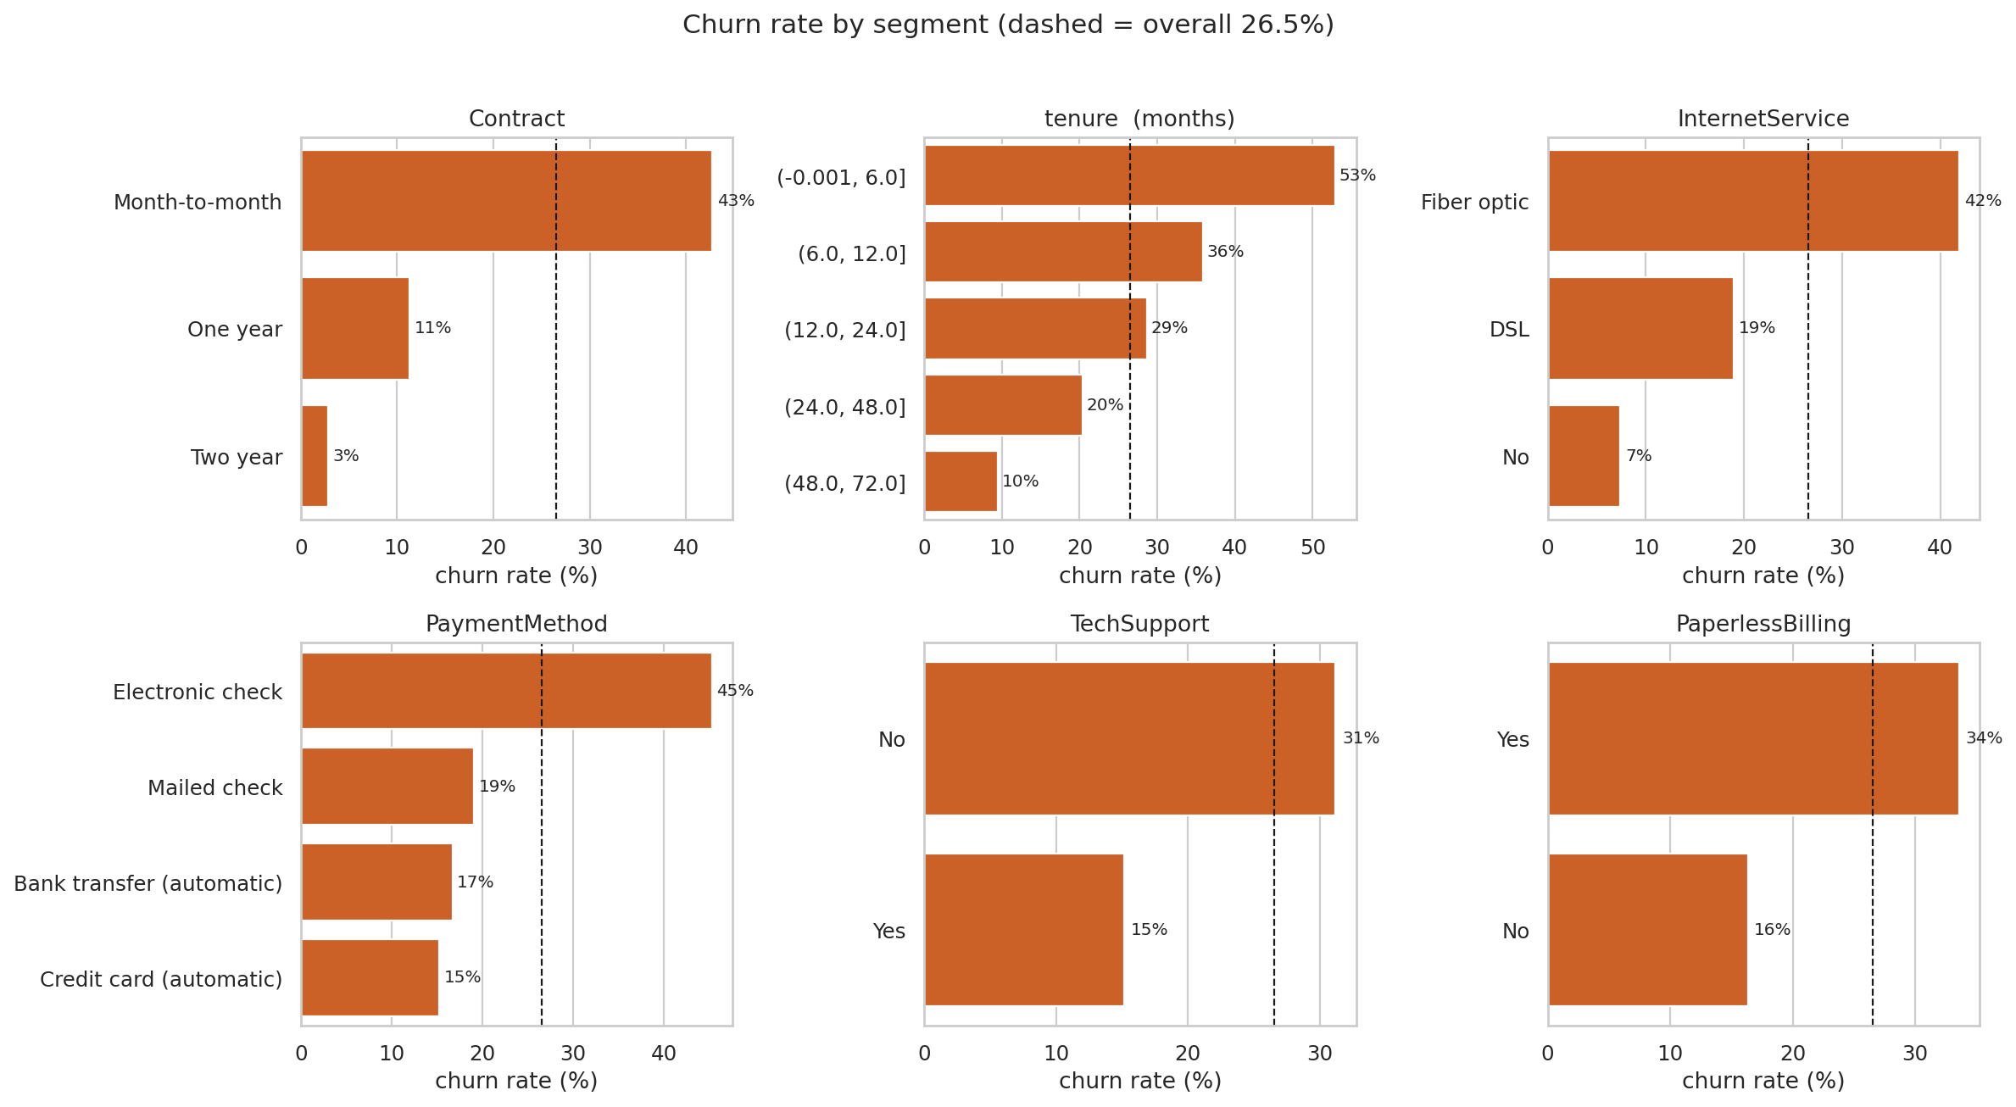
Figure 1. Churn rate by segment (dashed line = overall rate). Contract, tenure, internet service and payment method separate customers sharply.

4 Methodology and leak-free pipeline
The data was split once, stratified on churn, into 5,634 training and 1,409 test customers (churn rates 26.5% and 26.5%). The test set was used only for the final evaluation. Every choice (features, hyper-parameters, calibration method, threshold) was made on training data only.
Stage | What happens | Leakage control
1. Deterministic cleaning | clean_telco(): whitespace, numeric conversion, label harmonisation, identifier and leakage-column removal | Rules only; nothing is learned from data, so it is safe before the split.
2. Feature engineering | ChurnFeatureEngineer transformer builds 13 features from each row (groups can be switched on or off for ablation) | Row-wise and stateless; no target information is used.
3. ColumnTransformer | Numeric: median imputation and standard scaling. Categorical: most-frequent imputation and one-hot encoding (unknown categories ignored) | Fitted inside each CV fold on training rows only.
4. Model | Logistic regression, random forest or gradient boosting with tuned class weights | Tuned with stratified 5-fold CV on training data.
5. Calibration and threshold | CalibratedClassifierCV (5-fold cross-fitting); threshold from out-of-fold predictions | Test set untouched until the final evaluation.
Table 3. Pipeline stages and leakage controls.
The custom classes live in an importable module (churn_pipeline.py) rather than in the notebook itself. This allows the saved model file to be reloaded in any Python session without the notebook.

5 Feature engineering and ablation
Thirteen features were engineered in five groups, each tied to a business hypothesis about why customers leave.
Group | Features | Hypothesis
tenure_lifecycle | tenure_band, is_new_customer | Risk is non-linear in customer age; the first months are fragile.
spend_pattern | avg_monthly_spend, charge_delta, charge_per_service | Paying more than historically, or a lot per service, drives exits.
service_bundle | addon_count, protect_count, stream_count | More bundled services raise switching costs.
contract_payment | is_month_to_month, is_electronic_check, is_autopay | Low commitment and manual payment make leaving easy.
risk_combos | fiber_no_support, family_score | Premium fibre without support is fragile; households with partner or dependents are stickier.
Table 4. Engineered feature groups (13 features).
Ablation design. Logistic regression (C = 0.1) was scored with repeated stratified 5 x 3 cross-validation on the training set under three conditions: raw features only (baseline), each group added alone, and each group removed from the full set. Table 5 reports the change in ROC AUC.
Setting | CV ROC AUC | Change vs baseline (added alone) | Change vs all (group removed) | CV PR AUC
Baseline (raw features only) | 0.8454 | — | — | 0.6596
tenure_lifecycle | 0.8480 | +0.0027 | −0.0027 | 0.6636
spend_pattern | 0.8449 | −0.0005 | +0.0004 | 0.6581
service_bundle | 0.8454 | +0.0000 | +0.0000 | 0.6595
contract_payment | 0.8454 | +0.0000 | −0.0000 | 0.6592
risk_combos | 0.8452 | −0.0001 | +0.0001 | 0.6595
All 5 groups (13 features) | 0.8476 | +0.0022 | — | 0.6619
Table 5. Ablation of engineered feature groups (logistic regression, 15 CV folds). Group rows show the group added alone.
Reading the result. All groups together improve CV ROC AUC from 0.8454 to 0.8476 (+0.0022) and CV PR AUC by +0.0022. The tenure-lifecycle group carries the gain on its own (+0.0027), and removing it from the full set is the only removal that lowers the score below the baseline. The spend-pattern group is neutral to slightly negative for the linear model (−0.0005 alone), which is expected because it is largely a re-expression of columns the model already has. The honest conclusion is that the raw data already holds most of the signal; the engineered features give a small, consistent lift and, more importantly, interpretable signals: fiber_no_support and charge_per_service rank among the top SHAP drivers in Section 9.
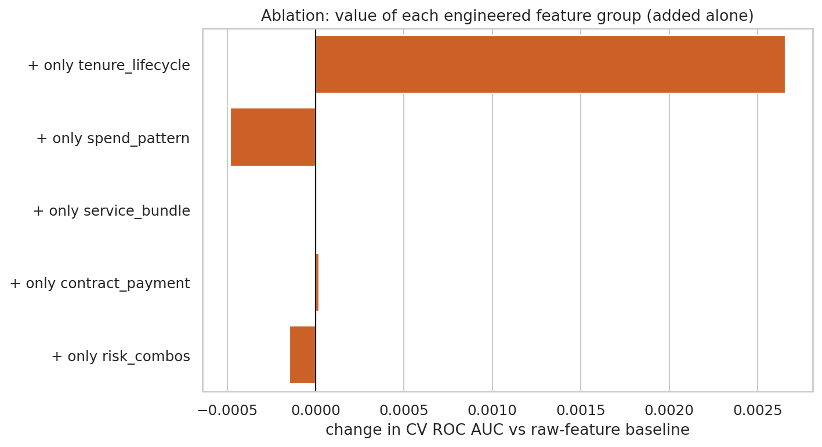
Figure 2. Change in CV ROC AUC when each engineered group is added alone to the raw features.

6 Model training, tuning and comparison
Three model families were tuned with RandomizedSearchCV over stratified 5-fold cross-validation, optimising ROC AUC (PR AUC recorded alongside). Whether to use class weights was itself a tuned hyper-parameter for every model. Cross-validation preferred unweighted training for logistic regression and gradient boosting and balanced weights for the random forest; for the unweighted models the class imbalance is handled downstream by probability calibration and the cost-based threshold. The best parameters are listed in Appendix A.
Ranking quality (probabilities, threshold-free)
Model | CV ROC AUC (mean ± sd) | CV PR AUC | Test ROC AUC | Test PR AUC
Logistic Regression | 0.8469 ± 0.0113 | 0.6617 | 0.8444 | 0.6492
Random Forest | 0.8471 ± 0.0098 | 0.6599 | 0.8462 | 0.6553
Gradient Boosting | 0.8476 ± 0.0120 | 0.6617 | 0.8462 | 0.6601
Baseline (prior only) | 0.5000 | 0.2653 | 0.5000 | 0.2654
Table 6. Ranking metrics. Highlighted row: model selected on cross-validated ROC AUC only.
Classification quality at two operating points
Model | Prec. @0.50 | Recall @0.50 | F1 @0.50 | Cost threshold | Prec. @cost | Recall @cost | Test cost
Logistic Regression | 0.659 | 0.511 | 0.575 | 0.19 | 0.470 | 0.882 | 592
Random Forest | 0.538 | 0.786 | 0.639 | 0.38 | 0.478 | 0.853 | 624
Gradient Boosting | 0.668 | 0.468 | 0.550 | 0.16 | 0.438 | 0.920 | 591
Table 7. Held-out test precision, recall and F1 for the churn class. "@cost" uses each model's own cost-optimal threshold chosen on out-of-fold training predictions (FN = 5, FP = 1). Test cost uses the uncalibrated model scores.
Interpretation. The three models are statistically indistinguishable on ranking quality; differences in the third decimal are far smaller than the fold-to-fold spread (about ±0.011). Gradient boosting has the highest cross-validated ROC AUC and PR AUC and was therefore selected, but logistic regression remains an excellent, fully transparent fallback. The big differences appear in classification at 0.50: the random forest, trained with balanced weights, trades precision (0.54) for recall (0.79), while the unweighted models are conservative. This is why a threshold must be chosen from costs rather than defaulted to 0.50.
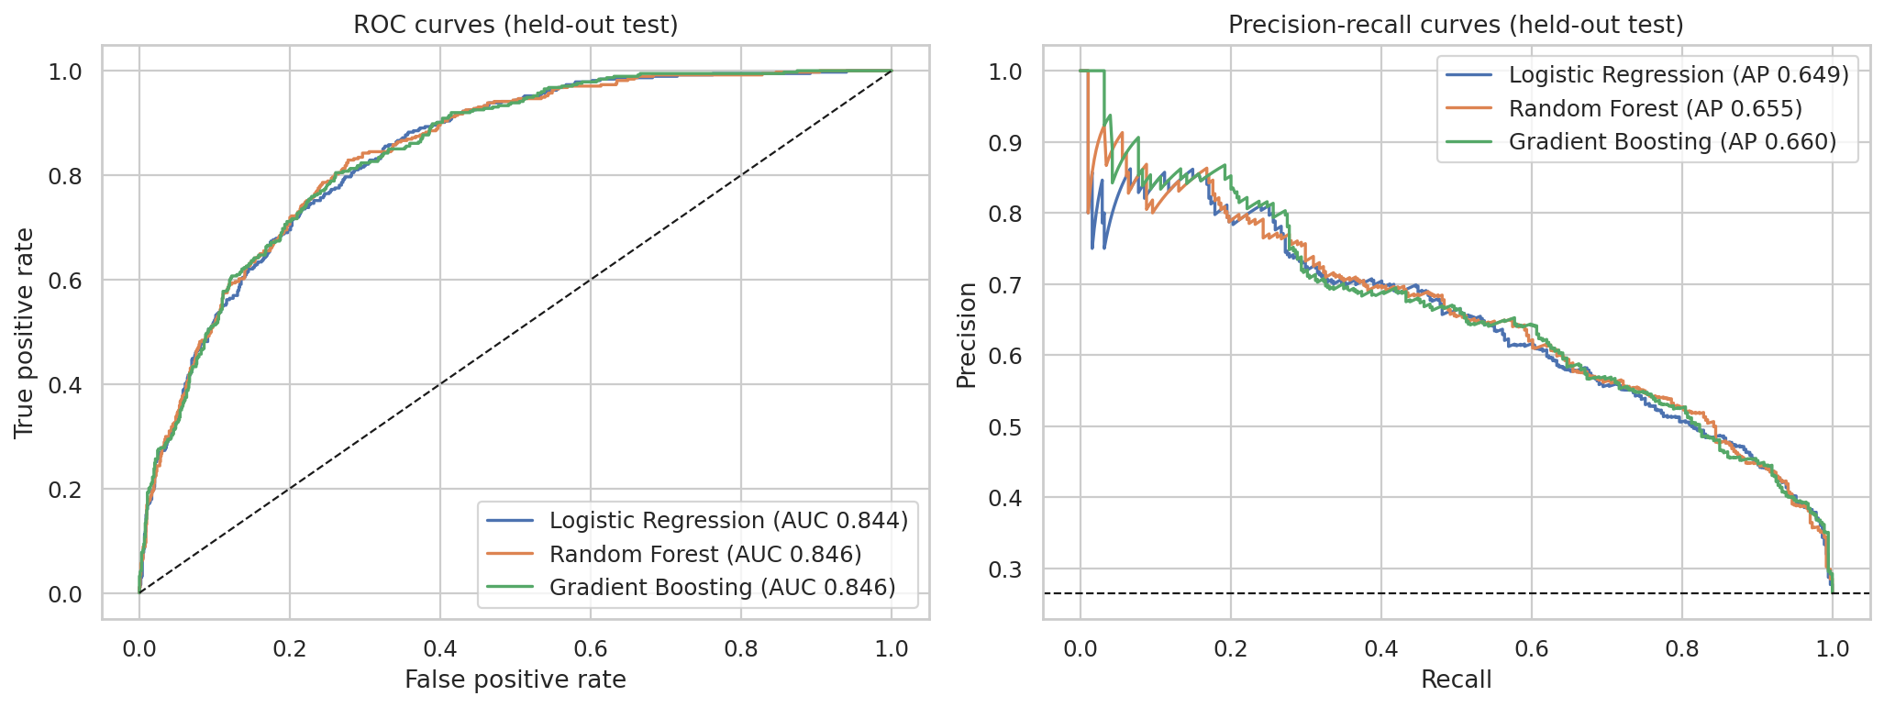
Figure 3. ROC and precision-recall curves for the three tuned models on the held-out test set.

7 Calibration and the cost-based threshold
A cost-based threshold is meaningful only if a predicted 30% really means a 30% chance of churn. The selected model was wrapped in CalibratedClassifierCV (five-fold cross-fitting). Sigmoid and isotonic calibration were compared by out-of-fold Brier score on the training set (raw 0.1351, sigmoid 0.1345, isotonic 0.1344); isotonic won and was used.
Held-out test | Brier score | Expected calibration error | ROC AUC | Mean predicted | Actual churn rate
Uncalibrated | 0.1359 | 0.0327 | 0.8462 | 26.70% | 26.54%
Calibrated (isotonic) | 0.1350 | 0.0224 | 0.8464 | 26.69% | 26.54%
Table 8. Calibration improves Brier score and calibration error while leaving ranking unchanged.
Calibration lowers the expected calibration error from 0.0327 to 0.0224. The gain is modest because gradient boosting trained without class weights is already reasonably calibrated; the step still matters because it makes the threshold mathematically interpretable. For perfectly calibrated probabilities the cost-optimal threshold equals FP / (FP + FN) = 1/6 = 0.167.
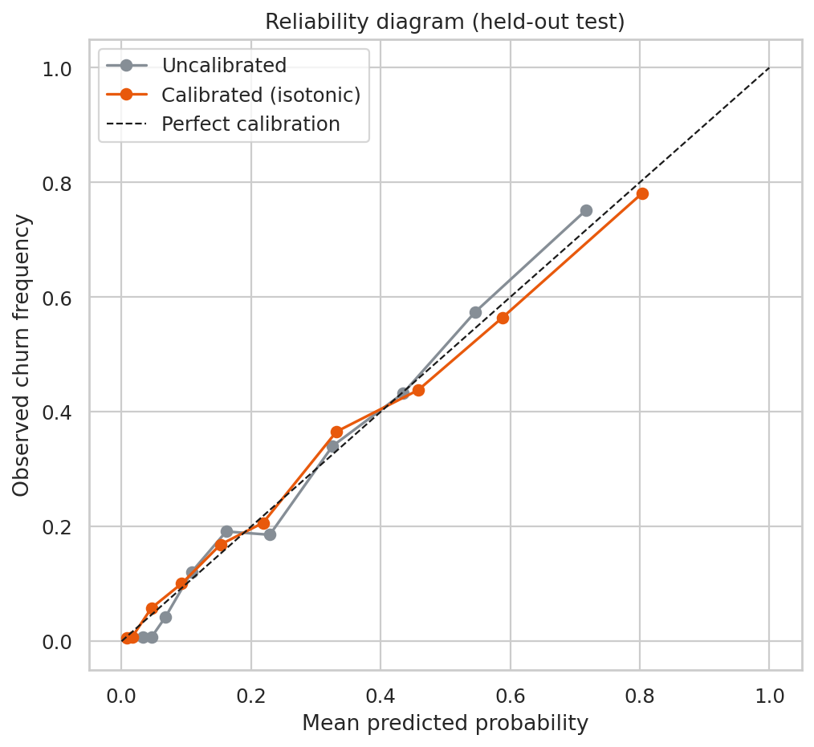
Figure 4. Reliability diagram on the held-out test set.

Cost matrix and threshold selection
 | Predicted: stays | Predicted: churns
Actually stays | 0 | 1 (wasted offer)
Actually churns | 5 (missed churner) | 0
Table 9. Cost matrix.
The threshold was chosen by minimising total cost over out-of-fold calibrated predictions on the training set, giving 0.17, which matches the theoretical value of 0.167. It was then fixed and applied once to the test set.
Strategy | Contacted | Caught | Wasted | Missed | Precision | Recall | Total cost | Saving vs nobody
Contact nobody | 0 | 0 | 0 | 374 | 0.000 | 0.000 | 1,870 | 0%
Contact everybody | 1,409 | 374 | 1,035 | 0 | 0.265 | 1.000 | 1,035 | 45%
Model @ 0.50 | 310 | 205 | 105 | 169 | 0.661 | 0.548 | 950 | 49%
Model @ 0.17 (cost-optimal) | 721 | 329 | 392 | 45 | 0.456 | 0.880 | 617 | 67%
Table 10. Strategy comparison on the held-out test set (1,409 customers, 374 churners).
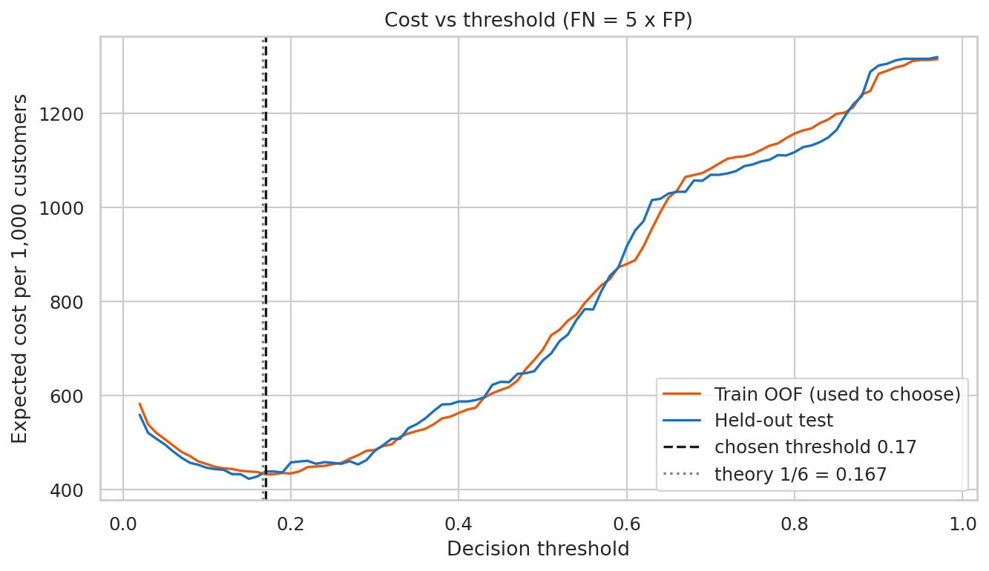
Figure 5. Expected cost per 1,000 customers as the threshold moves. The minimum sits at the theoretical 1/6.

8 Final held-out evaluation and lift
With the calibrated model and threshold fixed, the held-out test set was scored once. ROC AUC is 0.8464 (95% bootstrap interval 0.824 to 0.867), meeting the 0.84 requirement, and PR AUC is 0.6582 against a no-skill level of 0.265. At the 0.17 threshold precision is 0.456, recall 0.880 and F1 0.601; the confusion matrix is TN 643, FP 392, FN 45, TP 329.
Lift over random targeting. Customers were ranked by calibrated churn probability and cut into ten equal deciles. The top decile churns at 2.78 times the average rate and the top two deciles together at 65.6%, a lift of 2.47x (95% interval 2.28 to 2.73), capturing 49.5% of all churners while contacting only 20% of customers. The bottom two deciles contain 2 of 374 churners, so these customers can be safely excluded from campaigns.
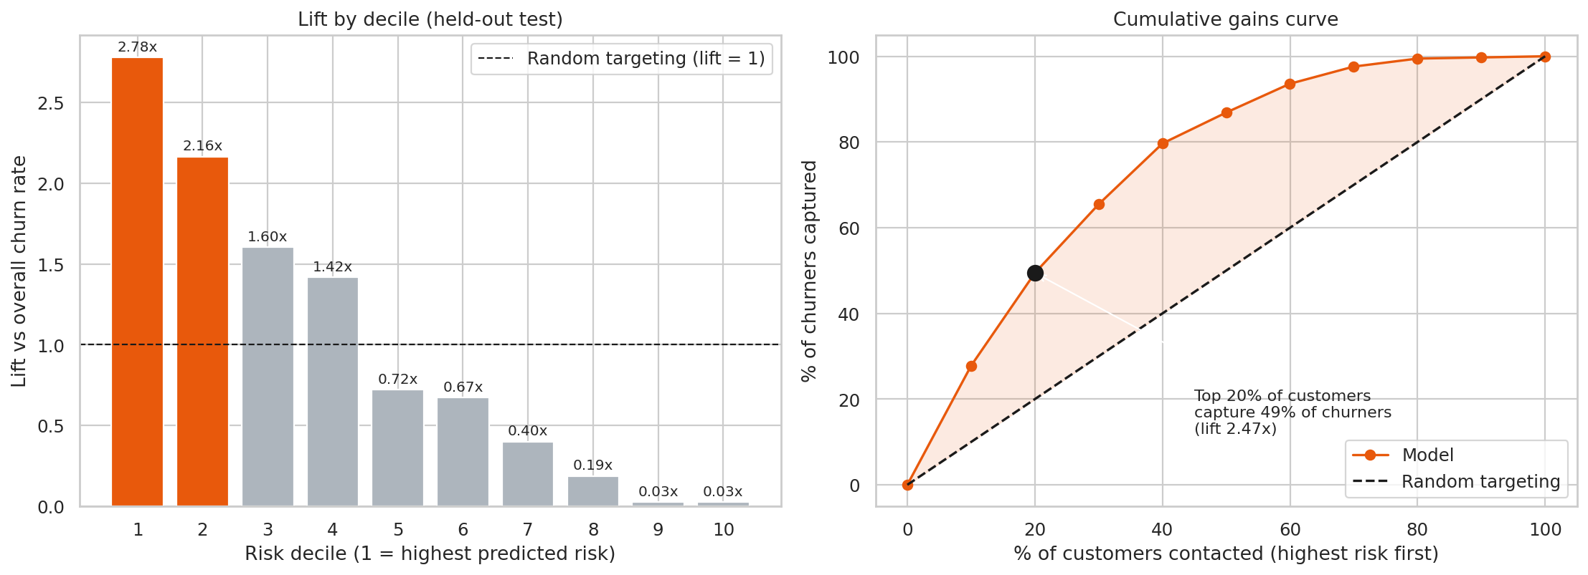
Figure 6. Lift chart: lift by risk decile (left) and cumulative gains (right) on the held-out test set. Highlighted bars are the top two deciles.
Decile | Customers | Churners | Churn rate | Lift | Cumulative capture | Cumulative lift
1 | 141 | 104 | 73.8% | 2.78x | 27.8% | 2.78x
2 | 141 | 81 | 57.4% | 2.16x | 49.5% | 2.47x
3 | 141 | 60 | 42.6% | 1.60x | 65.5% | 2.18x
4 | 141 | 53 | 37.6% | 1.42x | 79.7% | 1.99x
5 | 141 | 27 | 19.1% | 0.72x | 86.9% | 1.74x
6 | 140 | 25 | 17.9% | 0.67x | 93.6% | 1.56x
7 | 141 | 15 | 10.6% | 0.40x | 97.6% | 1.39x
8 | 141 | 7 | 5.0% | 0.19x | 99.5% | 1.24x
9 | 141 | 1 | 0.7% | 0.03x | 99.7% | 1.11x
10 | 141 | 1 | 0.7% | 0.03x | 100.0% | 1.00x
Table 11. Decile table (decile 1 = highest predicted risk). The top two deciles are the retention team's first call list.

9 Explainability with SHAP
SHAP values were computed on the held-out test set for the selected gradient-boosting pipeline (TreeExplainer). They are additive contributions in log-odds: positive values push a customer towards churn, negative values towards staying. Calibration is a monotonic rescaling and does not change which features push the score up or down.

Global view: what drives churn across all customers
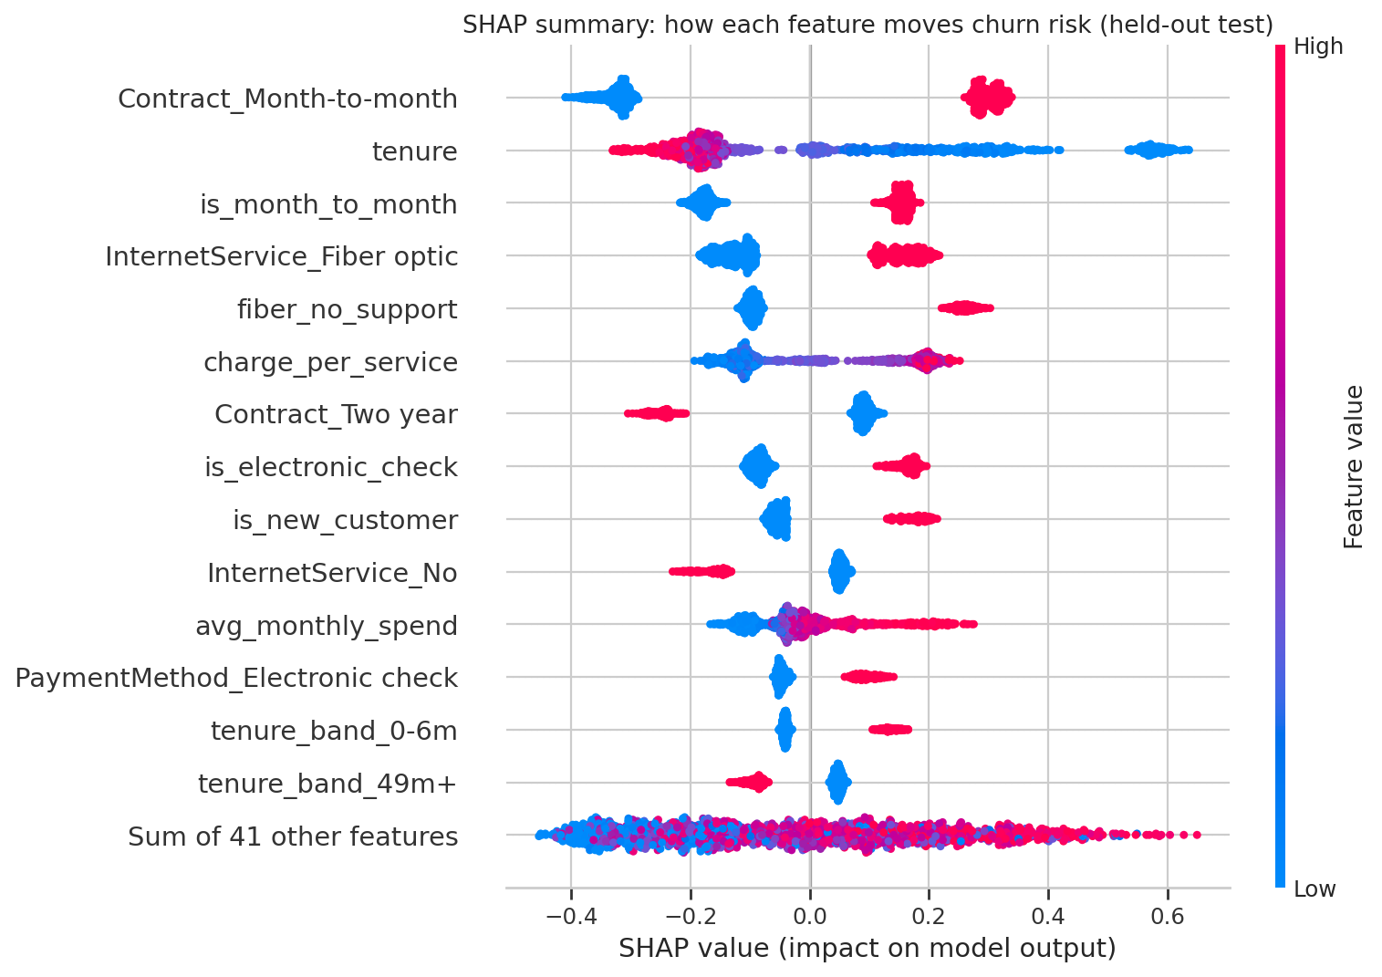
Figure 7. SHAP summary (beeswarm). Each dot is a customer; red means a high feature value. Month-to-month contracts, short tenure and fibre without support push risk up; two-year contracts and long tenure push it down.
Because one-hot encoding splits a single field into several columns, attributions were also rolled up to the original feature:
Rank | Feature (original level) | Mean |SHAP| | Share of total | Engineered?
1 | Contract | 0.445 | 19.6% | no
2 | tenure | 0.223 | 9.8% | no
3 | InternetService | 0.221 | 9.7% | no
4 | is_month_to_month | 0.165 | 7.2% | yes
5 | fiber_no_support | 0.137 | 6.0% | yes
6 | charge_per_service | 0.132 | 5.8% | yes
7 | tenure_band | 0.126 | 5.5% | yes
8 | is_electronic_check | 0.113 | 5.0% | yes
9 | PaperlessBilling | 0.105 | 4.6% | no
10 | is_new_customer | 0.081 | 3.6% | yes
Table 12. Top ten churn drivers by mean absolute SHAP value (held-out test set).
Contract type alone accounts for 20% of total attribution. Customer age (tenure, tenure_band and is_new_customer together) accounts for about 19%, internet service and the fibre-without-support flag about 16%, and payment method about 8%. Six of the top ten drivers are engineered features, evidence that the feature work added interpretable value even though the headline AUC gain is small. Gender does not appear among the top drivers.
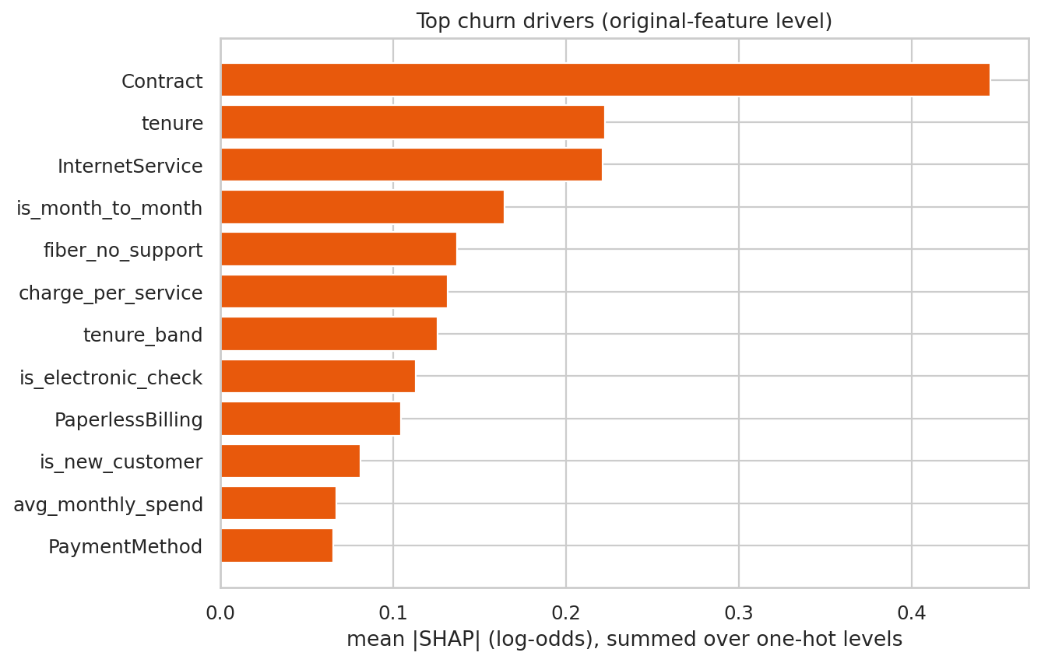
Figure 8. Top churn drivers with one-hot levels summed back to the original feature.

Individual view: why one customer is flagged
Waterfall plots start from the average model output and add each feature's contribution to reach the customer's score. Three cases illustrate the range.
Case | Churn probability | Outcome | Profile | Top three drivers (log-odds)
Highest risk | 97.9% | Churned | Tenure 1 months; Month-to-month; Fiber optic; Electronic check; tech support: No | tenure (+0.56); Contract_Month-to-month (+0.30); fiber_no_support (+0.24)
Borderline | 16.8% | Churned | Tenure 59 months; One year; Fiber optic; Electronic check; tech support: No | Contract_Month-to-month (−0.38); fiber_no_support (+0.26); tenure (−0.22)
Lowest risk | 0.0% | Stayed | Tenure 72 months; Two year; No; Bank transfer (automatic); tech support: No | Contract_Month-to-month (−0.32); Contract_Two year (−0.24); tenure (−0.21)
Table 13. Three individual explanations from the held-out test set.
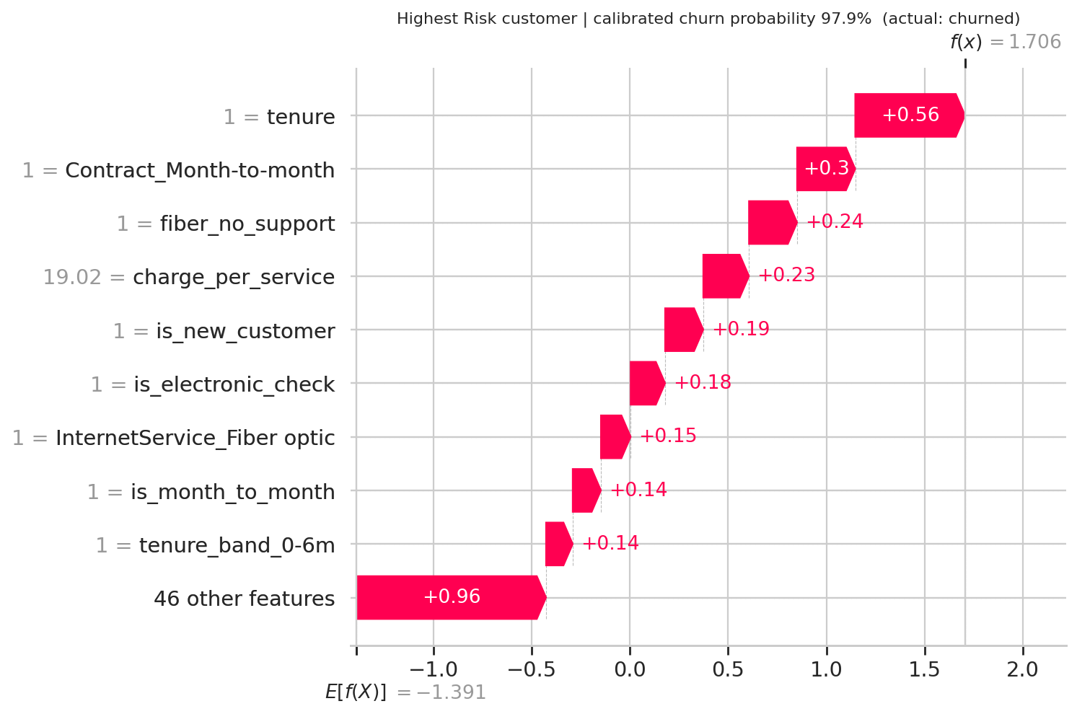
Figure 9. Highest-risk customer: a one-month fibre customer on a rolling contract, paying by electronic check with no tech support.
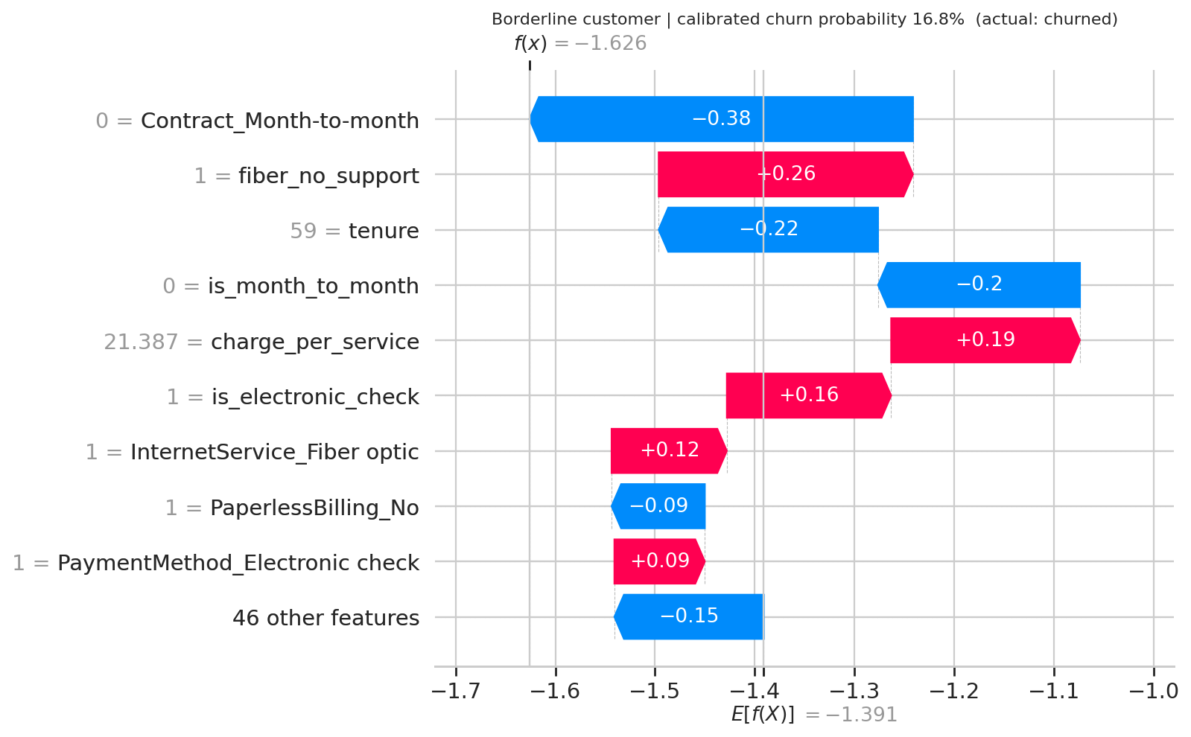
Figure 10. Borderline customer at the decision threshold: long tenure and a one-year contract offset the fibre-without-support and charge-per-service risk.

10 Retention segments and actions
The SHAP drivers translate directly into three retention segments, applied to every customer flagged at or above the 0.17 threshold (3,622 of 7,043 customers, 51%, containing 88% of all churners). Probabilities are out-of-sample: out-of-fold for training customers and test predictions for test customers. Segments are mutually exclusive and assigned in priority order A, B, C, D.
Segment | Rule | Customers | Predicted churn | Actual churn | Avg tenure (months) | Avg monthly charge | Revenue at risk / month
A. New month-to-month customers | Month-to-month and tenure of 12 months or less | 1,846 | 54.1% | 54.1% | 4.2 | 60.89 | 67,904
B. Fibre customers without tech support | Fibre optic and no tech support | 1,146 | 43.0% | 42.3% | 36.5 | 90.98 | 44,708
C. Manual-payment, no-commitment customers | Electronic or mailed check and month-to-month | 358 | 31.5% | 29.3% | 30.0 | 68.96 | 8,445
D. Other flagged customers | Flagged, none of the above | 272 | 24.1% | 23.9% | 38.4 | 85.46 | 5,748
Table 14. Retention segments (revenue in dataset currency units; total predicted revenue at risk among flagged customers: 126,805 per month). Predicted churn tracks actual churn closely in every segment, which confirms the calibration.
Segment | Recommended action | How to measure success
A. New month-to-month customers (largest and riskiest) | 90-day onboarding journey (welcome call, day-30 and day-60 check-ins) and an incentive to commit to a 12-month contract. | 90-day churn versus a random control group; share converting to 12-month terms.
B. Fibre customers without tech support | Bundle 3-6 months of free tech support or online security into fibre plans; proactive service-quality outreach for high bills. | Churn of treated versus control; attach rate of support services.
C. Manual payers on rolling terms | Small bill credit for switching to automatic payment; term-upgrade offer at renewal time. | Autopay enrolment rate; churn of treated versus control.
D. Other flagged | Low-cost automated nurture; monitor. | Cost per retained customer.
Table 15. Actions and success measures. Effects of offers must be validated with randomised controls; a high churn probability does not guarantee a customer will respond.

11 Limitations and next steps
- Public data stands in for the operator's data. The dataset has no prepaid/postpaid split, usage, complaint or network-quality data, which an operator would hold and which would probably lift performance further.
- Test-set uncertainty. With 1,409 test customers the ROC AUC interval is 0.824 to 0.867. The three model families are tied within noise, so model choice should weigh transparency and maintenance as well as AUC.
- The 5:1 cost matrix is a simplification. It ignores customer lifetime value, offer cost, and acceptance rates. A value-based cost matrix and uplift modelling (who is persuadable, not just who is likely to leave) are the natural next steps.
- The optimal threshold flags about half of all customers (51% on the test set). If the budget is smaller, work down the ranked list; the top 20% already reaches 66% precision.
- Fairness and governance. Gender and the senior-citizen flag are in the data. Gender is not a top driver, but any production deployment should audit outcomes across demographic groups and consider excluding sensitive attributes.
- Monitoring. Re-score monthly, re-check calibration quarterly, and watch for drift in churn rate and product mix.

12 Deliverables and reproducibility
Deliverable | File | Notes
Notebook | Telecom_Churn_Risk_Model.ipynb | Runs top to bottom in Google Colab; downloads the data automatically; about 10-15 minutes on a free CPU.
Saved model | churn_model.joblib (+ churn_pipeline.py) | Calibrated model, threshold and metadata; reload check built into the notebook.
Comparison table | comparison_table.csv (Tables 6-7) | Precision, recall, ROC AUC, PR AUC for all models.
Lift chart | lift_chart.png (Figure 6) | Decile lift and cumulative gains.
Two-page summary | Appendix B and Churn_Drivers_Summary.docx | Drivers and recommended actions.
Supporting outputs | ablation_table.csv, decile_table.csv, retention_segments.csv, SHAP plots, retention_priority_list_top500.csv | All written to the churn_outputs/ folder and bundled as churn_deliverables.zip.
Table 16. Deliverables.
Reproducibility. A fixed random seed (42) is used for splitting, cross-validation, tuning, calibration and bootstrap resampling. The notebook ends with a requirement checklist that tests each item of the brief in code and reports PASS or FAIL.

Appendix A Tuned hyper-parameters
Model | Best parameters (RandomizedSearchCV, stratified 5-fold CV, ROC AUC) | Search budget
Logistic Regression | C = 7.85  class_weight = null | 20 candidates x 5 folds
Random Forest | class_weight = balanced  max_depth = 10  max_features = sqrt  min_samples_leaf = 19  n_estimators = 258 | 12 candidates x 5 folds
Gradient Boosting | class_weight = null  learning_rate = 0.0249  max_depth = 3  max_features = sqrt  min_samples_leaf = 29  n_estimators = 148  subsample = 0.810 | 12 candidates x 5 folds
Table 17. Best hyper-parameters found for each model.

Appendix B Two-page summary
TWO-PAGE SUMMARY FOR THE RETENTION TEAM
Churn drivers and recommended actions
Telecom Churn Risk Model | held-out test of 1,409 customers | operating threshold 0.17
Bottom line. The model separates likely leavers from likely stayers well enough to act on (ROC AUC 0.846). Contacting the top 20% of customers by risk reaches a group where 66% actually churn, against 26.5% overall (lift 2.47x), and captures 49% of all churners.
Churn is concentrated in new customers on month-to-month contracts, fibre customers with no tech support, and customers who pay by electronic check. These are fixable with onboarding, bundling and payment-method actions.

0.846  ROC AUC (target 0.84) |  | 2.47x  lift in top 2 deciles |  | 49%  of churners in top 20% |  | 67%  cost saving vs no model

1. What drives churn
Churn rates below are measured on all 7,043 customers; the SHAP share is that feature family's part of the model's total attribution (held-out test).
Driver | Churn rate in the data | Why it matters (SHAP)
Contract type | Month-to-month 43% | 1-year 11% | 2-year 3% | Largest single driver (27% of attribution). Month-to-month pushes risk up, a two-year term pushes it down.
Customer age (tenure) | 0-6 months 53% | 7-12 months 36% | 49+ months 10% | 19% of attribution. The first year is the danger zone and risk falls steadily afterwards.
Fibre internet without support | Fibre 42% | DSL 19% | no internet 7%; no tech support 42% vs with support 15% | 16% of attribution. The engineered fibre-without-support flag is a top-5 driver.
Payment method | Electronic check 45% vs automatic bank/card 16% | 8% of attribution. Manual payment is a recurring decision point to leave.
Price per bundled service | Paperless billing customers 34% | 9% of attribution. High bills for few services raise risk (an engineered feature).
Association, not proof of cause: these are patterns in historical data. The retention actions below should be tested with a control group.

2. Three retention segments and what to do
Segments apply to every customer the model flags (probability at or above 0.17); they are mutually exclusive and evaluated on out-of-sample scores. Revenue figures are in the dataset's own currency units.
Segment | Size and risk | Why they leave | Recommended action | Revenue at risk / month
A. New month-to-month | 1,846 customers  54% churn  avg tenure 4.2 months | No commitment and no habit yet; the first months decide the relationship. | 90-day onboarding journey (welcome call, day-30 and day-60 check-ins), plus an incentive to move to a 12-month contract. | 67,904
B. Fibre without tech support | 1,146 customers  42% churn  avg bill 91 | Highest bills, no safety net when service or setup problems occur. | Bundle 3-6 months of free tech support or online security into fibre plans; proactive service-quality outreach for high-bill accounts. | 44,708
C. Manual payers on rolling terms | 358 customers  29% churn  avg bill 69 | Each manual payment is a chance to reconsider; no contract holds them. | Small bill credit for switching to automatic payment and a term upgrade offer at renewal time. | 8,445
D. Other flagged | 272 customers  24% churn | Lower, mixed risk. | Low-cost automated nurture only; monitor. | 5,748

3. How to use the model
- Daily/weekly list. Score the base and contact customers at or above 0.17. With a missed churner costing five times a wasted offer this is the cost-minimising rule: it reaches 51% of customers, catches 88% of churners and cuts expected cost by 67% versus doing nothing (40% versus contacting everyone).
- Tight budget? Work down the list. The top decile is 2.78x more likely to churn than average and the top two deciles 2.47x.
- Prove it before scaling. Hold out a random 10% of each segment as a control group and compare 90-day churn; a high churn probability does not guarantee a customer will respond to an offer.
- Keep it healthy. Re-score monthly, re-check calibration quarterly, and refresh the model if the churn rate or the product mix shifts.
Model uncertainty: the 95% interval for test ROC AUC is 0.824 to 0.867, and for top-two-decile lift 2.28x to 2.73x.

