**<<< sec 1 Intro ; icon ppl>>>**

**Who are we?**

College of Engineering, Guindy, is a 225- year-old prestigious institution, that has produced eminent technocrats, entrepreneurs and statesmen over time. Each year over 1200 students graduate from 14 disciplines of engineering from this meritorious institution.

We, the alumni of this institution, passed out in the year 1994 have joined together to form the CEG94 Trust on 29 Nov 2017 with an aim to help the CEG community. Although the college fees is nominal relative to other leading educational institutions, it has risen quite a bit from 1994 and is still not affordable to several deserving candidates. The aim of our Trust is to identify such deserving students and help them achieve their dreams.

Vision – change to “To give back to Society”

Mission

Documents

<intro> - do we need this?

<Trust Deed>

<<< sec 1 end >>>

<< sec 2 start icon –donation box>>>

**Donations**

*Your Small Contributions Today can Make a Big Diference to Some One.*

Minimum contribution of ₹ 10,000/- requested from each 1994 alumni would go towards building a corpus. Interest from this corpus would be used to sponsor students fees from AY 2020-21.

**If you choose to sponsor a student’s fees for one or more semesters (₹ 35,000 approx. per semester), kindly contact the trust team.**

The Trust started accepting donations from the 1994 alumni since March, 2018. Donations up to Rs.10,000/- were added to the corpus fund and amounts in excess of Rs.10,000/- were accumulated in a near-term kitty to fund immediate two years sponsorship needs for AY2018-19 & AY2019-20.

As of 01 August.2018, about Rs.14.5 Lacs in the corpus and Rs.7 Lacs was collected in the near-term kitty. The trust plans to support up to Rs.3.5 Lacs per year for students sponsorship in AY2018-19 & AY2019-20.

**How could you help?**

An alumni may choose to donate in one of 3 ways:

1. Minimum contribution of ₹ 10,000/- requested from each 1994 alumni would go towards building a Rs.30 Lacs corpus. Interest from this corpus would be used to sponsor students fees from AY2020-21.

2. Donors may also choose to specifically donate towards the near-term tuition and/or hostel fees for a particular academic year or semester. Any excess/unused amounts would be rolled forward to support subsequent semester(s) fees.

3. Donors giving repeat donations may need to inform the trust (by email or via department champions) if they would like to support near-term fees, otherwise, by default, their contribution would be added to the corpus.

**What kind of non-monetary help can be provided?**

The trust engages with CEG on various activities such as conducting mock interviews, mentor-ship and student development programs. Interested Alumni may contact the trust to contribute meaningfully to the student community.

**The CEG94 Trust is ever grateful to the donors, who have contributed so far in lighting the lives of twelve students in AY 2018-19. Specifically, your donation amounts in excess of Rs. 10,000, have helped us jump start the process since we are able to disburse up to Rs.3.5L through the Trust (excluding individual sponsorship amounts) in this academic year. Hence each and every one of you is a partial sponsor for the twelve students selected in this academic year. Together, we hope to sponsor students every year through your continued magnanimous donations.**

#### Account details

**A/C no:** 602205047907

**IFSC code:** ICIC0006022

**Beneficiary name:** CEG94Trust

**Address:** NAC Towers, Dr. R.K.Salai, Mylapore, Chennai, Tamil Nadu 600004

**Phone:** 044 3366 7777

## Contributions so far!!

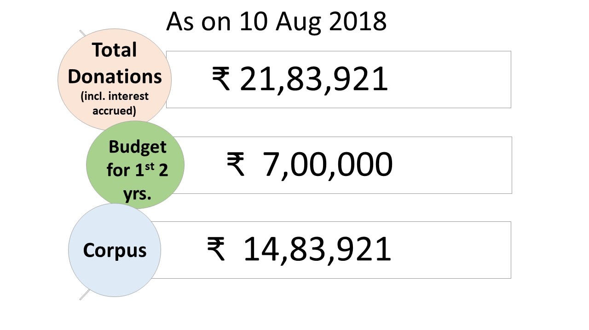

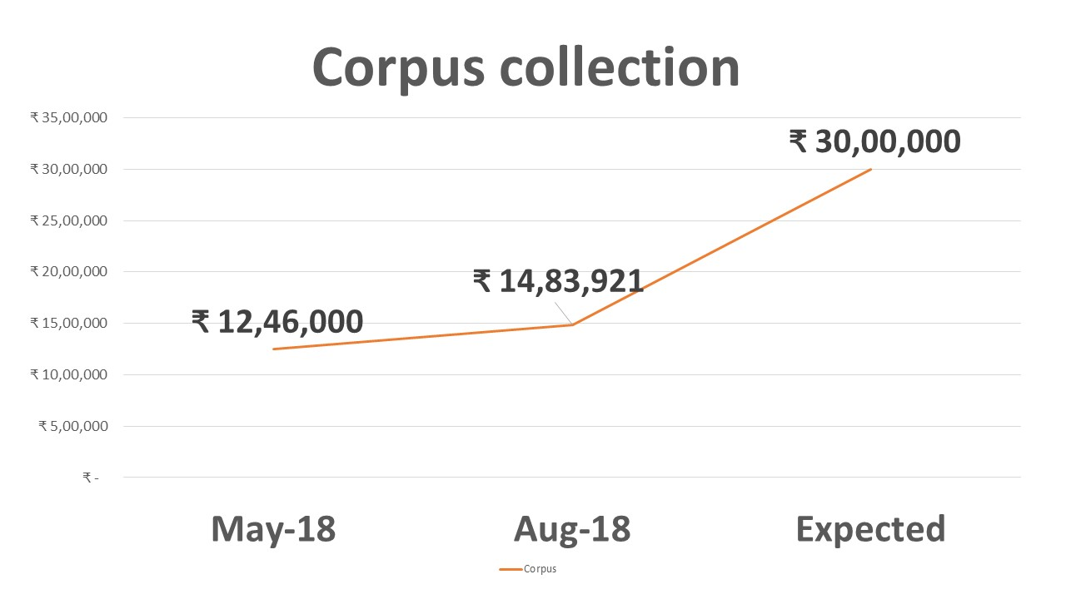

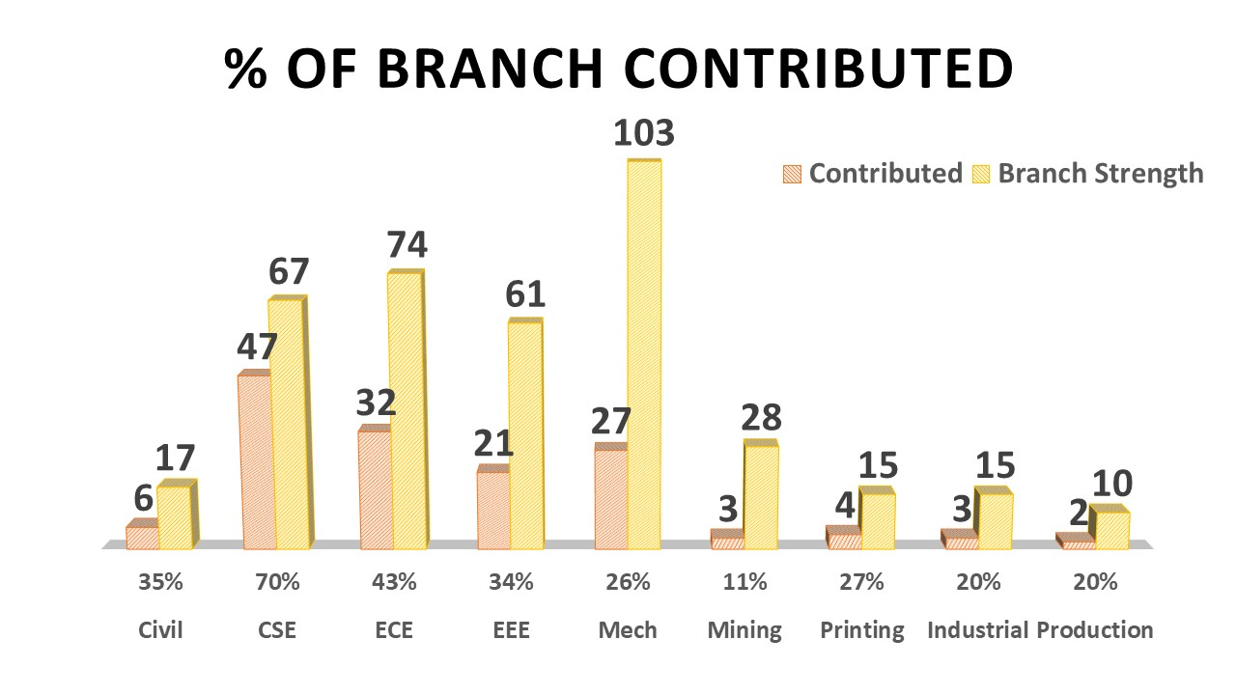

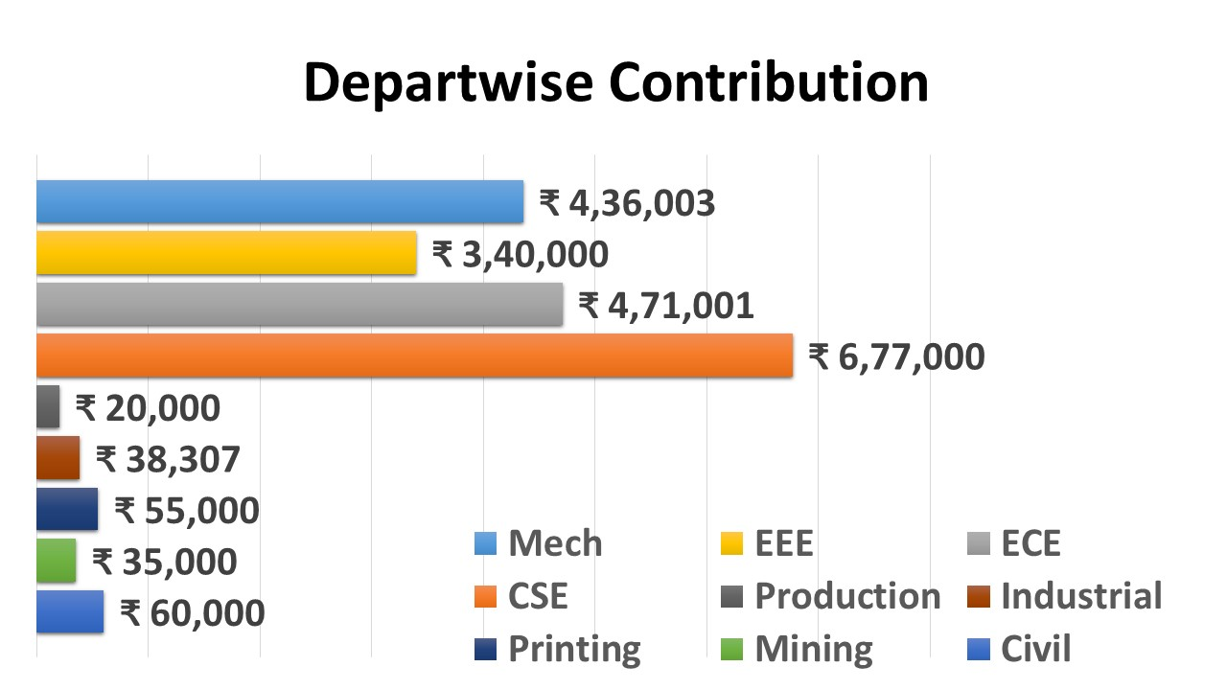

<< sec 2 end >>>

<< sec 3 icon hand; help so far >>>>

**Student support in Academic Year (AY) 2018-19**

**As on 1st Aug 2018** 

**Odd semester**   
7 students - ₹ 1,13,661   
**Even semester**  
12 students - ₹ 2,79,772   
**Total: ₹ 4,23,113**

**Full graduation support offered by 2 alumni to 2 students   
Partial fees support offered by 5 alumni to 3 students**

**Student Sponsorship in AY2018-19**

For AY2018-19, 12 students have been selected by the Trust for tuition and/or hostel fees support in odd and/or even semesters, depending on their financial situation. In summary, Rs.4.23 Lacs of sponsorship committed, with an additional Rs.1.95 Lacs support pledged for the current academic year.

Together with the direct sponsors, the Trust supports a total of 7 students in the odd sem & 12 in the even sem of AY2018-19

5 full graduation support & 4 on a one-time basis

2 Individual direct sponsors support 2 students (till graduation)

A group of 5 direct sponsors support 3 students (on a one-time basis)

Further, for the even semester commencing Dec’18,

Funding reserved by Trust for supporting two 1st year students (Rs.70k)

Funding pledged by 1 Individual Donor for supporting two 1st year students (Rs.70k)

Funding pledged by 2 Individual Donors for supporting hostel fees for two students (Rs.55k)

Total funding planned for current academic year is **Rs.6.18 Lacs.**

**CEG Fees Structure (collapse topic)**

Currently, two streams of courses are offered at CEG:

Core Engineering (Civil, Geo-Informatics, Mech, Manufacturing, Industrial, Mining, Printing, EEE, ECE & Computer Science) &

Self-supporting courses (Bio-medical, Agri & Irrigation, Material Science & Information Technology).

The tuition fees for the core engineering courses are Rs.7,500 per semester and for the self-supporting courses, Rs.15,000 per semester.

Hostel fees is about Rs.12,000 and Mess fees Rs.13,000, totaling Rs.25,000 per semester.

In comparison, the tuition fees at IIT-Madras is Rs.1.08 Lacs and hostel + mess fees is Rs.25k per semester.

We understand from the Anna University Vice-Chancellor & Alumni Association, that a majority of the requests for assistance is required to support hostel fees. The college reaches out to its extensive alumni network for supporting needy students so as to avoid dropouts.

For latest CEG fee structure, click here <provide link>



Make tables as image.

<<< sec 3 end >>>

<< sec 4 start icon - graduate>>>

**Student selection process**

The Trust strives to choose deserving students for sponsorship, irrespective of their caste, creed or sex. The process of student selection for sponsorship is based on the following criteria, in the order specified:

1. Max family income is Rs 2.5L per annum, with students from lowest income families gaining preference.
2. Whether the student is a First graduate from the family.
3. Whether (s)he studied in a Government or Government-Aided school
4. Whether (s)he studied in Tamil medium in their 12th std.
5. Supporting family members – Student with no parent/Single parent gains preference.
6. Whether (s)he hails from rural or Tier 3/2/1 town, with rural student gaining the higher preference.
7. Whether the student is in receipt of any other scholarships. Receipt of partial scholarship / assistance considered on case-by-case basis. Student will not be considered for sponsorship by our Trust if they are in receipt of any other full scholarship.
8. Whether the student is in receipt of a bank education loan. Depending on the loan amount, (s)he will be considered for sponsorship through the Trust.

**Sponsorship for subsequent academic years**

The AACEG receives applications on a per year basis for support. Our trust is not bound to support the student for further academic years, though they will be considered for support if they apply in the following year. In the case of continuing scholarship for subsequent years, the following criteria is applied.

* Minimum CGPA of 7.0
* The student should not have more than 3 cumulative arrears at any point of time.

**Student selection – July 2018**

For AY 2018-19, the Trust obtained a list of candidates studying in II to IV years, through Alumni Association CEG (AACEG) and shortlisted tweleve applicants for assessment. A panel of 5 trustees and advisory members met with them at the premises of AACEG on July 06, 2018. We are happy to announce that all the twelve students were granted partial or full support for this academic year for the help they sought.

The Trust pays the fees directly to college account, so in case the student had paid part of the fees for the current semester before our assessment, assistance is provided only for the part of unpaid fees. Hence some of them were eligible only for partial support for current semester.

Admission for first year students normally happens in August every year. From AY 2018-19, the admission counselling was made online, and the students were required to pay their fees prior to reporting at the college. The Trust anticipates that there will be students requiring assistance for their II semester fees in Nov’18.

**Future actions intended by Trust**

* Trust will provide support in applying for government scholarships, if applicable.
* Trust will explore helping students to obtain educational loan from banks, if they have relevant documents and are being denied education loans for no proper reasons.

<< sec 4 end>>>

<< sec 5 start icon – hand with love>>>

**Beneficiaries**

6 boys and 6 girls from 2nd to final year have benefited, and 4 more to be chosen from first year in Nov’18. All the students are from economically weaker sections of the society and most of them hail from villages or small towns. Several of them have tried to obtain bank education loans and were denied for no proper reasons.

We have provided details below about 4 of the 12 deserving students.

* Tamil medium girl student , scored 1178/1200 in 12th and a cut-off of 198, monthly income of family is 4k.
* Girl student , scored 1154 in 12th and a cut-off of 193.25, single parent, monthly family income of 5k.
* Male student, has a 12th score of 1136 with cut-off 192.25, monthly family income is 7k.
* Male student, Tamil medium at Government school , scored 1134 in 12th with a cut-off of 192 with family monthly ncome of less than 10k.

**Student Evaluation Experience**

The student evaluation experience was very intense. The family & economic background of some of these kids made us realize how heroic some of them truly are.

With parental income of Rs.4k to Rs.10k per month, single parent in some cases, transitioning from Tamil medium to English, not having money to go back & visit their parents even once during a semester, having to use scholarship money to pay for tuition fees, putting up with bank managers who make them run pillar to post to sanction loan, each & every one of them face not just financial issues but many more - but nothing has stopped these kids from achieving 1178,1154 & 1136 out of 1200 & a CGPA of nothing less than 8.0 at CEG.

**Trust (vs) Individual Sponsors**

While the trust is a collective sponsorship initiative, supported by as many as 140+ donors as of date, a few individuals expressed their willingness to do more. They came forward to support the financial needs of a deserving student for all 4 years, through graduation. A couple of them took a leap of responsibility in additionally mentoring the students, preparing them to succeed in the world outside. The trust is grateful to these individual sponsors for their commitment to the noble cause.

<< SudhaM write up link >>>

<< sec 5 end >>>

**<<< sec 6 start; icon office >>>**

**Office bearers info**

**<< sec 6 end>>>**

**<<< sec 7 start; icon letter >>>**

**Documents**

**FAQ ? Do we need this?**

**<< sec 7 end >>>**