SSL01 Indicator light explain

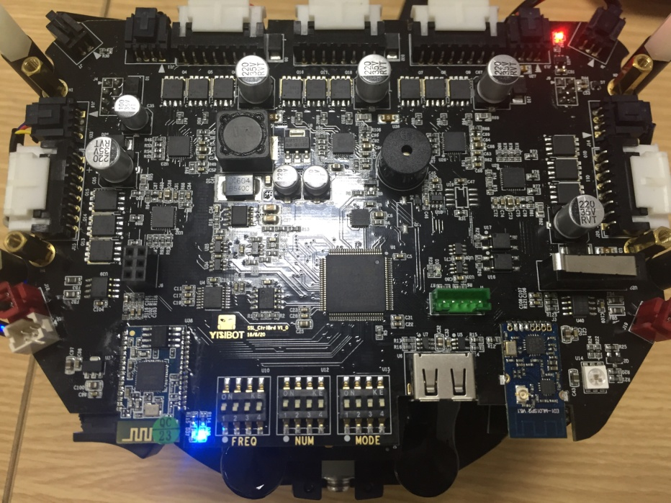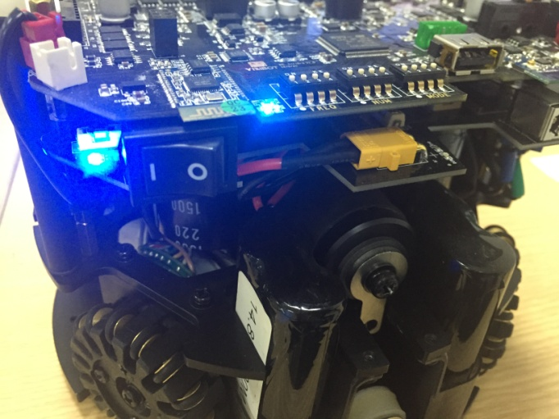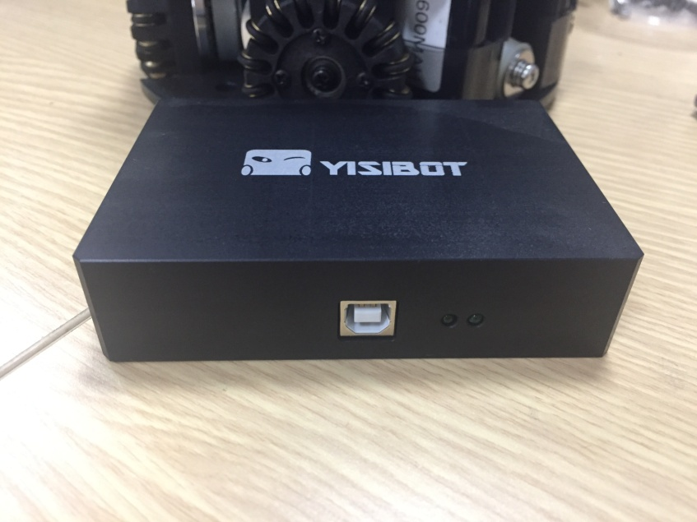

⑥Communication status indicator

⑤Power indicator

④Total power indicator

③Bluetooth indicator

②2.4G communication indicator

①Infrared indicator light红外指示灯

①Infrared indicator light：When the ball is controlled by SSL, one side of the infrared light emitted by the small ball block, the other side can not receive infrared light red light, and vice versa

②2.4G communication indicator：When the transmitter is successfully connected, the lamp is flashing；When the transmitter is not connected, the lamp is off or long.

③Bluetooth indicator：Turn on the Bluetooth, the right light flashes quickly；when successful, the two lights flashing alternately；when the Bluetooth connection is successful, the right light is blinking slowly.

④Total power indicator：Switch on the power, bright blue light

⑤Power indicator and⑥Communication status indicator：When the signal is not connected, the two lights flashing alternately；When the connection is successful, two lights have been working s；When sending data, the power indicator light is on，Communication status indicator light flashes（When there are other situations，Unplug the USB connection cable and connect again。Cause this kind of situation usually send the duplicate data）