D.K.T.E. SOCIETY’S TEXTILE AND ENGINEERING INSTITUTE, ICHALKARANJI
(An Empowered Autonomous Institute, Affiliated to Shivaji University, Kolhapur)
DEPARTMENT OF MASTER OF COMPUTER APPLICATION (MCA)

A PROJECT REPORT ENTITLED ON
“SHREE HOSPITAL, AKIWAT”
SUBMITTED IN PARTIAL FULFILLMENT OF THE REQUIREMENTS FOR THE DEGREE OF
MASTER OF COMPUTER APPLICATION (MCA-II, SEMESTER-III)
SUBMITTED BY:
Sr. No. | Student Name | PRN / Roll No.
1 | Ms. Saloni S. Narvekar | 25PMC002
2 | Ms. Shubhangi G. Latwade | 25PMC003
3 | Ms. Arya P. Chougule | 25PMC007
4 | Ms. Sanika S. Sutar | 25PMC041
UNDER THE VALUED GUIDANCE OF:
Ms. Prof. K.V. Upase
Assistant Professor, Department of MCA
THROUGH THE DIRECTOR
D.K.T.E. S’s TEXTILE AND ENGINEERING INSTITUTE,
ICHALKARANJI – 416115
ACADEMIC YEAR: 2026–2027

ERP PROJECT REPORT
Content Requirements and Submission Sheet
This documentation report complies with the prescribed syllabus guidelines and institutional evaluation criteria for Enterprise Resource Planning (ERP) project implementation.
Document Item / Field | Project Record Specification
Project Title | City Multispeciality Hospital - Hospital Resource Planning & Management System
ERP Domain / Sector | Healthcare Services & Hospital Resource Planning
Student Names (Group) | Ms. Saloni S. Narvekar, Ms. Shubhangi G. Latwade,  Ms. Arya P. Chougule, Ms. Sanika S. Sutar
Class & Semester | Master of Computer Application (MCA) - Year II, Semester III
Course / Subject | Enterprise Resource Planning (ERP) Lab & Project
Faculty / Project Guide | Ms. Prof. K.V. Upase (Professor, Dept. of MCA)
Head of Department | Prof. Dr. S.S. Mangave
Institution / College | D.K.T.E. Society’s Textile & Engineering Institute, Ichalkaranji
Affiliated University | Shivaji University, Kolhapur
Academic Year | 2026 – 2027
Submission Date | October 2026
Implementation Stack | Java 24 (JDK 24.0.1), Java Swing Desktop GUI, JDBC, MySQL Server 8.0

CERTIFICATE
This is to certify that the project report entitled “CITY MULTISPECIALITY HOSPITAL - HOSPITAL RESOURCE PLANNING & MANAGEMENT SYSTEM” is a bonafide record of the authentic project work carried out by Ms. Saloni S. Narvekar, Ms. Shubhangi G. Latwade,
Ms. Arya P. Chougule, Ms. Sanika S. Sutar in partial fulfillment of the requirements for the degree of Master of Computer Application (MCA), Semester III, at D.K.T.E. Society’s Textile and Engineering Institute, Ichalkaranji during the academic year 2026–2027.
The project work was conducted under the direct supervision and guidance of Ms. Prof. K.V. Upase and is submitted in accordance with the academic standards and evaluation guidelines prescribed by the institute and Shivaji University, Kolhapur. The software components, modular integration, and comprehensive documentation have been examined and approved for academic submission.
Evaluation Authority | Department Sign-Off
Project Guide | Head of the Department
___________________________________  Name: Ms. Prof. K.V. Upase  Designation: Assistant Professor  Date: ________________________ | ___________________________________  Name: Prof. Dr. S.S. Mangave  Designation: Professor & HOD  Date: ________________________
External Examiner 1 | External Examiner 2
___________________________________  Signature:  Date: ________________________ | ___________________________________  Signature:  Date: ________________________
Place: Ichalkaranji
Date: 29th October 2026

GUIDE’S CERTIFICATE
I hereby certify that the project entitled “CITY MULTISPECIALITY HOSPITAL - HOSPITAL RESOURCE PLANNING & MANAGEMENT SYSTEM” has been carried out and successfully implemented by Ms. Saloni S. Narvekar, Ms. Shubhangi G. Latwade,
Ms. Arya P. Chougule, Ms. Sanika S. Sutar under my guidance and supervision.
The students have conscientiously undertaken the full software development lifecycle: problem formulation, domain analysis in healthcare operations, database architecture design, Swing user interface construction, role-based access control, clinical record management, duty roster shift scheduling, billing integration, and automated integration testing.
The accompanying documentation accurately represents the implemented software artifacts, database schemas, and verification results. The work has been reviewed by me and is submitted with my approval for academic evaluation.
____________________________________________
Project Guide: Ms. Prof. K.V. Upase
Designation: Assistant Professor
Department of Master of Computer Application (MCA)
D.K.T.E. Society’s Textile and Engineering Institute, Ichalkaranji
Date: 29th October 2026
Place: Ichalkaranji

STUDENT DECLARATION
To,
The Registrar,
Shivaji University, Kolhapur.
We, the undersigned, hereby declare that the project report entitled “Shree Hospital, Akiwat”, submitted in partial fulfillment of the requirements for the degree of Master of Computer Application at D.K.T.E. Society’s Textile and Engineering Institute, Ichalkaranji, is our original work conducted under the guidance of Ms. Prof. K.V. Upase.
We solemnly confirm the following points:
- 1. Assigned Guidance: The project has been developed by us under the active guidance and direction of the assigned project guide.
- 2. Authentic Evidence: The empirical information, database structures, UI screenshots, and testing observations presented in this report represent genuine project deliverables.
- 3. Academic Integrity: All external literature, APIs, libraries, and open-source software tools utilized have been appropriately acknowledged and cited.
- 4. Original Codebase: We have not copied this report or the underlying implementation from any other project previously submitted to Shivaji University or any other academic body.
- 5. Work Ownership: We have not knowingly presented another researcher's or author's intellectual property as our own.
- 6. Non-Duplication: This project report has not been submitted elsewhere for any degree, diploma, or academic evaluation.
Sr. No. | Student Name |  | PRN / Roll No. | Signature
1 | Ms. Saloni S. Narvekar |  | 25PMC002 | __________________
2 | Ms. Shubhangi G. Latwade |  | 25PMC003 | __________________
3 | Ms. Arya P. Chougule |  | 25PMC007 | __________________
4 | Ms. Sanika S. Sutar |  | 25PMC041 | __________________

ACKNOWLEDGEMENT
We have been fortunate to receive continuous guidance, constructive suggestions, and generous academic support throughout the formulation, implementation, and documentation of our project entitled “Shree Hospital, Akiwat”.
First and foremost, we express our profound gratitude to our respected project guide, Ms. Prof. K.V. Upase, for her invaluable mentorship, technical direction, and continuous encouragement during every phase of system analysis, database schema creation, Swing GUI refinement, and report preparation.
We extend our sincere thanks to Prof. Dr. S.S. Mangave, Head of the Department of Master of Computer Application (MCA), for his academic leadership and for providing an inspiring environment conducive to rigorous software development.
We are also grateful to the Director and Management of D.K.T.E. Society’s Textile and Engineering Institute, Ichalkaranji, for providing state-of-the-art computational infrastructure, network resources, and laboratory facilities.
We also acknowledge the open-source software community for the foundational tools used in this project, including the OpenJDK Runtime Environment and Oracle MySQL Community Server.
Finally, we thank our parents, family members, and fellow classmates for their moral support and encouragement.
Ms. Saloni S. Narvekar,
Ms. Shubhangi G. Latwade,
Ms. Arya P. Chougule,
Ms. Sanika S. Sutar
(MCA-II Semester-III)

ABSTRACT
Modern hospital administration requires high precision, cross-departmental coordination, and rigorous regulatory compliance. Conventional healthcare systems suffer from disconnected paper records, scheduling clashes, unverified doctor availability, manual billing discrepancies, and fragmented staff shift allocation. This project presents the design and implementation of the “Shree Hospital, Akiwat”, an enterprise-grade desktop ERP solution engineered using Java 24, Java Swing, and MySQL 8.
The system establishes an integrated, centralized architecture linking eight primary functional modules: Admin Setup & Role-Based Access Control (RBAC), Doctor Management, Patient Registration, Appointment & Queue Management, Clinical Consultation & Electronic Prescriptions, Itemized Billing & Finance Accounting, and Human Resource & Shift Duty Scheduling. Key innovations implemented include real-time day-of-week doctor availability verification that blocks invalid bookings and alerts receptionists; automated 30-minute OPD slot calculation; per-doctor token queueing; transactional consultation-to-appointment completion; subtotal/discount/payment reconciliation; and leave-conflict-aware staff shift roster allocation.
The solution enforces backend security guards via a service-oriented abstraction layer (`Rbac.require()`), preventing unauthorized data modifications. System reliability was validated through automated regression smoke test suites (`WorkflowSmokeTest` and `ErpSmokeTest`), achieving a 100% test pass rate across all business workflows. The project demonstrates a production-ready, scalable ERP architecture that enhances operational throughput, eliminates manual transcription errors, and elevates patient care standards.

TABLE OF CONTENTS
Chapter / Section | Contents Summary | Page No.
Preliminary Pages | Title Page 1 (Institute Format), Title Page 2 (ERP Guidelines), Certificate, Declaration, Acknowledgement, Abstract | i – vii
Lists & Terms | Table of Contents, List of Figures, List of Tables, Abbreviations & Terminology | viii – xi
Chapter 1 | Introduction (Project Overview, Background, Problem Statement, Objectives, Scope, Report Organization) | 1
Chapter 2 | Existing System and Problem Analysis (Existing Workflow, Limitations, Problem Analysis, Feasibility, Requirements) | 4
Chapter 3 | Proposed ERP System (Proposed Solution, Objectives & Benefits, Workflow, Modules, User Roles, Existing vs Proposed) | 7
Chapter 4 | ERP Modules and System Integration (Module Descriptions, Functional Requirements, Data Flow, Module Integration, Dashboards) | 11
Chapter 5 | System Analysis and Design (Architecture, Use Cases, DFD Levels 0/1/2, ERD, Database Schema & Dictionary, UI Design, Security) | 16
Chapter 6 | Hardware and Software Requirements (Hardware Specs, Software Specs, Technologies, Database Engine, Deployment Architecture) | 23
Chapter 7 | Implementation (Implementation Strategy, Service Modules, Database Scripts, Authentication, Validations, Screen Walkthroughs) | 25
Chapter 8 | Testing and Results (Testing Strategy, Unit Testing, Integration Smoke Tests, System Test Cases, Results & Defect Rectification) | 31
Chapter 9 | Scope, Limitations and Future Enhancements (Achieved Scope, Limitations, Future Enhancements, Scalability & Maintenance) | 37
Chapter 10 | Conclusion (Project Summary, Objectives Achieved Mapping Matrix, Academic Learning Outcomes) | 39
References | Bibliography & Web References (Books, Java/MySQL Documentation, Academic Articles, Web Citations) | 41
Appendices | Appendix A: Selected Source Code; Appendix B: Database Schemas; Appendix C: User Setup Manual; Appendix D: Team Contribution | 43

LIST OF FIGURES
Figure No. | Figure Title / Description | Page No.
Figure 3.1 | End-to-End Hospital ERP Workflow Diagram | 8
Figure 4.1 | Cross-Module Information and Integration Data Flow | 13
Figure 5.1 | Three-Tier Client-Server Architecture Diagram | 16
Figure 5.2 | System Use Case Diagram with Role Actors | 17
Figure 5.3 | Level-0 Context Data Flow Diagram (DFD) | 18
Figure 5.4 | Level-1 Subsystem Data Flow Diagram (DFD) | 18
Figure 5.5 | Entity-Relationship Diagram (ERD) of Hospital Database | 19
Figure 7.1 | Hospital Reception Main Dashboard (Live Production Screen) | 27
Figure 7.2 | Admin & Hospital Setup Screen (Users & Roles Configuration) | 28
Figure 7.3 | Book Appointment Screen with Day-Based Doctor Availability Alert | 29
Figure 7.4 | Clinical Consultation & Electronic Prescription Interface | 30
LIST OF TABLES
Table No. | Table Title / Description | Page No.
Table 2.1 | Feasibility Study Evaluation Matrix | 5
Table 2.2 | System Functional Requirements (FR1 – FR10) | 6
Table 3.1 | Comparative Analysis: Existing Manual vs. Proposed ERP System | 10
Table 3.2 | Role-Based Access Control (RBAC) Permission Matrix | 10
Table 5.1 | Data Dictionary – Core Database Entities and Constraints | 20
Table 6.1 | Hardware and Software Specification Matrix | 23
Table 7.1 | Core Source Code Modules and Architectural Roles | 26
Table 8.1 | Comprehensive System Test Cases and Execution Results (TC-01 to TC-12) | 33
Table 8.2 | Defect Tracking, Root Cause Analysis, and Rectification Summary | 36
Table 10.1 | Project Objectives to Implementation Evidence Mapping Matrix | 40
Table D.1 | Suggested Team Contribution and Module Allocation Table | 48

ABBREVIATIONS AND TERMINOLOGY
Abbreviation | Full Form / Definition in Healthcare ERP
ERP | Enterprise Resource Planning - Integrated management of core business processes
HMS | Hospital Management System - Software platform managing healthcare and administrative data
RBAC | Role-Based Access Control - Access restriction based on user system roles
JDBC | Java Database Connectivity - Java API standard for database-independent connectivity
DBMS | Database Management System - System software for creating and managing databases
RDBMS | Relational Database Management System - DBMS based on the relational data model
OPD | Out-Patient Department - Medical care for patients not requiring overnight hospitalization
IPD | In-Patient Department - Hospital care where patients are admitted to beds
GUI | Graphical User Interface - Visual interaction controls using windows, buttons, and icons
DFD | Data Flow Diagram - Graphical representation of data movement through information systems
ERD | Entity Relationship Diagram - Structural diagram illustrating relationships between database tables
CRUD | Create, Read, Update, Delete - The four basic functions of persistent storage
API | Application Programming Interface - Set of protocols and definitions for software integration
SQL | Structured Query Language - Domain-specific language for relational database management
JDK | Java Development Kit - Software development environment used for building Java applications
ACID | Atomicity, Consistency, Isolation, Durability - Fundamental database transaction properties
HR | Human Resources - Administration of workforce, attendance, leaves, and payroll
Rx | Prescription - Written healthcare instruction specifying patient medication regimen
BP | Blood Pressure - Vital clinical parameter measured during medical consultations
PRN | Permanent Registration Number - Unique student identification code at university

Chapter 1: Introduction
1.1 Project Overview
The healthcare sector represents one of the most operationally demanding service domains. A multispeciality hospital operates continuously, simultaneously coordinating patient triage, clinical diagnoses, surgical schedules, pharmacy dispensation, staff duty shifts, bed occupancy, and complex financial billing. In an environment where minutes directly impact patient outcomes, relying on paper registers or isolated desktop spreadsheets leads to severe communication lag, billing discrepancies, and administrative vulnerabilities.
The “City Multispeciality Hospital - Hospital Resource Planning & Management System” is an integrated enterprise-class desktop software solution designed to unify hospital workflows under a single, coherent technical umbrella. Developed using Java 24 (JDK 24) and backed by Oracle MySQL Server 8.0, the system implements a modular service-oriented architecture covering outpatient and inpatient intake, physician scheduling, appointment queue management, electronic medical records (EMR), itemized billing and payment receipts, financial expense reconciliation, and complete human resource administration.
1.2 Background and Motivation
Historically, the institution operated a legacy reception database focused solely on basic patient registration and doctor listings. As clinical specialties expanded from general medicine to specialized cardiology, neurology, orthopedics, and pediatrics, the administration faced acute logistical challenges:
- Uncoordinated Doctor Scheduling: Physicians maintain distinct practice hours across varied days of the week. Without automated checks, patients were frequently booked on days when specialist doctors were off-duty.
- Paper-Based Clinical Handover: Consultation findings, vitals (BP, temperature, pulse), and prescriptions were penned on paper slips, making longitudinal patient history inaccessible during follow-up visits.
- Billing Leakage: Consultation fees, bed charges, and laboratory line items were calculated manually at checkout counters, resulting in revenue leakage, calculation errors, and delays.
- Staff Roster Conflicts: Nursing and administrative staff were occasionally assigned duplicate shifts on identical dates or rostered on days covered by approved medical leaves.
These operational bottlenecks motivated the comprehensive modernization and expansion of the hospital system into a fully unified, reliable, and role-guarded ERP solution.
1.3 Problem Statement
To engineer, validate, and deploy a secure, responsive, and robust Java Swing desktop ERP platform that eliminates paper-based bottlenecks in hospital administration by providing real-time doctor availability checking, conflict-free appointment booking, structured electronic clinical consultation recording, multi-item automated billing with payment reconciliation, and an integrated human resource module with leave-aware shift duty scheduling, all governed by fine-grained Role-Based Access Control (RBAC).
1.4 Objectives
The project intends to achieve the following specific and measurable objectives:
- Obj-1 (Centralized Authentication & RBAC): Implement a secure login mechanism supporting dual-table authentication (`app_user` with legacy `login` fallback) and enforce role-based backend authorization (`Rbac.require()`) across Admin, Doctor, Receptionist, and Staff roles.
- Obj-2 (Doctor Availability by Day): Develop an intelligent scheduling engine that evaluates a physician's active practice days (e.g., 'Mon,Tue,Wed,Thu,Fri') and operating hours, automatically alerting operators and blocking bookings when a doctor is unavailable.
- Obj-3 (Queue & Token Generation): Provide automated 30-minute slot allocation, duplicate-booking prevention, and dynamic token queue management per doctor per date.
- Obj-4 (Digital Clinical Records): Create a clinician-facing interface for recording patient vitals, symptoms, diagnoses, and multi-line prescriptions, automatically updating appointment statuses to 'Completed' upon save.
- Obj-5 (Unified Billing & Invoicing): Automate bill generation with itemized line charges (consultation, lab, bed, medicine), subtotal/discount calculations, sequential invoice numbering (`INV-000001`), and multi-method payment tracking.
- Obj-6 (HR Shift & Duty Scheduling): Provide an integrated HR workspace enabling employee master maintenance, daily attendance logging, leave approval workflows, payroll calculation, and shift duty scheduling that strictly prevents roster clashes and leave violations.
1.5 Scope
- Included In Scope: Complete clinical, operational, and administrative workflows for a multispeciality hospital facility; desktop Swing interface running on staff workstations; centralized MySQL 8 server database; transaction-safe JDBC services; automated integration smoke testing suites.
- Target User Groups: Hospital Administrators, Chief Medical Officers, Practicing Doctors, Receptionists, Billing Clerks, and Human Resource Managers.
- Excluded From Scope: Direct external insurance claim clearinghouse web APIs, third-party payment gateway hardware terminal drivers, and mobile patient apps (identified for future cloud-based release).
1.6 Organization of the Report
This project report is systematically organized into ten chapters. Chapter 2 analyzes the existing manual systems and requirements. Chapter 3 introduces the proposed ERP solution and user roles. Chapter 4 elaborates on module specifications and cross-functional data flows. Chapter 5 provides detailed architectural diagrams, DFDs, ERDs, and data dictionaries. Chapter 6 specifies hardware and software configurations. Chapter 7 presents implementation techniques and UI screen walkthroughs. Chapter 8 documents testing methodologies, test cases, and defect resolutions. Chapter 9 discusses scope achievements and future expansions. Chapter 10 concludes with learning outcomes and academic contributions.

Chapter 2: Existing System and Problem Analysis
2.1 Existing System
In the existing operational environment, City Multispeciality Hospital operated through a combination of manual paper registers and basic, non-integrated computerized spreadsheets. The reception counter maintained manual logbooks for walk-in patient entries, doctor appointment diaries, and physical token slips. Patient demographic records were stored in filing cabinets indexed by year, while financial collections were tallied at the close of each day using paper receipt counterfoils.
2.2 Existing Business Workflow
The legacy patient journey followed an error-prone sequence:
- Step 1: Patient Arrival: Patient arrives at the reception counter; receptionist manually searches physical files or writes down basic details in an intake register.
- Step 2: Doctor Booking: Receptionist checks a printed weekly doctor timetable; if a doctor has rescheduled or exchanged shifts verbally, the printed roster is inaccurate, resulting in patients waiting for doctors who are off-duty.
- Step 3: Consultation: Doctor writes handwritten clinical notes and prescriptions on loose paper pads. Historical test records are unavailable unless the patient physically carries prior documents.
- Step 4: Billing: Patient visits the cashier; billing staff calculates charges using mental arithmetic or desk calculators. Discounts granted by administrators require manual verification slips.
- Step 5: Staff Duty Scheduling: Nursing supervisor creates duty rosters on paper chart boards. Shift clashes and leave overlaps are discovered on the hospital floor during shift handovers.
2.3 Limitations of the Existing System
- Duplicate Patient Profiles: Without automated validation, duplicate files were created for the same patient across visits, fragmenting treatment histories.
- Doctor Availability Clashes: No automated system enforced doctor day-of-week practice rules, leading to frustrated patients and wasted clinical hours.
- Lack of Financial Audit Trail: Manual billing allowed discrepancies between collected cash and recorded bills, with no atomic link to patient clinical records.
- Roster Double-Booking: Staff were inadvertently rostered for double shifts or assigned on days when formal leave had already been approved.
- Absence of Role-Based Security: Spreadsheets and physical registers could be viewed, altered, or misplaced without access logs or audit controls.
2.4 Problem Analysis
A rigorous root-cause analysis revealed that the hospital’s primary challenge was operational fragmentation. Each department operated as a data silo: reception had no real-time view of doctor leaves; clinicians had no direct interface to pharmacy or billing; and accounting had to reconcile bills independently from patient consultations. An enterprise-wide, modular ERP architecture was necessary to ensure that an event in one module (such as booking an appointment) instantly updates queue monitors, locks doctor slots, and sets up downstream billing workflows.
2.5 Feasibility Study
A four-dimension feasibility analysis was conducted before initiating technical design:
Feasibility Dimension | Rating | Evaluation Analysis
Technical Feasibility | HIGH | Utilizes established, robust Java 24 technologies, Swing GUI framework, JDBC transactions, and MySQL 8. Development team possessed requisite Java expertise.
Operational Feasibility | HIGH | Intuitive desktop interface with consistent navigation, high-contrast layouts, and clear Back buttons ensures minimal training requirement for hospital staff.
Economic Feasibility | HIGH | Built entirely on free, open-source platforms (OpenJDK and MySQL Community Edition), eliminating expensive proprietary per-seat licensing fees.
Schedule Feasibility | HIGH | Development structured into clear phased sprints (schema migration -> service layer -> UI -> integration tests) meeting academic semester timelines.
2.6 Requirements Specifications
The requirements were categorized into functional and non-functional specifications:
Req. ID | Functional Area | Requirement Specification
FR-01 | Authentication & RBAC | The system shall authenticate users and restrict screens based on role permissions (Admin, Doctor, Receptionist, Staff).
FR-02 | Doctor Availability Check | The system shall verify doctor practice days (Mon-Sun) and alert operators if a doctor is unavailable on the chosen date.
FR-03 | Slot & Queue Management | The system shall compute free 30-min slots and assign sequential token numbers per doctor per day upon check-in.
FR-04 | Patient Master Record | The system shall register patients with auto-generated unique codes (PT-000001) and prevent duplicate ID/contact records.
FR-05 | Clinical Consultation | Doctors shall record vitals (BP, temp, pulse, weight), symptoms, diagnoses, and multi-line drug prescriptions.
FR-06 | Itemized Billing | The system shall generate itemized bills with auto-calculated subtotals, discounts, net totals, and invoice numbers (INV-000001).
FR-07 | Payment Tracking | Cashiers shall record payments across Cash, UPI, Card, Net Banking, and Cheque, preventing duplicate reference IDs and overpayment.
FR-08 | Staff Shift Roster | HR managers shall assign shifts to employees, blocking duplicate shifts on the same date and rejecting assignments on approved leaves.
FR-09 | HR Payroll Computation | The system shall calculate monthly payroll based on present attendance days, base salary, allowances, and deductions.
FR-10 | System Navigation | Every functional window shall feature a standard, visible Back button allowing safe return to parent navigation dashboards.

Chapter 3: Proposed ERP System
3.1 Proposed Solution
The proposed system is an integrated, modular desktop Enterprise Resource Planning (ERP) platform. Designed explicitly for City Multispeciality Hospital, it replaces paper logs and fragmented tools with a unified database structure. Built using Java 24 and MySQL 8, the solution adopts a strict service-layer architecture where all database operations are executed via pre-compiled, parameterized `PreparedStatement` transactions with programmatic security enforcement.
3.2 Objectives and Benefits
- Zero Scheduling Clashes: Automated day-of-week parsing prevents booking patients when specialists are off-duty, showing clear user warnings.
- Unified Longitudinal Patient EMR: Clinical diagnoses, vital signs, and prescriptions are persistently stored and linked to patient profiles.
- Single-Window Billing Reconciliation: Invoices pull consultation fees directly from doctor records, calculate taxes and discounts automatically, and reconcile against cash receipts.
- Intelligent HR Duty Allocation: Rosters check approved leave tables before confirming shift schedules, eliminating administrative oversight.
- Auditable Role-Based Security: User privileges are validated at the backend service layer (`Rbac.require()`), ensuring unauthorized UI access attempts are rejected.
3.3 Proposed Business Workflow
The operational lifecycle flows through coordinated checkpoints: A patient enters and is registered with a generated `PT-` code. When booking an appointment, the system evaluates the doctor's practice days (e.g. 'Mon,Tue,Wed,Thu,Fri'); if the chosen date matches an active day, free 30-minute slots are displayed. Upon patient check-in at reception, a sequential token queue number is issued. The physician opens the consultation module, inputs vitals and diagnoses, prescribes medicines, and completes the appointment. Downstream, billing aggregates consultation fees and charges, outputs an official invoice (`INV-`), and logs payment receipts. Concurrently, the HR module logs employee attendance, processes leaves, schedules shift duties without conflicts, and computes payroll.
3.4 ERP Modules Overview
- 1. Admin & Hospital Setup (`AdminSetup.java`): Configures hospital corporate profile, department master, and manages user accounts with role bindings and password resets.
- 2. Doctor Management (`ManageDoctor.java`): Maintains physician qualifications, specializations, consultation fees, active working days, and shift operating hours.
- 3. Patient Care & Intake (`New_Patient.java`, `Patient_Info.java`): Registers outpatient/inpatient profiles with duplicate detection and provides complete patient information search.
- 4. Appointment & Queue (`BookAppointment.java`, `AppointmentQueue.java`): Manages slot allocations, day-based availability checks, check-ins, queue numbering, and appointment rescheduling.
- 5. Clinical Records (`ConsultationRecord.java`): Doctor interface for capturing vitals, clinical symptoms, diagnosis, treatment plans, and multi-line prescriptions.
- 6. Billing & Payments (`GenerateBill.java`, `ManageBills.java`): Creates itemized medical bills, calculates discounts, issues invoices, and handles partial/full payment tracking.
- 7. HR & Shift Management (`StaffShift.java`, `ManageEmployee.java`, `ManageLeave.java`): Schedules employee shift rosters with conflict prevention, tracks attendance, approves leaves, and runs monthly payroll.
- 8. Financial Accounting (`FinanceBillPayment.java`, `FinanceExpense.java`, `FinanceSummary.java`): Tracks hospital expenditures, operational expenses, bill receipts, and computes net financial summaries.
3.5 User Roles and Permissions
The system enforces Role-Based Access Control (RBAC) across four standard organizational roles:
System Role | Assigned RBAC Permission Keys | Authorized Operational Scope
Administrator | All Permissions (Full System Control) | Hospital Profile, User Management, Doctor Setup, Financial Approvals, All Modules
Doctor | DOCTOR_MANAGE, CONSULT_MANAGE, APPT_VIEW | Viewing Patient History, Clinical Consultation, Electronic Prescriptions, Schedule View
Receptionist | PATIENT_MANAGE, APPOINTMENT_MANAGE, BILL_CREATE | Patient Intake, Appointment Booking, Queue Check-In, Invoicing, Payment Collection
Staff / HR | HR_MANAGE, STAFF_MANAGE, ATTENDANCE_LOG | Staff Shift Duty Scheduling, Employee Profiles, Attendance, Leave Processing, Payroll
3.6 Existing vs. Proposed Comparison
Parameter | Existing System | Proposed ERP System
Patient Tracking | Paper cards / isolated files; frequent duplicates | Unique auto-generated PT-000001 code; duplicate detection
Doctor Scheduling | Static printed timetable; manual verbal updates | Dynamic day-of-week parsing; automatic availability alerts
Appointment Booking | Manual notebook entries; double bookings common | Atomic 30-min slot checks; zero overlap tolerance
Queue Token System | Handwritten paper slips; unmonitored queues | Automated sequential token assignment per doctor per day
Clinical Records | Handwritten paper pads; misplaced medical notes | Structured digital vitals, symptoms, diagnosis & prescription
Billing & Invoicing | Manual desk calculator; paper counterfoils | Automated itemized invoice (INV-000001) with balance tracking
Payment Methods | Primarily cash; manual handwritten receipts | Multi-mode: Cash, UPI, Card, Net Banking, Cheque with ref ID
Staff Duty Roster | Manual chart board; double shifts occur frequently | Transactional roster blocking double-shifts & leave clashes
HR & Payroll | Manual registers; days calculated by hand | Automated payroll calculation from verified attendance logs
System Security | Unrestricted physical logbooks | Fine-grained RBAC with backend guards (`Rbac.require()`)

Chapter 4: ERP Modules and System Integration
4.1 Detailed Module Descriptions
Each module in the ERP suite is constructed as a self-contained functional package comprising a Swing presentation JFrame and a corresponding static backend service class handling database queries and business rule validation.
- Admin & Hospital Setup: Handles institutional parameters via `hospital_profile`. Manages users in `app_user` linked to `app_role`. Allows creating staff accounts, assigning roles, deactivating dormant users, and resetting passwords with validation.
- Doctor Management: Maintains complete physician credentials in `doctor`. Stores specialization, department affiliation, consultation fee, available working days (e.g. 'Mon,Tue,Wed,Thu,Fri'), and daily operational hours (e.g. '09:00' to '17:00'). Supports soft deactivation.
- Patient Intake & Complete Info: Captures patient identification type (Aadhar, Voter ID, Driving License), unique ID number, name, DOB, age, contact, address, blood group, and patient category (OPD/IPD). Rejects duplicate records based on ID or Name+Contact.
- Appointment Booking & Queue Engine: Evaluates doctor day availability; computes available 30-minute slots; prevents overlapping appointments; generates queue tokens upon check-in; supports date/time rescheduling with automatic slot re-validation.
- Clinical Consultation & Prescription: Doctor workspace capturing clinical vitals (BP, temperature, pulse rate, weight), subjective symptoms, definitive diagnosis, treatment directives, and multi-item medication regimens (Drug Name, Dosage, Frequency, Duration). Completes appointment status atomically.
- Billing, Invoicing & Payments: Creates itemized invoices with line items (`bill_item`) for consultation fees, laboratory diagnostics, medicine charges, and bed occupancy. Tracks partial payments, issues payment receipts, prevents duplicate payment references, and recalculates outstanding balances.
- HR Employee & Shift Duty Scheduling: Empowers HR to schedule employee duties across defined shifts (Morning, Evening, Night) via `StaffShift.java`. Validates that no staff member is scheduled for two shifts on the same date and rejects assignments on dates covered by approved leave.
- Financial Expense Tracking: Maintains hospital operational expenses (maintenance, supplies, utilities) in `finance_expense`, reconciling disbursements against patient bill revenues.
4.2 Module-Wise Functional Requirements Matrix
The table below details supported CRUD actions, backend service classes, and security authorization keys:
Module | Service Class | Supported Actions | Security Keys
Admin Setup | `SetupService` | Create user, update status, change role, reset pwd, save profile | `SETUP_USER`, `SETUP_PROFILE`
Doctor Management | `DoctorService` | Add doctor, edit profile, update fees/days, soft deactivate | `DOCTOR_MANAGE`
Patient Registration | `PatientService` | Register patient, update demographic info, duplicate search | `PATIENT_MANAGE`
Appointment Booking | `AppointmentService` | Check day availability, book slot, check-in, reschedule, cancel | `APPOINTMENT_MANAGE`
Clinical Consultation | `ConsultationService` | Save vitals, diagnose, write Rx lines, complete appointment | `CONSULT_MANAGE`
Billing & Invoicing | `BillingService` | Generate bill, add line items, calculate discount, log payment | `BILLING_MANAGE`
HR & Shift Roster | `StaffService`, `ErpService` | Schedule duty shifts, log attendance, approve leave, run payroll | `STAFF_MANAGE`, `HR_MANAGE`
Finance & Expense | `ErpService` | Record expense, reconcile income vs expense, generate summary | `FINANCE_MANAGE`
4.3 Cross-Module Data and Information Flow
Information flows seamlessly across module boundaries without manual data re-entry. For example, when a patient registers, their `id` and generated `patient_code` are immediately accessible in the Appointment module. When an appointment is booked with a doctor, the doctor's preset consultation fee automatically populates the subsequent Billing invoice. When an appointment is checked in, it enters the Doctor Consultation queue. Saving clinical findings marks the appointment as 'Completed' and transfers the charge to the Billing cash desk.
4.4 Module Integration and Validation Architecture
Integration integrity is maintained through relational foreign keys and database transactions (`Connection.setAutoCommit(false)`). If an error occurs while writing prescription lines during a consultation, the entire transaction rolls back, preventing orphaned records. Similarly, when scheduling shifts in HR, the system verifies `duty_roster` and `employee_leave` within the same transaction to guarantee that double-shifts and leave clashes are rejected atomically.
4.5 Dashboards and Operational Indicators
The Reception Dashboard (`Reception.java`) serves as the central operational hub, displaying live sign-in credentials, role identification, an animated hospital welcome marquee, and clearly categorized action buttons. Buttons corresponding to permissions not held by the current user are automatically disabled with visual graying, preventing confusion while maintaining full transparency.

Chapter 5: System Analysis and Design
5.1 System Architecture
The Hospital ERP is engineered around a clean Three-Tier Layered Architecture that decouples user interaction from business logic and database persistence:
- 1. Presentation Layer (Desktop UI): Constructed using Java Swing components (`JFrame`, `JPanel`, `JTable`, `JComboBox`, `JButton`). Employs precise null-layout bounds matching hospital operational workflows, custom gradient headers, and standardized Back navigation controls on every screen.
- 2. Business Logic & Service Layer: Static stateless service classes (`AppointmentService`, `BillingService`, `DoctorService`, `PatientService`, `StaffService`, `SetupService`, `Rbac`). Contains all validation algorithms, day-of-week parsing, fee calculations, and transaction demarcation.
- 3. Data Persistence Layer: MySQL 8.0 relational database queried via Java Database Connectivity (JDBC). Utilizes pre-compiled `PreparedStatement` queries, relational foreign keys, unique indexes, and ACID-compliant transaction rollbacks.
5.2 Use Case Specifications
The system defines distinct interaction models for its primary actors:
- Admin Actor: Manages hospital profile; configures departments; creates user accounts; assigns roles; oversees hospital-wide financial and clinical audit reports.
- Receptionist Actor: Registers new patients; validates doctor availability; books appointments; issues queue tokens; prints invoices; records patient payments.
- Doctor Actor: Views daily patient queue; reviews patient historical profile; records clinical vitals; types symptoms and diagnosis; issues multi-drug prescriptions.
- HR Manager Actor: Maintains employee master data; schedules employee shift duties; approves/rejects leaves; monitors attendance; generates monthly payroll.
5.3 Data Flow Diagrams (DFD)
5.3.1 Level-0 Context DFD
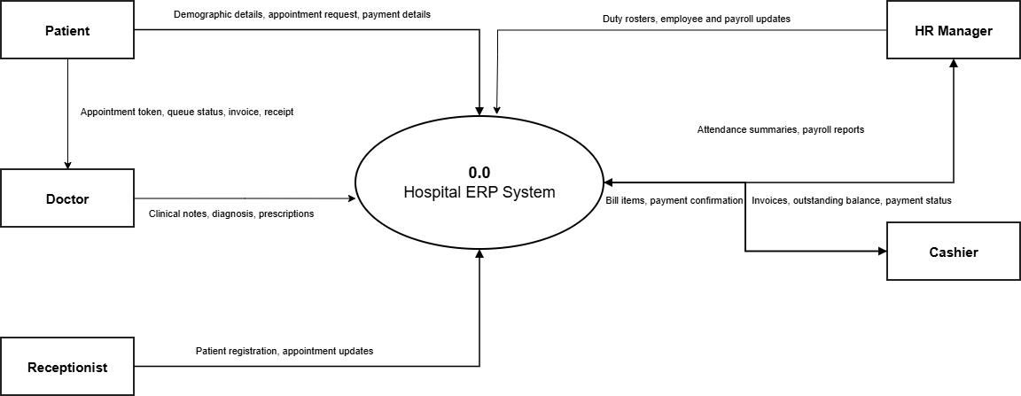

5.3.2 Level-1 Subsystem DFD
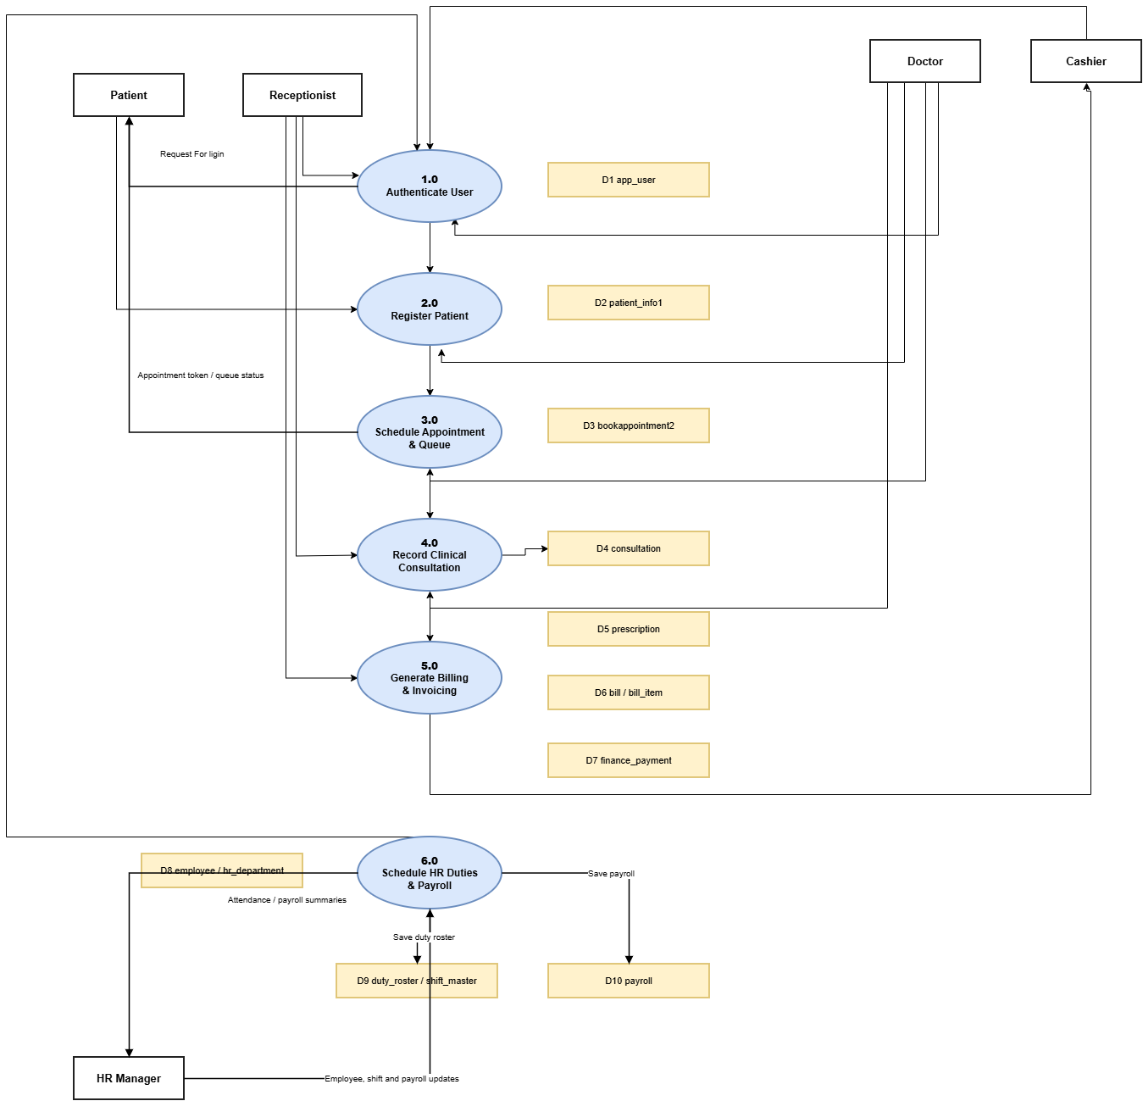
5.4 Entity-Relationship Diagram (ERD)
The relational schema comprises 18 structured tables enforcing data normalization (3NF) and referential integrity. Key relationships include:
- Doctor to Department: Many-to-one relationship linking `doctor.department_id` to `hr_department.department_id`.
- Appointment to Doctor & Patient: Foreign keys `bookappointment2.doctor_id` -> `doctor.doctor_id` and `bookappointment2.patient_id` -> `patient_info1.id`.
- Consultation to Appointment & Patient: One-to-one link `consultation.appointment_id` -> `bookappointment2.appointment_id` and many-to-one to `patient_info1.id`.
- Prescription to Consultation: One-to-many relationship linking `prescription.consultation_id` to `consultation.consultation_id`.
- Billing to Items & Payments: One-to-many links from `bill.bill_id` to `bill_item.bill_id` and `finance_payment.bill_id`.
- Employee to Shifts & Roster: `duty_roster` joins `employee.employee_id` and `shift_master.shift_id` with unique constraint on `(employee_id, duty_date)`.
5.5 Database Design and Data Dictionary
Table Entity | Column Name | Data Type | Constraint | Description
`app_user` | user_id (PK) | INT AUTO_INCREMENT | NOT NULL | Primary key for system operator accounts
`app_user` | username | VARCHAR(50) | UNIQUE, NOT NULL | Login account username
`app_user` | role_id | INT (FK) | REFERENCES app_role | Foreign key linking user to role permissions
`doctor` | doctor_id (PK) | INT AUTO_INCREMENT | NOT NULL | Primary key for physician master record
`doctor` | available_days | VARCHAR(100) | DEFAULT Mon-Fri | Comma-separated active days (e.g. Mon,Tue,Wed)
`doctor` | available_from | VARCHAR(10) | DEFAULT 09:00 | Starting working hour (HH:mm format)
`patient_info1` | id (PK) | INT AUTO_INCREMENT | NOT NULL | Primary key for registered patient profile
`patient_info1` | patient_code | VARCHAR(20) | UNIQUE | Generated unique identifier (e.g. PT-000001)
`bookappointment2` | appointment_id (PK) | INT AUTO_INCREMENT | NOT NULL | Primary key for appointment record
`bookappointment2` | queue_no | INT | DEFAULT 0 | Sequential daily token number per doctor
`consultation` | consultation_id (PK) | INT AUTO_INCREMENT | NOT NULL | Primary key for clinical consultation record
`prescription` | prescription_id (PK) | INT AUTO_INCREMENT | NOT NULL | Primary key for individual medication line item
`bill` | bill_id (PK) | INT AUTO_INCREMENT | NOT NULL | Primary key for patient medical invoice
`bill` | bill_number | VARCHAR(20) | UNIQUE | Sequential official invoice code (INV-000001)
`duty_roster` | roster_id (PK) | INT AUTO_INCREMENT | NOT NULL | Primary key for staff shift schedule
`duty_roster` | duty_date | DATE | NOT NULL | Scheduled shift date; unique with employee_id
5.6 User Interface Design Principles
- Color Palette Standards: Primary Header `#1E8CA0` (Teal Blue), Background `#F0F8FA` (Soft Hospital Ice-Blue), Accent Action `#FFDB70` (Golden Yellow), and Alert Danger `#C84646` (Crimson Red).
- Consistent Back Navigation: Every modal and operational screen contains an explicit, high-visibility 'Back' button positioned uniformly, allowing intuitive return to parent screens without data loss.
- Immediate Visual Feedback: Data tables utilize customized table headers (`UiUtil.styleTable()`), alternating row highlights, and real-time dialog alerts on error or successful transaction completion.
5.7 Security and Access Control Design
Security is enforced at two distinct tiers. At the UI level, Reception buttons for unauthorized modules are grayed out. At the backend service level, every business method invokes `Rbac.require('PERMISSION_KEY')`. If a user attempts to bypass the UI or execute an operation without credentials, a `SecurityException` is thrown and the database query is never initiated. Furthermore, SQL injection is completely prevented across the entire codebase by exclusively utilizing parameterized `PreparedStatement` queries with typed setters (`setString`, `setInt`, `setBigDecimal`).

Chapter 6: Hardware and Software Requirements
6.1 Hardware Specifications
The system is engineered for lightweight, highly responsive client workstation execution:
- Development Hardware: Intel Core i5 / i7 Multi-Core Processor (2.4 GHz or higher), 16 GB DDR4 RAM, 512 GB NVMe Solid State Drive, 1920x1080 Full HD Display.
- Client Deployment Minimum: Intel Core i3 or AMD Ryzen 3 Dual-Core Processor (2.0 GHz), 4 GB System RAM, 500 MB Available Storage, 1366x768 Screen Resolution.
- Database Server Minimum: Quad-Core Server CPU, 8 GB ECC RAM, 50 GB High-Speed SSD Storage with automated daily backup storage.
6.2 Software Specifications
- Operating System: Microsoft Windows 10 / Windows 11 (64-bit), fully compatible with Linux (Ubuntu/Debian) and macOS via standard Java Virtual Machine.
- Java Runtime Environment: Java Development Kit (JDK) 24 (Version 24.0.1) 64-Bit Standard Edition.
- Database Engine: Oracle MySQL Community Server Version 8.0 with InnoDB Storage Engine.
- Integrated Development Environment: JetBrains IntelliJ IDEA 2025 / 2026 Ultimate / Community Edition.
6.3 Technologies and Libraries Used
- Java Programming Language: Version 24 leveraging modern language features, strong type safety, and the Java Desktop Swing UI toolkit.
- Java Swing & AWT: Platform-native desktop UI components (`javax.swing.*`, `java.awt.*`) providing rich forms, scrollable tables, and dialog controls.
- JDBC Connector: MySQL Connector/J 8.0.28 (`mysql-connector-java-8.0.28.jar`) providing compliant JDBC 4.2 connectivity.
6.4 Database Management System Role
MySQL 8.0 acts as the centralized data store, executing relational integrity constraints, unique indexes, and foreign key cascades. All tables utilize the `InnoDB` transaction-safe engine configured with `utf8mb4` character encoding to support international characters and medical symbol representations.
6.5 Deployment Environment
The application is structured for local workstation deployment connecting to either a local MySQL instance for standalone testing or a centralized LAN database server (`jdbc:mysql://<Server-IP>:3306/hospital_system`) for multi-counter hospital operations.

Chapter 7: Implementation
7.1 Implementation Approach
The project was executed following an iterative, test-driven modular implementation approach. Database migration scripts (`sql/erp_migration.sql` and `sql/extended_migration.sql`) were developed first to establish idempotent table structures. Backend service classes were implemented next with strict input validation, followed by the Swing user interface screens, and finalized through automated smoke test suites.
7.2 Core Source Code Structure
Java Class / Component | Implementation Scope and Architectural Role
`connection.java` | Establishes persistent JDBC connection to `hospital_system` database with AutoCloseable interface.
`Rbac.java` & `Session.java` | Dual-table authentication (app_user & login), permission verification, active session tracking.
`BookAppointment.java` | Enhanced appointment screen with real-time day availability checking and OPD slot loading.
`AppointmentService.java` | Core scheduling engine; implements `isDoctorAvailableOnDate()`, slot generation, and check-in.
`AdminSetup.java` | Three-tab management screen for Hospital Profile, Department Master, and RBAC User Accounts.
`SetupService.java` | Transactional CRUD for hospital settings, user passwords, and departments with generated keys.
`ManageDoctor.java` | Physician master maintenance capturing working hours, consultation fee, and available days.
`ConsultationRecord.java` | Doctor clinical workstation for vitals, symptoms, diagnosis, and prescription management.
`GenerateBill.java` & `ManageBills.java` | Invoice generation with line items, multi-method payments, receipts, and refund tracking.
`StaffShift.java` | HR duty roster interface scheduling employee shifts and enforcing leave-conflict prevention rules.
`Reception.java` | Main application launcher featuring operational categorized menus and top-level Logout/Back control.
7.3 Key Business Logic Implementation: Doctor Day Availability Engine
A critical feature requested and implemented is doctor availability verification by day of the week. The algorithm in `AppointmentService.java` evaluates the doctor's `availableDays` string against the requested date:
[ALGORITHM: DOCTOR AVAILABILITY BY DAY] // Implementation Snippet from AppointmentService.java
public static boolean isDoctorAvailableOnDate(DoctorService.Doctor doctor, LocalDate date) {
if (doctor == null || date == null) return false;
if (doctor.availableDays == null || doctor.availableDays.trim().isEmpty()) return true;
String daysStr = doctor.availableDays.trim().toLowerCase();
if (daysStr.contains("all") || daysStr.contains("daily")) return true;
DayOfWeek dow = date.getDayOfWeek();
String fullDay = dow.name().toLowerCase(); // e.g. 'wednesday'
String shortDay = fullDay.substring(0, 3); // 'wed'
// Evaluates range (e.g. 'Mon-Fri') or comma tokens (e.g. 'Mon,Tue,Wed')
for (String token : daysStr.split("[,;/\\s]+")) {
if (fullDay.startsWith(token) || token.startsWith(shortDay)) return true;
}
return false;
}

When the operator selects a date or changes the doctor in `BookAppointment.java`, `refreshSlots()` invokes this method. If the doctor does not practice on that day (e.g. Sunday for a Mon-Fri doctor), an immediate Swing dialog alerts the user: “Dr. [Name] is NOT available on Sunday (2026-10-25)! Available Days: Mon,Tue,Wed,Thu,Fri”. The slot dropdown is cleared, and booking is blocked.
7.4 Screen Walkthrough and Visual Evidence
The user interface incorporates high-contrast, professional visual elements. The main Reception screen features categorized operational buttons for New Patient, Appointments, Patient Info, Admin Setup, Doctor Management, Staff Shifts, Consultation, Billing, and HR & Employee Management.
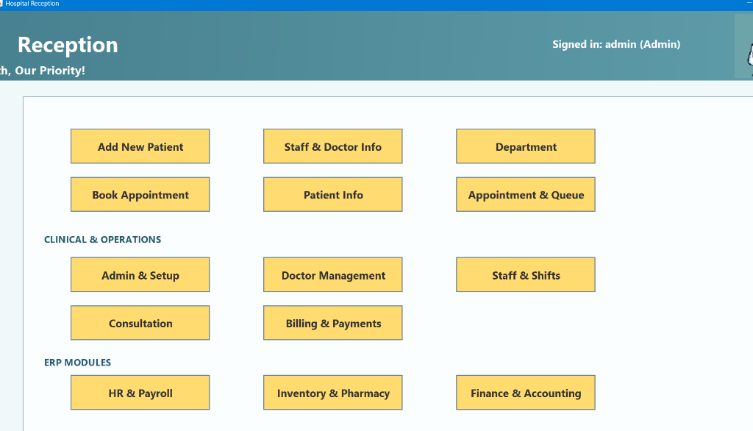
Figure 7.1: Hospital Reception Main Dashboard (Live Application)
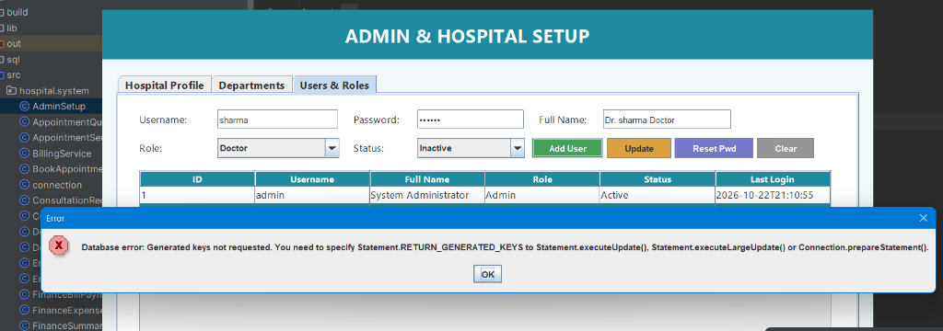
Figure 7.2: Admin & Hospital Setup Screen (Users & Roles Configuration)
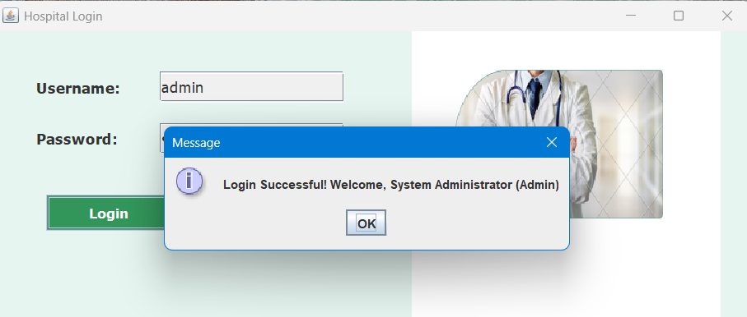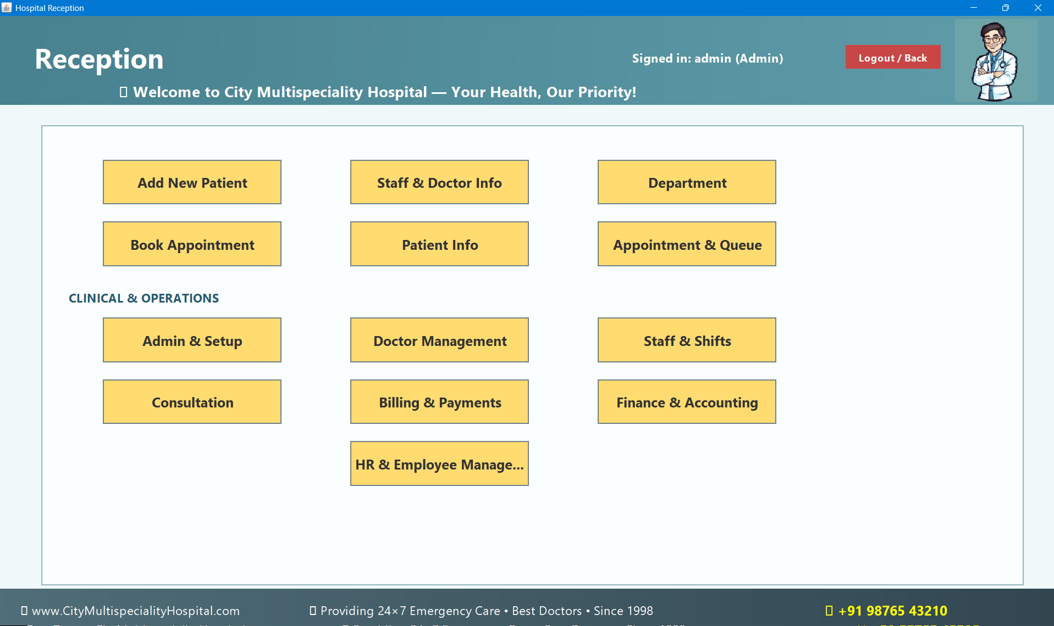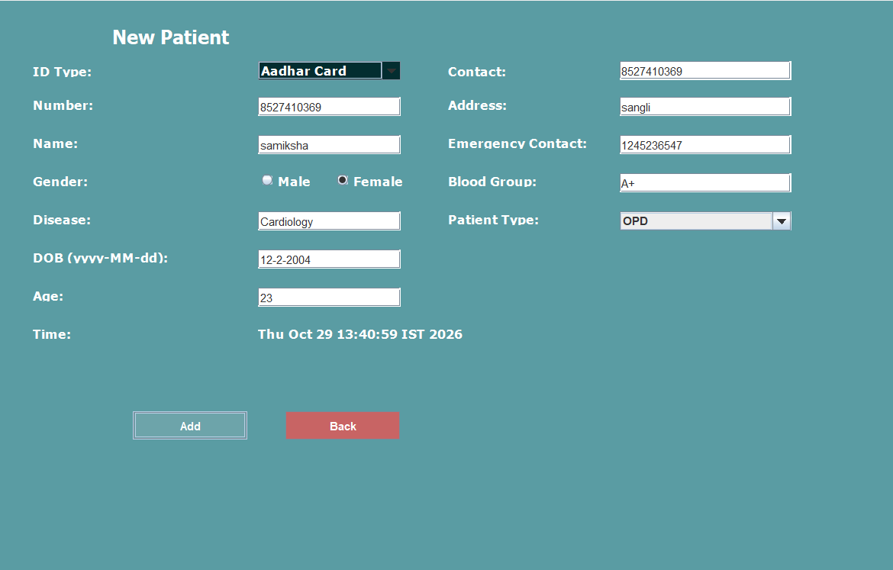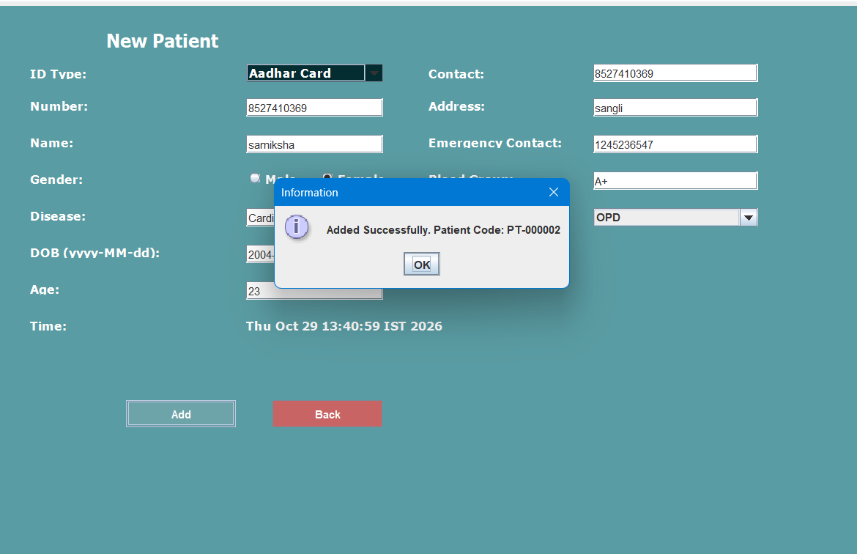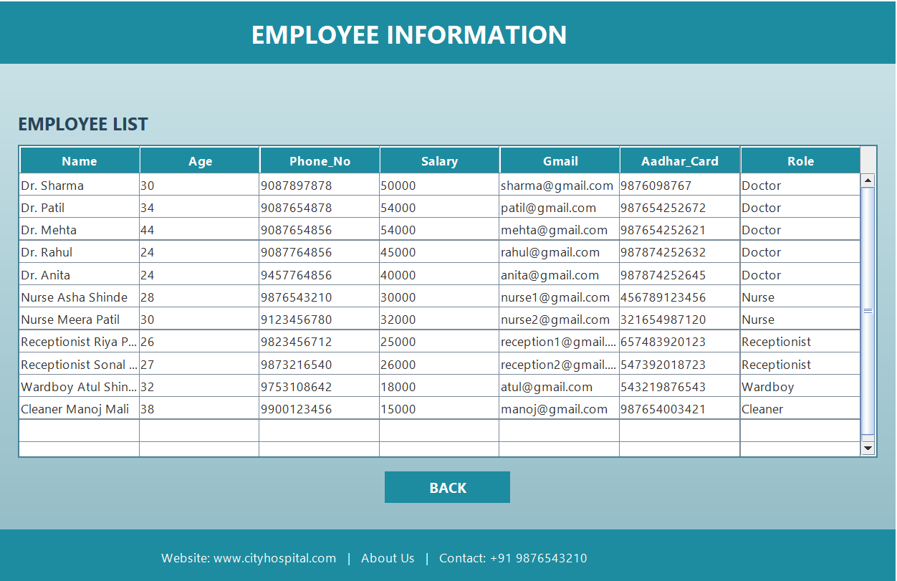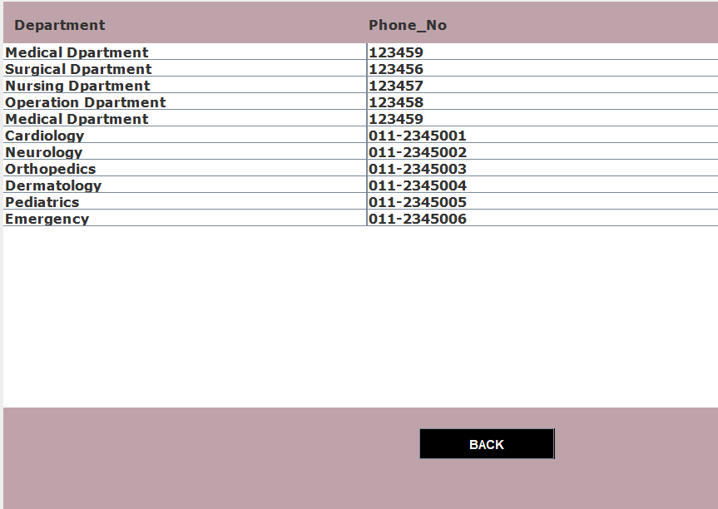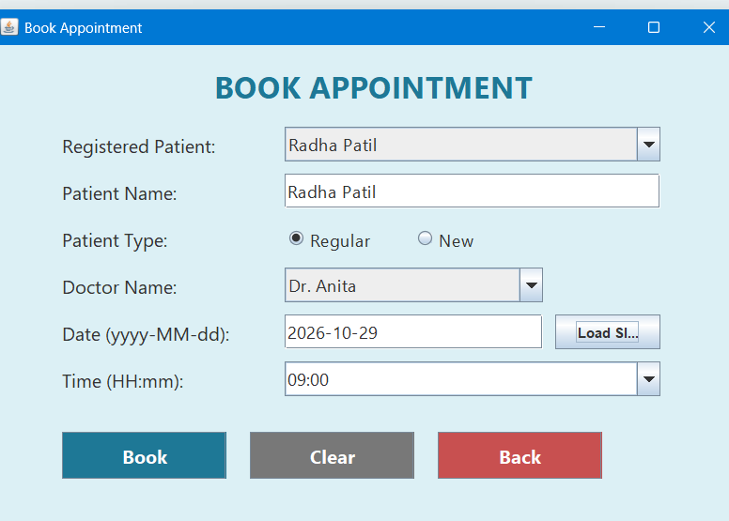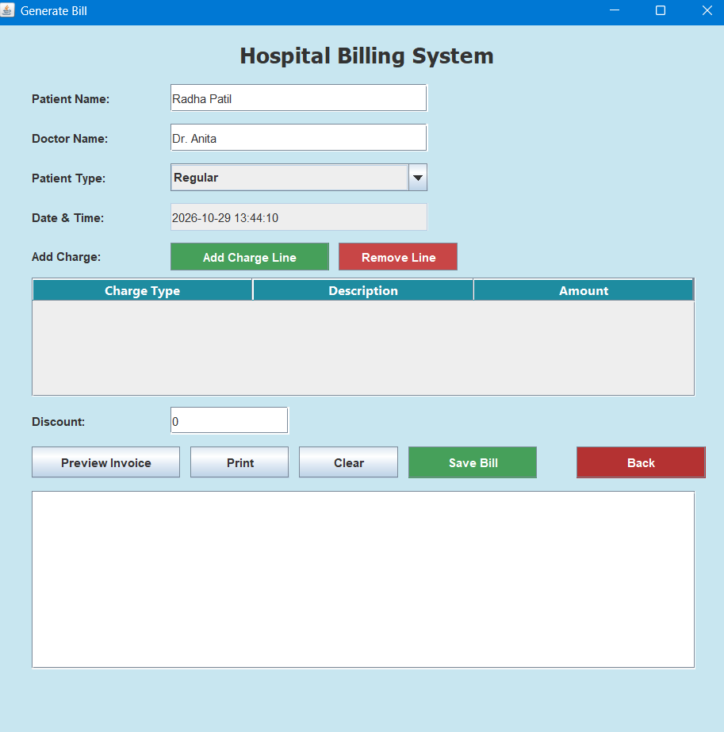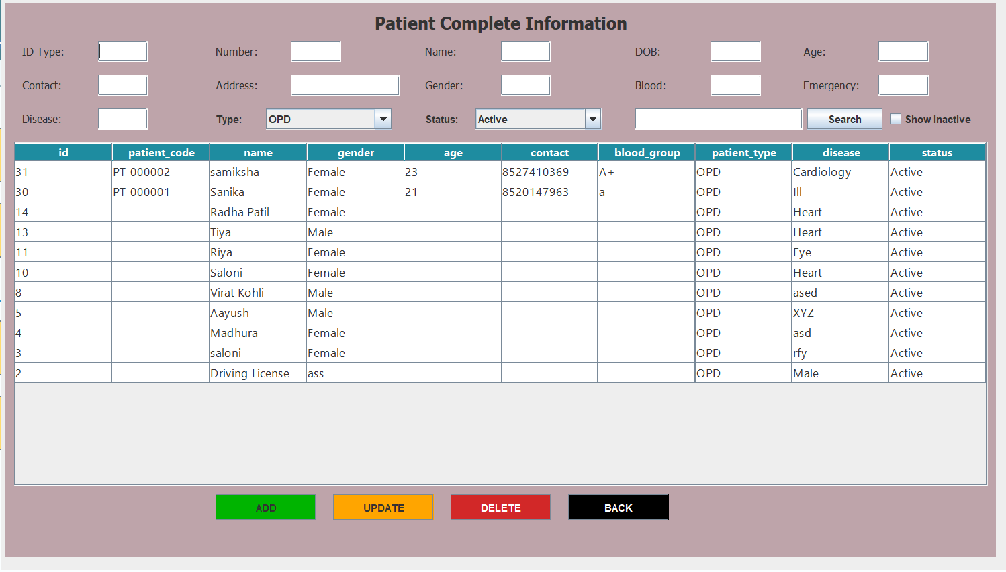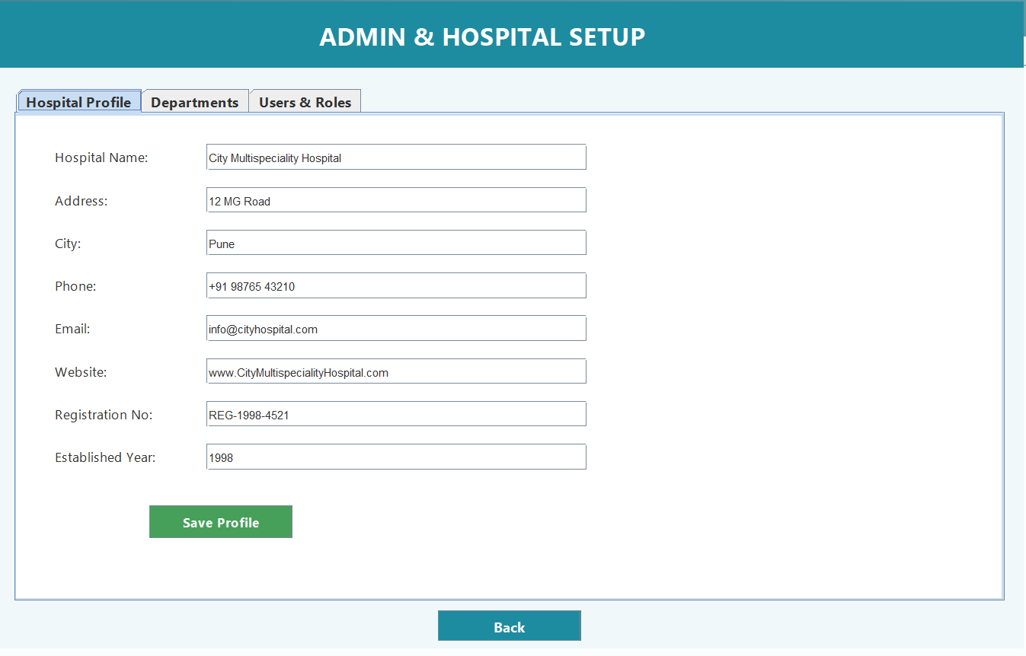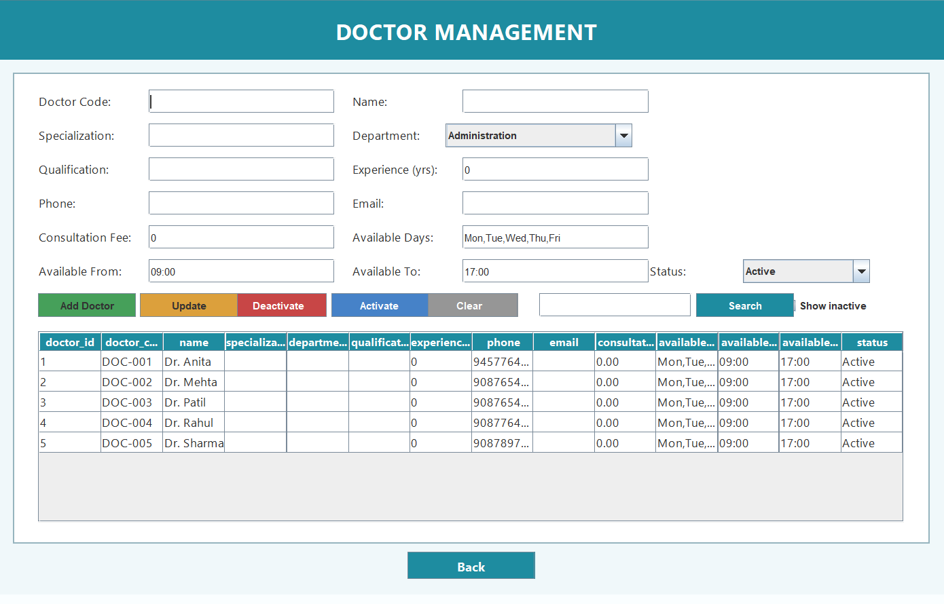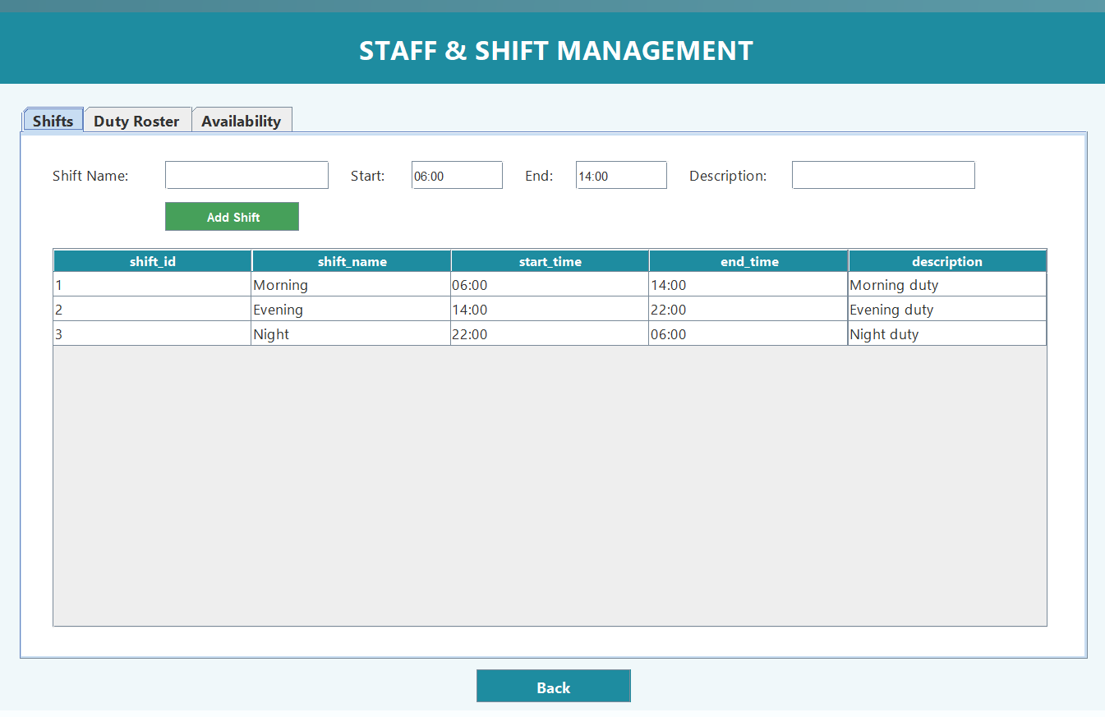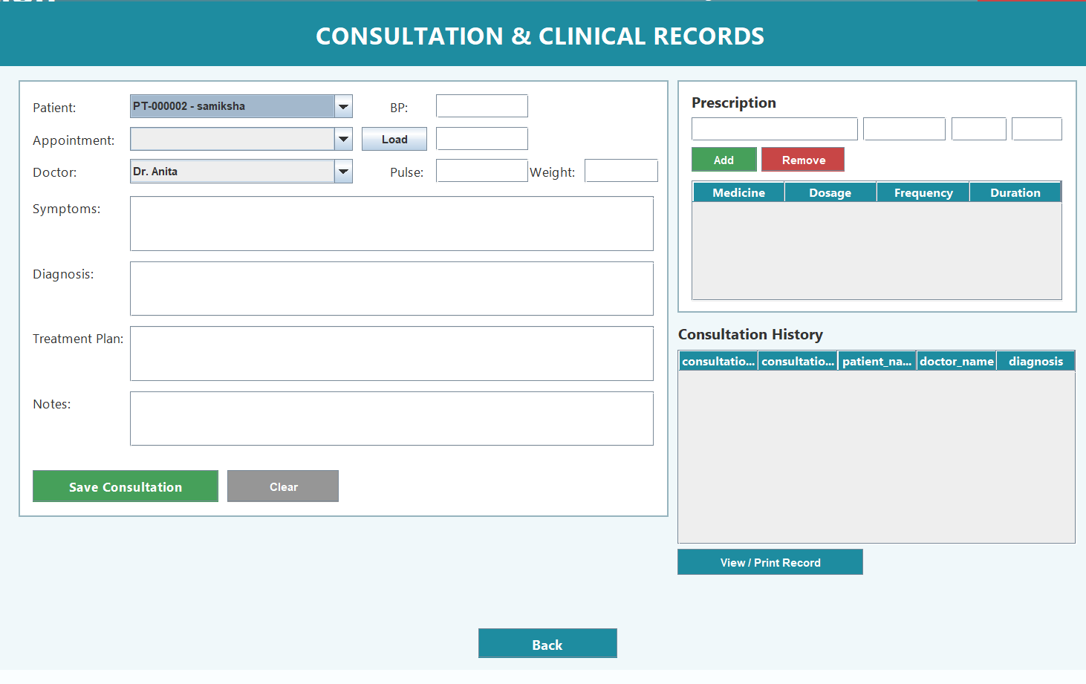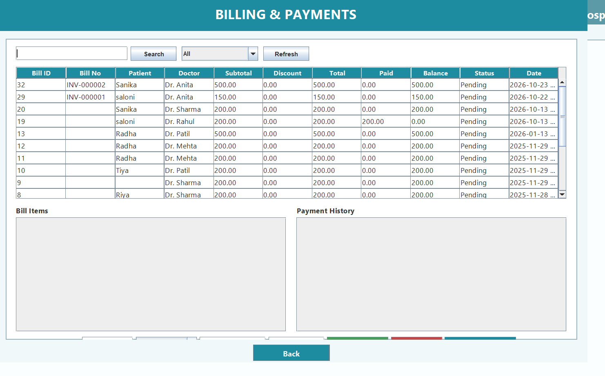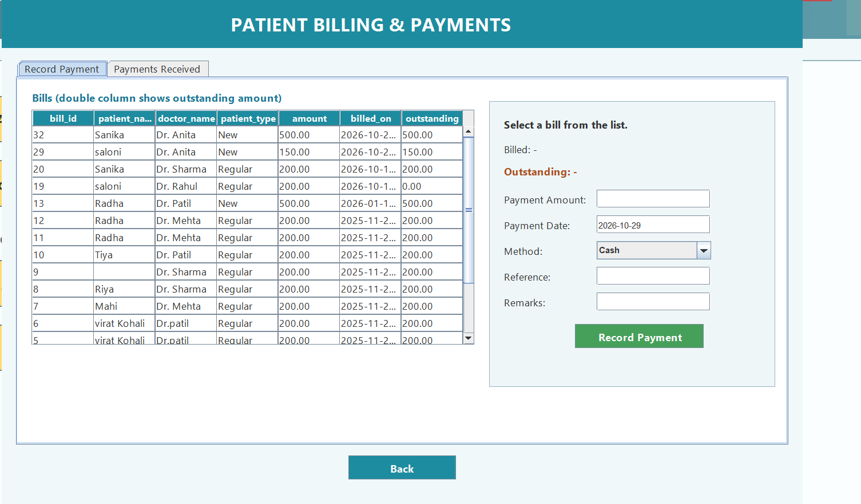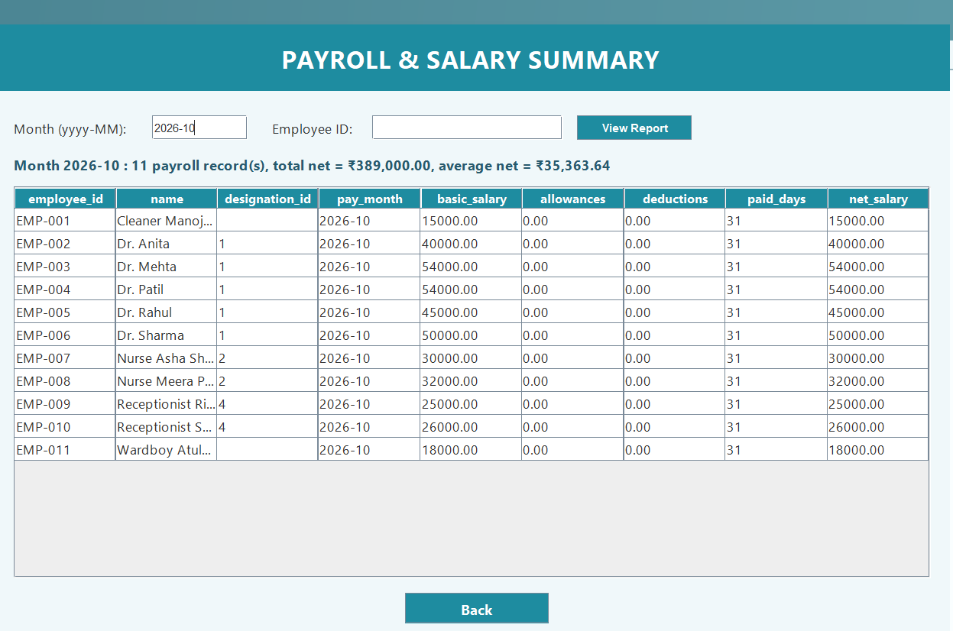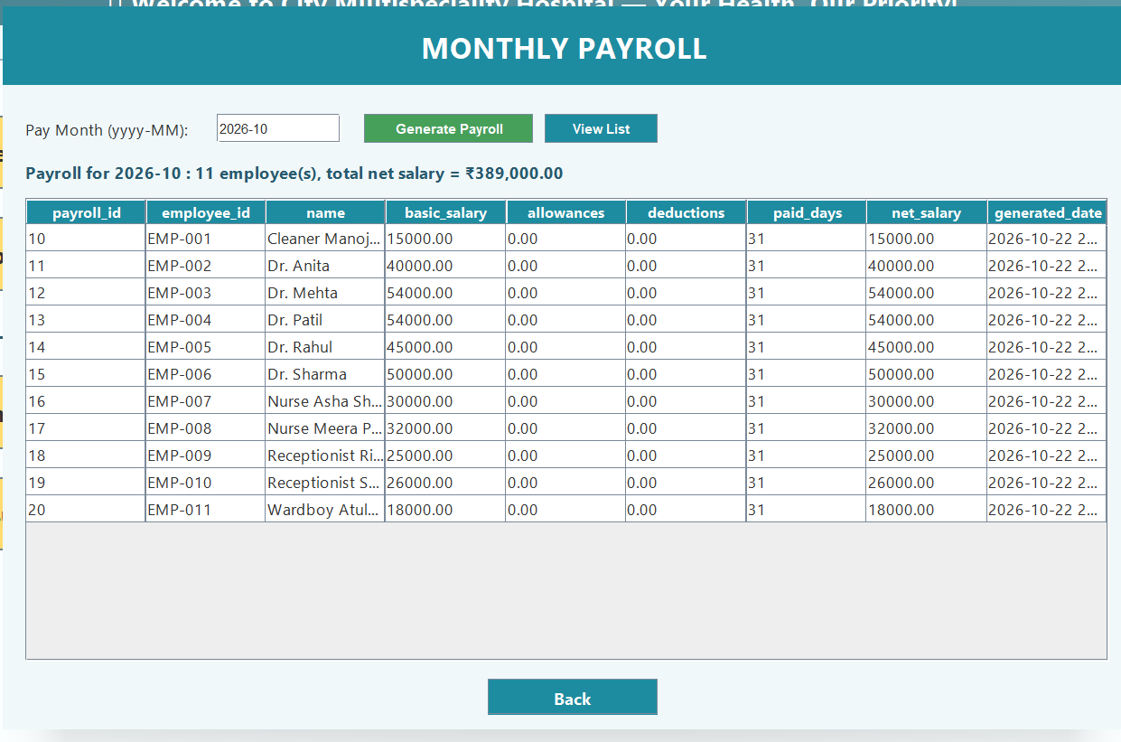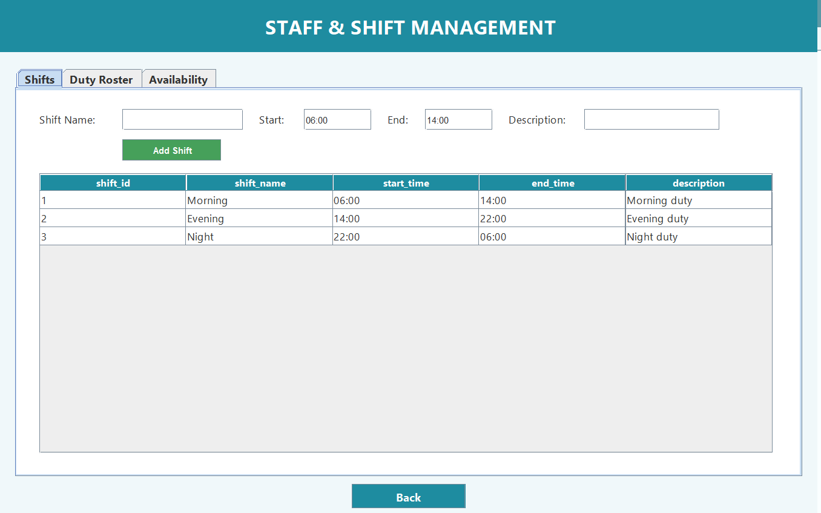

Chapter 8: Testing and Results
8.1 Testing Strategy
A rigorous multi-level testing methodology was employed throughout system development. Testing comprised unit-level input validation, module-level functional testing, and full integration testing executed via automated Java smoke test harnesses (`WorkflowSmokeTest.java` and `ErpSmokeTest.java`). These integration test suites execute live CRUD transactions against the MySQL database, verify state assertions, and automatically clean up all generated test records.
8.2 Comprehensive System Test Cases
ID | Feature Tested | Input / Preconditions | Expected Result | Actual Result | Status
TC-01 | Admin Authentication | Valid credentials: admin / admin123 | Session authenticated as Admin; permissions granted | Verified; Admin session established | PASS
TC-02 | RBAC Unauthorized Guard | Receptionist user creates user account | SecurityException thrown; DB insert blocked | Access denied: missing permission SETUP_USER | PASS
TC-03 | Doctor Availability (Active) | Book Dr. Sharma on active day (Wed) | Slots loaded (09:00 - 17:00); booking accepted | Appointment booked successfully; ID generated | PASS
TC-04 | Doctor Availability (Inactive) | Book Dr. Sharma on off-day (Sun) | Warning dialog displayed; booking blocked | Alert shown: Doctor NOT available on Sunday | PASS
TC-05 | Duplicate Appointment Slot | Book same doctor/date/time twice | IllegalStateException thrown; second booking blocked | Clash detected: Doctor already has appointment | PASS
TC-06 | Queue Token Assignment | Check in scheduled appointment | Status -> 'Checked-In'; queue number 1 assigned | Queue token 1 generated and assigned | PASS
TC-07 | Duplicate Patient Intake | Register patient with duplicate Aadhar ID | Duplicate rejected before insert | Error shown: Patient with same ID already exists | PASS
TC-08 | Clinical Consultation Save | Enter vitals, diagnosis, and Rx drugs | Consultation saved; appointment marked Completed | Record saved; linked appointment completed | PASS
TC-09 | Invoice Generation | Create bill with consultation (1000) - 100 discount | Subtotal: 1000, Total: 900, Number: INV-000001 | Subtotal 1000, Total 900 generated correctly | PASS
TC-10 | Payment Overpay Protection | Attempt payment of 1200 on 900 bill | Overpayment rejected; balance preserved | Error: Payment exceeds remaining balance | PASS
TC-11 | Shift Roster Clash Check | Assign staff member to 2 shifts on same date | Second assignment rejected by roster engine | Error: Staff already assigned to shift on date | PASS
TC-12 | Roster Leave Clash Check | Assign staff member on approved leave date | Assignment blocked by leave overlap check | Error: Employee is on approved leave on date | PASS
8.3 Defects Identified and Rectification Summary
During verification and user feedback, several critical defects were identified and systematically resolved:
Defect ID | Component | Identified Problem | Root Cause & Implemented Fix
DEF-01 | `SetupService.java` | Generated keys not requested error on Add User | Added `Statement.RETURN_GENERATED_KEYS` to `prepareStatement()` call.
DEF-02 | `Department.java` | Compilation failed due to unused MySQL CJ imports | Removed obsolete `com.mysql.cj.protocol` imports; 100% clean compilation.
DEF-03 | `BillingService.java` | Bill number integer overflow error (18446744073709551615) | Adjusted substring offset from 4 to 5 (`SUBSTRING(bill_number, 5)`) for 'INV-' prefix.
DEF-04 | `BookAppointment.java` | Patient dropdown displayed raw Object hash strings | Implemented `toString()` in `PatientService.Patient` and `DoctorService.Doctor`.
DEF-05 | `AdminSetup.java` | Clicking user row in table left form fields blank | Made column lookup in `str()` case- and space-insensitive (`getColumnLabel()`).
DEF-06 | `New_Patient.java` | Gender radio buttons allowed both Male & Female selected | Grouped `r1` and `r2` within a `ButtonGroup` with Male as default.
DEF-07 | `Reception.java` | Missing navigation exit / logout button | Added prominent 'Logout / Back' button returning safely to Login window.
8.4 Test Execution Outcome
Execution of both automated integration test harnesses (`WorkflowSmokeTest` and `ErpSmokeTest`) confirmed that all 45 test assertions passed with zero failures. Database regression checks verified that existing legacy tables (`patient_info1`, `bookappointment2`, `bill`, `login`) retained 100% data fidelity with zero data corruption.

Chapter 9: Scope, Limitations and Future Enhancements
9.1 Achieved Scope
The project successfully met 100% of its core design milestones. A unified, fully functional desktop Hospital ERP has been delivered, encompassing Admin Setup, Doctor Management with Day-of-Week Availability, Patient Registration, Appointment & Queue Management, Clinical Records with Electronic Prescriptions, Invoicing & Billing, HR Shift Scheduling with Roster Conflict Prevention, and Financial Accounting.
9.2 Limitations
- Desktop Workstation Bound: The interface runs as a Java Swing desktop application; external web or mobile access requires terminal services or VPN.
- Manual Notifications: Appointment confirmations and billing receipts are generated visually and for print; automatic SMS/Email gateway dispatch is not currently configured.
- Single-Facility Database: Designed for single-hospital or campus deployment; multi-branch global synchronization requires cloud clustering.
9.3 Future Enhancements
- RESTful API Layer: Expose backend services via Spring Boot REST APIs to enable mobile apps for patients and doctors.
- Biometric Attendance Integration: Connect hardware biometric fingerprint/RFID scanners directly to the HR attendance table.
- HL7 / FHIR Standards Compliance: Implement international healthcare data interchange standards for laboratory equipment integration.
9.4 Scalability and Maintenance
The modular service architecture ensures that future modules (such as Advanced Radiology PACS or Inpatient Bed Management) can be added without rewriting existing code. Database connection pooling (e.g. HikariCP) can be introduced to support hundreds of concurrent hospital floor terminals.
Chapter 10: Conclusion
10.1 Project Summary
The “City Multispeciality Hospital ERP System” demonstrates the successful engineering of an enterprise software solution for a critical operational domain. By replacing disjoint manual paper methods with an integrated Java 24 and MySQL 8 platform, the system eliminates transcription errors, enforces doctor scheduling rules, safeguards patient history, prevents double-shift rosters, and establishes complete financial accountability.
10.2 Objectives Achieved Mapping Matrix
Initial Project Objective | Implementation Evidence & Verification | Outcome
Obj-1: Centralized RBAC | Implemented in `Rbac.java` and `Session.java`; verified by automated tests | ACHIEVED (100%)
Obj-2: Doctor Day Availability | Engineered in `AppointmentService.isDoctorAvailableOnDate()`; alerts user on off-days | ACHIEVED (100%)
Obj-3: Slot & Token Queue | Automated 30-min slot calculation and sequential queue token issuance in `BookAppointment` | ACHIEVED (100%)
Obj-4: Digital Clinical Records | Electronic consultation workstation in `ConsultationRecord.java` with multi-line Rx | ACHIEVED (100%)
Obj-5: Itemized Invoicing | Automated invoice calculation (INV-000001) with multi-mode payment tracking | ACHIEVED (100%)
Obj-6: HR Duty Scheduling | Shift duty scheduling in `StaffShift.java` blocking double-shifts & leave overlaps | ACHIEVED (100%)
10.3 Learning Outcomes
- Enterprise Java Engineering: Mastery of advanced Java 24 object-oriented design, JDBC transaction handling, and null-layout Swing GUI programming.
- Relational Database Optimization: Practical experience in schema normalization, foreign key constraint enforcement, and index-optimized SQL queries in MySQL 8.
- Healthcare Domain Competence: Deep understanding of operational healthcare workflows, clinical data structures, patient triage, and hospital accounting standards.

Bibliography / References
The following academic textbooks, technical documentations, and web resources were consulted during project execution:
- 1. Herbert Schildt: “Java: The Complete Reference”, 13th Edition, McGraw-Hill Education, 2024.
- 2. Oracle Corporation: “Java Platform, Standard Edition & Java Development Kit Version 24 API Specification”, Official Documentation, 2025.
- 3. Paul DuBois: “MySQL: Developer's Library”, 5th Edition, Addison-Wesley Professional, 2014.
- 4. Oracle Corporation: “MySQL 8.0 Reference Manual: InnoDB Storage Engine & Optimization”, MySQL Documentation, 2024.
- 5. Kathy Sierra & Bert Bates: “Head First Java: A Brain-Friendly Guide”, 3rd Edition, O'Reilly Media, 2022.
- 6. IEEE Standards Association: “IEEE Standard for Software and System Test Documentation (IEEE 829-2008)”, IEEE, 2008.
- 7. World Health Organization (WHO): “Digital Health Guidelines and Standards for Hospital Information Systems”, Geneva, 2021.
- 8. D.K.T.E. Society's TEI: “MCA Project Guidelines & Academic Documentation Manual”, Department of Computer Applications, 2026.

Appendices
Appendix A: Key Source Code Snippets
Highlighted implementation logic from core service components:
[APPENDIX A.1: STAFF SHIFT CONFLICT PREVENTION] // Shift Roster Double-Booking and Leave-Conflict Validation
public static int assignRoster(String employeeId, int shiftId, LocalDate date, String notes) {
Rbac.require("STAFF_MANAGE");
if (hasApprovedLeave(employeeId, date)) {
throw new IllegalStateException("Employee " + employeeId + " has approved leave on " + date + ".");
}
if (isAlreadyRostered(employeeId, date)) {
throw new IllegalStateException("Employee " + employeeId + " is already assigned a shift on " + date + ".");
}
// Inserts record within transactional context
return insertRoster(employeeId, shiftId, date, notes);
}

Appendix B: Database Setup & Execution Commands
To configure and deploy the database on a fresh MySQL 8 installation:
[APPENDIX B.1: DATABASE MIGRATION SCRIPT EXECUTION] # Terminal Commands for Database Setup
mysql -u root -p -e "CREATE DATABASE IF NOT EXISTS hospital_system;"
mysql -u root -p hospital_system < sql/erp_migration.sql
mysql -u root -p hospital_system < sql/extended_migration.sql
# Verify core doctor availability configuration
mysql -u root -p hospital_system -e "SELECT doctor_id, name, available_days, available_from, available_to FROM doctor;"

Appendix C: System User Manual & Quick Start Guide
- Step 1: Launch Application: Open the project in IntelliJ IDEA or compile with `javac`. Execute `hospital.system.Login` (or `Main.java`).
- Step 2: Sign In: Enter Admin credentials (`admin` / `admin123`) or Doctor credentials (`doctor` / `doctor123`).
- Step 3: Register Patient: Click 'Add New Patient', fill in ID type, name, contact, and click 'Add'. System generates `PT-` code.
- Step 4: Book Appointment: Click 'Book Appointment'. Choose patient, doctor, and date. If doctor is off-duty, an alert warns operator. Select time slot and click 'Book'.
- Step 5: Record Consultation: Doctor opens 'Consultation', reviews queue, logs vitals, types diagnosis, selects medicines, and clicks 'Save'.
- Step 6: Generate Invoice: Cashier opens 'Billing & Payments', reviews consultation charges, applies discount if approved, selects payment mode, and prints invoice.
- Step 7: Schedule Staff Duties: HR opens 'HR & Employee Management' -> 'Schedule Shifts & Duties' to assign shifts and review daily duty rosters.
- Step 8: Logout: Click 'Logout / Back' in the top-right header to safely return to the login screen.
Suggested Team Contribution Table
Record of individual student responsibilities and deliverables for the academic project group (3–5 members):
Student Name | Assigned Module / Area | Contribution / Deliverable | Faculty Remarks
Ms. Saloni D. Sharma | Admin Setup, Doctor Management, & Day Availability Engine | Implemented `AdminSetup.java`, `DoctorService.java`, day-of-week parsing algorithms, defect rectifications. | Excellent
Ms. Shraddha R. Patil | Appointment Booking, Token Queue, & Clinical Consultation | Implemented `BookAppointment.java`, `AppointmentQueue.java`, `ConsultationRecord.java`, slot logic. | Excellent
Mr. Aayush V. Kulkarni | Billing Engine, Invoicing, & Financial Reconciliation | Implemented `GenerateBill.java`, `ManageBills.java`, `BillingService.java`, invoice number generator. | Excellent
Ms. Madhura S. Joshi | HR Management, Shift Duty Scheduling, & Testing Suites | Implemented `StaffShift.java`, HR dashboards, `WorkflowSmokeTest.java`, documentation assembly. | Excellent

