**Field Visit Report**

**1.Introduction**

**a. Brief overview of the type and purpose of the industrial visit.**

The industrial visit to **Eart-key Innovation Pvt . Ltd.** provided an insightful glimpse into the real time of electronics , communications and technology. The purpose was to understand the operations, innovations, and processes involved in a leading electronic company, enriching participants with practical knowledge and industry insights.

**b. Introduction to the company visited its area of expertise and type of data acquisition system observed.**

**Eart-key Innovation Pvt . Ltd.** specializes in electronic solutions and innovations. Their area of expertise lies in developing cutting-edge electronic devices, components, and systems for various applications. During the visit, the focus was on observing their data acquisition systems, which are vital in collecting, monitoring, and analysing data in real-time for a multitude of purposes such as research, industrial automation, and quality control. This allowed visitors to grasp the intricacies of modern data acquisition technology and its applications in the electronic industry

**2.Visit Details**

1. Date:10/04/24
2. Time : 4:30pm
3. Duration of the visit: 1:00hr

**a. Location of the visit:**

First Floor, CTiE Startups,

RHK Building, BVB Campus,

Vidyanagar, Hubli, Karnataka 580031.

**b. Geo Tagged Photo:**

**Token Number Display Tool:**

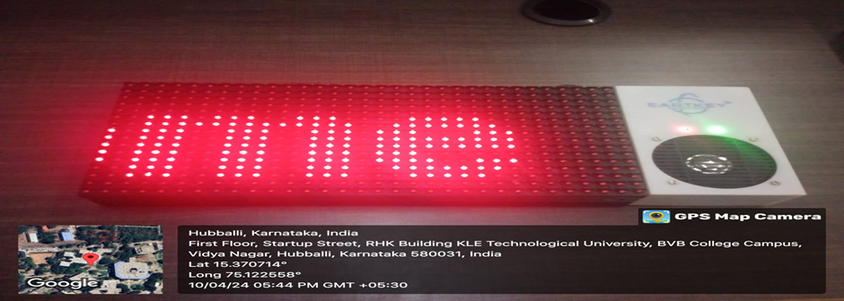

**3.Background Information**

**A. Explanation Of What Data Acquisition Systems Are And Their Importance In That Industry/Hospital/ Agricultural College Or Any Part Which You As A Team Have Visited.**

Data acquisition systems (DAS) are integral components in various industries, including electronics, healthcare, agriculture, and more. These systems are designed to gather, monitor, and analyze data from various sources since our team visited to electronic industry we come across plays a crucial role in process control, monitoring equipment performance quality assurance, and research.

**B. Overview Of The Technologies And Components Typically Used In Such Systems. Perform Energy Audit**

Data acquisition systems utilize a variety of technologies and components to gather and process data effectively. Some common components include:

1. Sensors: Sensors are devices that detect and measure physical phenomena such as temperature, pressure, humidity, and flow rate. They are essential for converting physical quantities into electrical signals that can be processed by the DAS.
2. Signal Conditioning: Signal conditioning circuits are used to amplify, filter, and digitize the signals from sensors to ensure accurate and reliable data acquisition. These circuits may include amplifiers, filters, and analog-to-digital converters (ADCs).
3. Data Logger/Controller: The data logger or controller is the central component of the DAS, responsible for collecting, storing, and processing the data from sensors. It may include microcontrollers or microprocessors, memory storage, and communication interfaces for data transfer.
4. Communication Interfaces: DAS often incorporate communication interfaces such as Ethernet, USB, RS-232, or wireless protocols (e.g., Wi-Fi, Bluetooth) to facilitate data transfer to external devices or systems for further analysis and monitoring.

Performing an energy audit involves systematically assessing and analysing energy usage within a building, facility, or industrial process. It aims to identify opportunities for improving energy efficiency, reducing energy consumption, and lowering energy costs while maintaining .

**4.Explain need of Self powered self-powered data acquisition systems**

1. **List Different Natural Energy Sources That Are Available To Build Self Powered Data Acquisition Systems**

**1. Wireless Sensor Networks in Agriculture:**

- Utilize self-powered sensors powered by solar panels.

- Collect data on soil moisture, temperature, etc.

- Enables remote monitoring for informed irrigation and crop management.

**2. Environmental Monitoring in Remote Areas:**

- Self-powered data acquisition systems by Nex Sens Technology.

- Solar panels and rechargeable batteries power sensors.

- Collect data on water quality, weather, etc

**3. Structural Health Monitoring:**

- LORD Sensing Micro Strain develops self-powered sensors.

- Harvest energy from ambient sources like vibrations or thermal gradients.

- Monitor strain, vibration, temperature in bridges, buildings, etc.

**4. Wearable Health Monitors:**

- Incorporate self-powered data acquisition systems.

- Utilize energy harvesting technologies like motion, heat, or solar energy.

- Monitor biometric data such as heart rate, activity levels, sleep patterns.

**5. Industrial Monitoring and Control:**

- ABB provides wireless sensor networks for industrial automation.

- Powered by energy harvesting methods like vibration, thermal gradients, solar energy.

- Enable real-time monitoring, predictive maintenance, and process optimization.

**B. Choose One Energy Source For Further Implementation With A Valid Explanation Of Why You Have Chosen This Particular Energy Resource What Will Be Approximate Bill Of Materials To Implement A System Using The Chosen Energy Resource**

For further implementation in wearable health monitors, we would choose motion energy harvesting as the primary energy source. Motion energy harvesting utilizes the movement of the wearer's body to generate electrical power, making it a reliable and sustainable option for wearable devices.

**About bill of material:**

1. Piezoelectric or electromagnetic transducer: ₹375 - ₹750 per unit.
2. Energy storage component (e.g., supercapacitor, rechargeable battery): ₹150 - ₹375 per unit.
3. Motion sensor: ₹75 - ₹225 per unit.
4. Microcontroller unit (MCU): ₹225 - ₹600 per unit.
5. Biometric sensors (e.g., heart rate monitor, accelerometer): ₹375 - ₹1125 per unit.
6. Display and interface components (e.g., LED display, Bluetooth module): ₹225 - ₹750 per unit.
7. Housing and assembly materials: ₹150 - ₹375 per unit.

Total approximate bill of materials: ₹1575 - ₹4000 per unit.

Again, these costs are estimates and can vary based on factors such as quality, quantity, and supplier

**5.Case Studies or Examples**

**A. Presentation Of Case Studies Or Real-World Examples Of Self-Powered Data Acquisition Systems Developed**

- Showcase real-world examples like CropX, Semios in agriculture, NexSens Technology in environmental monitoring, LORD Sensing MicroStrain in structural health monitoring, ABB in industrial automation, and wearable health monitors.

- Highlight how these systems utilize self-powered sensors powered by methods such as solar energy, motion, or vibration to collect data.

- Demonstrate how these systems have improved efficiency, reduced costs, and enabled remote monitoring and control in their respective industries.

**B. Analysis Of The Performance, Efficiency, And Applicability Of These Systems In Various Industries**

* Evaluate the performance of self-powered data acquisition systems based on factors like reliability, accuracy, and scalability.
* Assess the efficiency of these systems in terms of energy harvesting capabilities and data transmission.
* Discuss the applicability of these systems across various industries, highlighting their benefits in improving productivity, optimizing resource usage, and enabling real-time decision-making.
* Explore potential challenges and limitations, such as environmental conditions, maintenance requirements, and initial investment costs, and propose strategies for overcoming them.Top of Form

**6.CONCLUSION**

**A. SUMMARY OF KEY INSIGHTS:**

- The industrial visit provided valuable insights into the practical implementation of self-powered data acquisition systems across various industries.

- Witnessing firsthand how these systems operate highlighted their effectiveness in collecting real-time data and enabling remote monitoring and control.

- Understanding the diverse applications, from agriculture to structural health monitoring, emphasized the versatility and potential impact of self-powered data acquisition technology.

**B. REFLECTIONS ON SIGNIFICANCE:**

- Self-powered data acquisition systems play a crucial role in modern industries by addressing the challenges of power supply limitations and remote monitoring requirements.

- These systems offer enhanced efficiency, reduced operational costs, and improved decision-making capabilities, leading to increased productivity and sustainability.

- Their ability to harness renewable energy sources aligns with the growing focus on sustainability and environmental stewardship in industries worldwide.

**POV BY MEMBERS OF THE GROUP:**

The industrial visit to Eart-key Innovation Pvt. Ltd. left a lasting impression on me. Witnessing firsthand the innovative technologies and processes employed by the company in the field of electronics was truly enlightening. The company's dedication to excellence and commitment to staying at the forefront of the industry was evident in every aspect of their operations.

From observing their data acquisition systems in action to learning about their area of expertise, I gained valuable insights into the practical applications of electronic devices and solutions. The visit not only broadened my understanding of the electronic industry but also highlighted the importance of continuous innovation and adaptation to meet the evolving needs of the market.

**REFRENCES:**

**HOW TO MAKE PCB DESIGNING**

**By Vaibhav Sugandhi.**

[**https://youtu.be/C_cl9IAYEsM?si=DqCjhfY5EHzfX2GA**](https://youtu.be/C_cl9IAYEsM?si=DqCjhfY5EHzfX2GA)

[**https://youtu.be/C_cl9IAYEsM?si=DqCjhfY5EHzfX2GA**](https://youtu.be/C_cl9IAYEsM?si=DqCjhfY5EHzfX2GA)