**Wireframe Document**

**Amazon Sales Data**

**Revision Number - 1**

**Last Date of Revision – 29/01/2023**

**Shreyas Patil**

WIREFRAME DOCUMENT DESIGN

## Summary Of year-month, monthly, yearly

Indicating the top countries and total sales

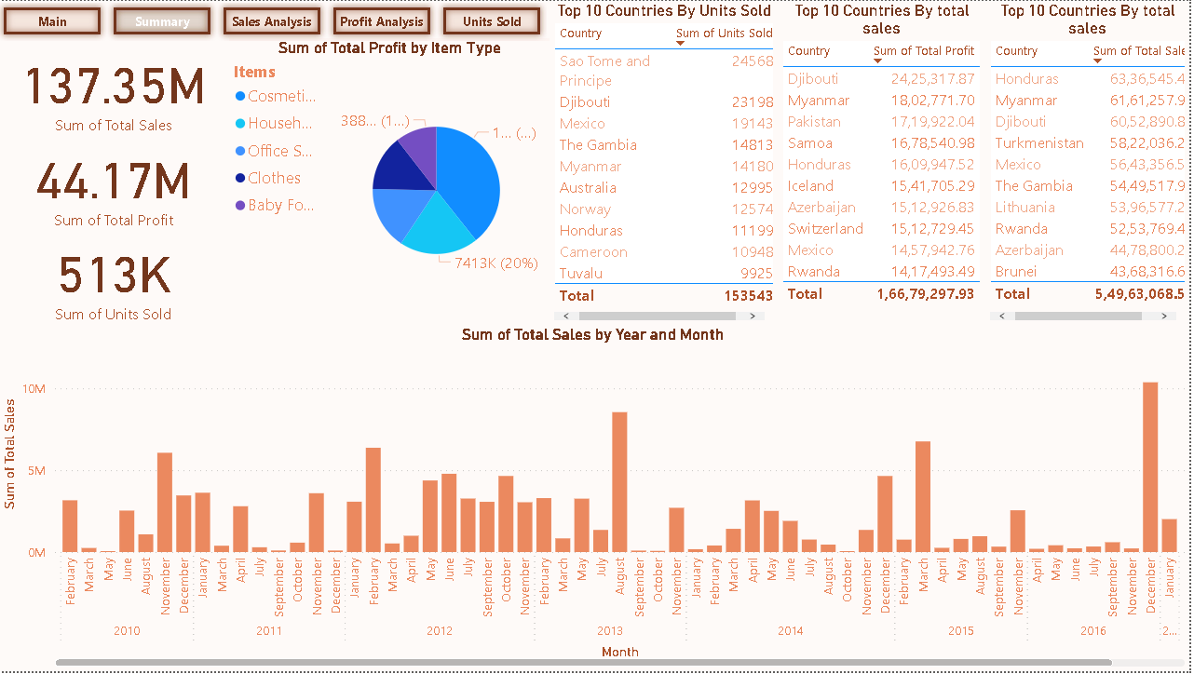

Sales Analysis

Providing region wise insights

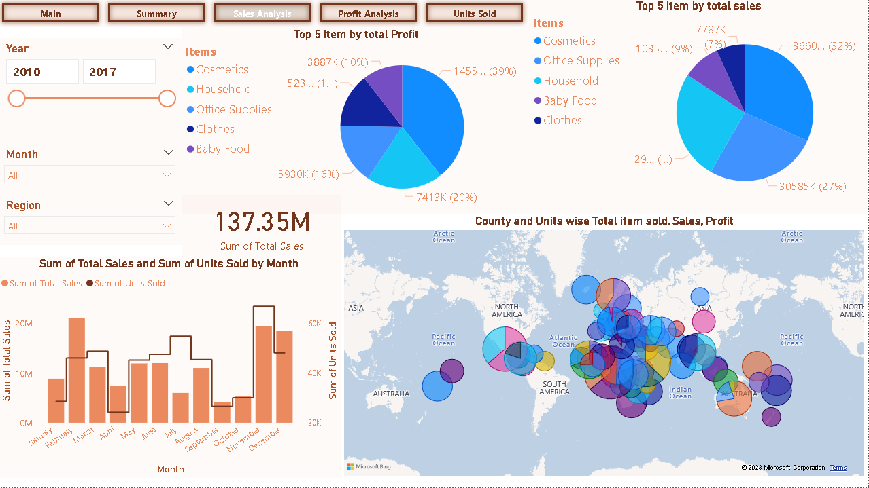

Profit Analysis:

Providing insights on most and least profitable item and countries

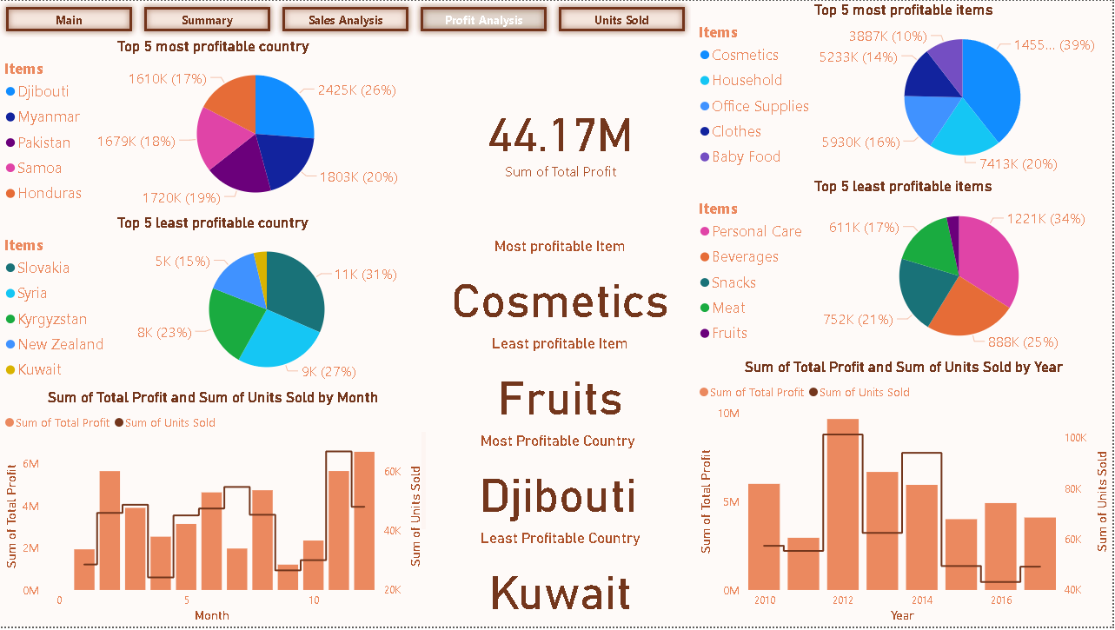

Units Sold:

Provide insights on maximum and minimum units sold:

