**Architecture Design**

**Amazon Sales Data**

**Revision Number - 1.1**

**Last Date of Revision - 29/03/2023**

**Shreyas Patil**

ARCHITECTURE DESIGN

**Document Control**

|  |  |  |  |
| --- | --- | --- | --- |
| **Date** | **Version** | **Description** | **Author** |
| 29/03/2023 | 1.0 | Introduction,  Architecture,  Deployment | Shreyas Patil |

Contents

Introduction 3

What is Architecture Design Document? 3

What is Scope? 4

Architecture 4

Power BI Architecture 4

Components of Power BI Architecture 5

Components of Power BI Architecture 5

Working of Power BI Architecture 6

Power BI Service Architecture 7

The Front-end Cluster 7

The Back-end Cluster 7

Power BI Dashboard 7

Power BI Features 7

Power BI Key Components 8

Power Query 9

Power Pivot 9

Power View 10

Power Map 10

Power Q & A 10

Power BI Desktop 11

Power BI Website 11

Power BI Mobile Apps 11

Deployment 11

Power BI Deployment 11

ARCHITECTURE DESI

# Introduction

## What is Architecture Design Document?

Any software needs the architectural design to represent the design of the software. IEEE defines architectural design as “the process of defining a collection of hardware and software components and their interfaces to establish the framework for the development of a computer system.” The software that is built for computer-based systems can exhibit one of these many architectures.

Each style will describe a system category that consists of:

* A set of components (eg: a database, computational modules) that will perform a function required by the system.
* The set of connectors will help in coordination, communication, and cooperation between the components.
* Conditions that how components can be integrated to form the system.
* Semantic models help the designer to understand the overall properties of the system.

## What is Scope?

Architecture Design Document (ADD) is an architectural design process that follows a step-by-step refinement process. The process can be used for designing data structures, required software architecture, source code and ultimately, performance algorithms. Overall, the design principles may be defined during requirement analysis and then refined during architectural design work.  
  
  
ARCHIT

ECTURE DES

# Architecture

## Power BI Architecture

Power BI Server is designed to connect many data tiers. It can connect clients from Mobile, Web, and Desktop. Power BI Desktop is a powerful data visualization tool. It is very secure and highly available.

It can run on both the physical machines and virtual machines. It is a **multi-process**, **multi-user**, and **multi-threaded** system.

Providing such powerful features requires unique architecture.

The different layers used in Power BI server are given in the following architecture diagram:

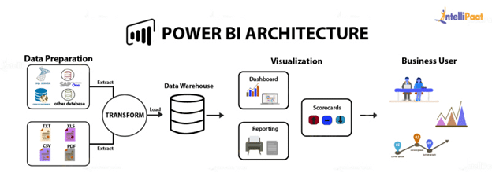

IG

## Components of Power BI Architecture

**1. Sourcing data:** Power BI extracts data from various servers, Excel sheets, CSV files, and databases. The extracted information can be directly imported to Power BI, or a live service link is established to receive it. If you directly import the data in Power BI, it will only be compressed up to 1 GB. Post that, you can only run live queries on your chunky datasets Transforming the data: Before visualizing the data, cleaning and preprocessing it should be done. This means removing useless or missing values from rows or columns. Following that, certain rules will be applied to transform and load the datasets into the warehouse.

**2. Report and publish:** After cleaning and transforming the data, reports will be created based on requirements. A report is a visualization of the data with different filters and constraints presented in the form of graphs, pie charts, and other figures.

**3. Creating dashboards:** Power BI Dashboards are created by pinning individual elements or pages of live reports. Dashboards should be created after you have published your reports to the BI service. When the reports get saved, the visual maintains the filter settings chosen so that the user can apply filters and slicers.

## Components of Power BI Architecture

1. Power BI Desktop: Power BI Desktop is a free software used to convert, connect, and visualize datasets on a PC or laptop. It’s one of the most important Power BI components where you can integrate distinct information sources and combine them to form a data model. Then, you can create graphics or image collections to share them as records with other individuals in your organization.
2. Power BI Service: After the reports are created on Power BI Desktop, you can publish them on the cloud using Power BI Service. The service connects users and allows them to create dashboards known as Power BI Workspace. It offers natural language Q&A and alerts, and it is available in both Power BI free and Power BI Pro versions,
3. Power BI Mobile Apps: The mobile apps of Power BI keep you connected with the data no matter where you are. You can see live reports and dashboards on your iOS and Android smartphones and make better market decisions on the go. Only pro Power BI architecture provides the feature of Mobile reports and dashboards.
4. Power BI Query: Power Query allows users to connect distinct information from multiple sources and convert them to satisfy their business requirements. Power Query is included in the Power Query Editor of Power BI Desktop.
5. Power Q&A: Power Q&A allows business users to explore information in their own words and phrases. This natural language question and reply engine is the fastest way to get the response from your data.
6. Power Map: Power BI queries offer a 3D visualization tool, Power Map, that shows differences in datasets with shadings ranging from dark to light.
7. Power Pivot: Power Pivot allows data storage with high compression, quick aggregation, and calculation. With Power Query, users can load information into it, or the pivot can load information on its own.
8. Power View: For a quick and effective visualization in Excel workbooks, Power View’s drag-n-drop feature and save your time. It’s an important part of MS Power BI architecture that enables the user to quickly visualize the data in a few clicks.

## ****Working of Power BI Architecture****

The architecture is mainly divided into two parts: On-cloud and on-premises services. It will be more clear from the image. You can also consider it as a Power BI data flow Diagram that helps you understand the flow of data from On-premises to On-cloud server applications.

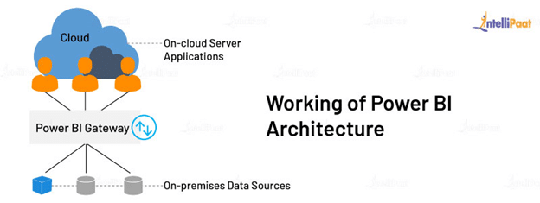

**On-premises**

Here, all kinds of reports published in the Power BI Report Server are distributed to the end-user. Power Publisher enables the user to publish Excel workbooks to Power BI Report Server. Report Server and Publisher tools help you create datasets, paginated reports, mobile reports, and more.

**On-cloud**

In the Power BI Gateway architecture, the BI gateway acts as a bridge in transferring data from on-premises data sources to on-cloud servers or applications. The cloud consists of various components such as dashboards, datasets, reports, Power BI Embedded, etc. These on-cloud data sources are connected with the Power BI tools.

## Power BI Service Architecture

### The Front-end Cluster

The front-end cluster acts as a medium between the client and the on-cloud servers in the Power BI data flow diagram. After the initial connection and authentication using Azure Active Directory, the client can interact with the datasets located across the globe.

### The Back-end Cluster

The back-end cluster manages datasets, storage, reports, visualizations, data connections, data refreshing, and other services in Power BI. At the cluster, web clients have only two points to interact with the information, i.e., Azure API Management and Gateway Role. These components are responsible for authorizing, routing, authentication, load balancing, etc.

Now that you know about the Power BI architecture and its works, let’s discuss the Power BI dashboard and its unique features of Power BI.

### Power BI Dashboard

Power BI dashboard is a single-page visualization generated from different reports based on your datasets. In other words, it is a canvas that brings different elements representing multiple datasets together. A report can be of multiple pages, but a dashboard will only be of a single page.

Data visualizations attached to a BI dashboard are called tiles. You can alter these tiles by adding or removing some of them as per requirements.

### Power BI Features

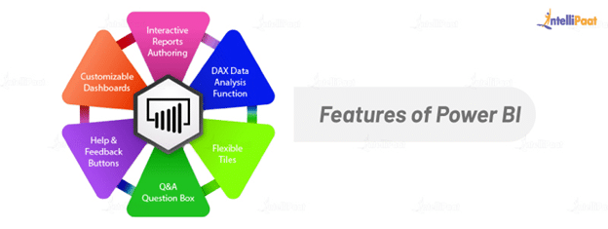

* **Interactive reports authoring:** You can apply filter and sorting operations to expose the target columns and create highly customized reports. These reports provide an overview of the current situation, which helps you run appropriate queries on the entire database.
* **DAX data analysis function:**Data Analysis Expressions (DAX) is a library that can be combined to build expressions and formulas for new measures and visualizations in Power BI, Analysis Services, and Power Pivot.
* **Flexible tiles:**Talking about customization, you can add, remove, or edit various properties of every tile on the dashboard and achieve your business goals.
* **Q&A question box:** It enables you to run queries on the data in the form of natural sentences and voice commands. Power BI uses Cortana’s Deep Learning technology to identify the commands given by the user.
* **Stream analytics:**Power BI provides stream analytics, i.e., processing data while it is in motion. This feature assists real-time analytics of the ‘in-motion data through different websites, sales, social media, and other sources to make timely decisions.
* **Help and Feedback buttons:**You get 24/7 assistance from Microsoft’s support team as it resolves any issue or question you have in mind.
* **Customizable dashboards:**In case the default standards are not able to meet your requirements, you can access custom visualization libraries to process the datasets and create custom dashboards.
* **Dataset filtration:**With Power BI, you can create visualizations using data filtrations and have smaller subsets of contextual relevance or important information.

### Power BI Key Components

* Power Query
* Power Pivot
* Power View
* Power Map
* Power Q&A
* Power BI Desktop
* Power BI Website
* Power BI Mobile Apps

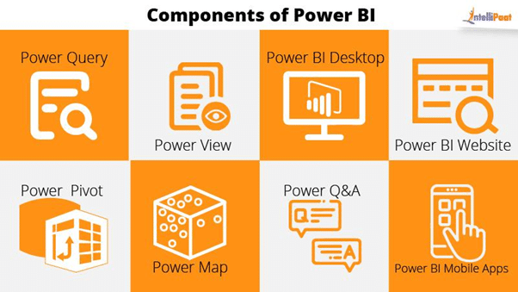

### **Power Query**

Power Query is one of the important components of Power BI. This can be included in your Excel or can be used as a component of the Power BI Desktop. Using Power Query, you can delete data from numerous data sources and extract data from a wide range of different databases like Oracle, SQL Server, MySQL, and other different databases. You can also fetch data from records like text files, CSV files, or Excel files. Power BI gives you a strong GUI so that you can transform and use the data as you need, such as the date and time changes, adding columns, changing the types and content, and many different options. It uses a simple language, Power Query M Formula Language, as a behind code which is more vigorous than a GUI. Power Query M Formula Language in Power BI is case sensitive and is optimized for building highly flexible data mashup queries which are available to Power BI Desktop and Power Query. It has many functionalities which cannot be accessed by a GUI.

* 1. **Bottom of Form**

### **Power Pivot**

Power Pivot is a data modelling and calculation engine. It is used for modelling simple and complex data. In Power Pivot, you can set or create relationships between different tables and calculate values that can be viewed in Pivot tables. It provides you with a huge space to create your design.  
The language used by Power BI Pivot is Data Analysis Expression (DAX), which is a strongly functional language, and all your calculations are done here.

### **Power View**

Power View is the fundamental data visualization component of Power BI. It is an interactive component that connects to data sources and retrieves metadata that can be utilized for data analysis. There are many blueprints for visualization in the Power View lists. With Power View, you can filter data for each visualization component or even for the entire report. Slicers can be used for better slicing and dicing of data. Reports in Power View are interactive; the user can highlight some part of the data or different components in Power View to interact with each other.

### **Power Map**

Power Map is used to visualize geospatial data in 3D mode. As soon as the visualization renders in 3D mode, it provides another dimension to it. In Power Map, you can assume one attribute as the length of a column in 3D and another attribute as a heatmap view. Based on a geographical location, the data can be highlighted. Geographical locations can be a country, state, city, or street address.  
To get the best visualization, Power Map works with the Bing Maps based on the geographical latitude or longitude or a country, state, city, or street address data.

### **Power Q & A**

Power BI Q&A is an ordinary language motor for your data model’s questions and answers. After assembling your data model and updating it on Power BI Website, you or your users can ask questions, if any, and get solutions to those questions. There are some shortcuts and hints for the construction of your model so that it can answer questions in the best possible way. For data visualizations, Power Q&A works with Power View so that users can ask questions, like the number of customers by state, and the question is answered in the form of a map view with numbers represented as bubbles by Power Q&A.

### **Power BI Desktop**

Power BI Desktop is a new component in the Power BI suit. It is an integrated development tool for Power Query, Power Pivot, and Power View. It lets you build advanced queries, models, and reports. With Power BI Desktop, it is easy to advance your skills in BI and your experience in data analytics.

### **Power BI Website**

The solutions of Power BI can be published on the Power BI Website. You can create dashboards in Power BI for your reports and share them with others, and you can also create reports directly on the Power BI Website. With Power BI Website, you can perform slice and dice operations on data online using a web browser, and it doesn’t even require any other tool.

### **Power BI Mobile Apps**

Power BI Mobile Apps have three mobile operating systems (OS) providers: Android, iOS, and Windows. These applications provide you with an interactive view of reports and dashboards on the Power BI site. You can even share them from your mobile app. A portion of the reports can be featured and a note can be composed on it and shared with others.

## Deployment

### Power BI Deployment

Prioritizing data and analytics couldn’t come at a better time. Your company, no matter what size, is already collecting data and most likely analyzing just a portion of it to solve business problems, gain competitive advantages, and drive enterprise transformation. With the explosive growth of enterprise data, database technologies, and the high demand for analytical skills, today’s most effective IT organizations have shifted their focus to enabling self-service by deploying and operating Power BI at scale, as well as organizing, orchestrating, and unifying disparate sources of data for business users and experts alike to author and consume content.

* **Sectoral Analysis : -**

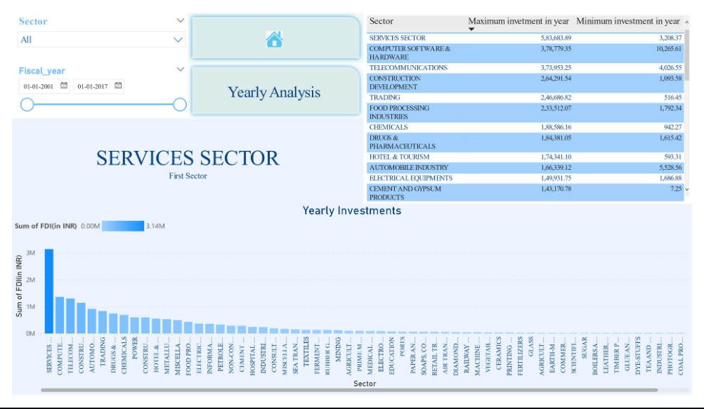

* **Yearly Analysis: -**

