**Low Level Design (LLD)**

**Investment Analysis**

**Revision Number - 1.2**

**Last Date of Revision–29/03/2023**

**Shreyas Patil**

**Document Control**

|  |  |  |  |
| --- | --- | --- | --- |
| **Date** | **Version** | **Description** | **Author** |
| 29/03/2023 | 1.0 | Introduction, Problem Statement  Dataset Information, Architecture Description  Final Revision | Shreyas Patil |

**Why this Low-Level Design Document?**

The purpose of this document is to present a detailed description of the Amazon sales data trend. It will explain the necessary steps which have to be followed before any analysis can begin. LLD describes the class diagrams with the methods and relations between classes and programs specs. It describes the modules so that the programmer can directly code the program from the document. This document is intended for both the stakeholders and the developers of the system and will be proposed to the higher management for its approval.

The LLD will be focusing on the below objectives:

* Problem Understanding.
* Data Acquisition.
* Data Pre-Processing and Exploratory Analysis
* Development of models
* Auditing accuracy and retrain if require
* Finalizing the model
* Dashboard report for important activities

**Scope**

The LLD documentation presents the detailed structure of the Investment analytics for each of its individual components. The goal of LLD is to give the internal logical design of the actual program code. Low-level design is created based on the high-level design. The LLD documentation contains the complete description of the model used along with the comparisons of the proposed model/library compared with a baseline(existing) model against a set of metrics.

**Project Introduction**

Sales management has gained importance to meet increasing competition and the need

for improved methods of distribution to reduce cost and to increase profits. Sales

management today is the most important function in a commercial and business

enterprise.

The given dataset contains sales data.

**Constraints**

Our analysis is done based on a limited dataset provided. The analysis is done on year vs sales trends, month vs sales trends and month year vs sales trends.

**Risks**

Document specific risks that have been identified or that should be considered.

**Out of Scope**

Delineate specific activities, capabilities, and items that are out of scope for the project.

* **Technical specifications**

**Dataset**

The Dataset is taken from iNeuron’s provided dataset-

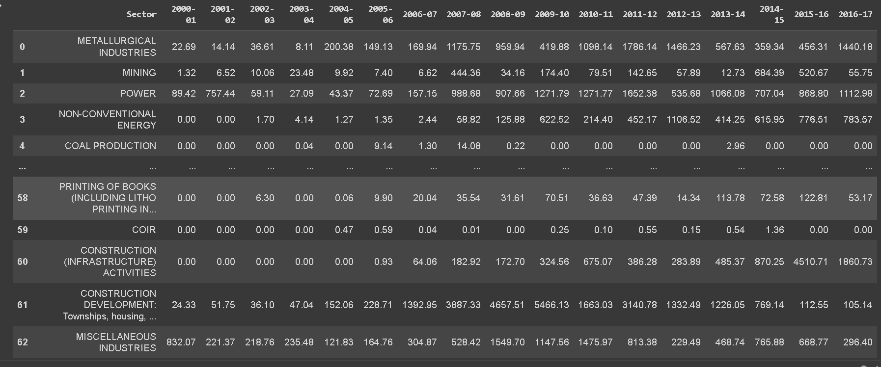

* **Problem Statement**

Sales management has gained importance to meet increasing competition and the need

for improved methods of distribution to reduce cost and to increase profits. Sales

management today is the most important function in a commercial and business

enterprise.

To understand the sales trends:

This dataset contains sales of the product and we have to find -

Month vs sales trends

Year vs sales trends

Month year vs sales trends

Find key metrics and factors and show the meaningful relationships between attributes.

Do your own research and come up with your finding

* **Architecture Description**
* **Raw Data Collection-** The Dataset was taken from iNeuron provided Project Description Document.
* **Data Pre-Processing**

Before building any model, it is crucial to perform data pre-processing to feed the correct data to the model to learn and predict. Model performance depends on the quality of data to the model to train.

This Process includes-

* Handling Null/Missing Values
* **Data Cleaning**

Data cleaning is the process of fixing or removing incorrect, corrupted, incorrectly formatted, duplicate, or incomplete data within a dataset.

* Remove duplicate or irrelevant to observations
* Filter unwanted outliers
* Renaming required attributes
* Resetting Datatype
* **Exploratory Data Analysis (EDA)**

Exploratory Data Analysis refers to the critical process of performing initial investigations on data to discover patterns, spot anomalies, test hypothesis

and to check assumptions with the help of summary statistics and graphical representations.

* **Reporting**

Reporting is a most important and underrated skill of a data analytics field. Because being a Data Analyst you should be good in easy in report because your model will be used by many stakeholders who are not from technical background.

* High Level Design Document(HLD)
* Low Level Design Document(LLD)
* Architecture
* Wireframe
* Detailed Project Report
* Power Point Presentation
* **Modelling**

Data Modelling is the process of analysing the data objects and their relationship to the other objects. It is used to analyse the data requirements that are required for the business processes. The data models are created for the data to be stored in a database. The Data Model's main focus is on what data is needed and how we have to organize data rather than what operations we have to perform.

* **Deployment**

I have created dashboard which has Pages like Summary, Sales Analysis, Profit Analysis, Units Sold.

* **Yearly Analysis: -**

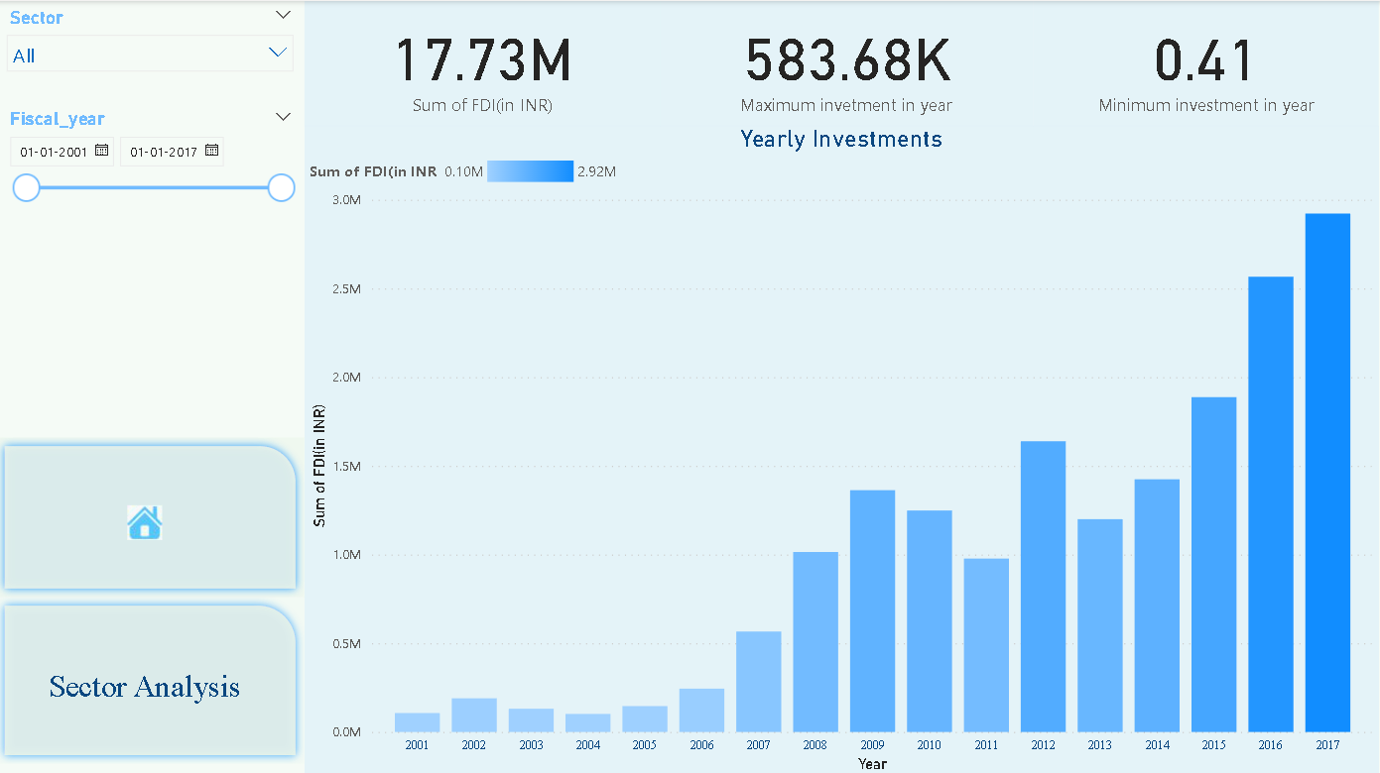

* **Sectoral Analysis: –**

