**Wireframe Document**

**Investment Analysis**

**Revision Number - 1**

**Last Date of Revision – 29/03/2023**

**Shreyas Patil**

WIREFRAME DOCUMENT DESIGN

## Summary Of Yearly and sectoral analysis

Yearly Analysis

<https://app.powerbi.com/links/1Zj6ytKblh?ctid=897f5385-e329-4627-a9b9-dbf5ccd74824&pbi_source=linkShare>

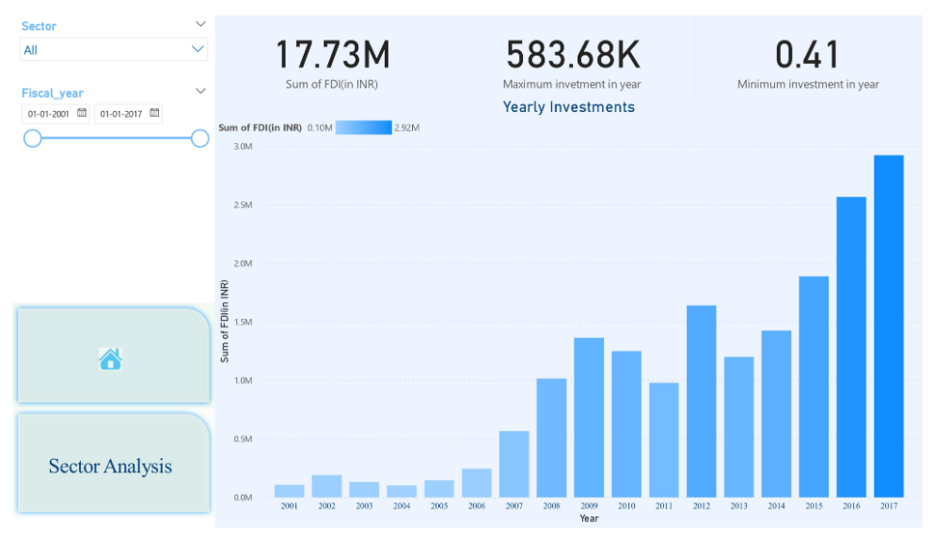

Sectoral Analysis

<https://app.powerbi.com/links/1Zj6ytKblh?ctid=897f5385-e329-4627-a9b9-dbf5ccd74824&pbi_source=linkShare>

