**Name:** Shubham Vilas Pawar

**Phone:** (+91) – 9146070223

**Email:** [shubhamvpawar121@gmail.com](mailto:shubhamvpawar121@gmail.com)

**LinkedIn**: <https://www.linkedin.com/in/shubham-pawar-a83169160/>

**Location:** Pune, India

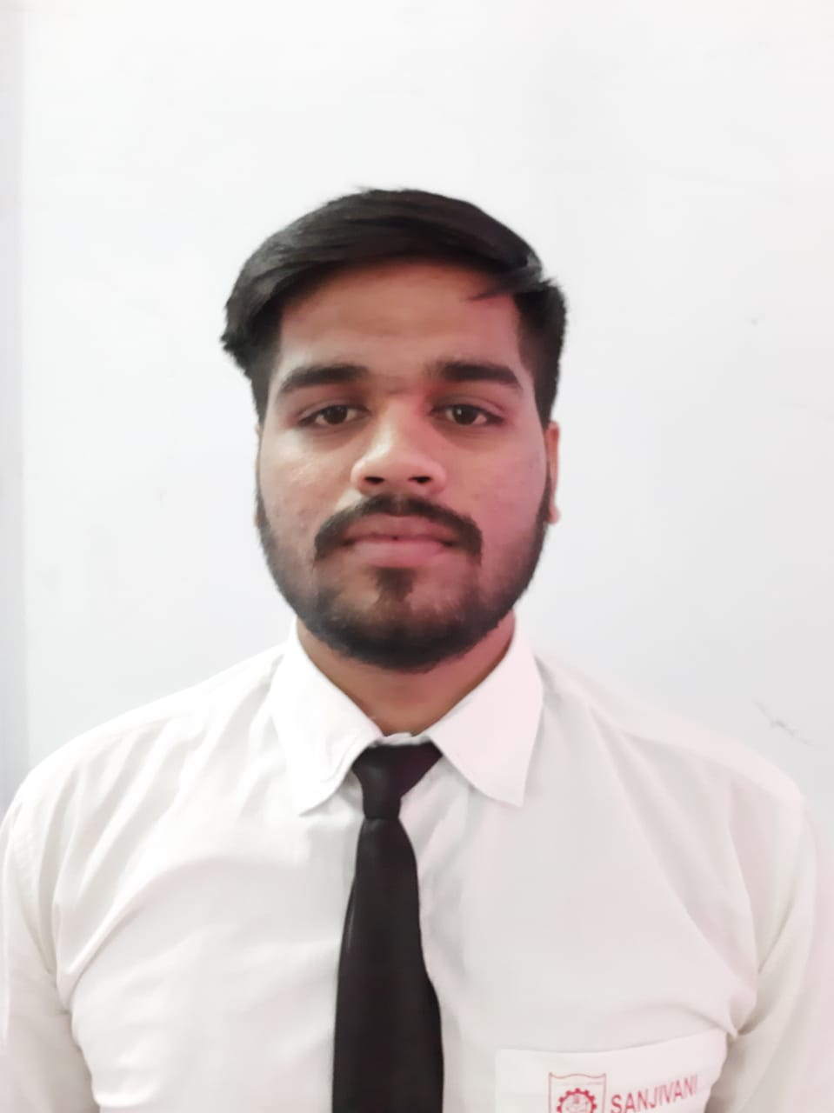



**Objective:**

To make use of my interpersonal skills to achieve goals of company that focus on customer

satisfaction and customer experience.

**Work Experience:**

|  |  |  |
| --- | --- | --- |
| Company Name | Joined Since | Number Of Year |
| Accenture Sol. Pvt. Ltd. Pune | July, 2021 | 1 Year 9 Month |

# 

# Skills

|  |  |
| --- | --- |
| **RPA Tools** | Blue Prism, UiPath |
| **Technical** | HTML, CSS, JavaScript, C, C++, Oracle-SQL,Basic Java |
| **Productive Tool** | VS code, Linux, Dev C++ |
| **Interpersonal** | Team Management, Hard Working and Achieve Listening |

**Project:**

# Title: SAP-HCM

**Training:**

* + Doing online training on Blue Prism RPA tool.
  + Certification Course of **Oracle SQL** and **Core Java** at ITpreneur Data System Pvt.Ltd,

Akurdi, Pune.

* + I have received domain training from Accenture called LINUX

In that I have gone through following training.

* + - * **LINUX**
      * **AWS**
      * **AZURE**

# Co/Extra-Curricular Activities:

* + Completed the level 1 training in International English
  + Completed online Linux training

**Roles and Responsibility:**

* + Hands on and comfortable with Blue Prism and UiPath
  + Basic understanding and comfortable to write code in C and C++ and Java
  + Having an efficient knowledge of about OOP

# Achievements:

* + Represented Ahmednagar district at zonal level in Boxing Competition
  + Runner Up in Inter College Boxing Competition

# Education Qualification:

|  |  |  |  |  |
| --- | --- | --- | --- | --- |
| **Course** | **Institute Name** | **University/Board** | **Year** | **Percentage/CGPA** |
| B.E(Info.Tech.) | Sanjivani College of Engineering  Kopargaon | Savitribai  Phule Pune  University | 2020 | 6.70 |
|  |  |
|  |  |
| HSC | Sant Bahinabai  Junior College,  Shivoor | Maharashtra  State  Board,Pune | 2016 | 70 |
|  |
| SSC | Z.P.High School,  Borsar | Maharashtra  State  Board,Pune | 2014 | 71.60 |
|  |

**Personal Details:**

**Name:** Shubham Vilas Pawar.

**DOB:** 08 Jun 1998

**Gender:** Male

**Email:** shubhamvpawar121@gmail.com

**Address:** A/P- Borsar, Tal. - Vaijapur, Dist. – Chatrapati Sambhajinagar, Pincode-423703

I declare that above mentioned information is correct as my knowledge.

# Date:

**Place:**

**SHUBHAM PAWAR**