TapTap Adaptive Modular Game Engine (TAMGE)

Team: S S PRAJWALA

Engine League – Round 1 Submission
Theme: Gamify Learning. Amplify Employability.
Built using:
React + TypeScript | Node.js + Express | MongoDB Atlas

SYSTEMS BLUEPRINT CHECK

SYSTEM ARCHITECTURE
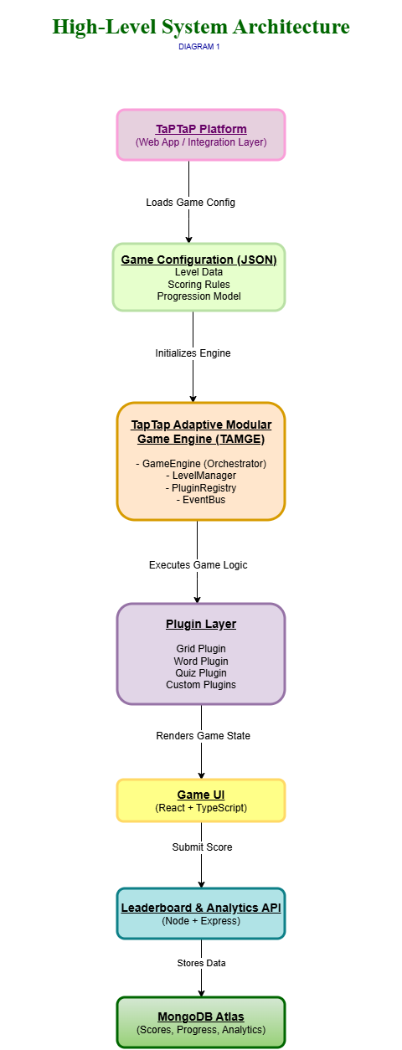
The TapTap Adaptive Modular Game Engine follows a modular, web-based architecture designed for scalability, flexibility, and platform integration.
The system consists of:
• Frontend Engine Layer (React + TypeScript)
• Backend Services Layer (Node + Express)
• Database Layer (MongoDB Atlas)
• Config-Driven Game Loader
The frontend dynamically loads game configurations (JSON-based) from the backend. The engine processes gameplay logic, adaptive difficulty decisions, scoring, and progression rules independently of specific game types.
This ensures:
- New games can be added without modifying engine core
- Game logic remains reusable
- Platform integration remains seamless
- High scalability across campuses
The architecture separates configuration from execution — enabling long-term extensibility.

ENGINE INTERNAL ARCHITECTURE
The engine is built using a modular internal design where each core responsibility is isolated into a dedicated component.
Core Modules:
• Game Loader – Loads and validates JSON game configuration
• Level Manager – Controls stage transitions
• Adaptive Engine – Applies performance-based difficulty branching
• Score Engine – Calculates time and accuracy-based scores
• Timer Engine – Manages dynamic level timers
• Leaderboard Interface – Sends performance data to backend
This modular structure ensures:
- Clean separation of concerns
- Plug-and-play game compatibility
- Maintainability and testability
- Future AI-based enhancements
Each module operates independently but communicates through a unified Engine Core Controller.
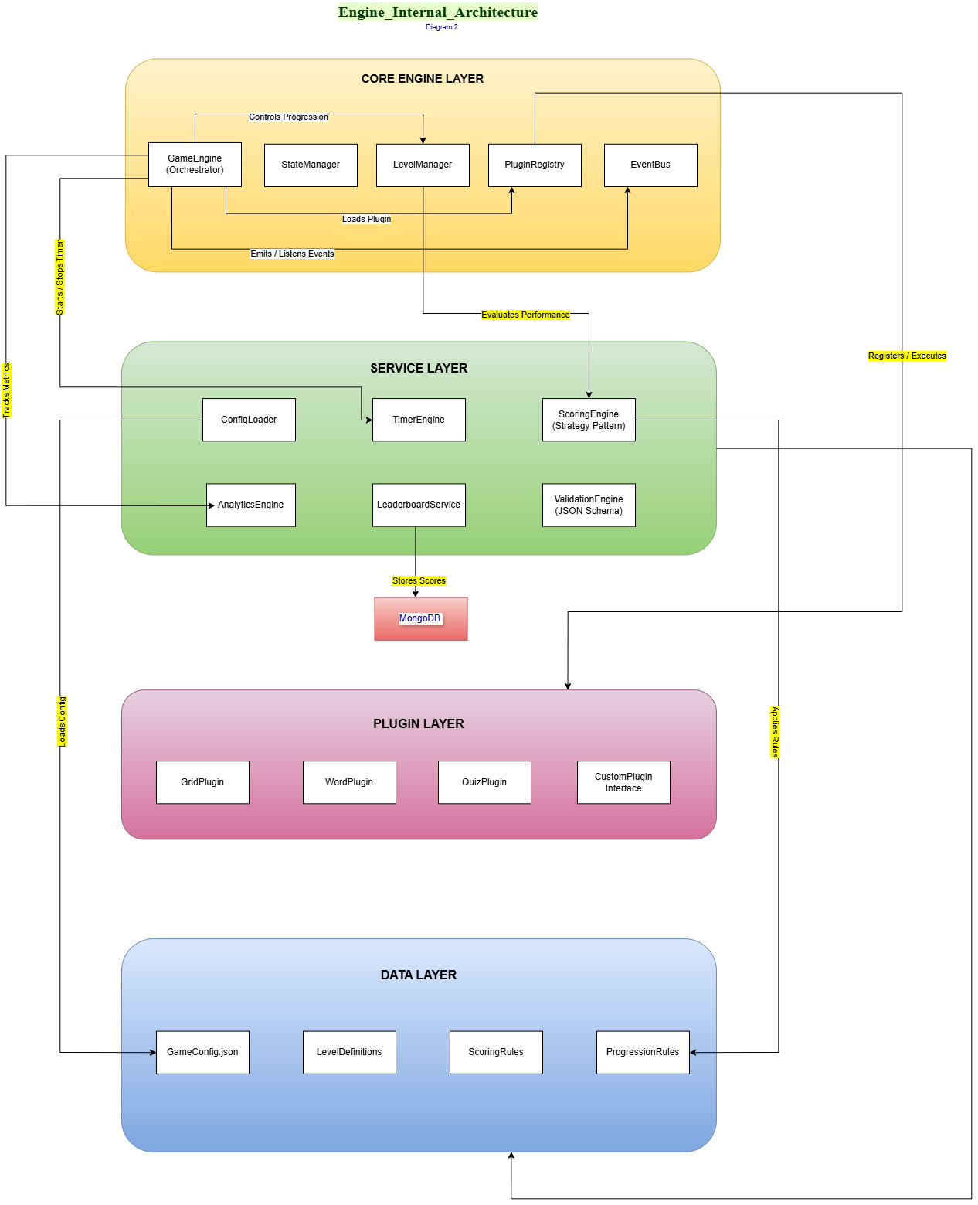

ADAPTIVE PROGRESSION FLOW
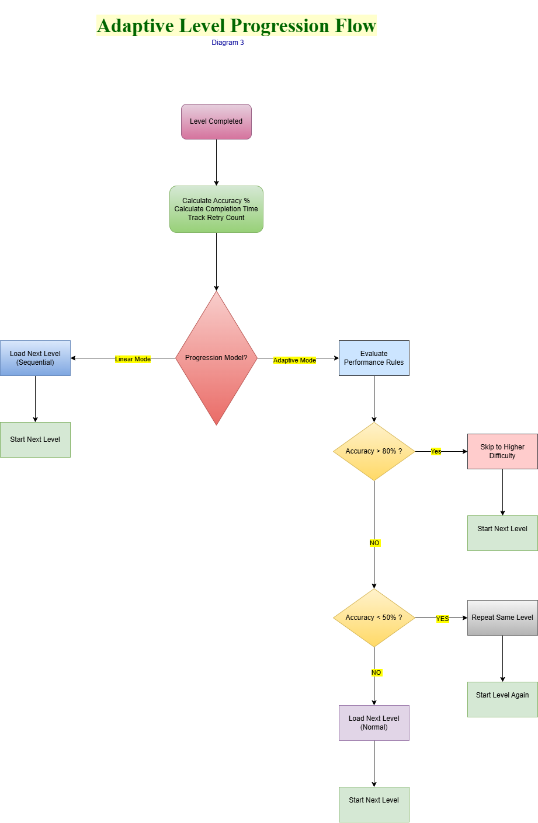
The Adaptive Progression Engine dynamically adjusts difficulty based on real-time player performance metrics.
Decision Logic:
• If Accuracy > 80% → Skip to higher difficulty level
• If Accuracy < 50% → Repeat level
• Else → Progress normally
Performance Metrics Used:
- Accuracy percentage
- Response time
- Attempt count
This adaptive model ensures:
- Personalized learning experience
- Skill-based progression
- Reduced frustration for weaker learners
- Optimized challenge for high performers
The system transforms static learning games into intelligent skill-evolving systems.

REUSABILITY MODEL
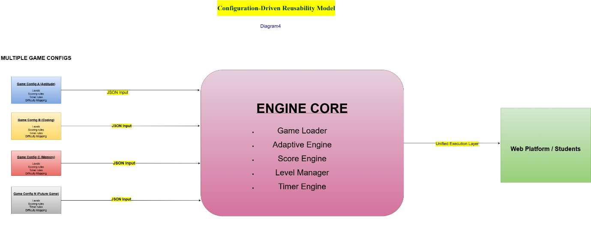
The TapTap Adaptive Modular Game Engine is fully configuration-driven.
Each game is defined through a JSON-based configuration file containing level structure, scoring logic, timer settings, and difficulty mapping.
The Engine Core remains unchanged while new games are plugged in via configuration inputs.
This enables:
• Rapid game deployment
• High scalability across domains
• Zero duplication of logic
• Maintainable and extensible architecture
The engine acts as a universal execution layer for multiple game types.

