**REACT JS**

What is React?

Answer: React is an open source JavaScript library to create user interfaces. It’s is not a framework, it’s basically focused in one thing and doing one thing really well that is nothing but BUILDING UI INTERFACES.

React dose not focus the other aspects of the application like routing and the http request, it is responsible only to building rich user interfaces. So all the other aspects are handled by the REACT ECOSYSTEM.

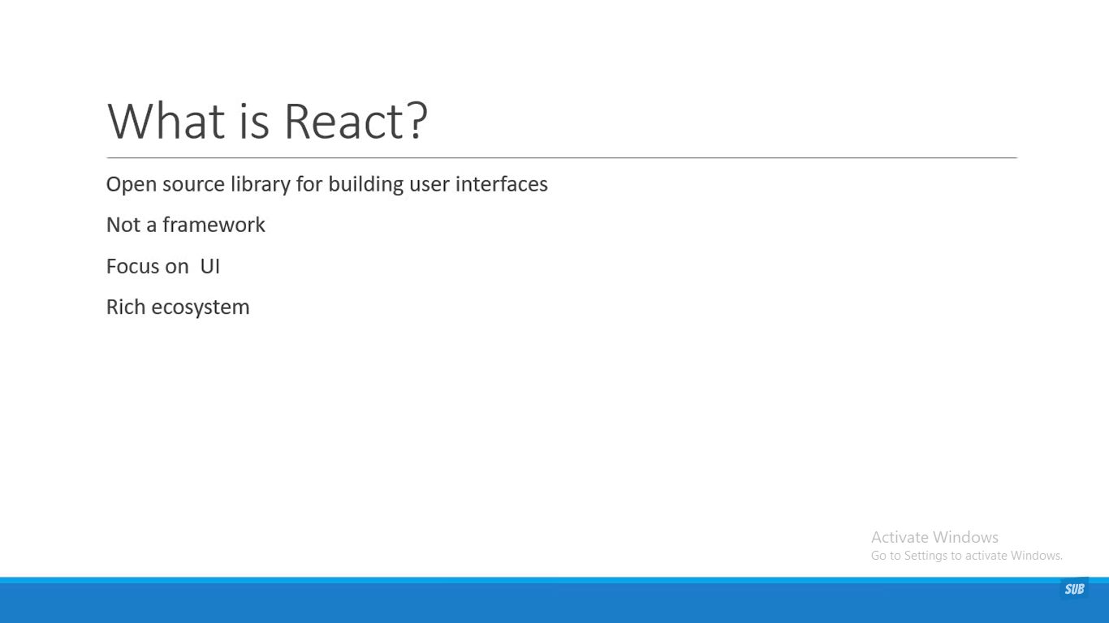

Why learn React?

Answer: React is created and maintained by the Facebook.

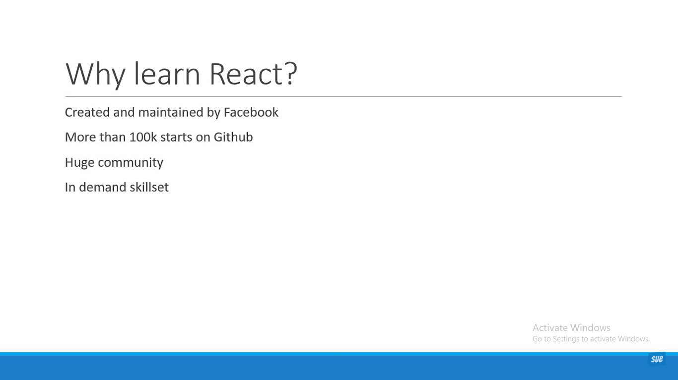

Component Based Architecture

React is a component based architecture it’s basically breakdown our application into small encapsulated part which help us to compose more complex UI. For example, a traditional website can be broken down HEADER, SIDENAV, MAIN CONTAINT and FOOTER, so each section represents a component which will compose in the right way to make up the website.

