Clouds Course

Assignment 2 Deliverable

**Name:**

Anthony El Mir

**Email:**

elmir@eurecom.fr

**Run Locust for 3 minutes each on**

**(i) locally deployed numerical integral**

**(ii) VM scaleset with 2 VMs where you shutdown the VM running the workload after 1 minute.**

**(iii) autoscale webapp initially configured with 1 instance and max 3.**

**(iv) autoscale function. Save locust output. Plot a graph of number of successful requests/seconds with one line for each of the four cases above. Paste the graph below.**

*Your answer:*

1. **Using 1000 Users, Spawn-rate 10, 3m (Locally)**

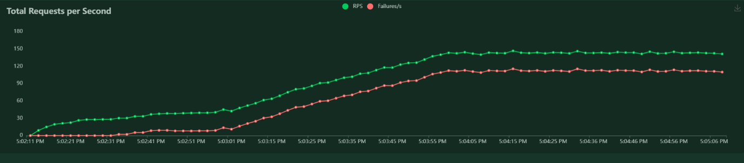

1. **Using 1000 Users, Spawn-rate 10, 3m (VM ScaleSet with 1 Turned off after 1 minute)**

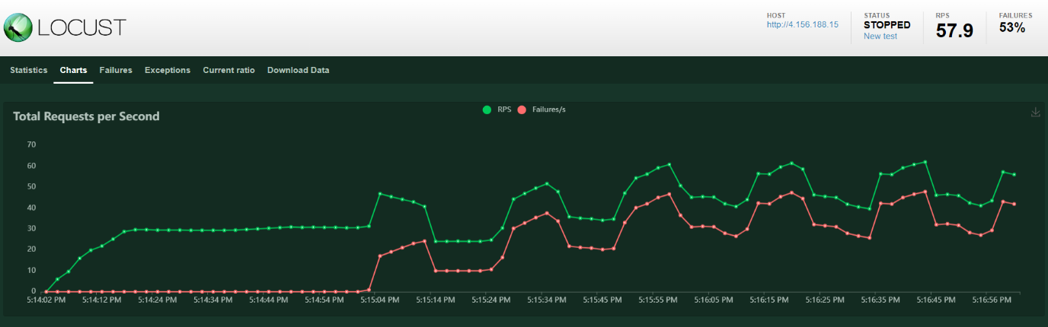

1. 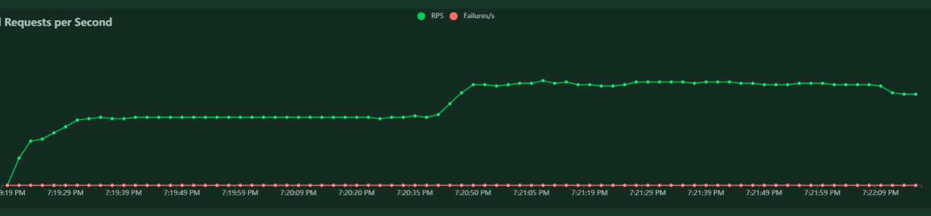**AutoScale w**  **ebapp from 1 instance to 3 max instances**

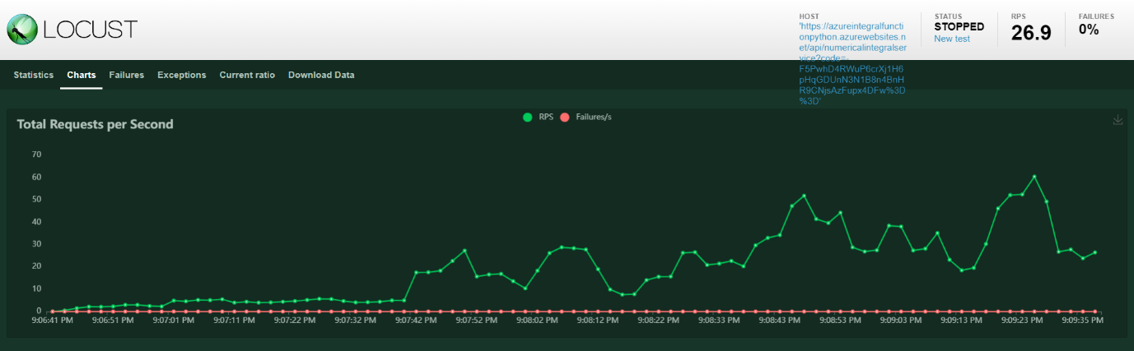**(iv)**

**What is the address of the numerical integral webapp where we can access your site?**

*Your answer:*

*https://wa-flask-integral.azurewebsites.net/numericalintegralservice/:lower/:upper*

*https://wa-flask-integral.azurewebsites.net/numericalintegralservice/0/3.14*

**What is the address of the numerical integral function deployment?**

*Your answer:   
By default the lower = 0, upper = 3*

[*https://azureintegralfunctionpython.azurewebsites.net/api/numericalintegralservice?code=-F5PwhD4RWuP6crXj1H6pHqGDUnN3N1B8n4BnHR9CNjsAzFupx4DFw%3D%3D*](https://azureintegralfunctionpython.azurewebsites.net/api/numericalintegralservice?code=-F5PwhD4RWuP6crXj1H6pHqGDUnN3N1B8n4BnHR9CNjsAzFupx4DFw%3D%3D)

**What is the address of the mapreduce durable function deployment where can invoke it?**

*Your answer:*

[*https://mapreducer.azurewebsites.net/runtime/webhooks/durabletask/instances/5457c36104a743d5ad172e50a7172045?taskHub=MapReducer&connection=Storage&code=tLfLX02aHkSBh3ciF7Qej7TxLNdamCM6YXJQ1C9wuj63AzFuXrnGeA==*](https://mapreducer.azurewebsites.net/runtime/webhooks/durabletask/instances/5457c36104a743d5ad172e50a7172045?taskHub=MapReducer&connection=Storage&code=tLfLX02aHkSBh3ciF7Qej7TxLNdamCM6YXJQ1C9wuj63AzFuXrnGeA==)

**What is the gitlab URL where you have saved your assignment code?**

*Your answer:*

*https://github.com/anthomir/Azure-Lab2*