

JapG Telecom

Project is about keeping new stock of mobile phones, set up mobiles, adding offers and viewing feedback given by people on site.

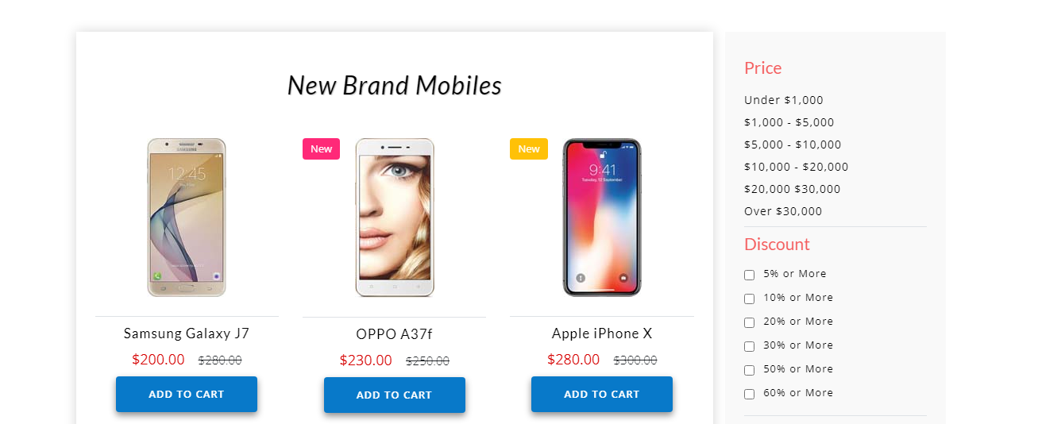

**Admin Login:**

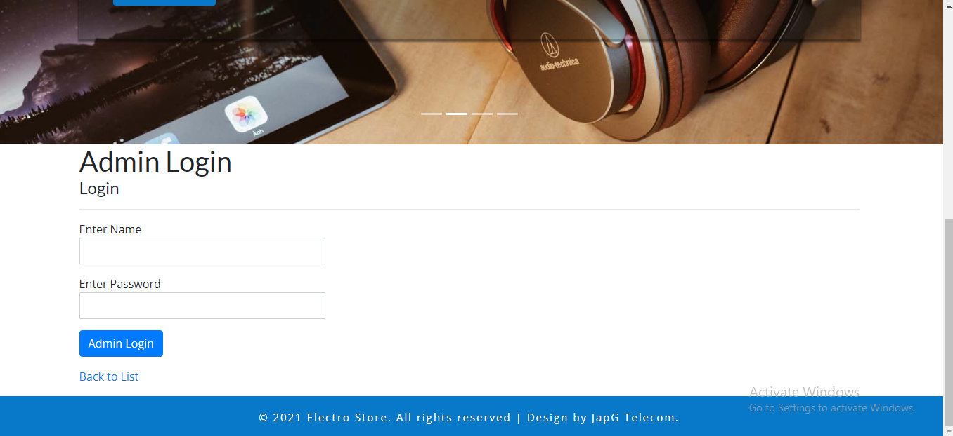

**Admin can safely login into the account by credentials given to them add the functionality to the website.**

|  |  |
| --- | --- |
| **Enter name** | **Enter Password** |
| [**Japg@gmail.com**](mailto:Japg@gmail.com) | **12345** |

**Admin Dashboard**

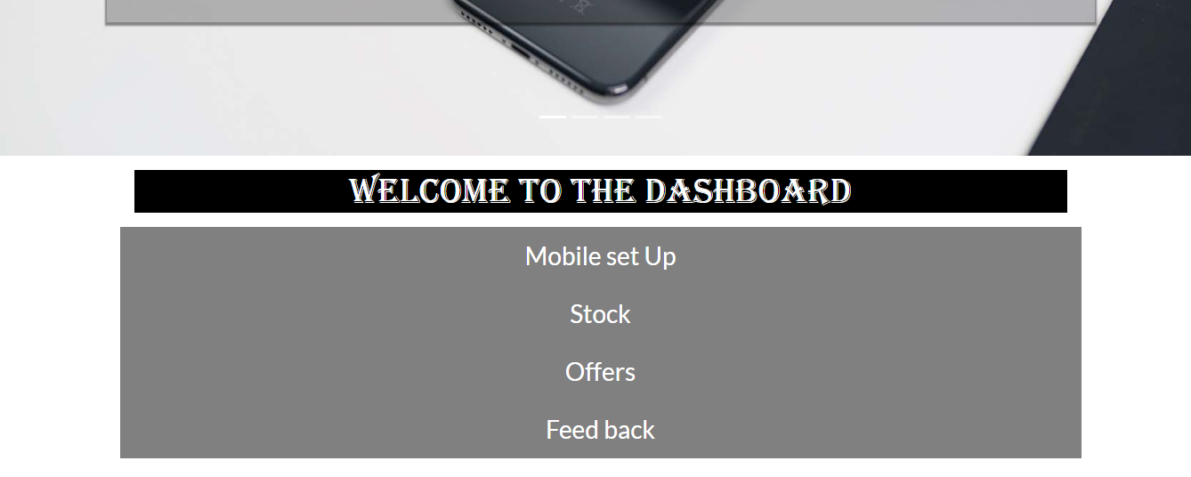

This is dashboard of admin in which admin can follow the given jobs on dashboard i.e. Mobile Set up, Stock, Offers, Feedback

**Mobile Set Up Page**

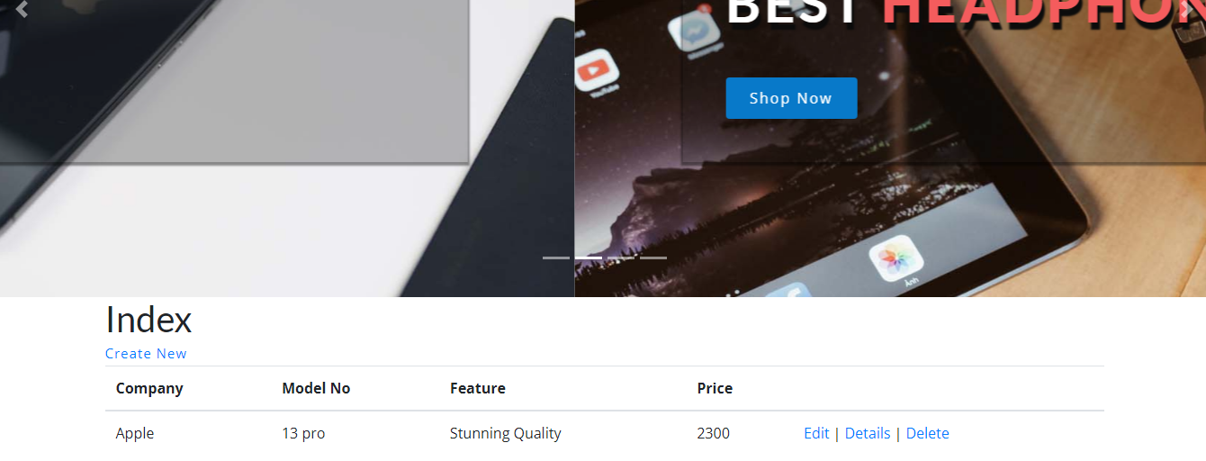

**Confirmation**

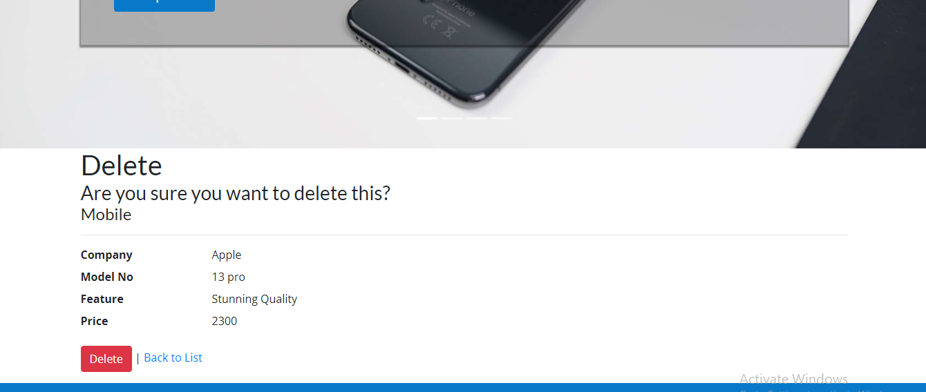

Application confirms before deleting a entry

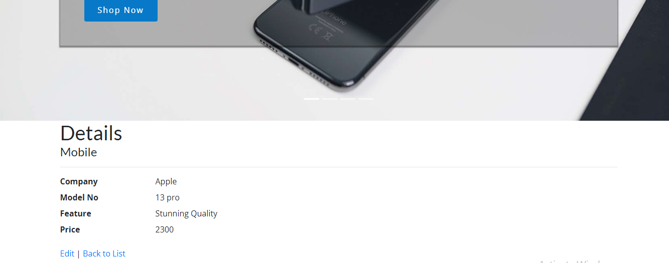

Detail View

Feedback Form

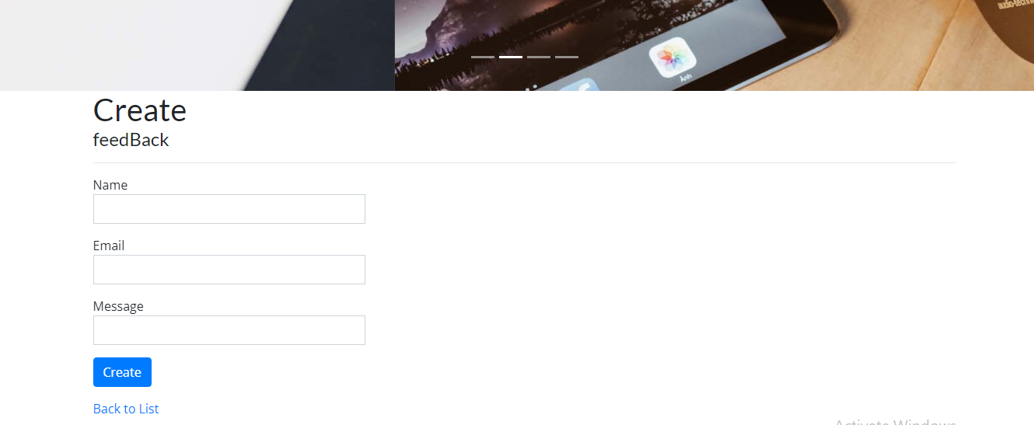

Feedback details can only be viewed by admin

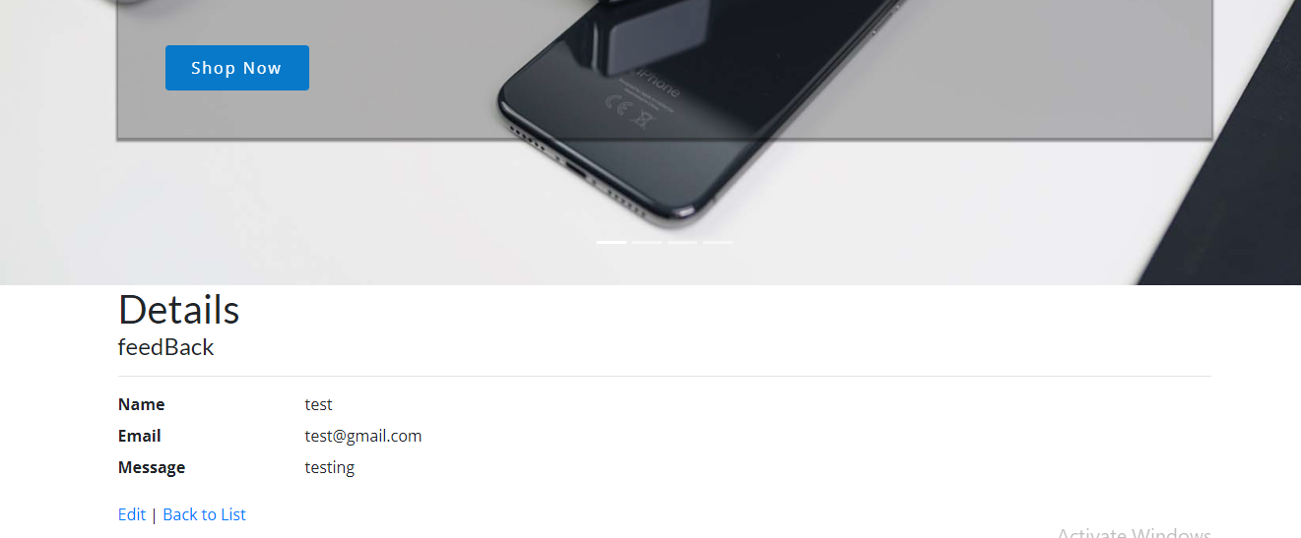

**Entering Stocks Page**

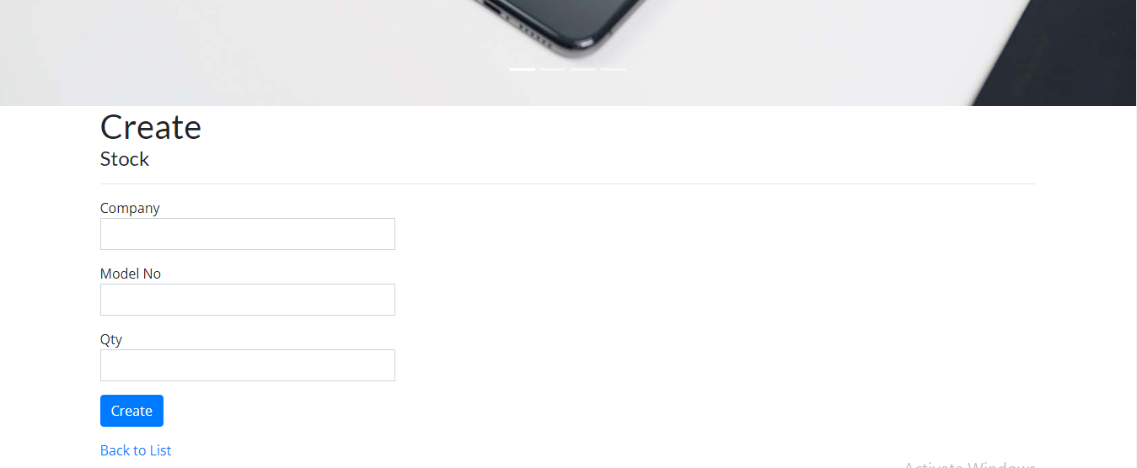

**Entering Offers**

