Olist E-Commerce Data Warehouse Project

2. Physical Model of the Source System
This section contains the physical Entity Relationship Diagram (ERD) of the source operational database (the original Olist dataset tables).
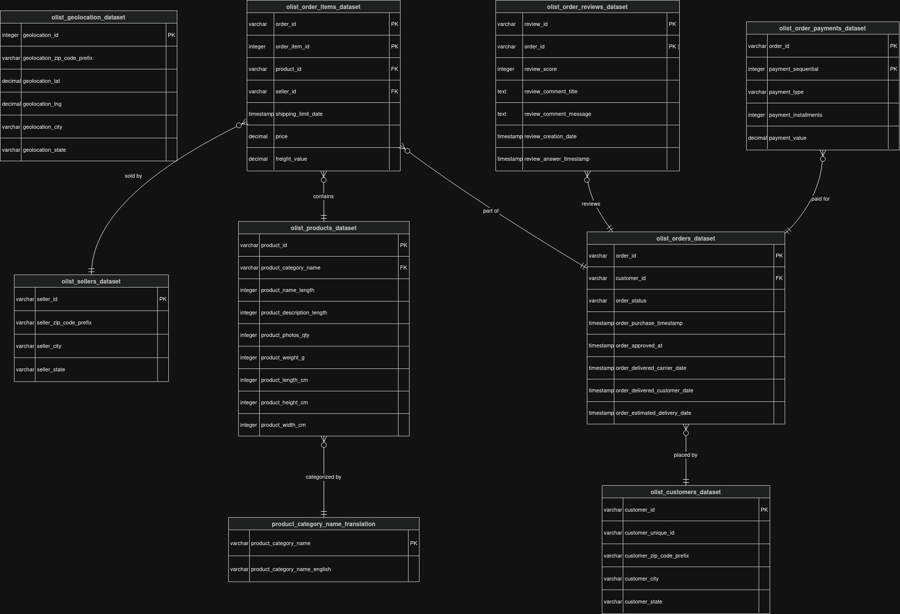

3. Dimensional Model
The data warehouse is built using a Kimball Galaxy Schema covering three main business processes: Sales, Payments, and Reviews.

A. The Sales Process
- a. Business Process: The process of a customer purchasing individual items through the e-commerce platform.
- b. Grain: One row per individual item sold within an order.
- c. Fact Table Type: Transaction Fact Table.
- d. Dimensions and Types:
- dim_product: Conformed Dimension (Flattened with English translation)
- dim_customer: Conformed Dimension (Implemented as SCD Type 2).
- dim_seller: Conformed Dimension (Implemented as SCD Type 2).
- dim_geolocation: Shared Dimension (Snowflake outrigger for clean geographic data)
- dim_date: Conformed / Role-Playing Dimension
- e. Measures and Types:
- price: Fully Additive
- freight_value: Fully Additive
- order_id & order_item_id: Degenerate Dimensions (Keys)

B. The Payment Process
- a. Business Process: Processing financial payments and funding sources for customer orders.
- b. Grain: One row per individual payment method used on an order.
- c. Fact Table Type: Transaction Fact Table.
- d. Dimensions and Types:
- dim_customer: Conformed Dimension (Implemented as SCD Type 2).
- dim_date: Conformed Dimension
- dim_order_attributes: Junk Dimension (Groups low-cardinality text like payment_type and order_status)
- e. Measures and Types:
- payment_value: Fully Additive
- payment_installments: Non-Additive (can be averaged)
- payment_sequential & order_id: Degenerate Dimensions (Keys)

C. The Review Process
- a. Business Process: The process of a customer submitting a feedback score and comment after receiving their order.
- b. Grain: One row per review submitted.
- c. Fact Table Type: Transaction Fact Table.
- d. Dimensions and Types:
- dim_customer: Conformed Dimension (Implemented as SCD Type 2).
- dim_date: Conformed Dimension
- dim_feedback_profile: Standard Dimension (Created specifically to offload heavy text strings from the fact table)
- e. Measures and Types:
- review_score: Fully Additive
- hours_to_answer: Fully Additive (Calculated measure)
- review_id & order_id: Degenerate Dimensions (Keys)

3f. Physical Model of the Dimensional Model
Below is the final Galaxy Schema displaying the relationships between all Fact Tables (Sales, Payments, Reviews) and their shared Dimensions.
