**Enhancing Neural Machine Translation with Attention Mechanism: Implementation and GUI Integration**

**Group members:**

|  |  |
| --- | --- |
| **Registration Number** | **Name** |
| 21BAI1918 | Sri Sai Ravi Charan Siddabathuni |

**Abstract:**

This report presents a Neural Machine Translation (NMT) system with a graphical user interface (GUI), implemented using Flask and JavaScript. The system adopts the Seq2Seq architecture with Gated Recurrent Unit (GRU) units for sequence processing as its foundational model. To enhance translation accuracy and mitigate overfitting we integrate the Bahdanau attention mechanism within the encoder-decoder paradigm. This integration allows the model to focus on relevant parts of the input sequence resulting in more accurate translations. The GUI facilitates user interaction enabling seamless input of Spanish text via text input or speech recognition. Real-time translations into English are then provided enhancing communication across language barriers. This project combines translation technology with an easy-to-use interface making it easier for people to understand each other across languages, whether it's for learning, business or connecting with others around the world.

**Introduction:**

The Seq2Seq model short for Sequence-to-Sequence, has proven to be a robust architecture for tasks involving variable-length input and output sequences, such as language translation. However, the traditional Seq2Seq model faces challenges when dealing with longer sequences, as it tends to lose context information from the input during the encoding process.

To overcome this limitation, we turn to the attention mechanism – a breakthrough concept that allows the model to dynamically focus on different parts of the input sequence while generating the output. Unlike a transformer layer, our goal is to implement attention as an augmentation to the existing Seq2Seq architecture, enhancing its ability to capture dependencies and nuances in the source language.

By incorporating attention, our model can weigh the importance of different elements in the input sequence at each decoding step, providing a more nuanced and context-aware translation. This not only improves the translation quality for longer sentences but also allows the model to handle ambiguous or context-dependent phrases more effectively.

**Implementation:**

**Methodology:**

1. Data Preparation:
   1. Download the Spanish-English translation dataset and preprocess the sentences.
   2. Convert Unicode characters to ASCII, add start and end tokens, and tokenize the sentences.
   3. Split the dataset into training and validation sets for model training and evaluation.
2. Model Architecture:
   1. Implement a sequence-to-sequence model with an encoder and a decoder using GRU units.
   2. Incorporate Bahdanau attention mechanism into the decoder to focus on relevant parts of the input sequence during translation.
   3. Define loss function and optimizer for training the model.
3. Training:
   1. Train the model using the training dataset with teacher forcing, where the target token from the previous time step is used as input to the decoder.
   2. Update model parameters using backpropagation and optimize the model for translation quality.
4. Evaluation:
   1. Evaluate the trained model on the validation dataset to measure translation accuracy and fluency.
   2. Compute metrics such as BLEU score to assess the quality of translations and compare them with human-generated references.
5. GUI Implementation:
   1. Develop a GUI using Flask for the backend and JavaScript for the frontend.
   2. Implement text input fields for users to enter Spanish sentences.
   3. Integrate speech recognition functionality to allow users to input text through speech.
   4. Display translated English sentences in real-time on the GUI interface.

**System Design:**

* The system architecture includes a Flask server for handling backend requests and a JavaScript frontend for user interaction.
* Backend components include route definitions for translation endpoints and loading trained NMT models.
* Frontend components include HTML templates for rendering the GUI interface and JavaScript functions for handling user input and displaying translation results.

**Output:**

**Model Test Loss Result:**

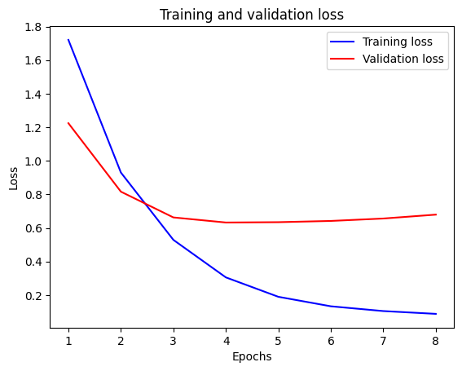

**Attention Mapping:**

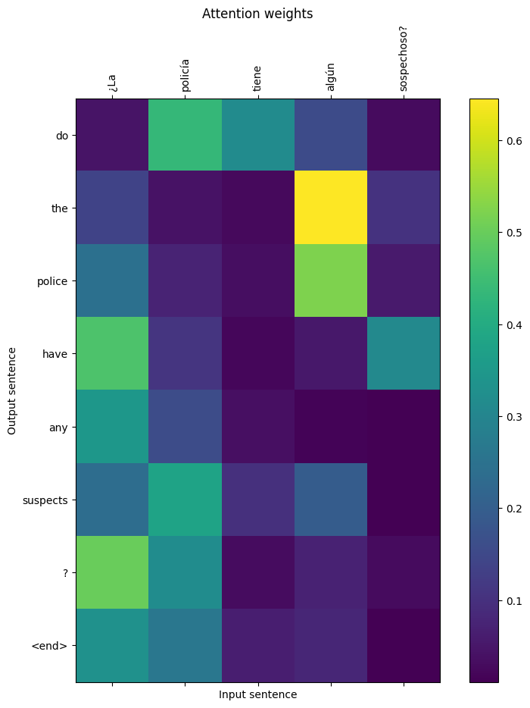

**Corpus BLEU (Bilingual Evaluation Understudy) score:**

For 10,000 samples belonging to the 70,000 samples, it was trained the Corpus BLEU score is 0.8133.

**GUI Results:**

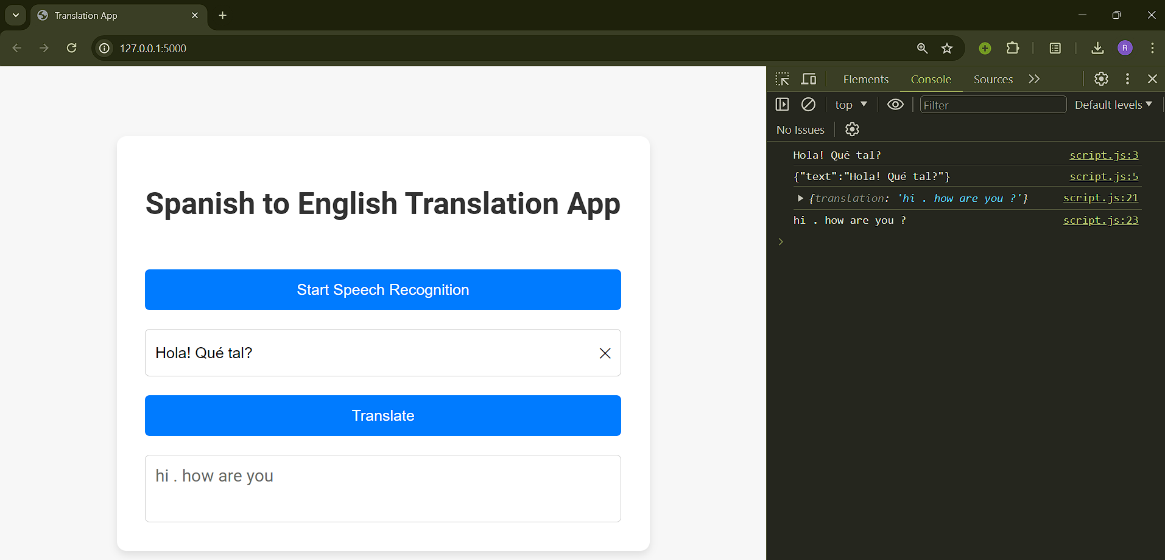

**References:**

1. Bahdanau, Dzmitry, Kyunghyun Cho, and Yoshua Bengio. "Neural Machine Translation by Jointly Learning to Align and Translate." arXiv preprint arXiv:1409.0473 (2014), <https://arxiv.org/abs/1508.04025>
2. "Neural Machine Translation with Transformer." Keras Documentation, 2022, <https://keras.io/examples/nlp/neural_machine_translation_with_transformer/>.
3. Sherratt, Adam. "Python Flask Embedding Machine Learning." BogoToBogo, <https://www.bogotobogo.com/python/Flask/Python_Flask_Embedding_Machine_Learning_1.php>.
4. "Tatoeba: Collection of Sentences and Translations." ManyThings.org, <https://www.manythings.org/anki/>.

**Appendix:**

**To use the web application:**

1. Set up the Flask environment:
   1. Navigate to the Flask application directory (project folder as the path for the terminal).
   2. Install necessary dependencies.
2. Start the Flask Server:
   1. Start the Flask Server: python app.py (in the same project folder as the path)

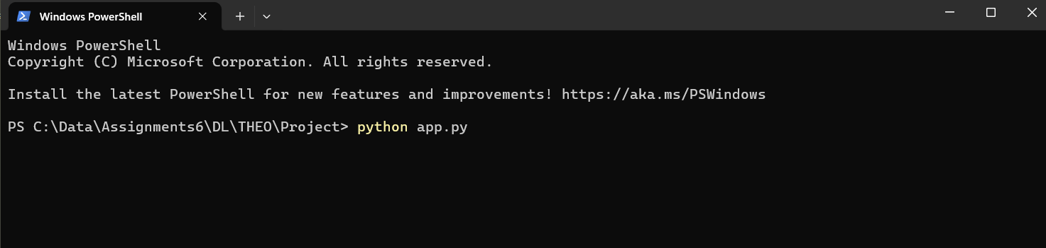

* 1. Access the server at <http://127.0.0.1:5000> on the Chrome web browser.

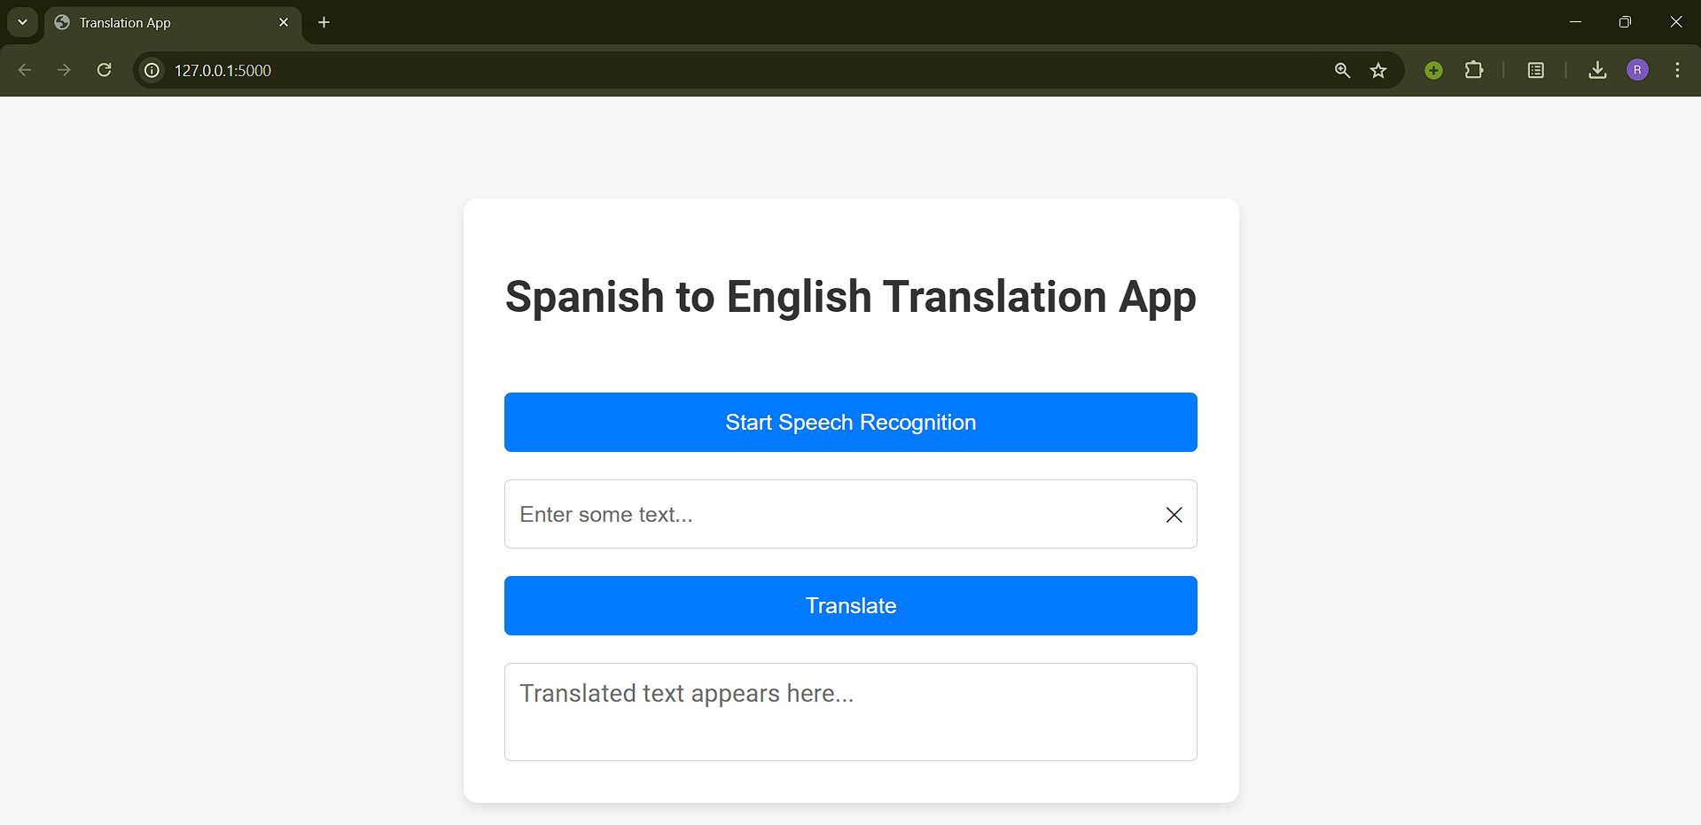

1. Interact with the Application:
   1. Visit the web application.
   2. Click ‘Start Speech Recognition’ to provide speech input in Spanish.
   3. Click ‘Translate’ to receive the English translation displayed as text and speech output.

**Dimensions:**

