Support Vector Domain Description (SVDD) is a sphereshaped data description algorithm proposed base on thetheory of Support Vector Machine . By mapping datapoints from the input data space to a high dimensionalfeature space, it first finds the minimal sphere enclosingmost of the mapped data points in the feature space.

Datapoints enclosed within the sphere surface are taken as thenormal points and those outside the sphere surface are takenas the outliers. SVDD can obtain a very flexible andaccurate data description relying on only a small number ofsupport vectors (SVs) lying on the sphere surface.

Given a training set X can be described as: consisting of N data points, where  , we look for the smallest hypersphere that encloses most of the mapped data points in the feature space.



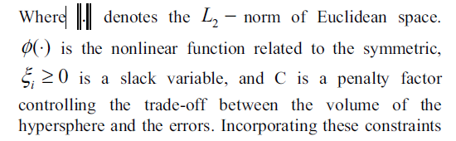 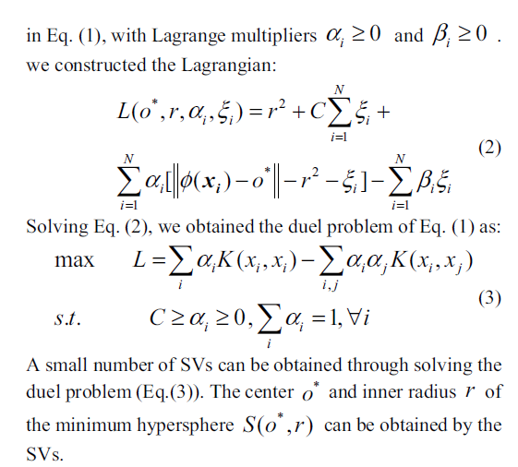

AUC