HisrtoriCal

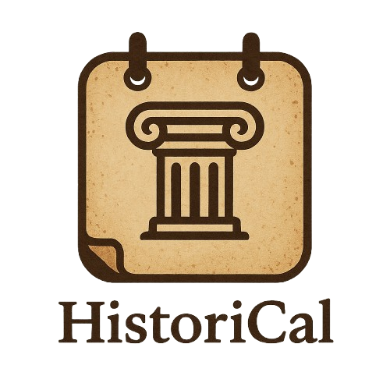

History Computer Application

Table of Contents

Team 2

Summary 3

Objectives 3

Main stages in development 3

• Reflection on the Topic 3

• Origin of the Name 3

• Development 3

• Introduction 4

Implementation 4

Conclusion 5

# Team

Full Stack developer

Simeon Stiliyanov Stefanov

# Summary

## Objectives

**The aim of HistoriCal is to provide users with daily insights into historical events, figures, and milestones** that occurred on each calendar day, enhancing their knowledge of world history through an interactive and engaging timeline-based experience.

## Main stages in development

### • Reflection on the Topic

At the start, the team discussed ideas and agreed on building a **Historical Calendar App**—a tool to help users explore important events that happened on each day in history.

### • Origin of the Name

The name **HistoriCal** combines “History” and “Calendar”, reflecting the app’s purpose in a simple, catchy way.

### • Development

Development spanned several weeks. **Simeon Stefanov** handled the backend, frontend and made the documentation and presentation.

### • Introduction

Each team member was assigned a section of the presentation to ensure fair participation.

# Implementation

Softwares for programming our project is Visual Studio



Our collaboration tools are GitHub, Git

Programming languages we used are C++

Softwires used for the presentation of the project are Microsoft Word and Microsoft PowerPoint



# Block Scheme

# 

# Conclusion

The development of **HistoriCal** allowed our team to combine creativity, collaboration, and technical skills to deliver an educational app with real value. We gained experience in project planning, coding, design, and teamwork. Overall, this project not only helped us grow as developers but also showed how technology can make learning history more engaging and accessible.