CSS Assignment

1.

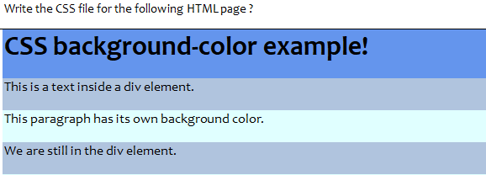

Code:

h1,h4,p{

margin: 0;

padding-bottom: 15px;

}

h4{

font-weight: 100;

}

.q1 h1{

background-color: cornflowerblue;

}

.q1 h4{

background-color:#779db5;

}

.q1 p{

background-color: lightblue;

}

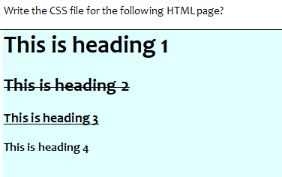2.

Code:

.q2{

background-color: lightblue;

}

.q2 h2{

text-decoration: line-through;

}

.q2 h3{

text-decoration: underline;

}

3.

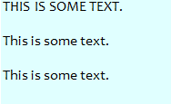

Code:

.up{

text-transform: uppercase;

}

.q3{

background-color: lightblue;

}

4.



Code:

.q4{

background-color: lightblue;

}

.q4 a{

font-weight: 700;

text-decoration-color:red;

}

.q4 a:link{

color:red;

}

.q4 a:visited{

color:darkmagenta;

font-weight: 700;

text-decoration-color:darkmagenta;

}

5.

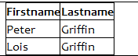

Code:

.q5 th,.q5 td{

border:1px solid black;

}

.q5 table{

border-spacing: 0px;

}

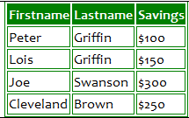6.

Code:

.q6 th{

background-color: green;

color: white;

}

.q6 th,.q6 td,.q6 table{

border:1px solid green;

}

7.

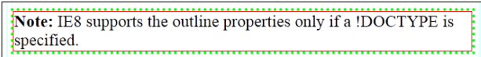

Code:

.q7 p{

border:1px solid orange;

outline-style: dotted;

outline-color: lightgreen;

}

8.

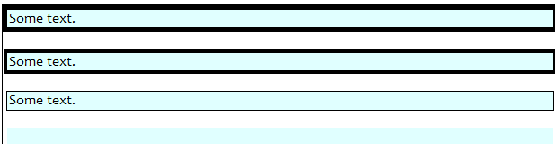

Code:

.q8 p{

margin:10px;

padding: 0;

background-color: lightblue;

}

.q8 p:nth-child(1){

border:6px solid black;

}

.q8 p:nth-child(2){

border:3px solid black;

}

.q8 p:nth-child(3){

border:1px solid black;

}