**MongoDB -Aggregation Exercises**

**Atlanta Population**

1. Use db.zipcodes.find() to filter only the results where city is ATLANTA and state is GA:

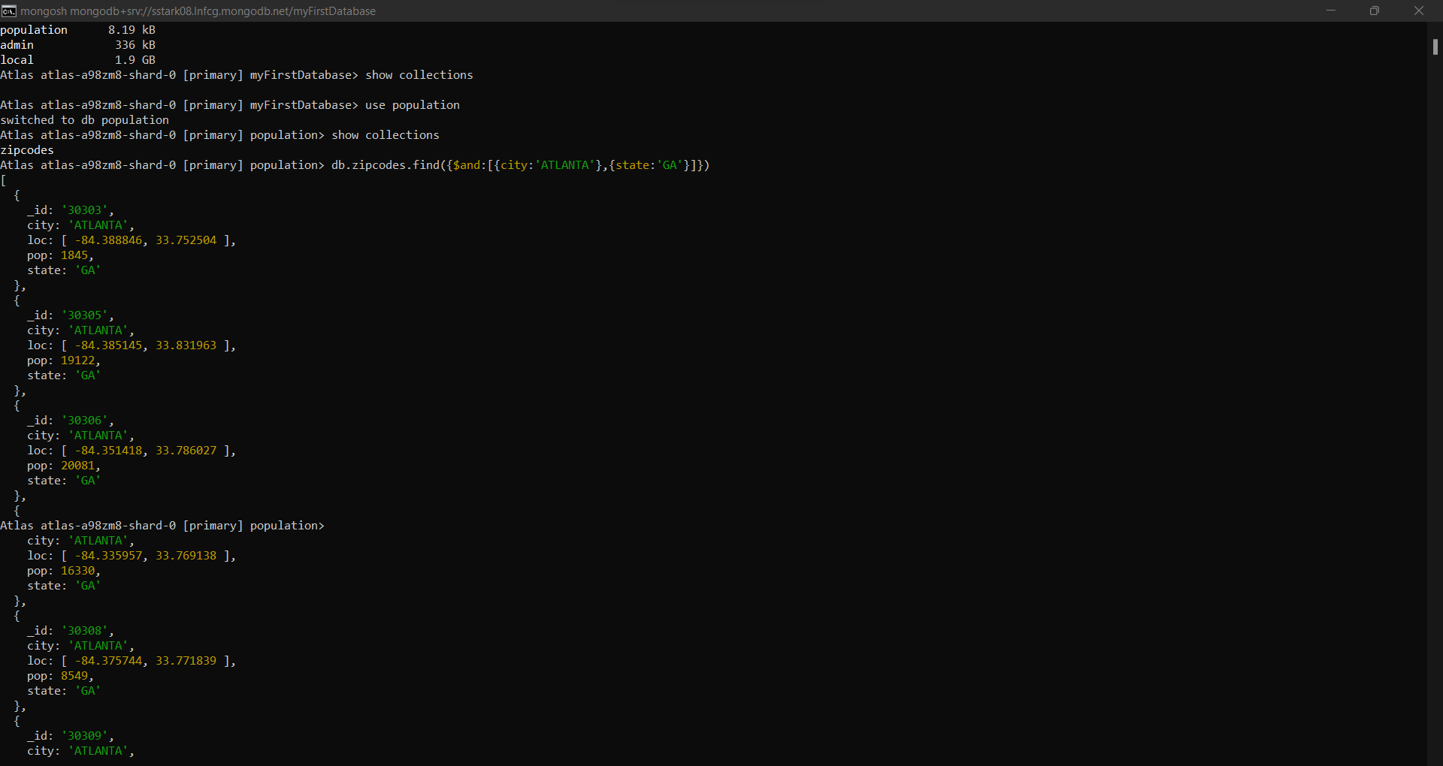

1. Use db.zipcodes.aggregate with $match to do the same as above:

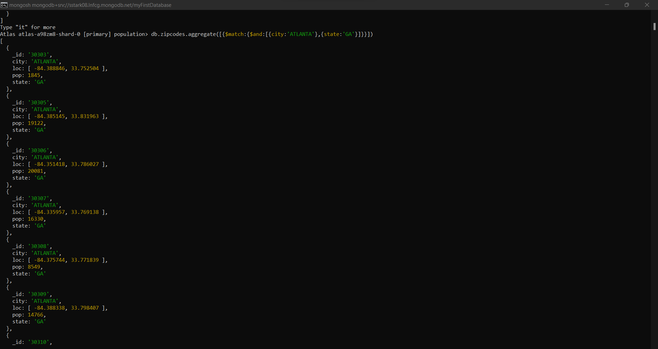

1. Use $group to count the number of zip codes in Atlanta:

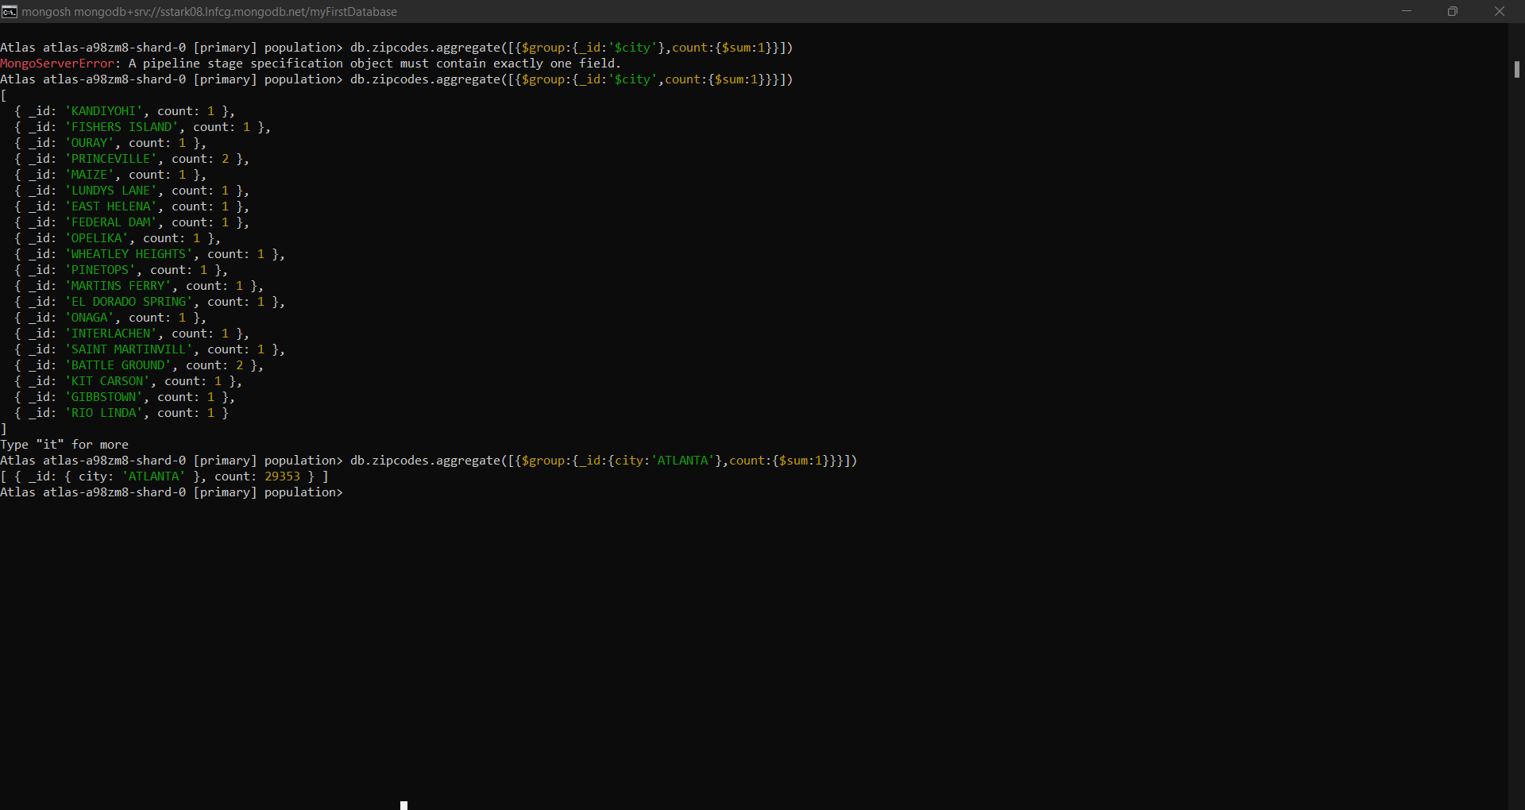

1. Use $group to find the total population in Atlanta:

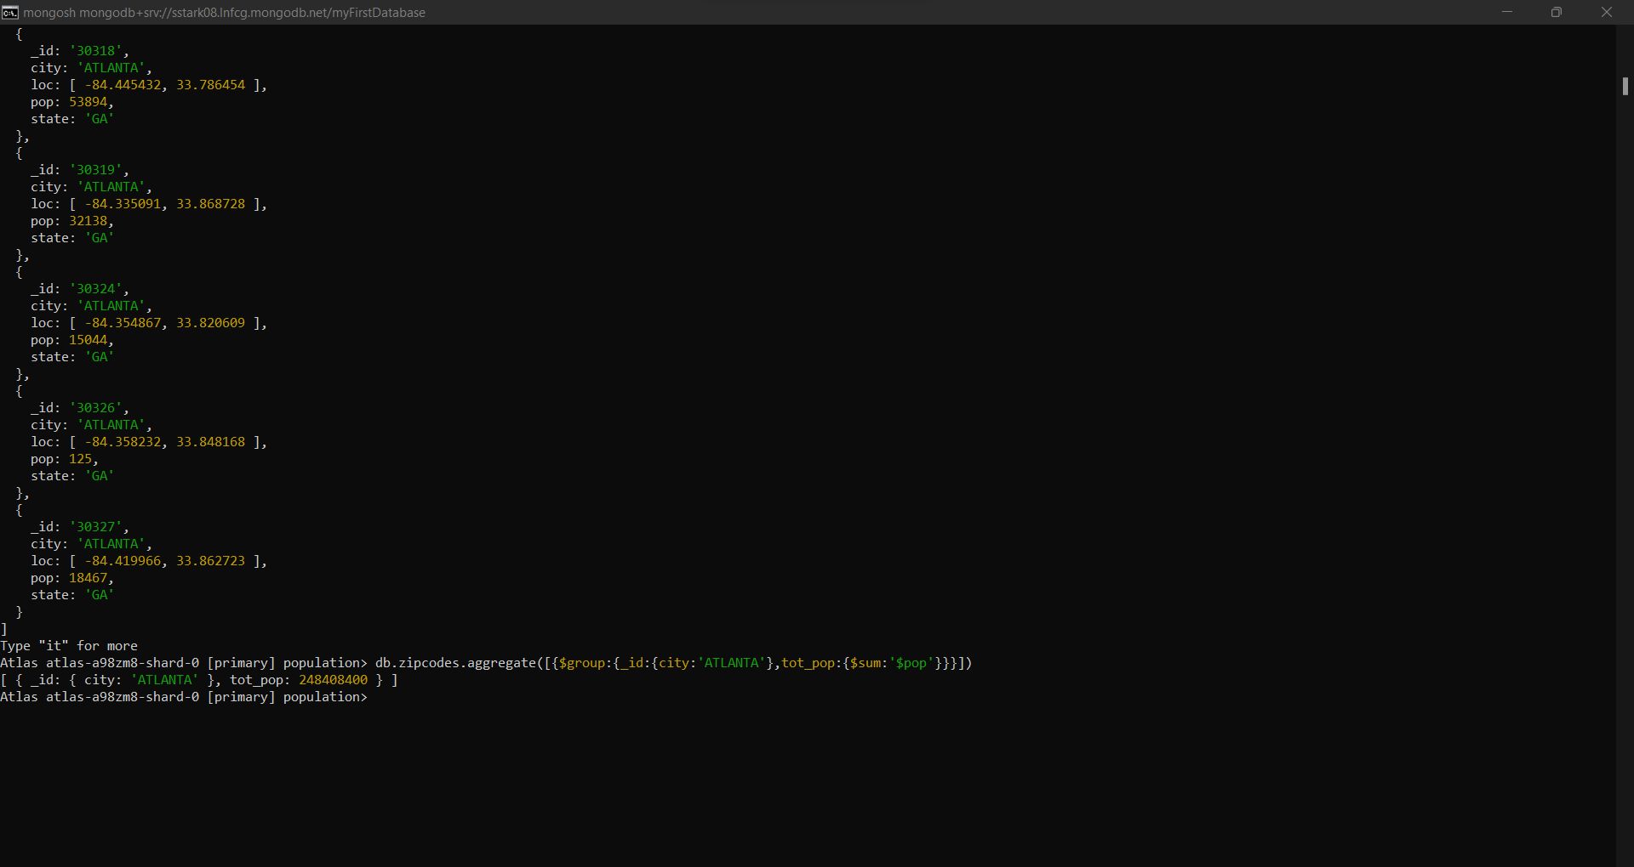

**Population By State:**

1. Use aggregate to calculate the total population of each state:

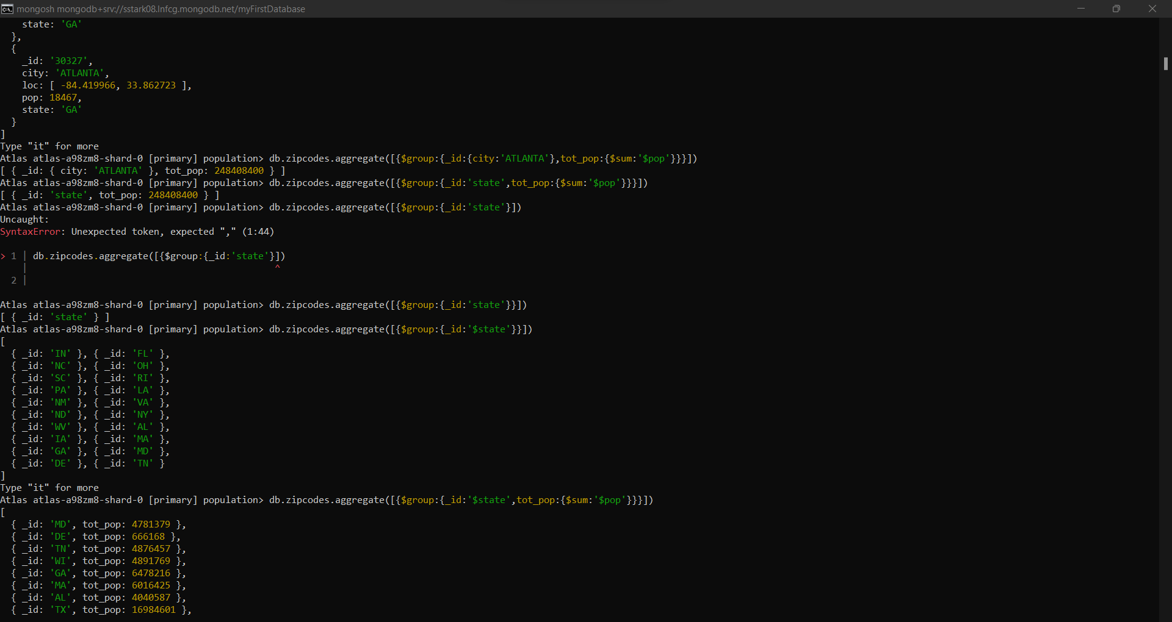

1. Sort the results by population, highest first:

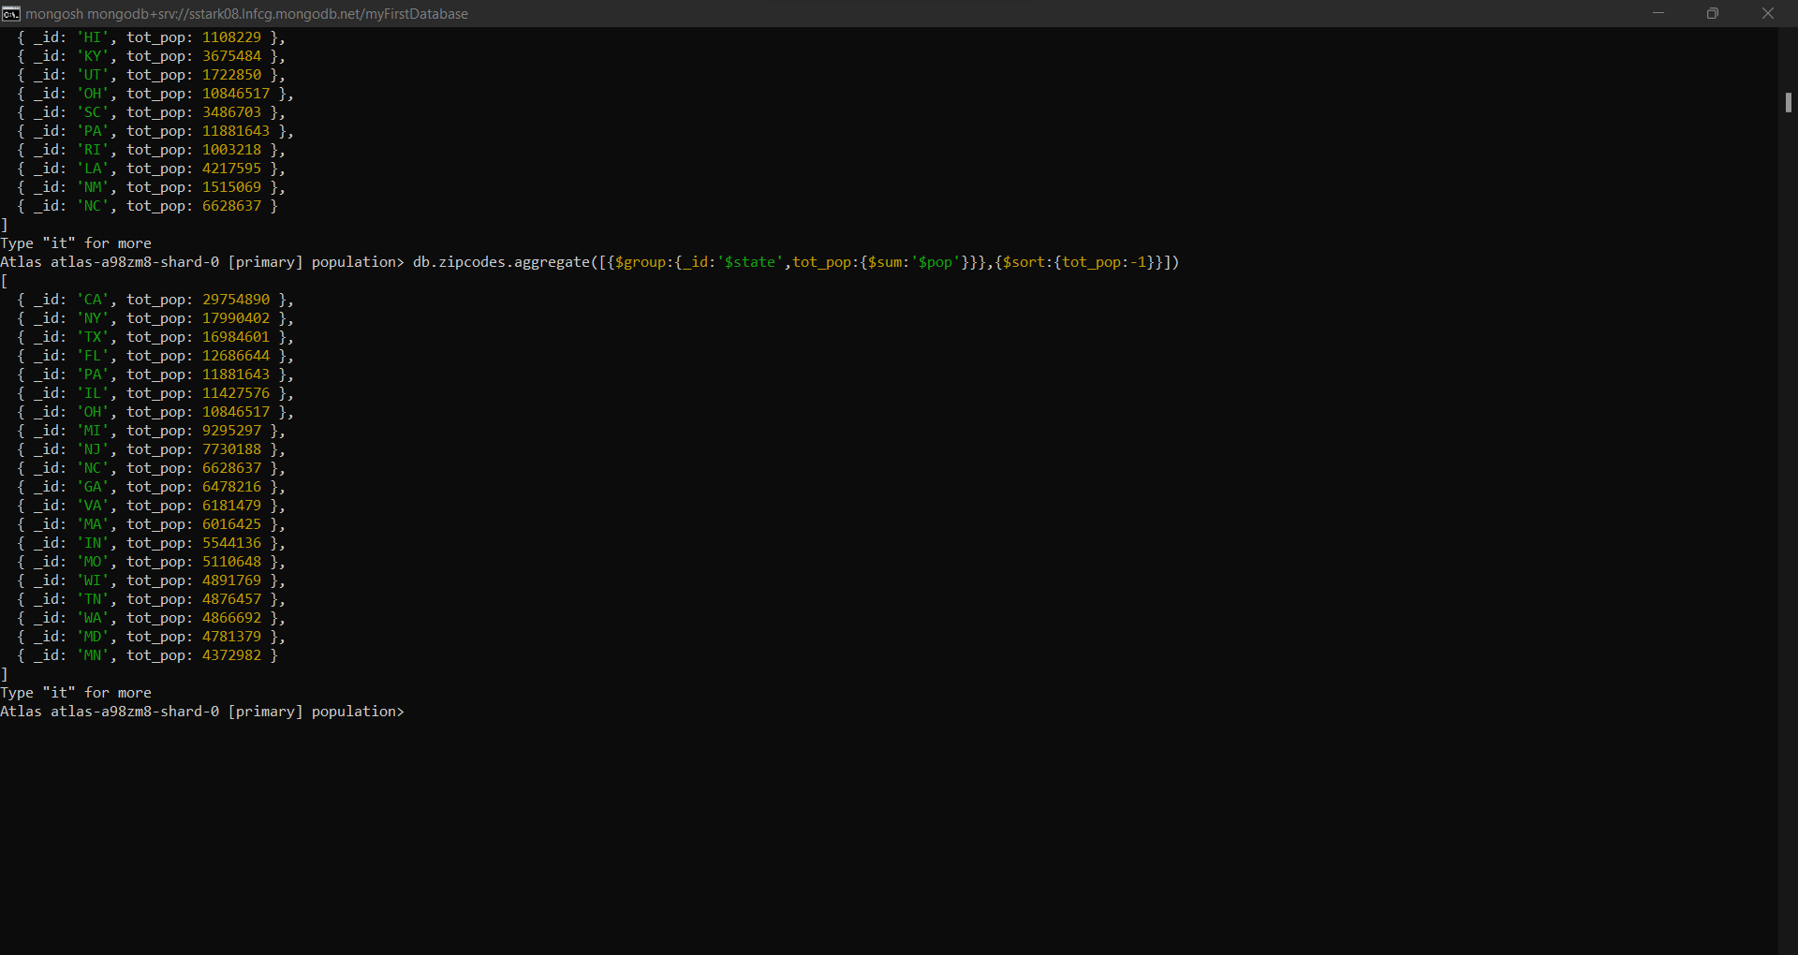

1. Limit the results to just the first 3 results. What are the top 3 states in population:

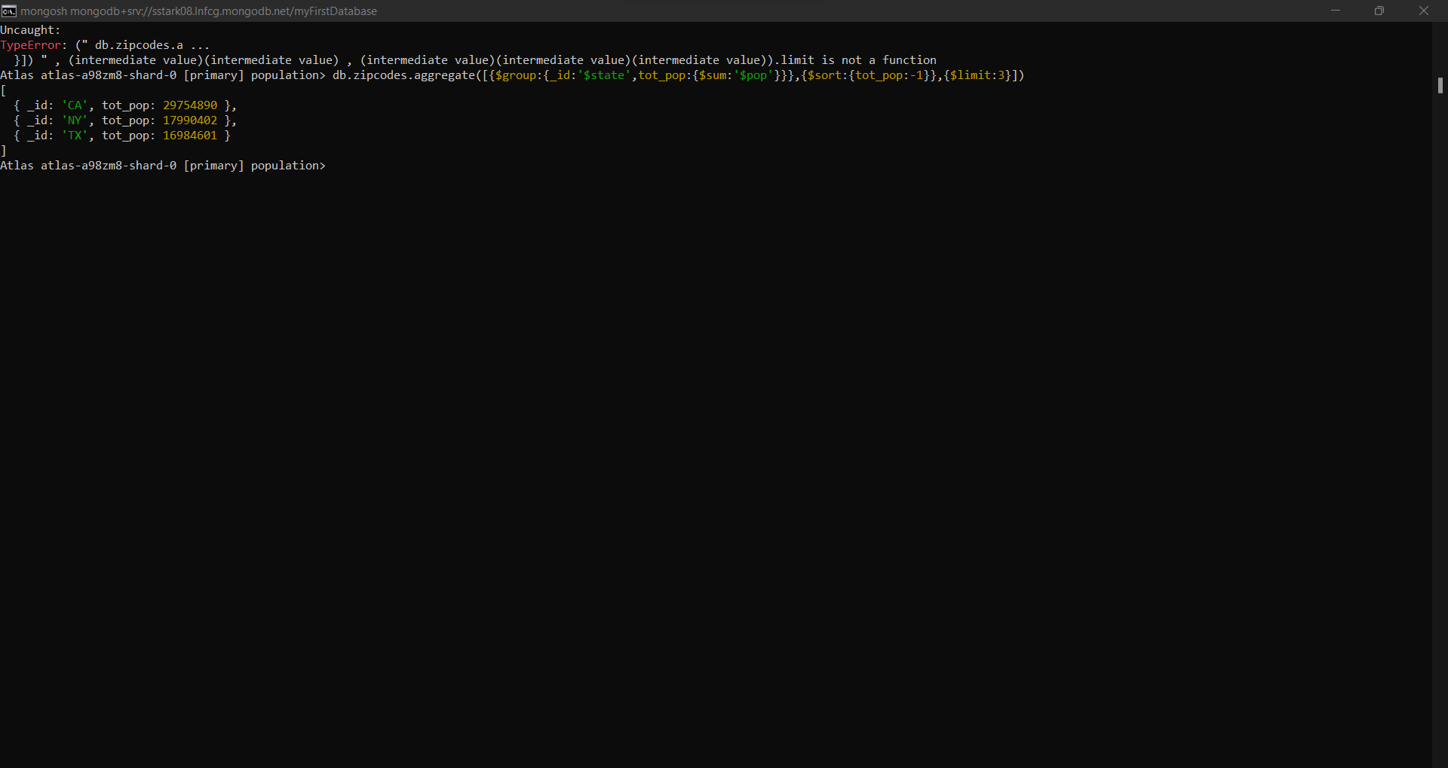

**Population By State:**

1. Use aggregate to calculate the total population of each city:

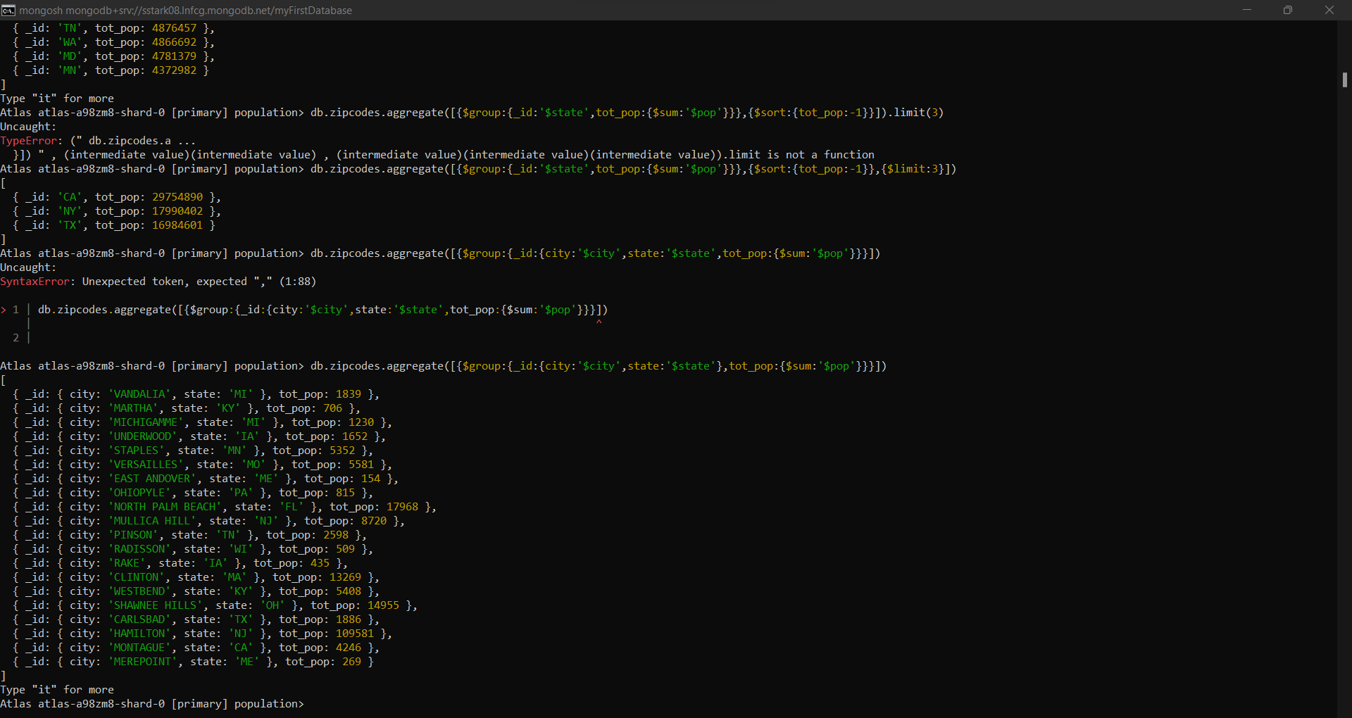

1. Sort the results by population, highest first:

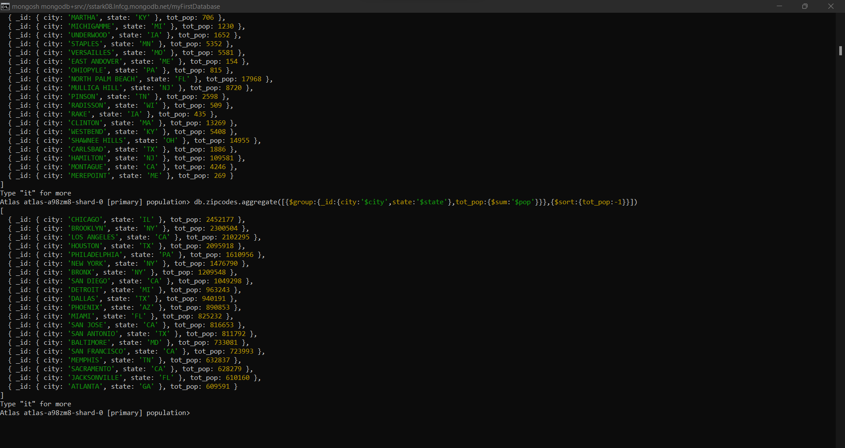

1. Limit the results to just the first 3 results. What are the top 3 cities in population:

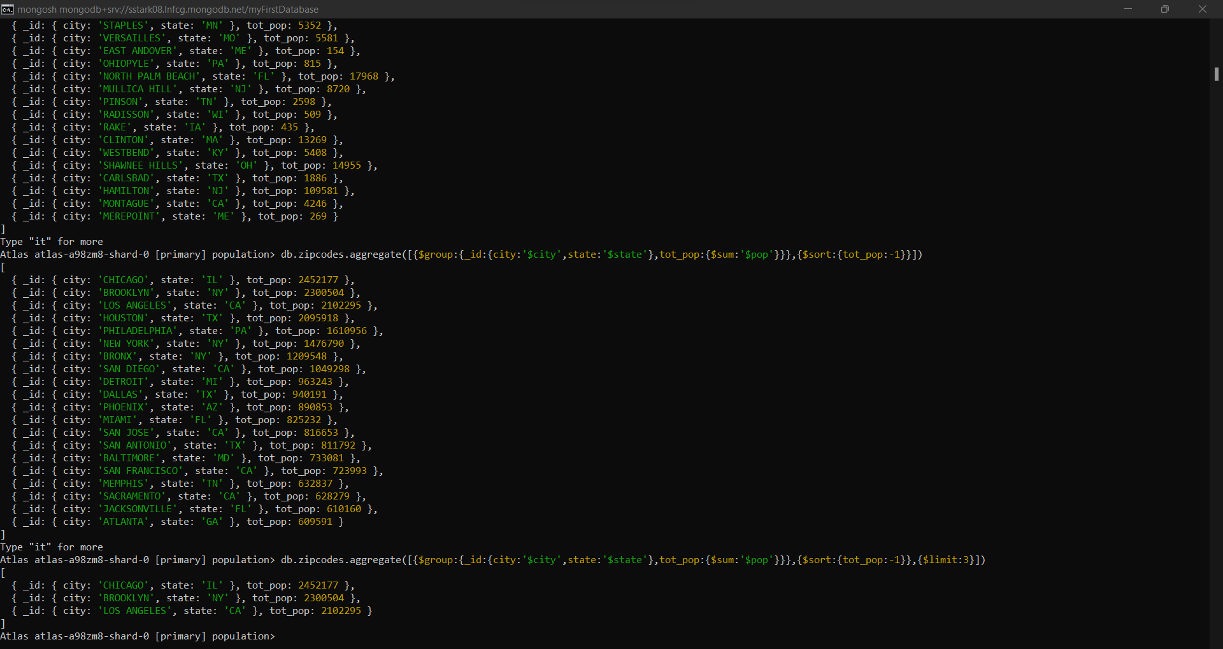

1. What are the top 3 cities in population in Texas:

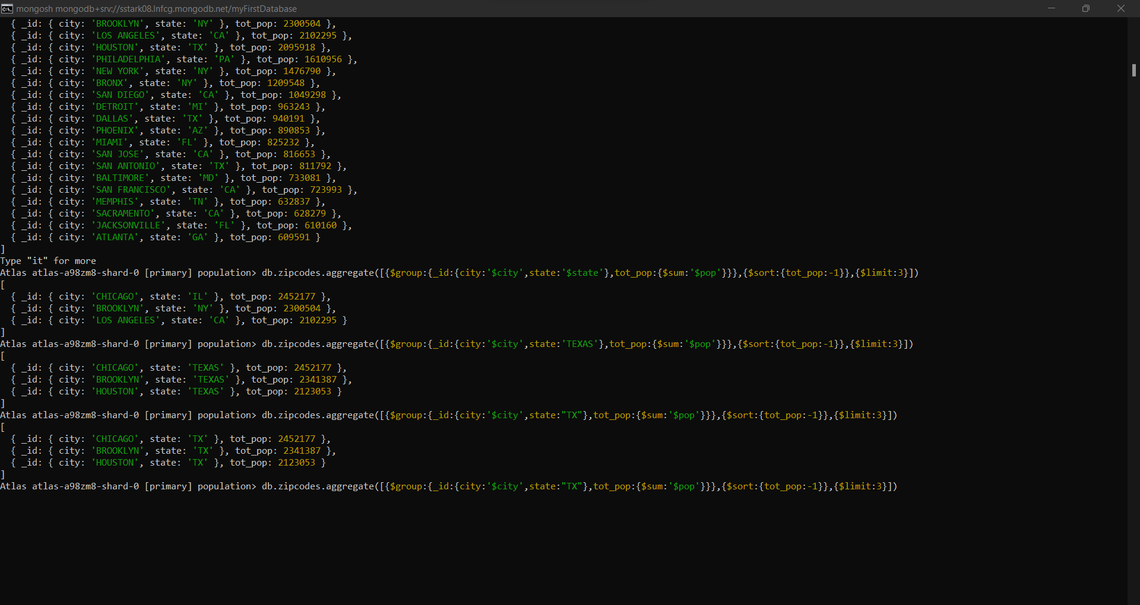

**Bonus:**

1. Get the average city population for each state:

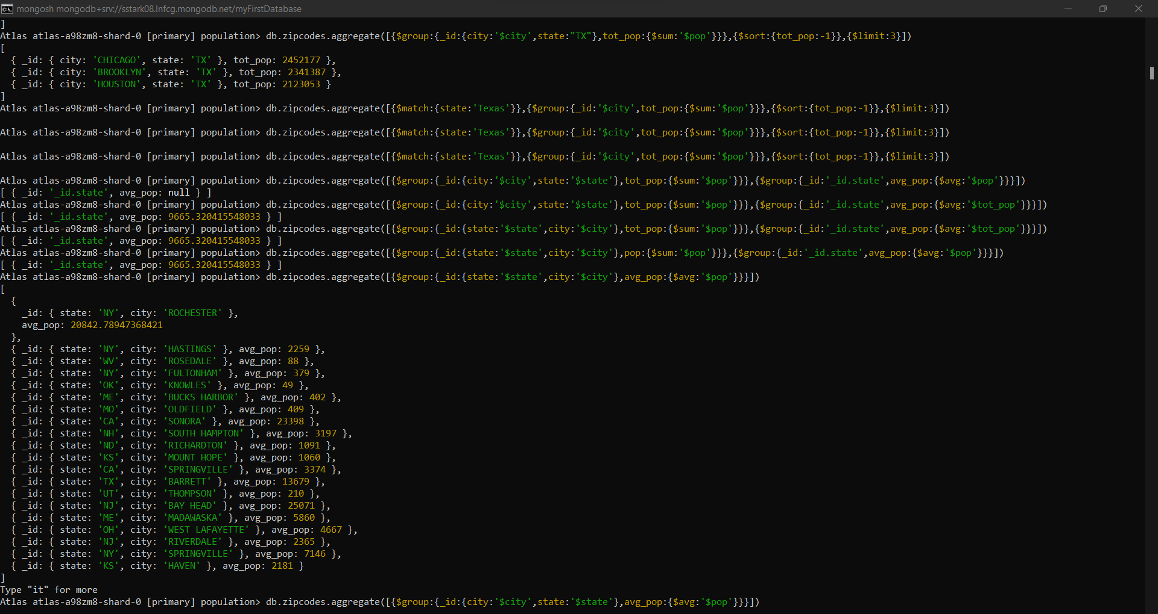

1. Top 3 states in terms of average city population:

