**MongoDB – Complex Queries**

**Exercise Questions:**

1. Query to display all the documents in the collection addresses:

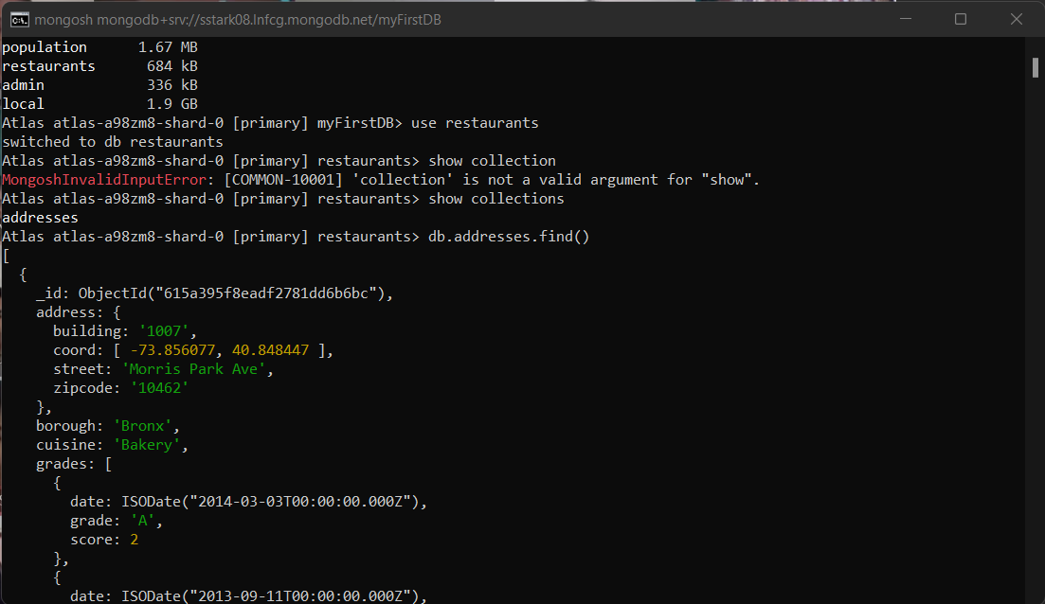

1. Query to display the fields: restaurant_id, name, borough and cuisine for all the documents in the collection addresses:

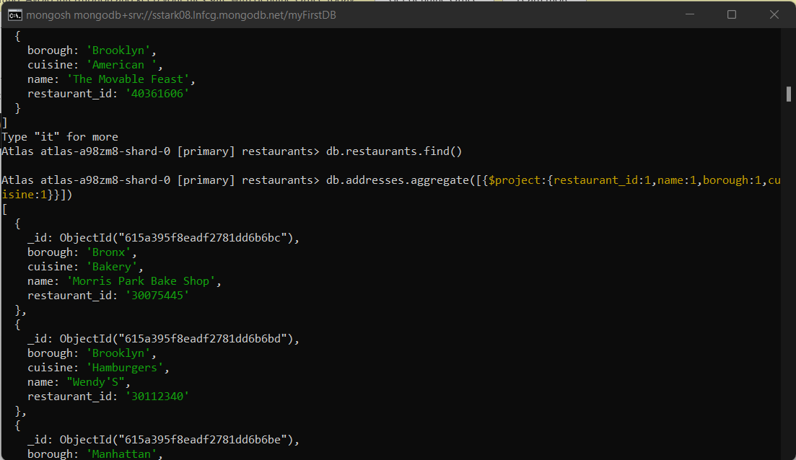

1. Query to display the fields: restaurant_id, name, borough and cuisine but exclude the field _id for all the documents in the collection addresses:

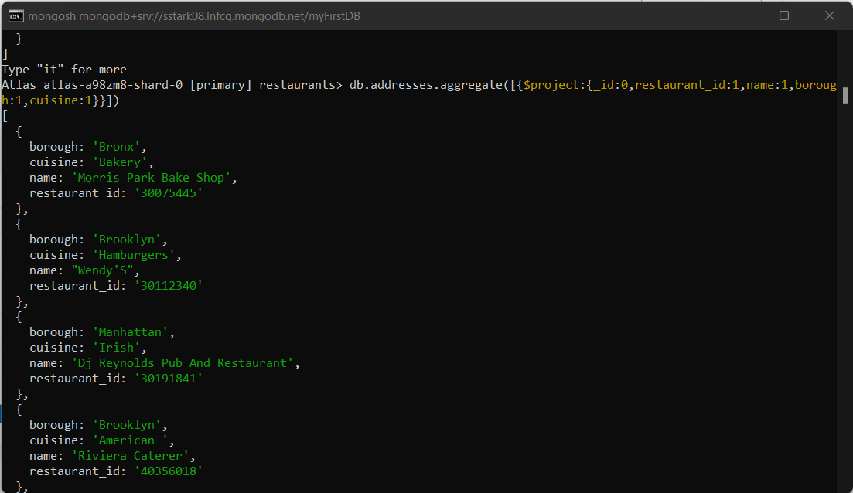

1. Query to display the fields: restaurant_id, name, borough and zip code but exclude the field _id for all the documents in the collection addresses:

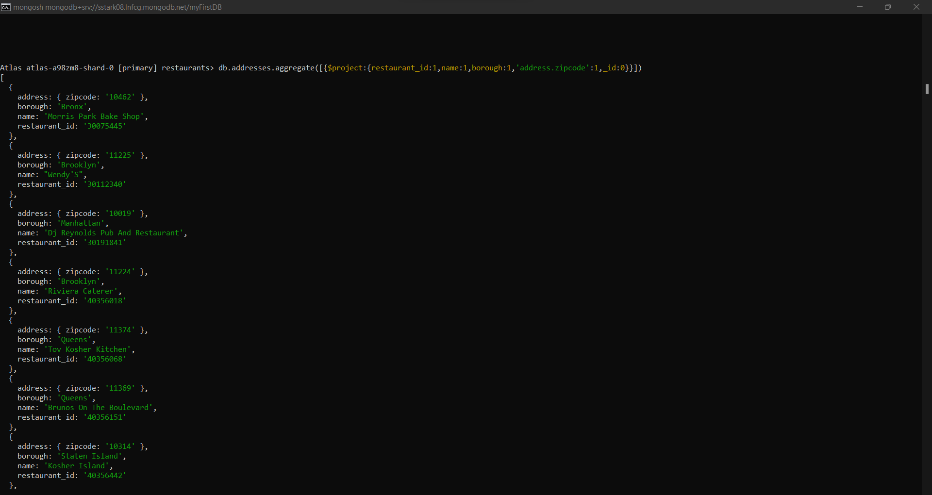

1. Query to display the 1st 5 restaurant which is in the borough Bronx:

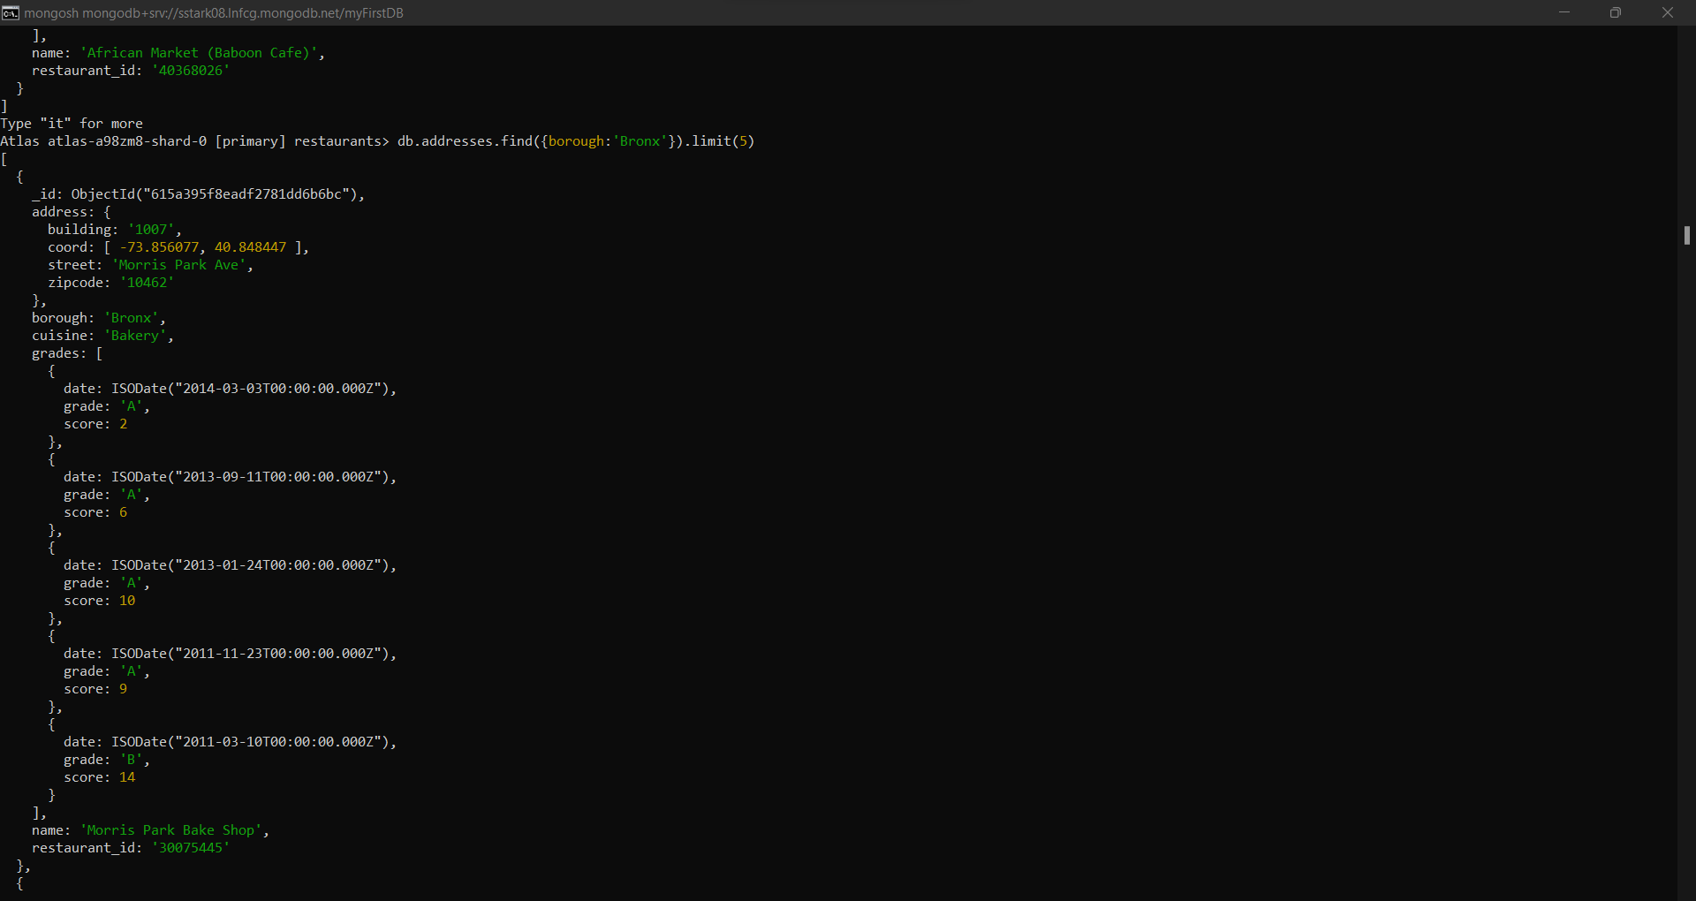

1. Query to display the all the restaurant which is in the borough Bronx:

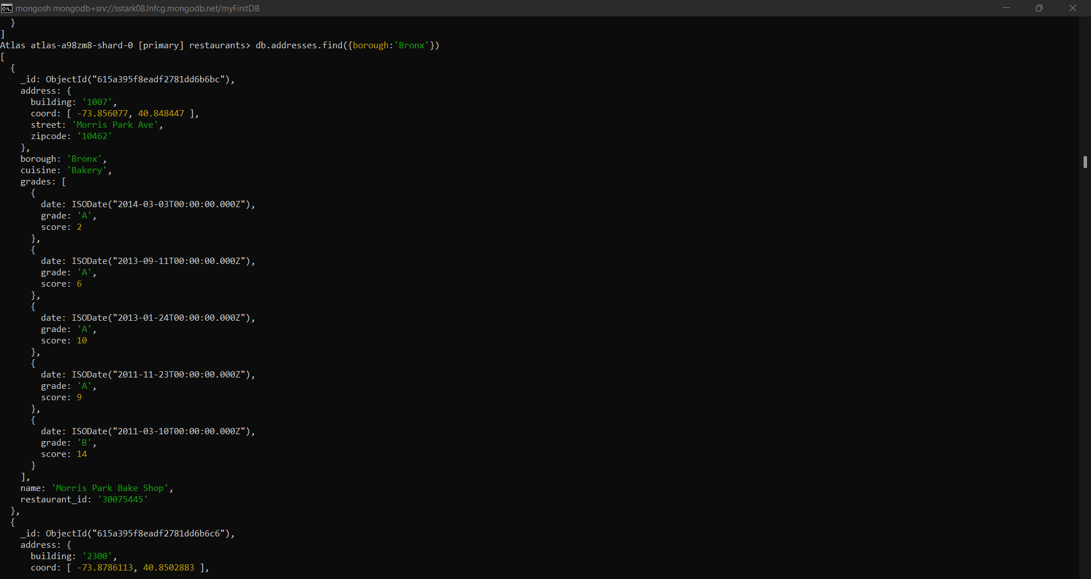

1. Query to display the next 5 restaurants after skipping 1st five which are in the borough Bronx:

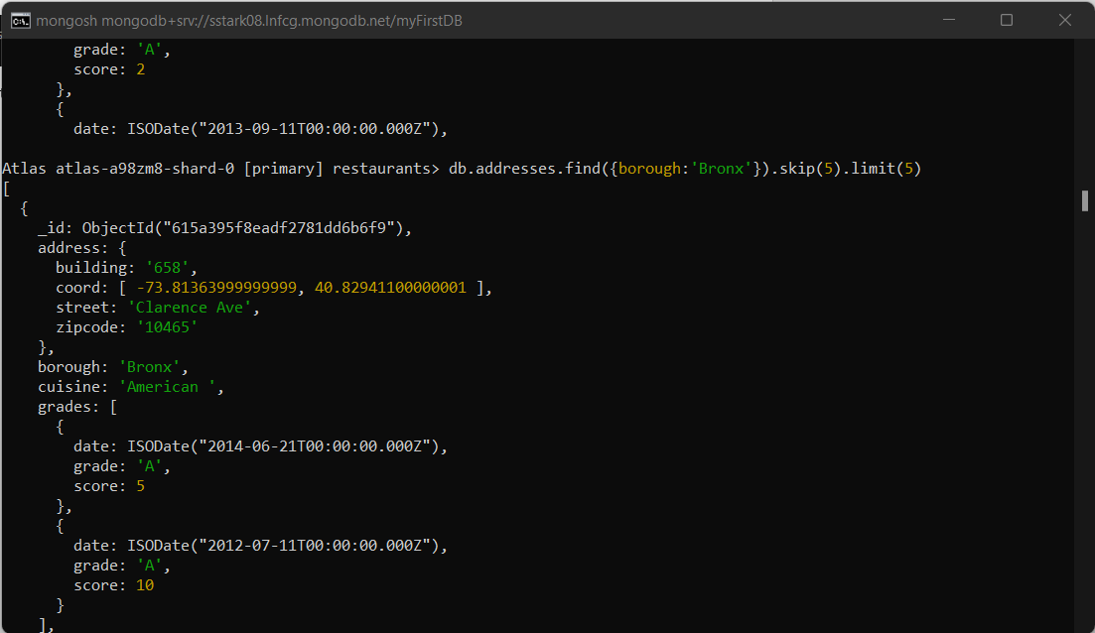

1. Query to find the restaurants who achieved a score more than 90:

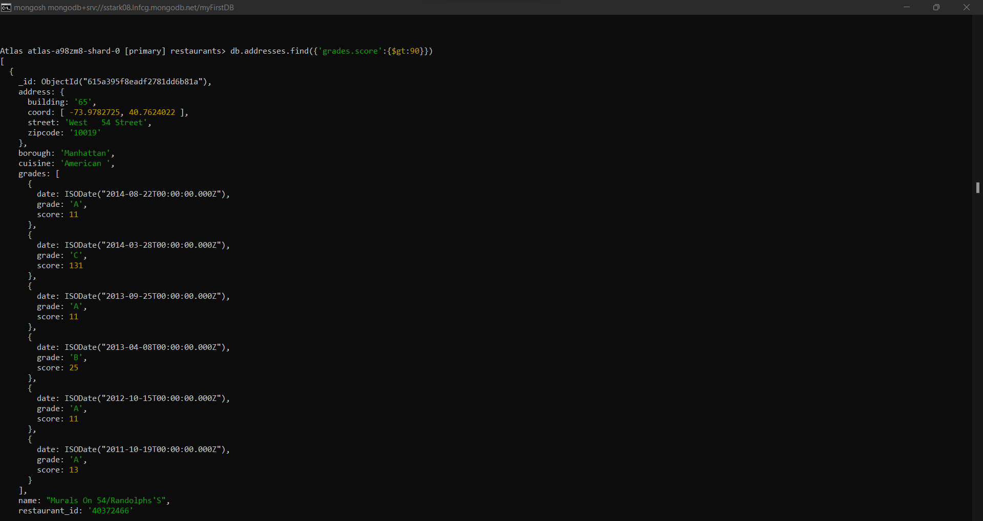

1. Query to find the restaurants who achieved a score more than 80 but less than 100:

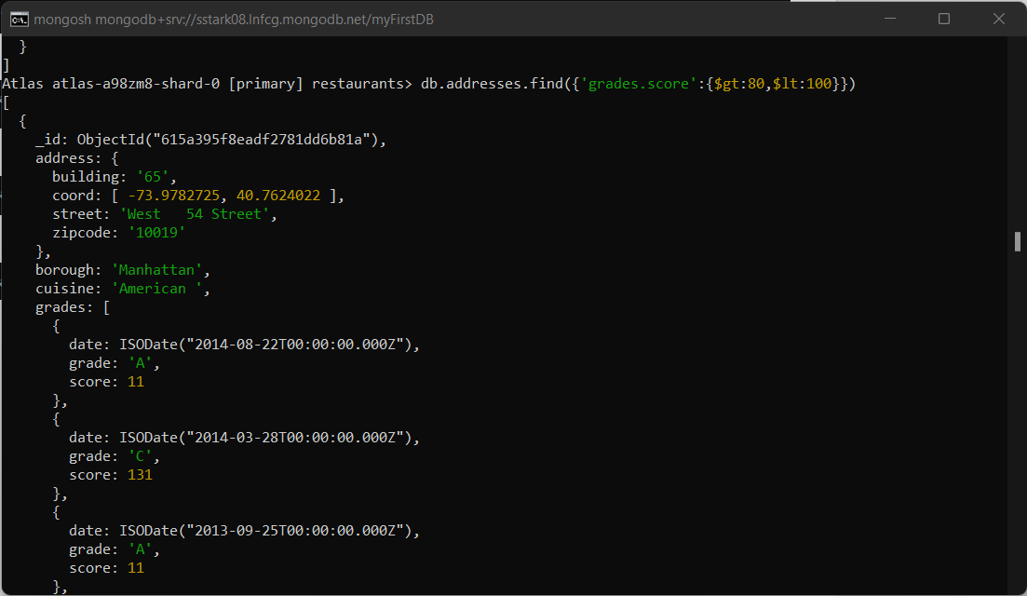

1. Query to find the restaurants which are located in latitude value less than -95.754168:

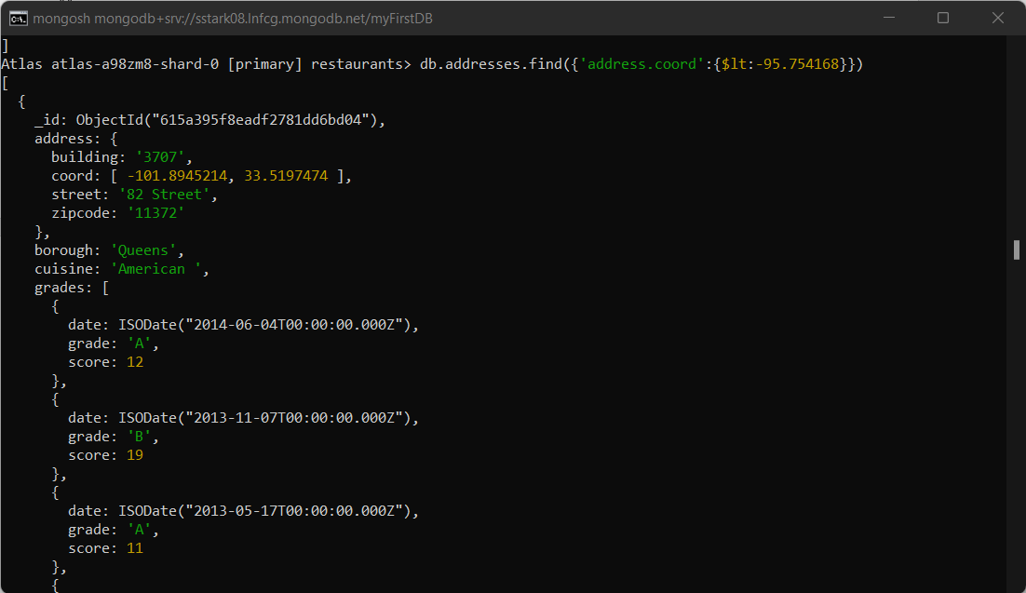

1. Query to find the restaurants that do not prepare any cuisine of ‘American’ and their grade score is more than 70 and latitude is less than -65.754168:

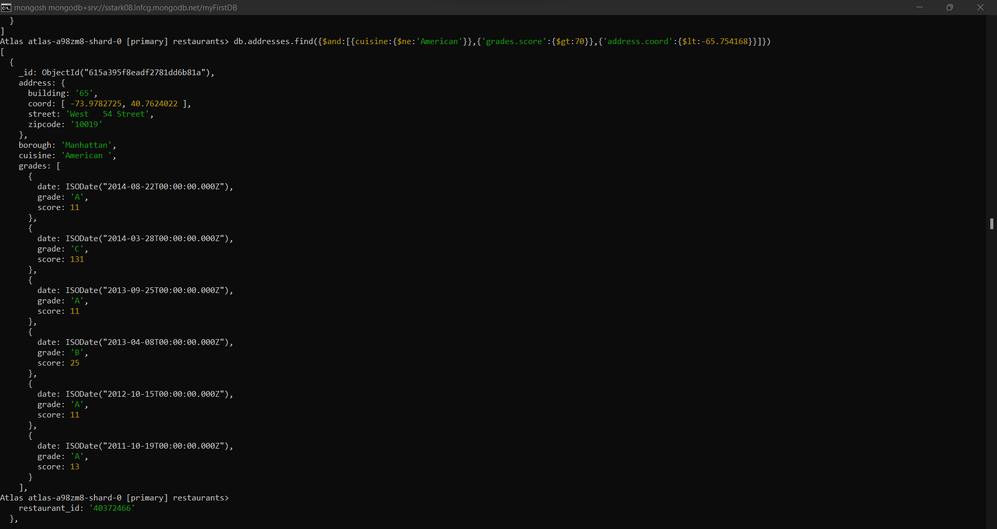

1. Query to find the restaurants that do not prepare any cuisine of ‘American’ and their grade score is more than 70 and longitude is less than -65.754168:

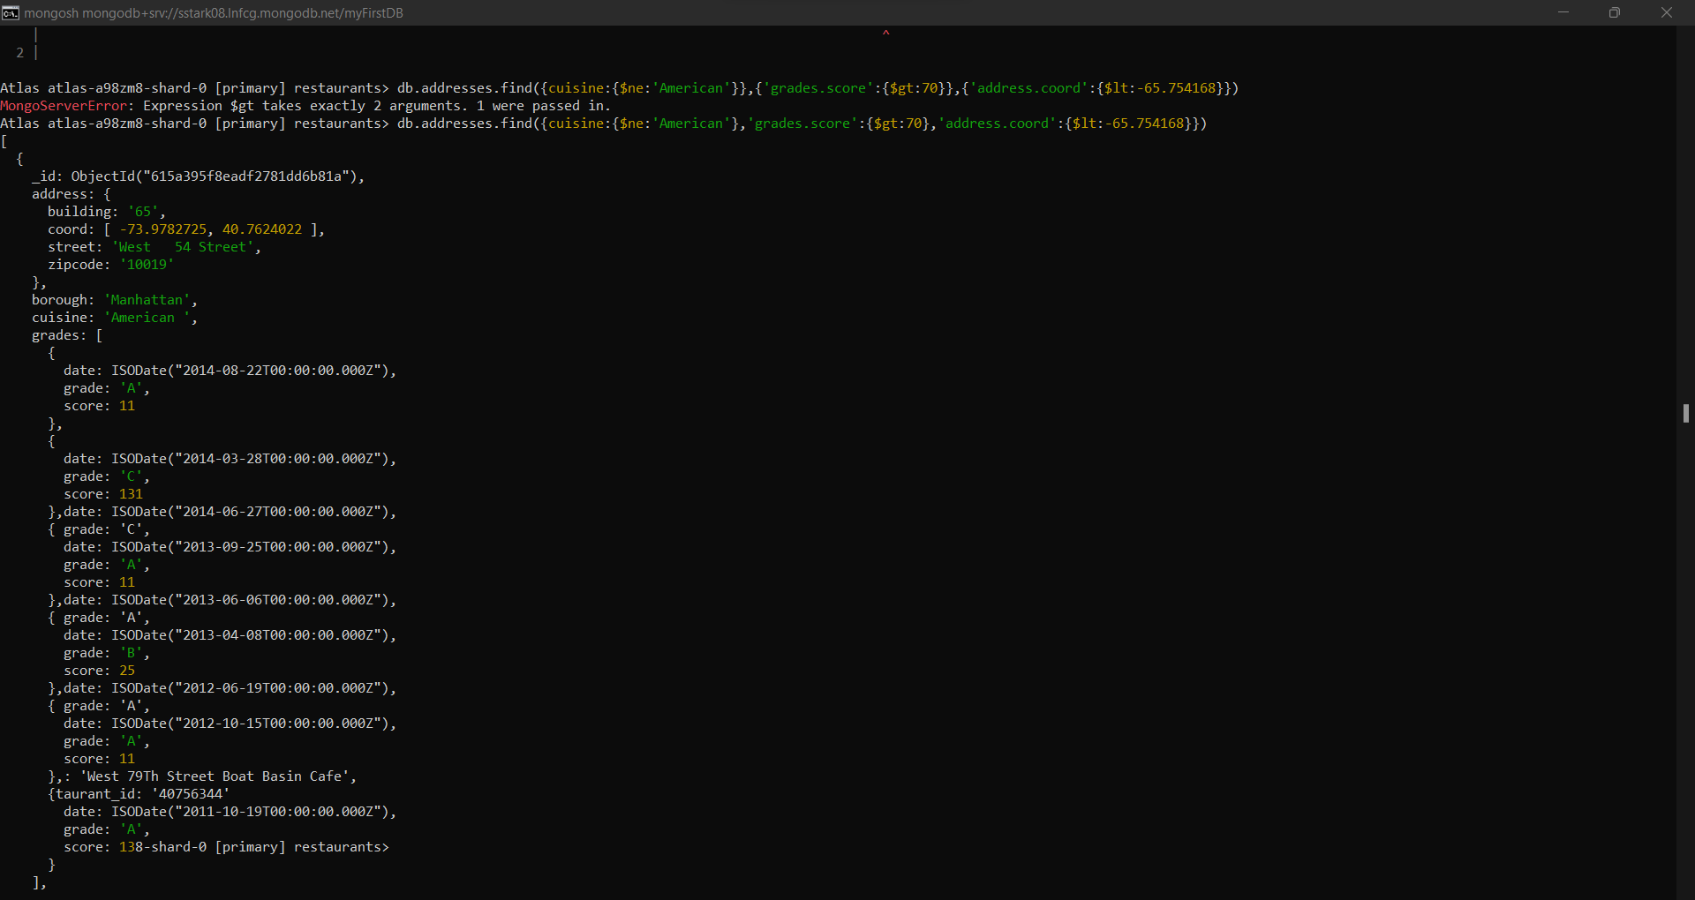

1. Query to find the restaurants that do not prepare any cuisine of ‘American’ and achieved a grade point ‘A’ not belongs to the borough Brooklyn. O/p should be in descending order according to the cuisine:

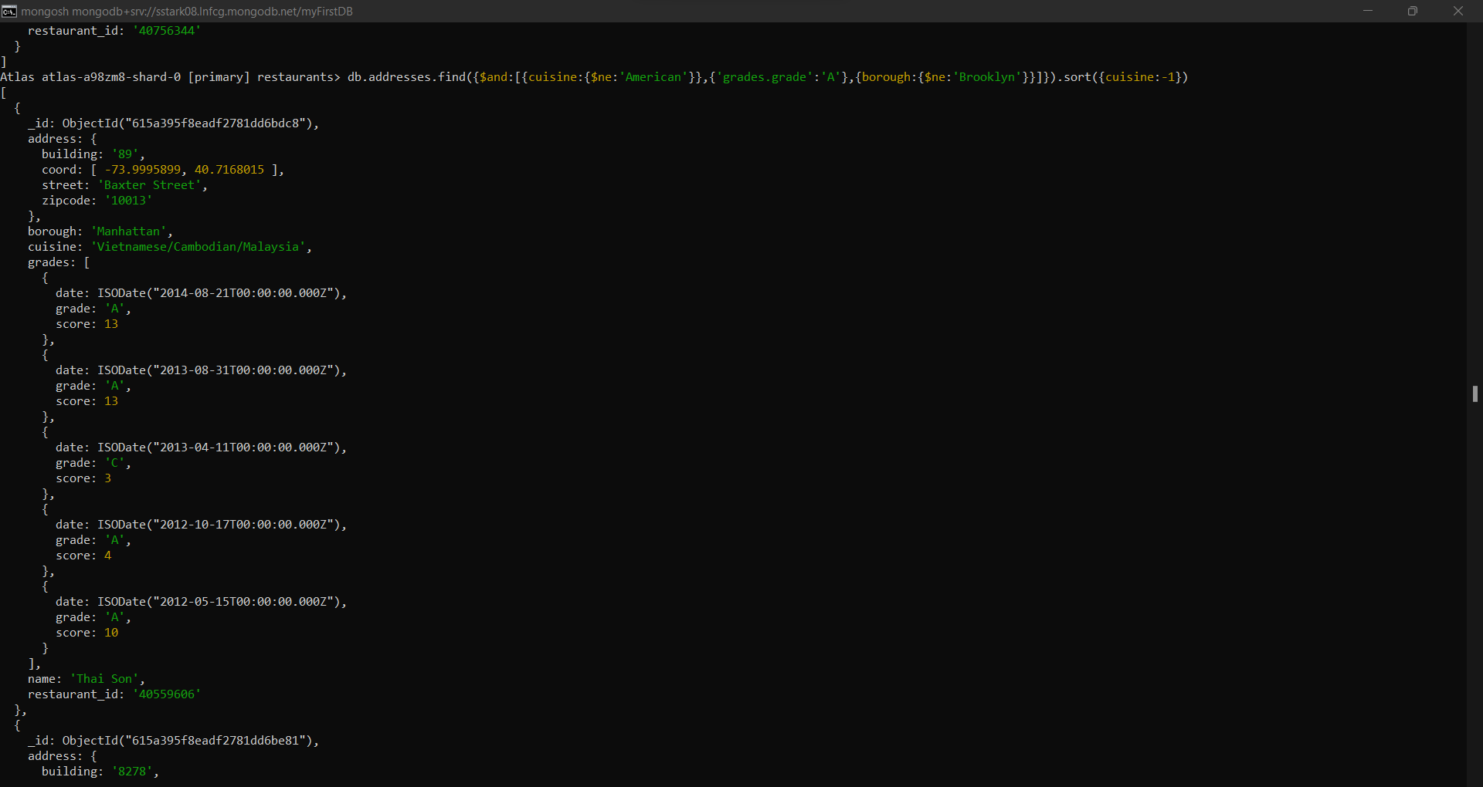

1. Query to find the restaurant id, name, borough and cuisine for those restaurants which contains ‘Wil’ as the 1st three letters in the name:

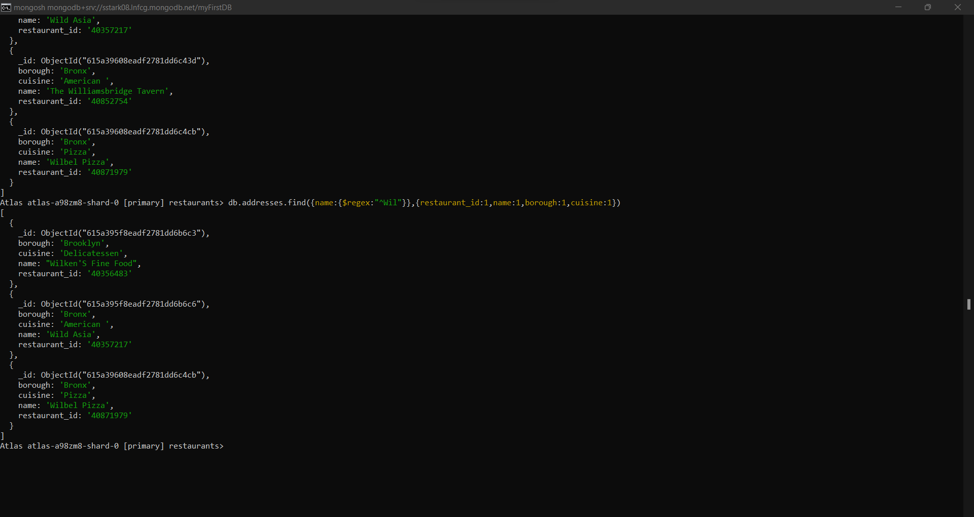

1. Query to find the restaurant id, name, borough and cuisine for those restaurants which contains ‘ces’ as the last three letters in the name:

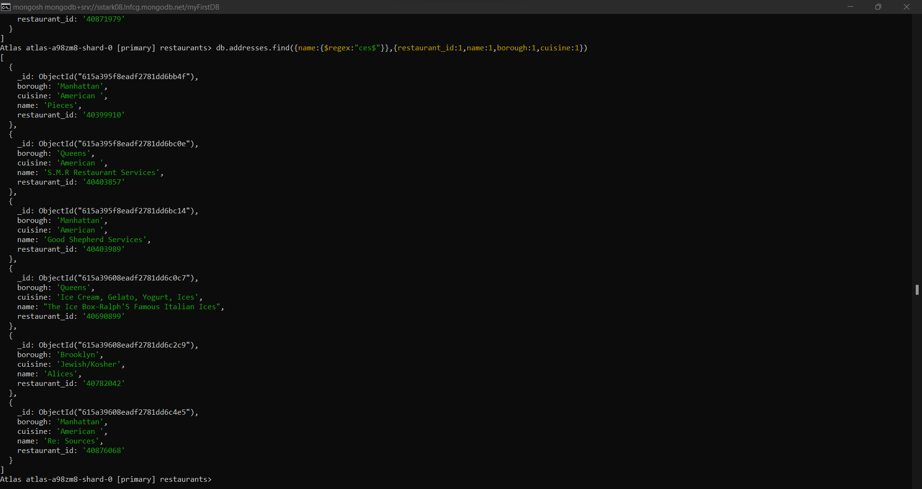

1. Query to find the restaurant id, name, borough and cuisine for those restaurants which contains ‘Reg’ as the three letters in the name:

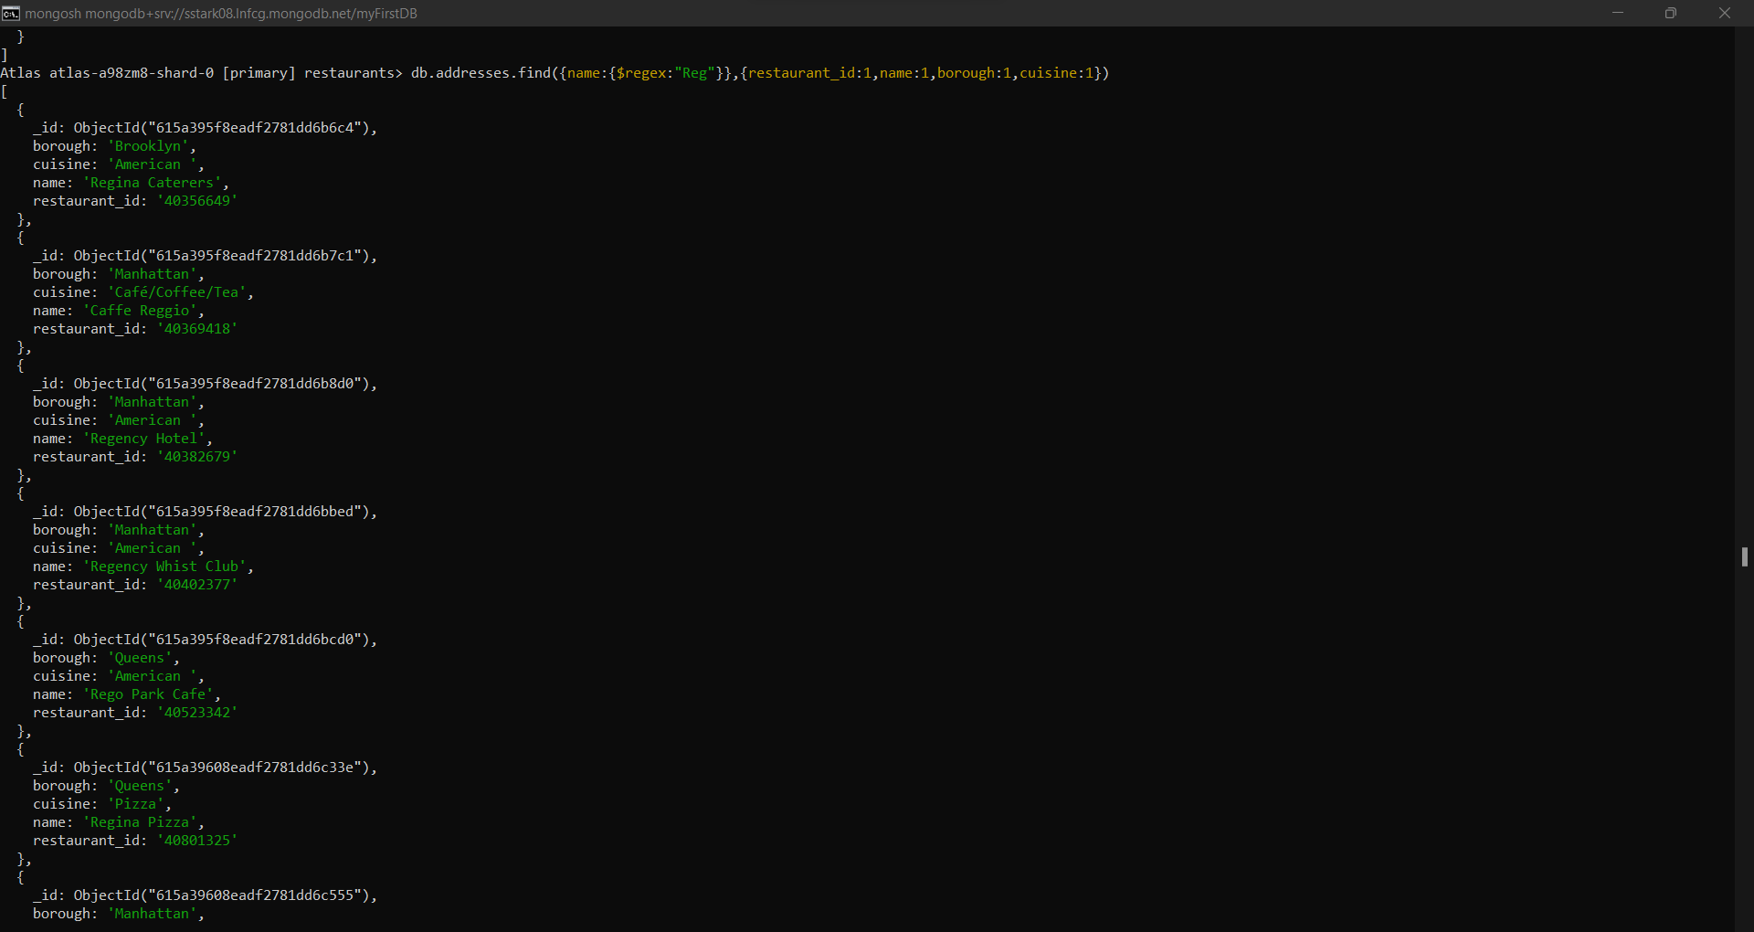

1. Query to find the restaurants which belong to the borough Bronx and prepared either American or Chinese dish:

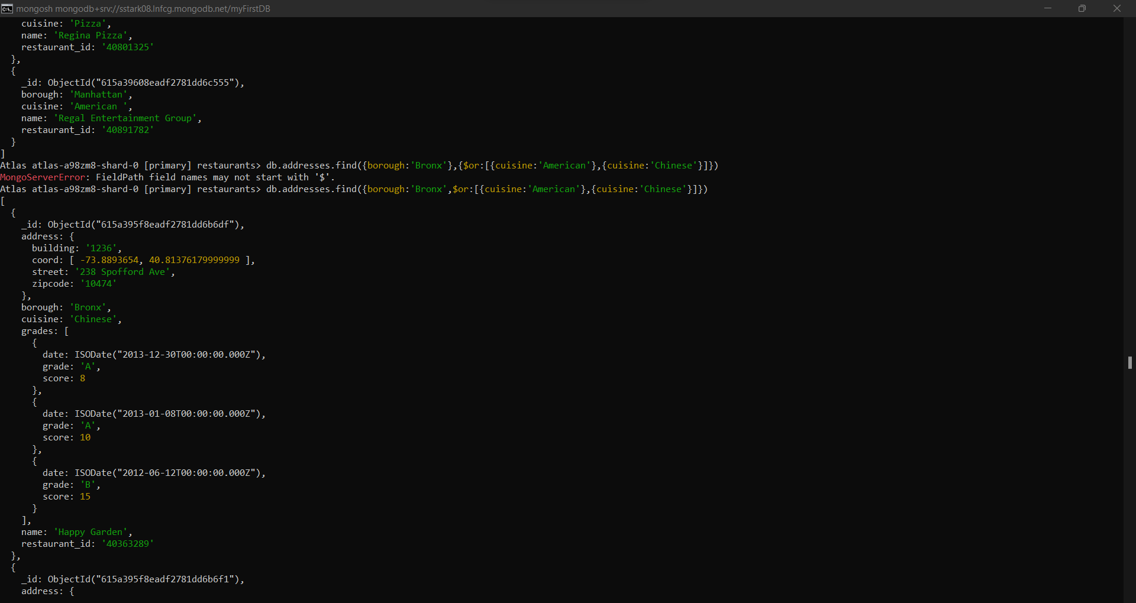

1. Query to find the restaurant id, name, borough and cuisine for those restaurants which belongs to the borough Staten island or Queens or Bronx or Brooklyn:

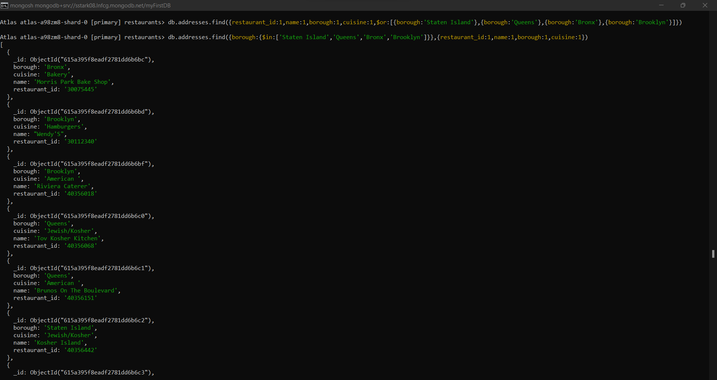

1. Query to find the restaurant id, name, borough and cuisine for those restaurants which does not belongs to the borough Staten island or Queens or Bronx or Brooklyn:

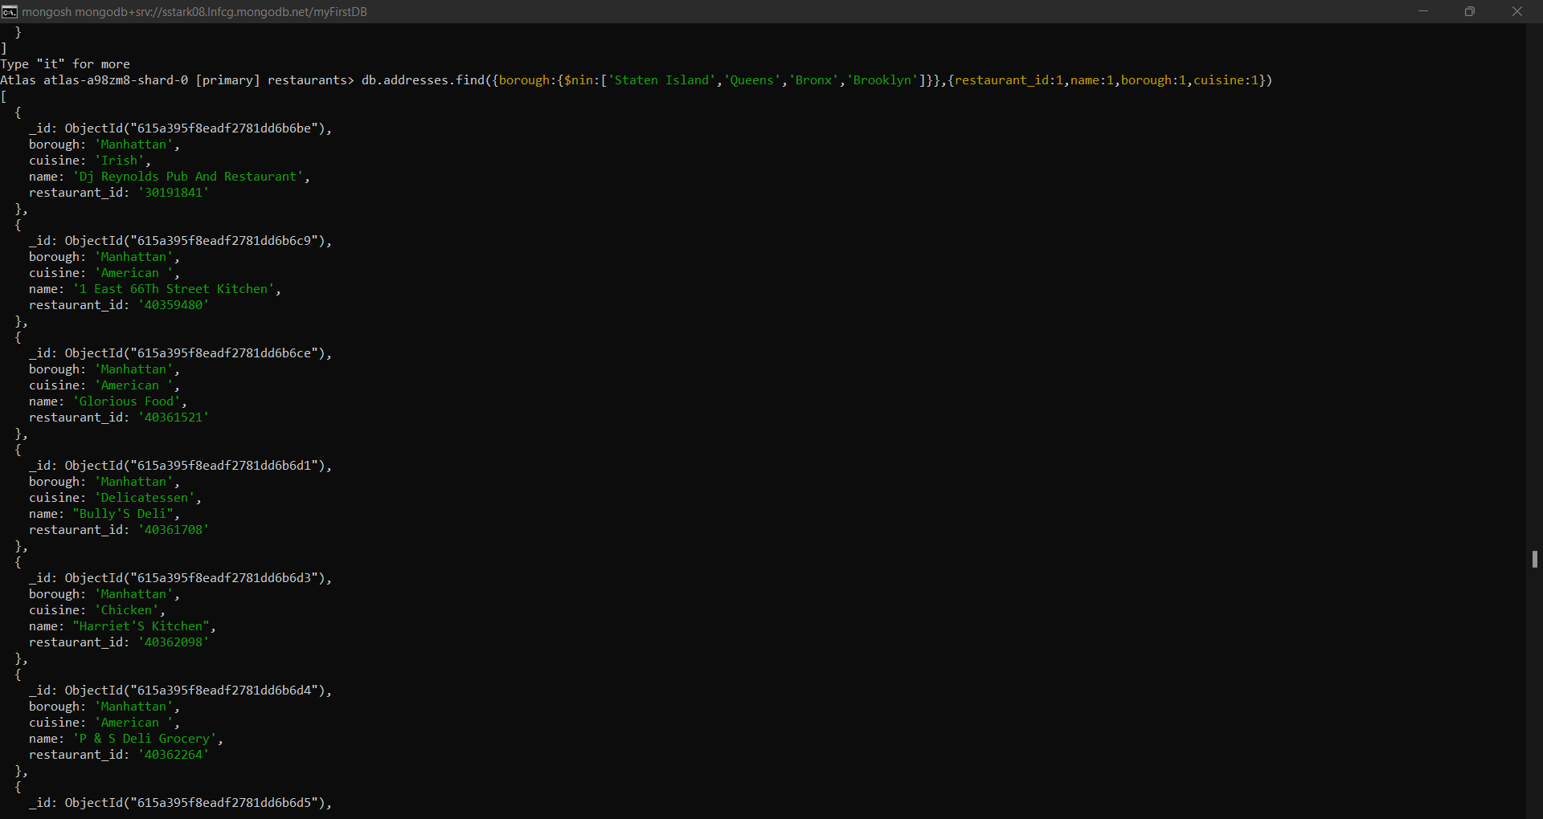

1. Query to find the restaurant id, name, borough and cuisine for those restaurants which achieved a score which is not more than 10:

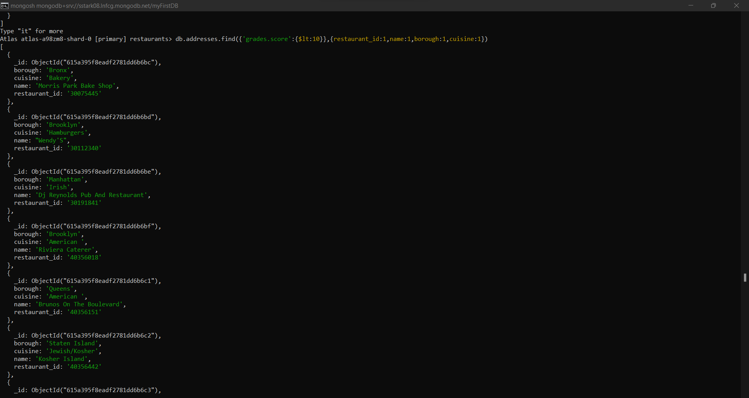

1. Query to find the restaurant id, name, borough and cuisine for those restaurants which prepared dish except ‘American’ and ‘Chinese’ or restaurant name begins with letter ‘Wil’:

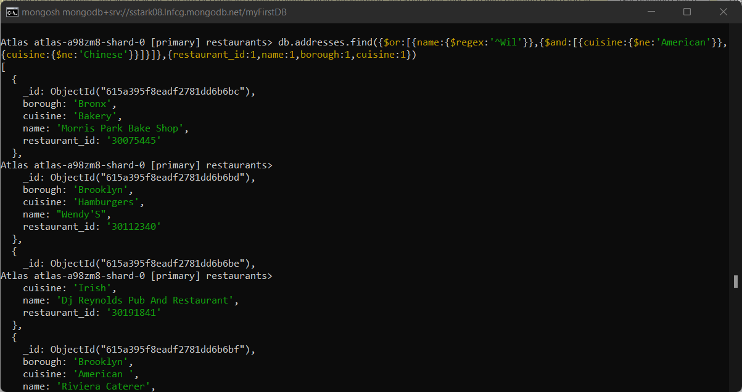

1. Query to find the restaurant id, name, borough and cuisine for those restaurants which achieved grade ‘A’ and scored 11 on ISO date “2014-08-11T00:00:00Z”:

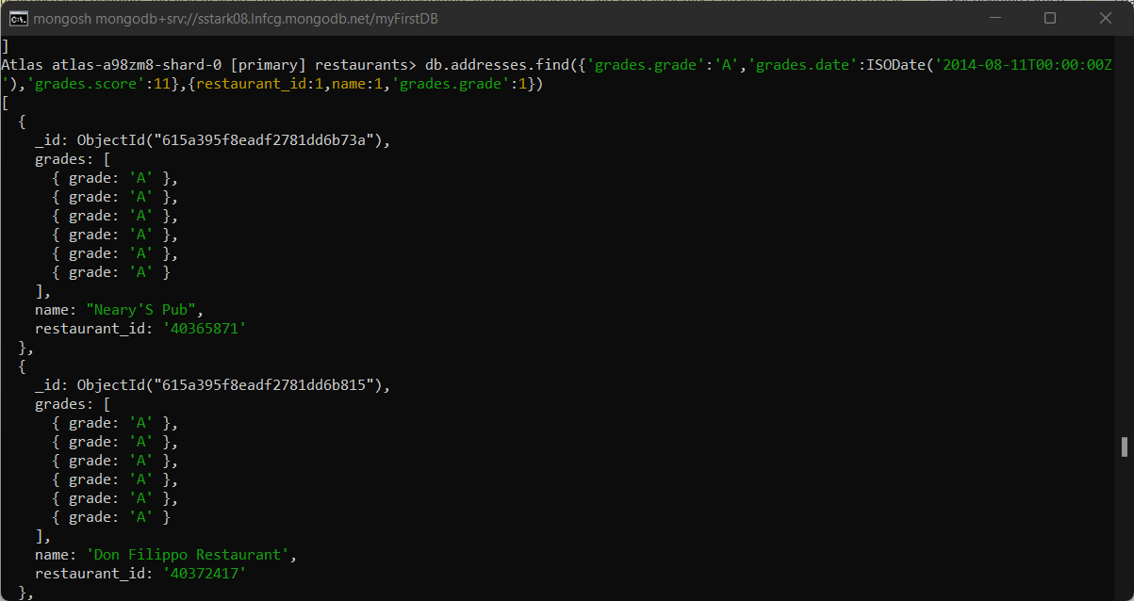

1. Query to find the restaurant id, name, borough and cuisine for those restaurants where the 2nd element of grades array contains a grade ‘A’ and scored 9 on ISO date “2014-08-11T00:00:00Z”:

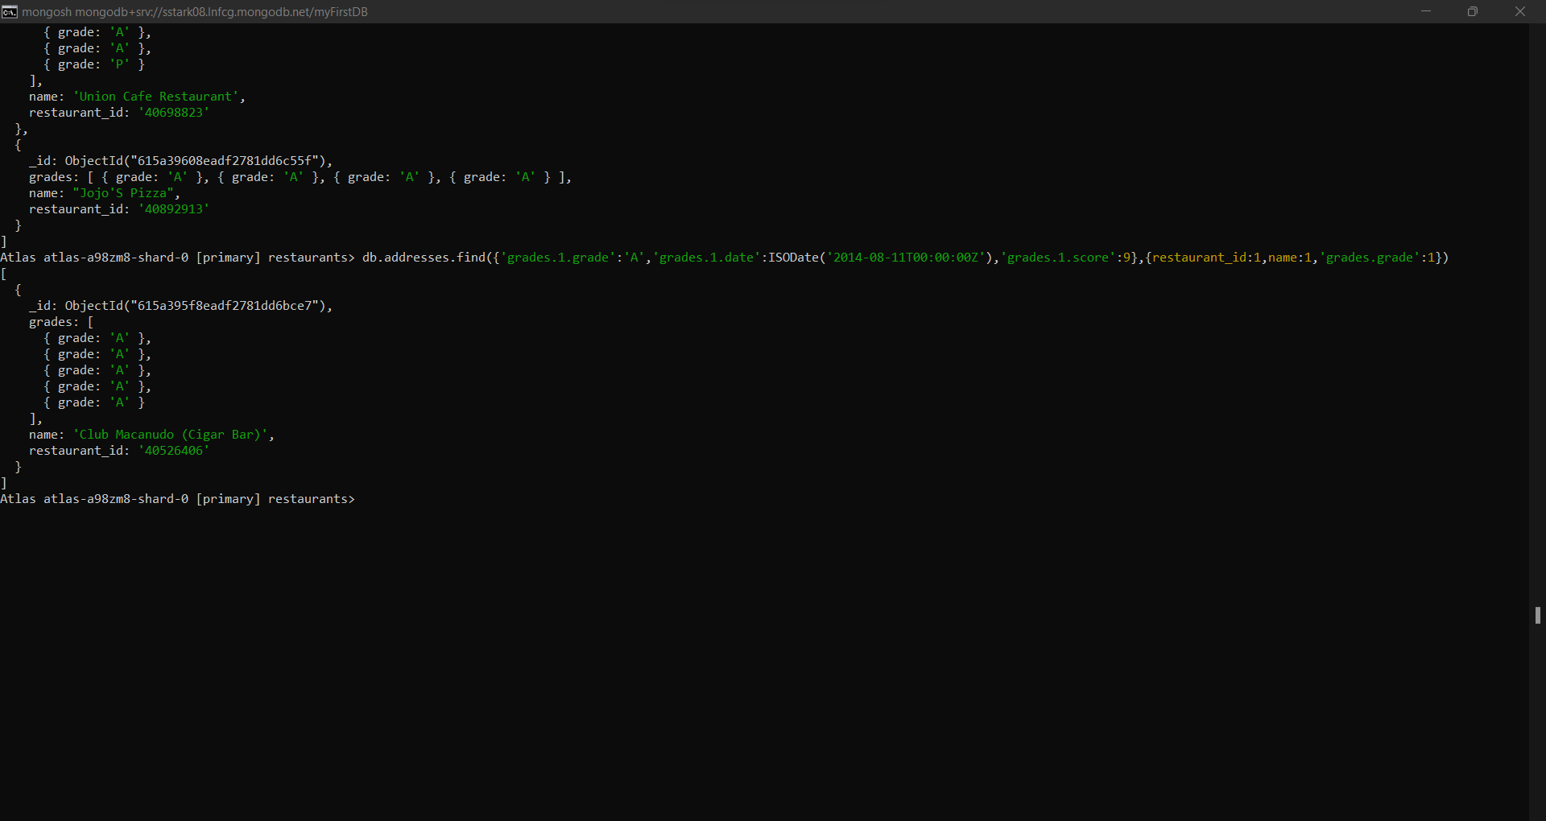

1. Query to find the restaurant id, name, address and geographical location for those restaurants where 2nd element of coord array contains a value which is more than 42 and upto 52:

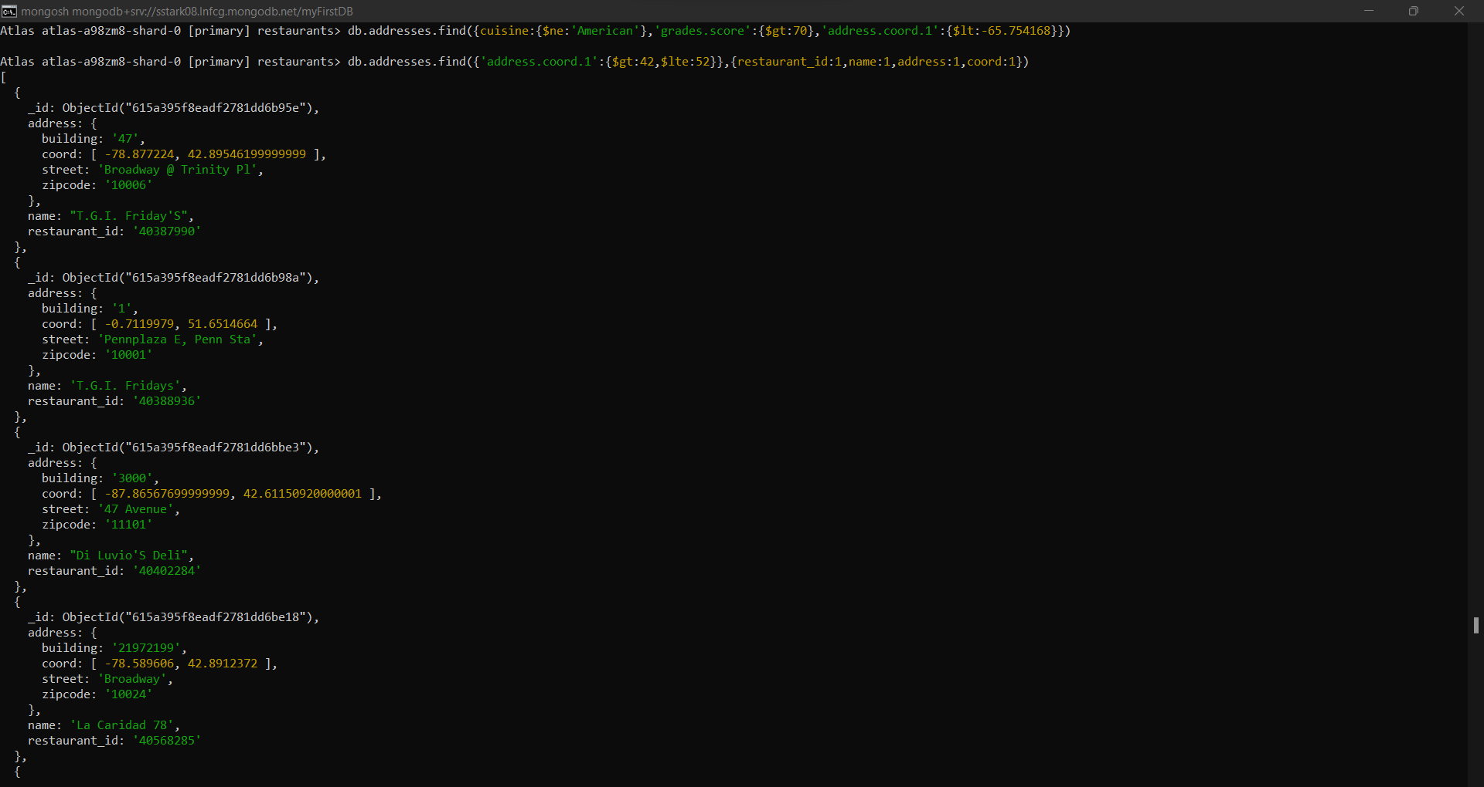

1. Query to arrange the name of restaurants in ascending order along with all the columns:

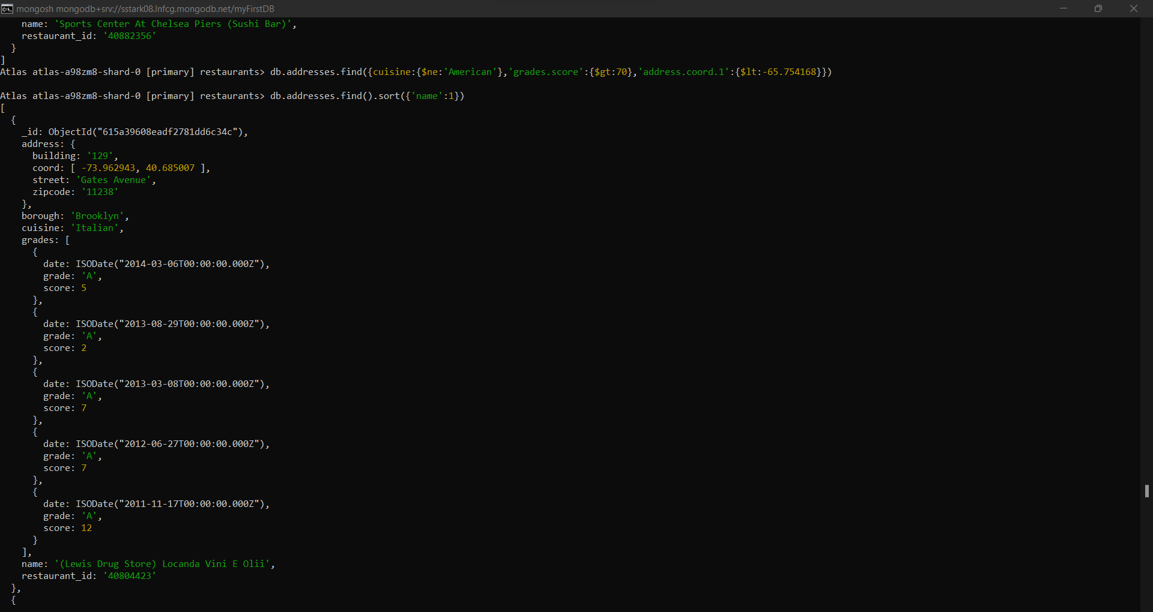

1. Query to arrange the name of restaurants in descending order along with all the columns:

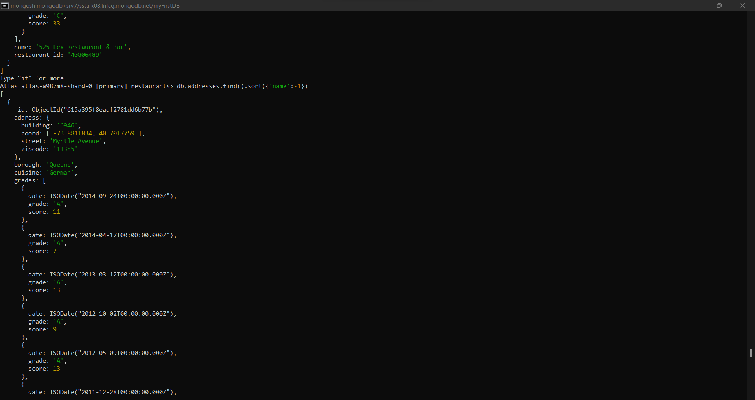

1. Query to arrange the name of cuisine in ascending and borough in descending order:

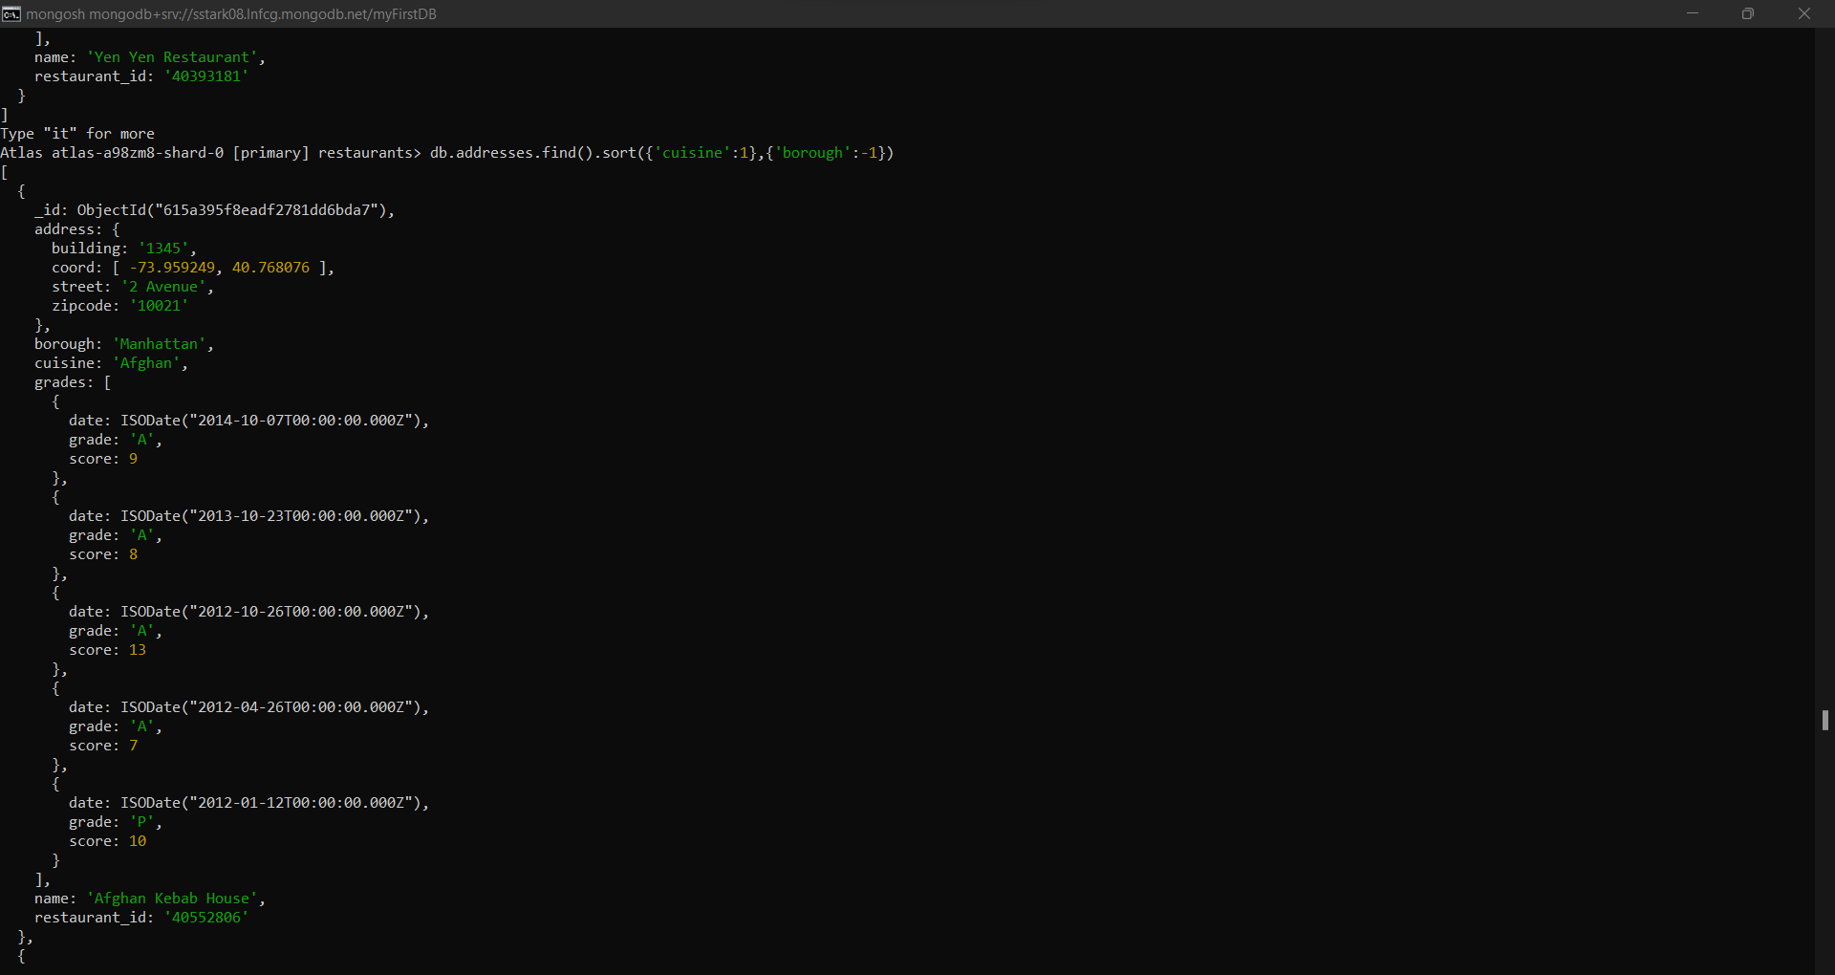

1. Query to know whether all the addresses contains the street or not:

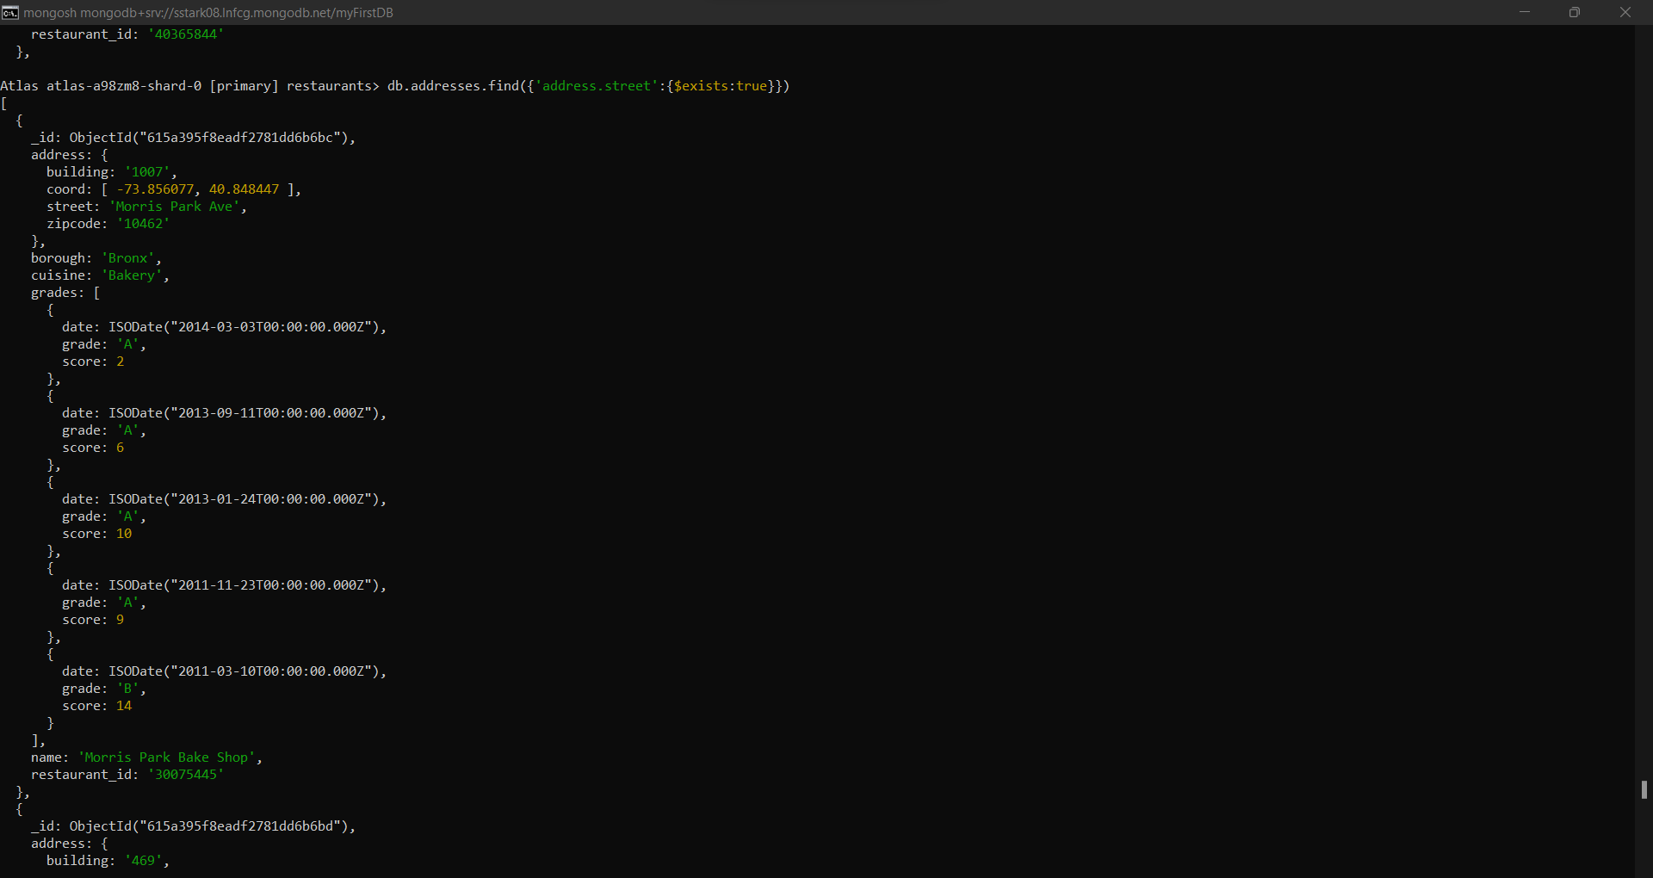

1. Query to select all documents where coord field value is Double:

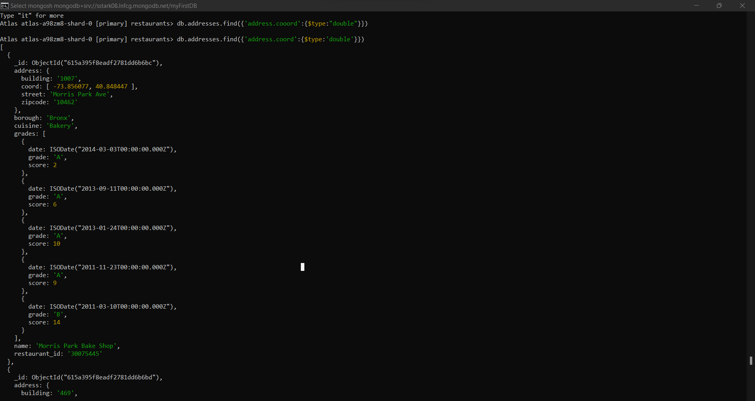

1. Query to select the restaurant id, name and grades for those restaurants which return 0 as a remainder after dividing the score by 7 :

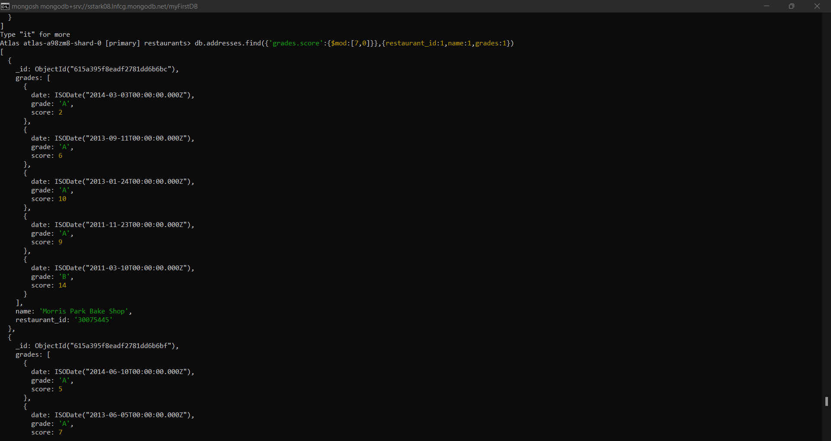

1. Query to find the restaurant name, borough , longitude and latitude and cuisine for those restaurants which contains ‘mon’ as 3 letters somewhere in the name:

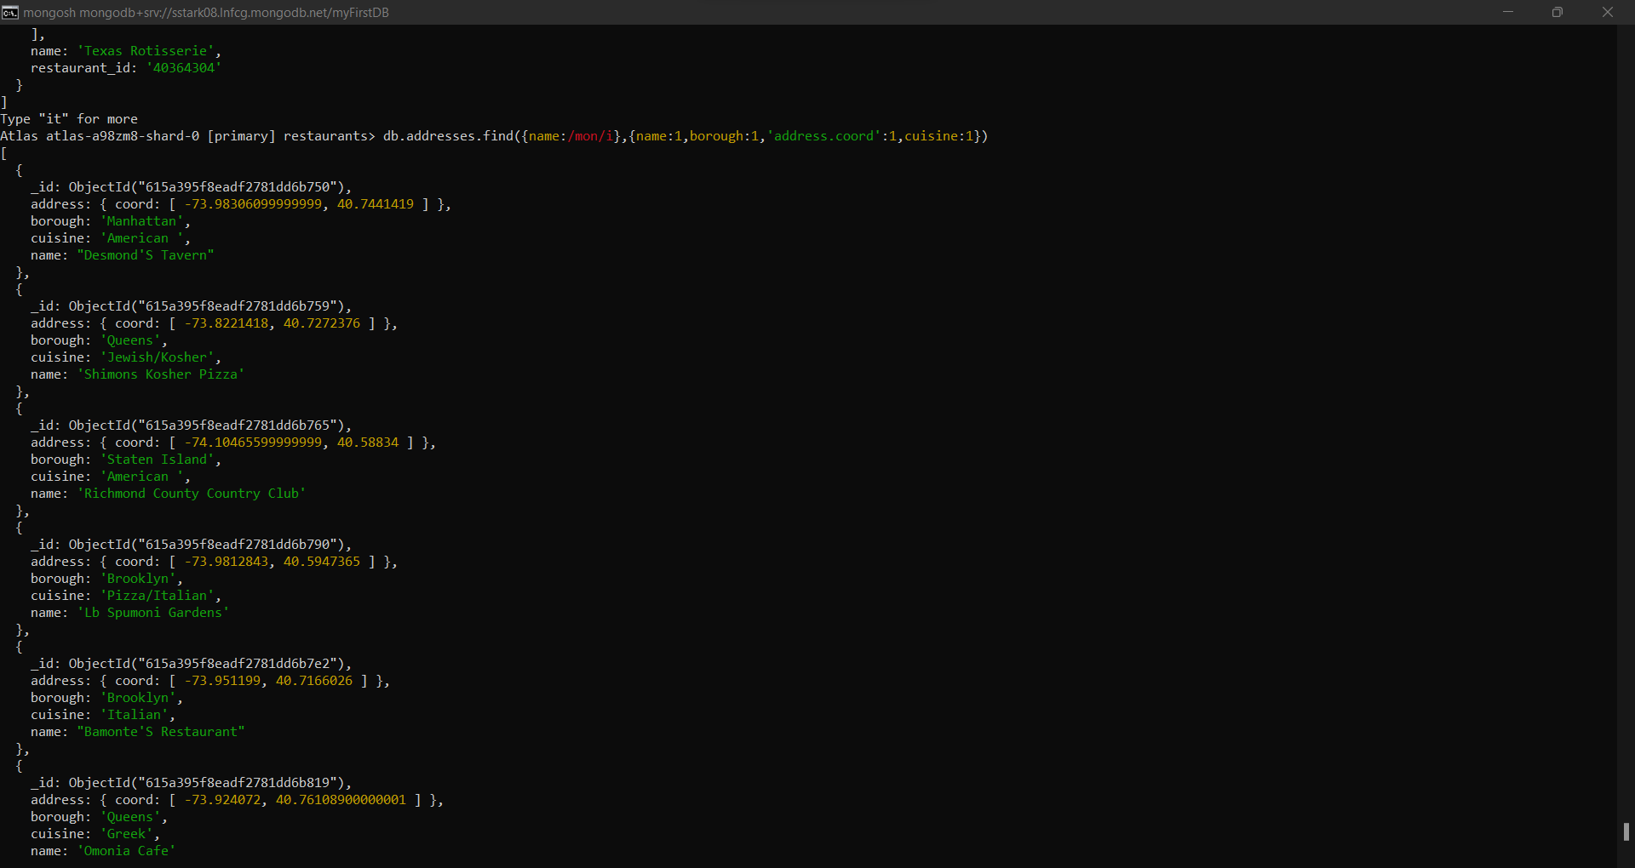

1. Query to find the restaurant name, borough, longitude and latitude and cuisine for those restaurants which contains ‘Mad’ as first 3 letters in the name:

