Laboratory Assignment AND Assessment Requirements Specification

Version 1.1

March, 2022

Developed by:

Student X, Student Y

933

Version History

|  |  |  |  |
| --- | --- | --- | --- |
| Version | Description of Change | Author | Date |
| V01 | Initial | Student X  Student Y | 16.03.2020 |
| V01.1 | Initial improved | Moldovan Andrei  Moldovan Ioana Ilinca | 10.03.2022 |

**Contents**

Laboratory Assignment AND Assessment Requirements Specification 1

Version 1.0 1

March, 2020 1

1 Functional Requirements 3

2 Actors 3

3 Use cases – diagram 3

3.1 Use case number 1 (Description of the use case) 3

4 Analysis 3

4.1 Entities 3

4.2 Relations between entities 3

4.3 Attributes 3

4.4 System behavior 4

4.4.1 Use case 1-2-3 4

4.5 System events 4

5 Design 4

**Analysis and design Document**

# Functional Requirements

List the functional requirements (FR) of the system.

(Functional requirements from the requirements assessment were added, the rest of the document will be completed with the other features in the next version)

|  |  |
| --- | --- |
| Section/ Requirement ID | Requirement Definition |
| FR1.0 | Implement CRUD operations for the Student entity:   1. Create 2. Delete 3. Update |
| FR1.1 | Adding a laboratory ~~theme~~ assignment |
| FR2.0 | Adding a grade for a particular student to a laboratory topic; |
| FR3.0 | Extending the term of delivery for an existing subject |
| FR4.0 | When adding a new laboratory theme, as well as modifying the delivery date of a theme, all students will be notified by email |
| FR5.0 | The NameStudent.txt file (or its content) will be emailed to the student, weekly, with the subject "Feedback laboratory MAP". |
| FR6.0 | Delay penalty will not be taken into consideration if the student has a medical note or for any other reason that the teacher might personally consider acceptable. |
| FR7.0 | If the grades are not posted in a timely manner by the teacher, it will be possible to specify along with the grade the week in which the assignment was delivered. |
| FR8.0 | Filtering entities based on criteria such as name, group, grade, delivery date, etc. |

# Actors

Teacher

# Use cases – diagram

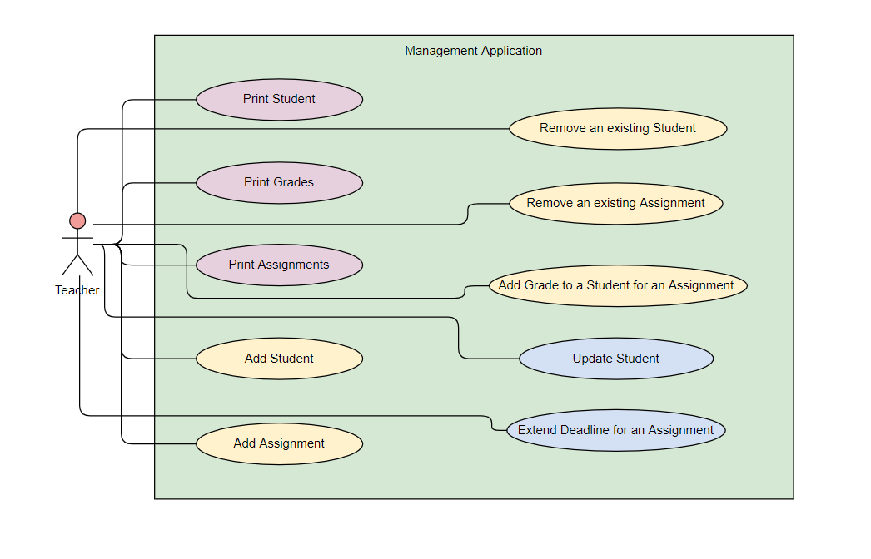

## Use case number 1 (Description of the use case)

Actors: teacher

Description: create a new student

Precondition: - all fields are specified

Postcondition: - a new student was added in the list

|  |  |
| --- | --- |
| Action | System Response |
| 1 Completes the id, name, group, email, professor name fields for adding |  |
|  | 2 Checks if the fields are compliant (number id that doesn’t already exist, group as number, names and email with compliant characters) and adds a new element in the list if so |
| 3 - | 3. If the input is invalid, throws an exception |

Exceptions: When the fields aren’t filled, when the fields do not have the right type or characters, when the id already exists. The exception is caught and a message is shown to the user in order for him to complete the right steps.

## 3.2 Use case number 2 (Description of the use case)

Actors: teacher

Description: delete student

Precondition: - valid id belonging to an existing student is specified

Postcondition: - the student with the specified id is removed from the list

|  |  |
| --- | --- |
| Action | System response |
| 1 Give an id as input |  |
|  | 2 Checks if it is a valid id and there is a student with that id and deletes the student |
| 3 - | 3. If the input is invalid, throws an exception |

Exceptions: When the field isn’t filled, when the field does not have the right type, when the id does not exist. The exception is caught and a message is shown to the user in order for him to complete the right steps.

## 3.3 Use case number 3 (Description of the use case)

Actors: teacher

Description: update student

Precondition: - valid id belonging to an existing student and all other fields for student are specified

Postcondition: - the student with the specified id has the data updated

|  |  |
| --- | --- |
| action | System response |
| 1 Give an id, name, group, email, professor name fields for the Student entity as input |  |
|  | 2 Checks if it is a valid id and there is a student with that id, than checks if the rest of the input is valid, and updates the data for that student |
| 3 - | 3. If the input is invalid, throws an exception |

Exceptions: When the fields aren’t filled, when the fields do not have the right type or characters, when the id does not exist. The exception is caught and a message is shown to the user in order for him to complete the right steps.

# Analysis

## Entities

Student, Assignment, Grade

## Relations between entities

One student can have multiple assignments and one assignment can be assigned to many students. It is a many-to-many relationship between the two classes. Class Grade has as id, a pair consisting of studentId and assignmentId and it is the association class between the Student and Assignment classes.

## Attributes

Student: id, name, group, email, professor name

Assignment: id, description, deadline, assignation date

Grade: id(studentId, assignmentId), value, deliver date, feedback

## System behavior

## Use case 1-2-3

The system will act as a subsystem to a larger environment, in order to speed up a certain process in the company’s workflow.

## System events

After each operation a message is shown to the user either if the command terminated succesfully or with an error message.

# Design

* 1. **Class diagram**

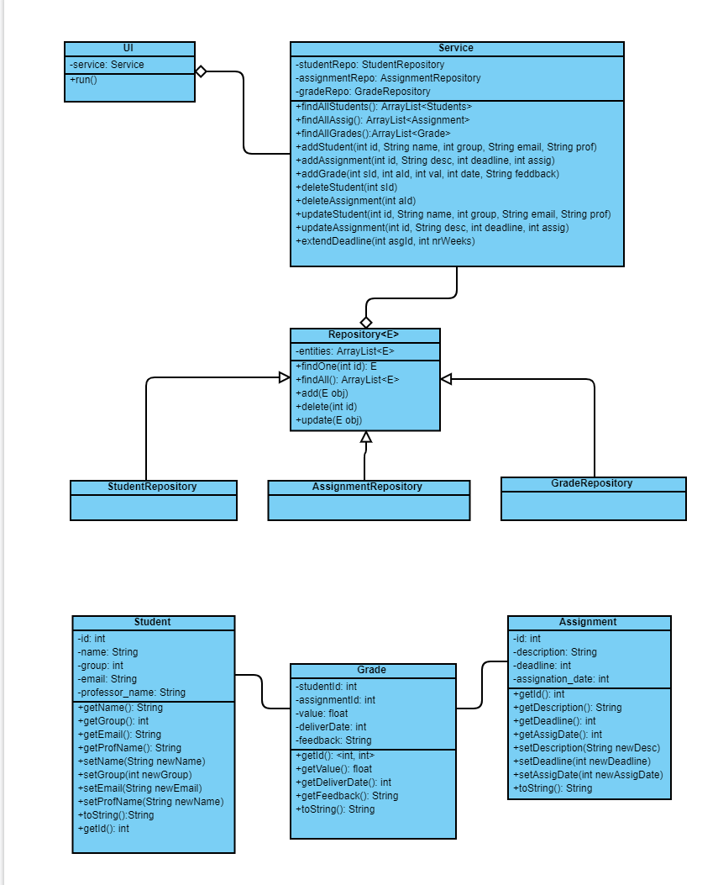

* 1. **Sequence diagrams (for each use case)**
* **Add Student Sequence Diagram**

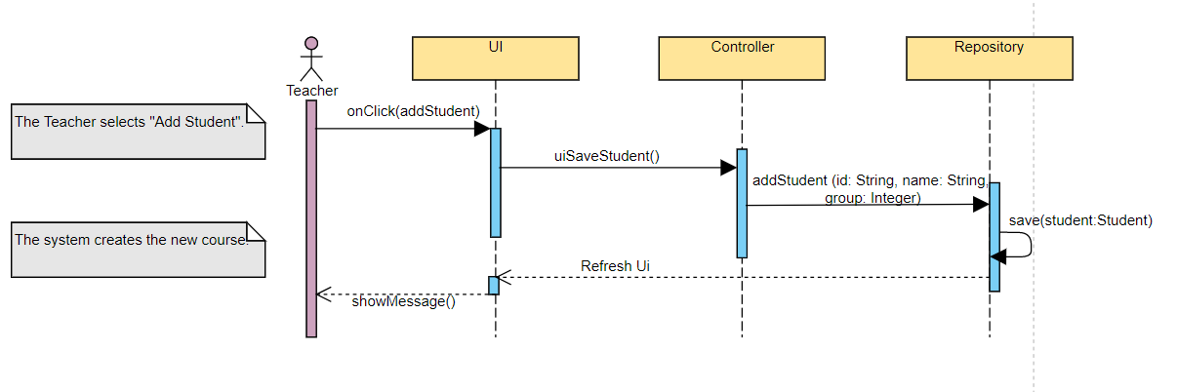

* **Delete Student Sequence Diagram**

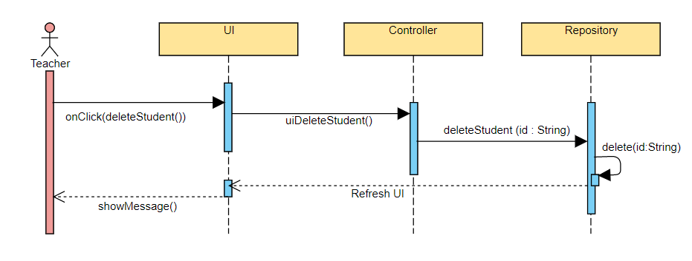

* **Update Student Sequence Diagram**

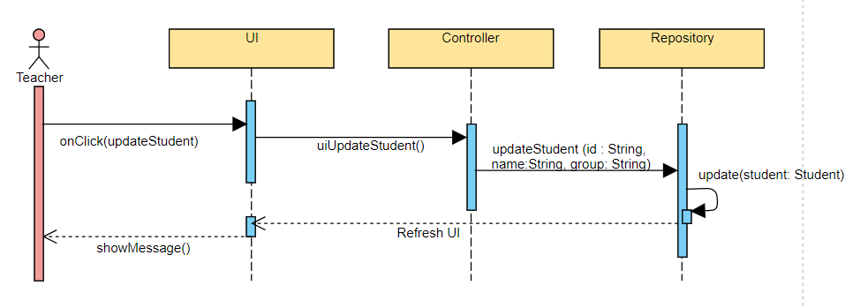

* 1. **GRASP**

GRASP is set of exactly 9 **G**eneral **R**esponsibility **A**ssignment **S**oftware **P**atterns:

1. Information Expert

2. Creator

3. Controller

4. Low Coupling

5. High Cohesion

6. Indirection

7. Polymorphism

8. Pure Fabrication

9. Protected Variations