### How to edit signatures?

DONOT edit the signatures from Outlook. Please follow the below instructions to edit a signature:

1. The signature master files are stored at \\fileserver\DataSSW\DataSSWEmployees\Templates\Outlook
2. Follow the instructions at <http://skunk/ssw/Standardsinternal/inductiontraining/inductionday1.aspx#Outlook>

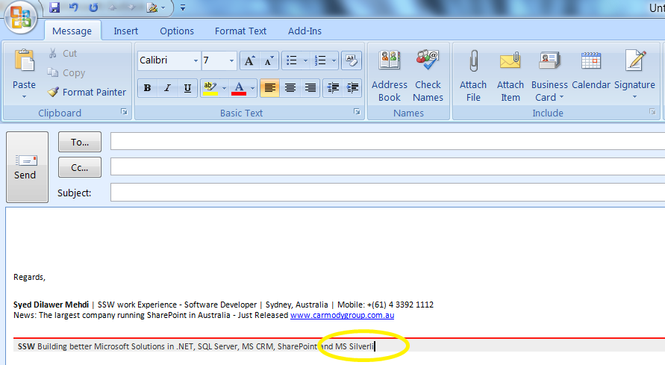

**Figure: Bad example – Editing a signature from Outlook**.

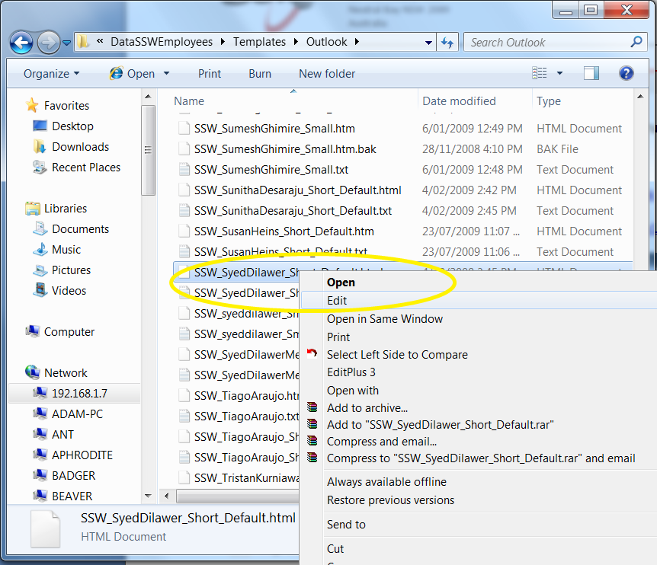

**Figure: Good example – Edit the signature in** **\\192.168.1.7\DataSSW\DataSSWEmployees\Templates\Outlook**

1. There should be four signatures for everyone, for e.g.:

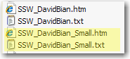

1. The signatures are automatically synced when you logon.

**Important:**

Remember to name your new signature as “SSW_<user name>_Small_Default.<ext>”

For e.g.: SSW_SyedDilawer_Small_Default.htm

**Note:**

Login Script will create a new 3rd signature at logon for all the SSW2000 domain users. This is how:

1. It uses the existing signature file for a user, i.e., SSW_<username>_Short_Default.<ext>

For e.g.: SSW_SyedDilawer_Short_Default.htm

1. **Find and replace** [www.worleyparsons.com](http://www.worleyparsons.com) with [www.carmodygroup.com.au](http://www.carmodygroup.com.au) and “Access” to “Silverlight”
2. Save the file as SSW_<username>_Small_Default.<ext> in \\192.168.1.7\DataSSW\DataSSWEmployees\Templates\Outlook

For e.g.: SSW_SyedDilawer_Small_Default.htm and SSW_SyedDilawer_Small_Default.txt

1. Then it copies the new signature i.e., SSW_<username>_Small_Default.<ext> to %Appdata%\Microsoft\Signatures
2. If SSW_<username>_Short_Default.<ext> does not exist at destination i.e., \\192.168.1.7\DataSSW\DataSSWEmployees\Templates\Outlook then it displays a message to manually create the signature.

**Owner of SSW Login Script:**

Brooke Rooney (as per employee responsibilities http://intranet.ssw.com.au/Employees/GroupByEmployeeName.aspx)

**Acknowledgement:**

Daragh Bannigan