**Different emails for order**

Here’s the process of purchasing SSW products:

1. Browse products and add them to basket (<http://www.ssw.com.au/ssw/shop/basket.aspx>)
2. Login if required. (Register if required).
3. Check out and submit order (<http://www.ssw.com.au/ssw/shop/checkout.aspx>).
4. Order emails received.

There’re two templates for order emails.

## Two Templates

The difference is that the first template contains registration related info.

* **RegistrationNeeded** – SoftwarePurchaseRegistrationRequired.xlst (see figure 1)

This is for products that need registration and activation, e.g., SSW Code Auditor, SSW Link Auditor.

If not registered, you cannot make full use of their functionalities.

* **RegistrationNotNeeded** – SoftwarePurchaseRegistrationNA.xlst (see figure 2)

This is for products that need no registration, e.g., Tech Breakfast or trainings.

People may purchase products that need registration (SSW Code Auditor, SQL Auditor) and Products that require no registration (SharePoint 101 Workshop, Tech Breakfast), thus an email should be sent for each template.

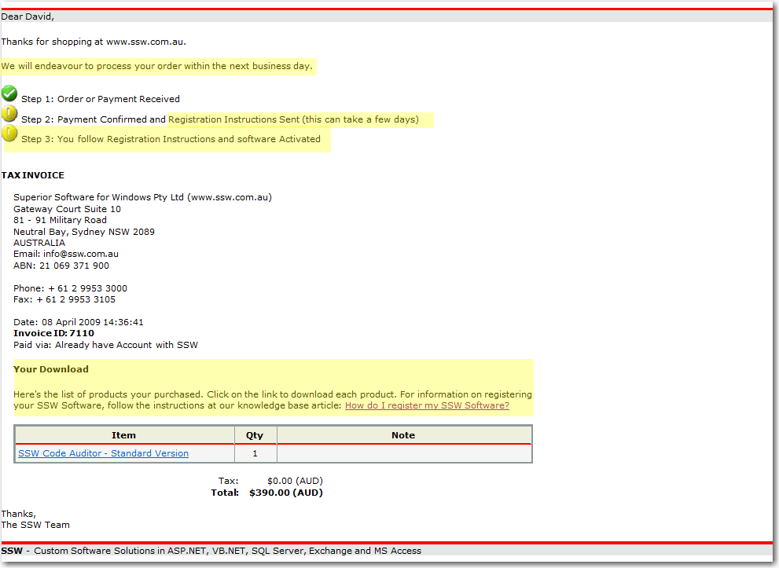

Figure 1: order email sample for **RegistrationNeeded**

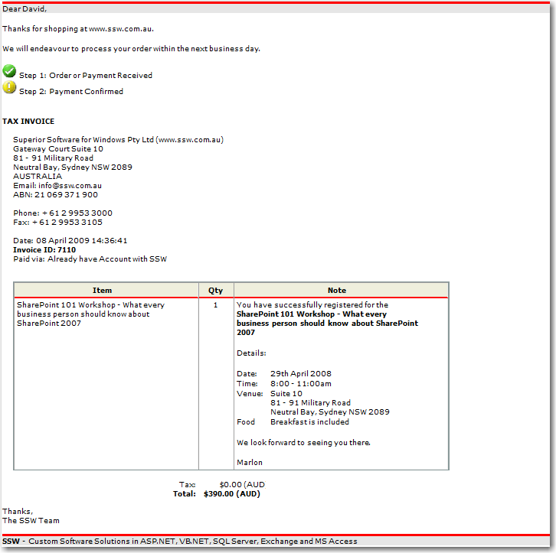

Figure2: order email sample for **RegistrationNotNeeded**

## How to divide product to two groups

In order to match these two templates, products have to be divided into two groups. Thus a field called ‘**ResigrationRequired**’ is added to ***Prod*** table of ***SSWData2005*** does this for us (figure 3).

|  |  |  |  |
| --- | --- | --- | --- |
| Field | Data type | Default value | Note |
| RegistrationRequired | bit | 0 | 0 - false, needs no registration  1 - true, needs registration  Make sure this field is filled. |

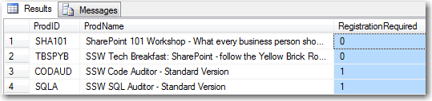

Figure 3

When the order is submitted, the products are grouped into two data sets by ***RegistrationRequired***. Then an email is generated on the basis of each template with binding data in each dataset and sent.