# Cisco IP Phone 7970 Setup Document

|  |  |
| --- | --- |
| History |  |
| Brite Cheng - Create | 11-Jul-08 |

## Flash firmware

### Prerequisite

**TFTP32**: The most difference from 7970 to 7940 in flashing firmware is when you make 7970 back to factory setting, it cannot get into its system if it can’t find the TFTP server and download the firmware. Since 7970 will consider the DHCP server as its default TFTP server, if the two services are on different server, the 7970 will be stuck in loading firmware and you can do nothing about that.

TFTP32 is a kind of software that can offer both TFTP and DHCP services.

### Configure TFTP32

1. You need to isolate your computer and 7970 from other LAN. This is to avoid the affection from other DHCP server.
2. TFTP server configuration

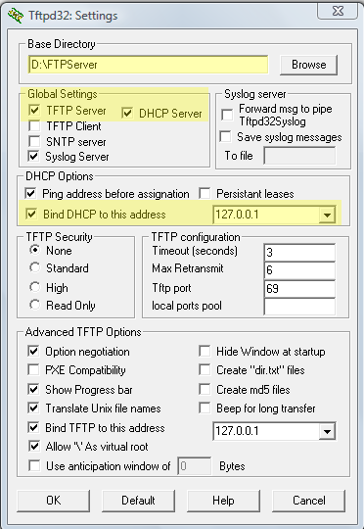

Base Directory: where you put the firmware

Global Settings: you must check TFTP server and DHCP server both

DHCP options: bind DHCP to the server’s address

1. DHCP server configuration

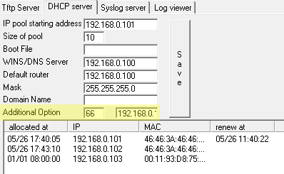

You needn’t do much about this. All is generated automatically. The only thing you have to do is add “66” (“150” is also ok) in the “Additional Option” and then the TFTP server’s address. The option is to let you connect 7970 to TFTP server manually.

### Flash the firmware

After you put the firmware files in the folder you choose above, you should connect 7970 to your computer directly, and start the flashing.

The steps are:

1. Unplug the power of 7970, hold on “**#**”, then plug the power.
2. Wait until you see the orange lights flash one by one, release “#” button then press “**3491672850*#**”
3. 7970 will do a factory recovery and reboot.
4. 7970 will get the IP from your DHCP server, but be stuck in finding the TFTP server as all information is erased. Now you can press “66*” to connect 7970 to your TFTP server.
5. 7970 will reboot 2-3 times, after that, new firmware is installed.
6. Disconnect 7970 from your computer and connect it back into the LAN, and reboot to re-connect to the DHCP server in LAN to get its own IP.
7. After the reboot, go to “Settings” -> “Network Configuration”. Find “TFTP Server 1” and change it to the IP of your current phone system server. Find “DHCP Enabled” and change it to NO, so that the TFTP server address won’t be changed back to DHCP server IP. To edit the field, you can press “**\*\*#**”.
8. Click on “save”, 7970 will reload its configuration. After this, all is done.

## IP phone configuration

Another difference between 7970 and 7940 is that 7970 only need one configuration file. You can get a typical template via

\\ant\ssw\standardsinteral\developernetworkphone (Sydney)

Or \\giraffe\datassw\phonesystem\ (Beijing)

In the template, you can leave most of fields. Only the following fields should be changed.

1. Time Zone

<dateTemplate>D/M/Ya</dateTemplate>

<timeZone>China Standard/Daylight Time</timeZone>

You can modify the date template displayed on the phone, and also the time zone of the phone. Here are some time zones we may use.

China Standard/Daylight Time

Cen. Australia Standard/Daylight Time   
AUS Central Standard Time   
E. Australia Standard Time   
AUS Eastern Standard/Daylight Time

Note: the time zone must be entered **exactly** as written above, including caps and spaces.

1. Phone server IP

The phone system server IP has to be filled in several fields, including

Name (in ntp)

sipIpAddr1

processNodeName (in callManagerGroup)

authenticationURL/DirectoryURL/servicesURL

1. NAT

We do not use NAT service in our phone system, so we need to disable it or the phone can’t register to server successfully. If there is no “natEnabled” section in the configure file, NAT is disabled by default. So you can delete this field or set it to “no”.

Don’t forget to disable NAT in Asterisk for the device mapped to this 7970.

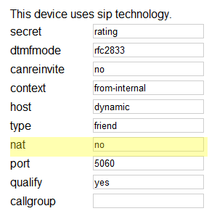

1. Line

A line in “sipLine” can be of various types. That depends on the feature ID you choose. For a common SIP extension, the feature ID should be 9. And you can add a speed dial with feature ID 2.

<line button="1">

<featureID>9</featureID>

<featureLabel>{Line label}</featureLabel>

<proxy>{Server IP}</proxy>

<port>5060</port>

<name>{auth name}</name>

<displayName>{caller id}</displayName>

<autoAnswer>

<autoAnswerEnabled>2</autoAnswerEnabled>

</autoAnswer>

<callWaiting>3</callWaiting>

<authName>{auth name}</authName>

<authPassword>{password}</authPassword>

<sharedLine>false</sharedLine>

<messageWaitingLampPolicy>3</messageWaitingLampPolicy>

<messagesNumber>*97</messagesNumber>

<ringSettingIdle>4</ringSettingIdle>

<ringSettingActive>5</ringSettingActive>

<contact></contact>

<forwardCallInfoDisplay>

<callerName>true</callerName>

<callerNumber>false</callerNumber>

<redirectedNumber>false</redirectedNumber>

<dialedNumber>true</dialedNumber>

</forwardCallInfoDisplay>

</line>

<line button="2">

<featureID>2</featureID>

<featureLabel>{speed dial label}</featureLabel>

<speedDialNumber>{number to dial}</speedDialNumber>

</line>

Above sample is a typical one. The first line is a common SIP extension, while the second one is a speed dial.

1. Load information

It is necessary to declare the firmware version you use in field “loadinformation”. It is the file name of your firmware package (.loads file).

<loadInformation>SIP70.8-3-1S</loadInformation>