# How to add New Music On Hold

Contents

SSW VOIP Phone Setup 1

Prerequisites 1

## Prerequisites

* **Music On Hold** – You must have the music on hold in mp3 format.
* **MP3 Splitter** – You need to copy to your local machine and install MP3 Splitter from \\bee\SetupFiles\SetupNotMS\SetupProgram\MP3Splitter

## Splitting

1. Add source file path in the text box or browse to the file by clicking the folder button next to the text box on the right.

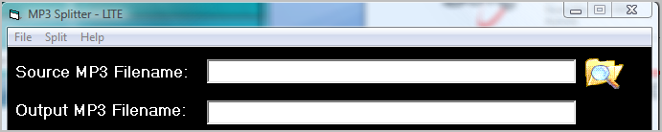

1. Choose a name for the output files. This name will be appended with a number when multiple files are outputted.



1. Choose split into X pieces. Split into **10 pieces for every half hour** of mp3. E.g. 20 pieces for one hour

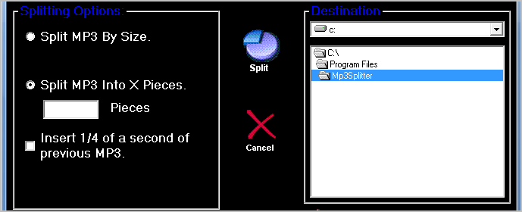

1. Click “Split”

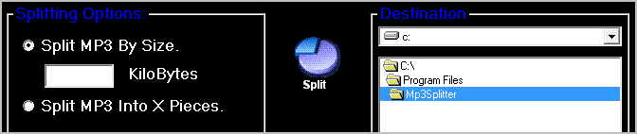

1. Copy all the output files into \\192.168.1.27\share\var\lib\asterisk\mohmp3
2. Ensure random play is **enabled** in [http://cockatoo/admin/config.php?type=setup&display=music#](http://cockatoo/admin/config.php?type=setup&display=music)

Username: maint

Password: password

Note: you may be prompted twice for username/password

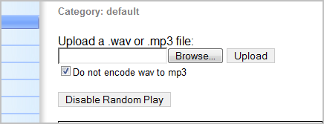

Note: It should say “Disable Random Play”, this means random is enabled