**SSW VOIP phone system backup**

Contents

Backup steps 2

Configuration Clone 2

Modules list 2

|  |  |
| --- | --- |
| Date | Author |
| **2008-09-04 Create** | **Brite Cheng** |

### Backup steps

1. You need to install “Backup & Restore” module first in Tools – Module Admin.

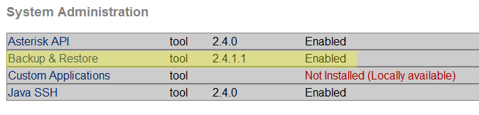

2. Then you will see the “Backup & Restore” link in System Administration panel.

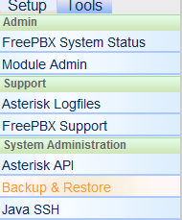

3. In the “System Backup” page, you can create a backup schedule. You can run the schedule daily, monthly, or right now.

4. In the “System Restore” page, you can see the schedule you just created.

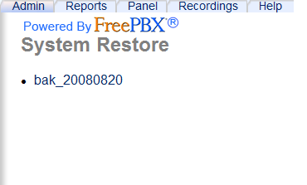

5. Click the schedule’s name and you can see the backup file list of this schedule.

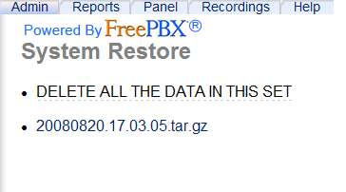

6. Click the backup file you want to restore

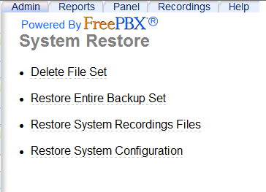

7. Don’t forget to apply the changes

### Configuration Clone

Here you can copy the system configuration from one Asterisk server to another one. However, not all the configuration files are included in the backup package, so you still need to copy some files manually, e.g. zaptel.conf (if they have the same zaptel device).

1. Backup the system configuration.

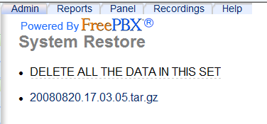

2. The backup file is kept at /var/lib/asterisk/backups

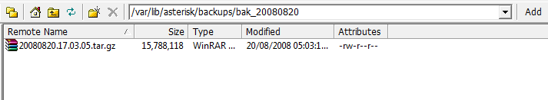

3. Copy this file to the same path of the other server

4. Now you can see the backup schedule and its file in the “backup & restore” page.

### Modules list

To recover the Trixbox server, you need to reinstall all the modules we are using. Here is the list of module we are using or will use.

1. Modules you can find in Module Administration

|  |  |
| --- | --- |
| Category | Module |
| Basic | Builtin |
|  | Core |
|  | Feature Code Admin |
|  | FreePBX Framework |
|  | System Dashboard |
|  | Voicemail |
| Inbound Call Control | Follow Me |
|  | IVR |
|  | Ring Groups |
|  | Time Conditions |
| Internal Options & Configuration | Call Forward |
|  | Call Waiting |
|  | Do-Not_Disturb (DND) |
|  | Info Services |
|  | Misc Destinations |
|  | Music on Hold |
|  | Recordings |
| Support | Asterisk Logfiles |
| System Administration | Asterisk API |
|  | Backup & Restore |
|  | Java SSH |

2. Modules not in Module Administration

To install this kind of modules, you have to go to Trixbox server | maint | packages. You also have to login by our Trixbox forum account to view the package list. For this part, you can check the phone system setup document.

Most of the modules in this list are installed during our setting up the server, so there are only a few modules that need us to install manually.

They are:

|  |  |
| --- | --- |
| Package Source | Package name |
| Trixbox | Tbm-hudadmin |
|  | Hudlite-server |
|  |  |
|  |  |
|  |  |
|  |  |
|  |  |