SSW

Phone System Setup

|  |  |  |
| --- | --- | --- |
| Version | Date | Modifier |
| 1.0 | 11-Jul-08 | Brite Cheng |

Contents

How to access the system 2

How to create a trunk 3

ZAP 3

SIP 3

Dial Rules 4

How to add extensions 4

Devices 4

Fax 5

Users 5

Voicemail 5

How to set up an outbound route 6

How to control inbound calls 6

Create ring group 6

Create IVR 7

Create FollowMe for user/extension 8

Others 8

How to update 8

How to edit device’s configuration file 9

Trouble shooting 10

# How to access the system

1) Login the system admin website via

URL: <http://cockatoo/admin> or <http://192.168.1.27/admin> (**Sydney**)

<http://192.168.20.3/admin> (**Beijing**)

Username: maint

Password: rating

2) Logon to the server

Telnet into cockatoo or login to galah and use the console in VMWare (**Sydney**)

Connect to 192.168.20.3 via SSH (you can use putty for teminal (\\gerbil\SetupFiles\SetupNotMS\PUTTY\) and SSHSecureClient (\\gerbil\SetupFiles\SetupPhoneSystem\) (**Beijing**)

Username: root

Password: rating

# How to create a trunk

A trunk is a kind of channel between Asterisk and your device. The Asterisk allows you to create several types of trunk, e.g. ZAP, SIP, IAX2.

Usually it is not very often to create/modify a trunk. This only happens when you want to

1) Add zaptel device

2) Connect to switch/PSTN

3) Use VOIP service

### ZAP

ZAP Channel Module provides a layer between Asterisk and your zaptel device (some kind of telephony hardware that has drivers which support zaptel API). So ZAP trunk is usually used when you try to connect your machine to PSTN.

To create a ZAP trunk, you only need to enter the “Trunks” section, and click “Add ZAP trunk”. There are only two things to be care of, the dial rules (talk about it later) and the ZAP identifier.

ZAP identifier is the group name of this trunk, e.g. ZAP/g0 stands for group 0. This can’t be changed. You can create multiple trunks over the same outer line, but you have to keep the same identifier for everyone.

To get more info of the group configuration, you can read the file //PhoneSystemServer/etc/asterisk/zapata.conf. It is Asterisk configure file to read your hardware interface.

Another configure file you maybe touch is //PhoneSystemServer/etc/zaptel.conf. This file contains the interface configuration of your hardware card. You may need to modify this file manually when you add/remove a module on the card. There are always two types of interface you will face, FXO and FXS. FXS interface is the module you use to connect your server to PSTN, while FXO interface is the module you use to connect to some of your device which can response, like fax.

### SIP

The SIP Channel Module enables Asterisk to communicate via VOIP with SIP telephones and exchanges. You will need to create such a trunk for using VOIP service.

To create a SIP trunk, you first need to get the username, password and server IP from your VOIP service provider. Then click “Add SIP trunk” in “Trunks” section. There you can set the dial rules and name this trunk, but the main point is the configuration of connection parameter.

Here are the formats:

Peer details:

username={user account}

type=friend

secret={password}

host={server ip}

fromdomain={server ip}

authuser={user account}

User details:

type=user

secret={password}

context=from-trunk

Register string:

{user account}:{password}@{server ip}

You can contact the service provider via

MyNetPhone (**Sydney**)

a. Tech Level1 – Sampson So -8008 8257

b.Tech Level2 – Nathan Steele – 8008 8264

BlueTel (**Beijing**)

a. Custom service number - 82250336

### Dial Rules

Dial rule has its own patterns like regular expression. You can apply the same pattern to inbound/outbound route. These rules are applied after the outbound dial pattern. That means, if you dial 912345678 and add a rule to remove 9 in the number in outbound route, the number passed to the trunk will be 12345678.

For the details of the rule’s grammar, please see the outbound route section.

# How to add extensions

In our system, an extension is divided into two parts, the device and the user. The device part describes the basic configuration of the extension, e.g. network parameters and user account.

### Devices

To create a device, you will need to navigate to “Devices”, and choose the type of device. For those IP phones and soft phone, we usually choose “Generic SIP Device”.

In the next page, you have to enter the device ID and secret. The device ID must be unique and digital only. It is also the phone number assigned to the device.

Here you can also select the default user of this device, if you already have one.

After you click the “submit” button, you will find the device you created in the right list. Click the device name in the list, then you will see the detailed configuration. Please set the “nat” to “**no**” since we do not use NAT in our system.

### Fax

Fax is a special kind of device. When you want to create an extension for a fax machine, you have to choose “Generic ZAP device” when creating a new device.

The configure page is different from the SIP’s. The Device ID and channel is required. The channel is the FXO interface you will use to connect to your fax machine. You have to fill its id in this blank. The id is related to your telephony hardware and can be got from zaptel.conf.

The detailed configuration is generated automatically, so you needn’t do anything there.

### Users

The “users” keeps the configuration of the services that users will use, like the voice mail, recording and fax.

You can create a user in “Users” and the device ID (so called “User Extension” in the form) is required. The user password is not necessary. It is only used to log on the device.

### Voicemail

Voice mail is already enabled in our system. When the call has not been answered for a period of time, the system will ask the caller to leave a message automatically. To set up a voice mail for special user, you can navigate to “Users”, and then select the user name in the list. At the bottom of the page you will see a “voicemail & directory” section.

The standard configure is like this.

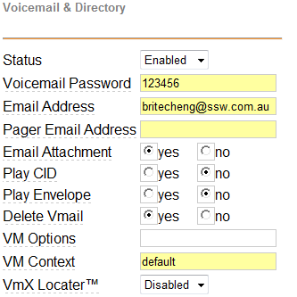

The “Voicemail Password” is used when you want to check the voicemail via IP Phone or soft phone. The notification email will send to the email address you enter, with a link to voicemail file on the server. If you enable the email attachment, the voicemail file will be attached to the email. “Delete Vmail” means the voicemail record file will be deleted after sending the email.

Note: **Don’t forget to click the “Apply Configuration Changes” at the top of the page, and then choose “Continue and Reload”, or the changes will not be saved and applied.**

# How to set up an outbound route

An outbound route is a collection of rules that redirect the calls to different trunks. You can create an outbound route via “outbound routes “. Here you can create rules in the “Dial Patterns”, one line for each, and set the sequence of trunks to catch the request in “[Trunk Sequence](javascript:void(null))”. The request call number that matches the rules will go through the trunk in order, and the later trunk will be chose only when the former one is busy or unavailable.

The grammar of rules:

|  |  |  |
| --- | --- | --- |
| Expression | Meaning | Sample |
| . | One or more digits | 1. matches all the numbers started with 1 |
| X | A single digit, 0-9 | 1XX matches 100-199 |
| Z | 1-9 | 1Z matches 11-19 |
| N | 2-9 | 1N matches 12-19 |
| | | The number before | will be removed | 9|123 will catch 9123 and remove 9 from the number then pass 123 to the trunk |
| + | The number before + will be added to the number after + | 9+123 will catch 123 and add 9 in front of 123 then pass 9123 to the trunk |
| [] | A single digit/character in special range | [146-8] will catch the number 1, 4, 6, 7 and 8 |
| ! | Zero or more digits | The difference between “.” and “!” is 1 can be caught by “1!” but ignored by “1.” |
| #/* | #/* character. |  |

# How to control inbound calls

### Create ring group

The ring group describes the extension ring order when a call comes in.

When you try to create a ring group, you must set the group name first. It is the identifier of the ring group and used every related field.

Then you need to choose the strategy of ringing the extensions. “Hunt” is preferred as it is to ring the extensions one by one. You can also set the ring duration.

In the extension list, you can enter the device id which is included in the group. One device for every line and the id must be ended with “#”.

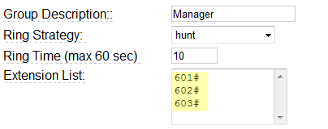

Another thing to be taken care of is the “Destination if no answer”. You can terminate the call, pick up an extension, ask for leaving a message, or redirect to another ring group.

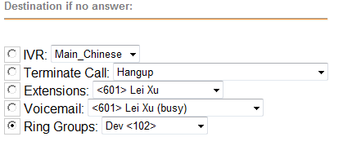

### Create IVR

IVR stands for Interactive Voice Response. We can use this to guide the caller to different groups or extensions.

First you need to choose the announcement (the audio file) to play in this IVR, then create the options.

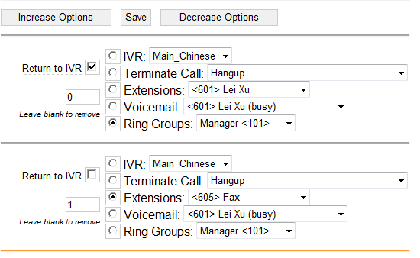

The above is a standard configuration of IVR options. Here you set the destination of an option and the button for users to press. Strongly recommend to have an option with its “Return to IVR” checked, so that the users can go back to previous menu if he press the wrong button.

### Create FollowMe for user/extension

A FollowMe redirects the unanswered call to other destinations, like your mobile phone, another extension or home.

In the FollowMe page, before you create a FollowMe rule, you need to choose the extension it belongs to. After that, you can add the destination phone number or extension number in the Follow-Me list.

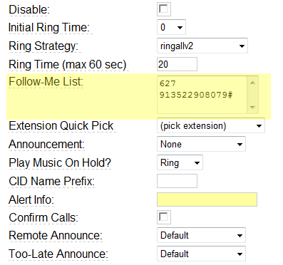

Be care of the phone number you add. It should follow the rules in outbound routes. In the sample above, the rule requires adding 9 before the number when you make an external call, so you have to add 9 in front of it. For external numbers, ending with “#” is a must.

Another thing you need look out for is the “Destination if no answer”. If you apply voicemail to a extension, in the case above, 627, and you choose “Terminate Call” in this page, you will hear no instructions of leaving voice message. That means, the priority of “Destination if no answer” in FollowMe is high than the one in “Users”.

# Others

### How to update

1. Load up the admin website at

<http://cockatoo/admin> or <http://192.168.1.27/admin> (Sydney)

<http://192.168.20.3/admin> (Beijing)

1. Click on “Module Admin”
2. Click “Check for updates online”
3. Check “Show only upgradeable”
4. Only install items that are already installed and have a newer version online

There is another upgrade area. I am not sure on the relevance however you should only do this AFTER you complete the upgrade in the above manner.

1. <http://cockatoo/maint/index.php?packages> (Sydney)

<http://192.168.20.3/maint/index.php?packages> (Beijing)

1. Login  
   User: ssw  
   Pass: rating
2. You don’t need anything to do with Zaptel or ISDN. Don’t know if you ever need anything here but worth a look

### How to edit device’s configuration file

1) Navigate to

<http://cockatoo/maint/> or <http://192.168.1.27/maint/> (Sydney)

<http://192.168.20.3/maint/> (Beijing)

2) Login

User: maint

Pass: rating

3) Click on “Asterisk”

4) Click on “Config Edit”

5) It is not recommended to modify the system configuration. I mention this function is only because it is an easy way to update the extension configuration. They are stored under /tftpboot.

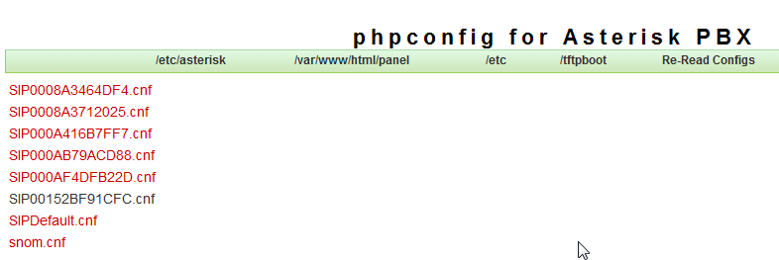

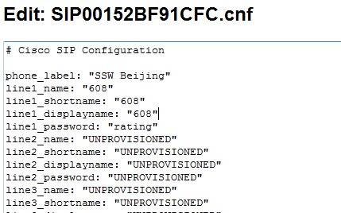

### Trouble shooting

Here are some steps you can follow when the phone system is not working.

1. Log on to the maintenance web page.
   1. <http://cockatoo/admin> or <http://192.168.1.27/admin/> (Sydney)
   2. <http://192.168.20.3> (Beijing)
   3. User: maint
   4. Pass: rating
2. Check the server status.
3. Make sure the server is not busy by checking the CPU usage in System Statistics.
4. Dialling “*43” and doing a quick echo test of phone server. In this test you should check
   1. Quality
   2. Speed
5. Try restarting the phone server
   1. Log on to the phone server (see how to access the system)
   2. restart by entering the command “restart” or shutdown using “Shutdown now”