**SSW VOIP phone system usage**

Contents

Prerequisite 1

Your extension 2

Add a new user 2

Remove user 3

Software/Phone 3

How to register your extension with 4

Eyebeam 4

Cisco 7940/7970 4

How to use HUD 5

Installation 5

Adding your name to Voice Mail 9

How to use the phone to 9

Make a call 9

Transfer a call 10

Hold a conference 11

Switch between calls 12

Forward a call to another number 13

DND (Do Not Disturb) 14

Get your voice messages 14

Pick up any Extension from any Phone 14

Tips 14

Hot keys 14

# Prerequisite

### Your extension

If you want to use the phone system, at first you need to have your own extension. You could find the extensions already created via

\\ant\ssw\StandardsInternal\GeneralPhone\PhoneList.xlsx (Sydney)

Or <http://cockatoo/xmlservices/LocalDirectory.php>

\\giraffe\datassw\phonesystem\BeijingOfficePhoneList.xlsx (Beijing)

Or <http://192.168.20.3/xmlservices/LocalDirectory.php>

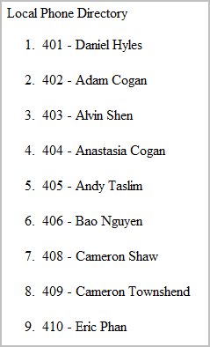

If there is not an extension for you, you could ask the administrator to create one, or do it by yourself (see below)

### Add a new user

1. Add yourself to the next available extension in the phone listspreadsheet
2. Go to

<http://cockatoo/admin>

Or <http://192.168.1.27/admin> (Sydney)

<http://192.168.20.3/admin> (Beijing)

Login with username: maint and password: rating

1. Click “**Users**”
   1. Add User
      1. User Extension – Follow the rules in Phonelist.xlsx/BeijingPhoneList.xlsx
      2. User Password – “rating”
      3. Display Name – Name of person
   2. Extension Options
      1. Direct DID – Phone number
      2. Outbound CID – Phone number
   3. Voicemail & Directory
      1. Status – “Enabled”
      2. Voicemail Password – “2727”
      3. Email Address – users email address
      4. Email Attachment – “yes”
      5. Delete Vmail – “yes”
2. Click “**Devices**”
   1. Choose “Generic SIP Device”
   2. Secret – “rating”
   3. Device ID – same as the user ID
   4. Description – name of person
   5. Default User – same as the userID
   6. Submit
   7. Click on the new Device
   8. Nat – “no”
   9. Default User - same as the user ID
   10. Submit
3. Setup HUD password
   1. <http://cockatoo/maint/index.php?hudManager>
   2. Change password to “rating”

### Remove user

1. Remove the Device
2. Remove the User
3. Remove out of any ring groups

### Software/Phone

We currently use Cisco IP phone 7940G/7970 and eyebeam.

# How to register your extension with

### Eyebeam

1. Go here

\\bee\setupfiles\SetupNotMS\SetupProgram\Eyebeam Softphone (Sydney)

\\gerbil\setupfiles\SetupNotMS\Eyebeam Softphone (Beijing)

And install eyebeam

1. Enter in your login details

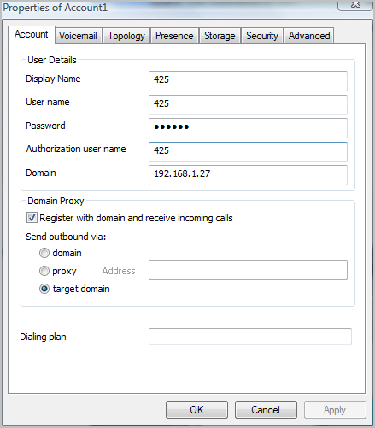

Phone system server IP Address

Sydney: Cockatoo

Beijing: 192.168.20.3

Password: rating

Same as Extension

Extension

User Name: Same as extension

### Cisco 7940/7970

You will need to edit the configuration file of the IP phone on Asterisk server. This is not recommended.

For details, you can view the setup documents of IP Phone.

# How to use HUD

HUD is a popup utility that integrates with outlook for quick dialling. This is not required however; it is strongly recommended that you have it installed. HUD basically acts as a contact list which you can easily dial from. It does **not** however show contacts on IAX2 as online. This will **only** work when you are connected through VPN or are in the office.

**When you dial using HUD, it rings you first and you must accept. It then puts you through to who you are calling.**

### Installation

1. Go here \\bee\setupfiles\SetupNotMS\SetupProgram\Hud and install HUD, then run it.

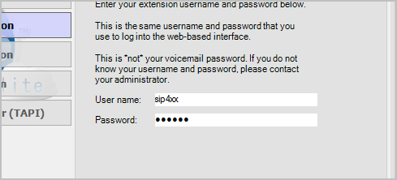

Password: rating

Replace xx with the last two numbers of your extension, for example, if your extension is 425, xx should be 25

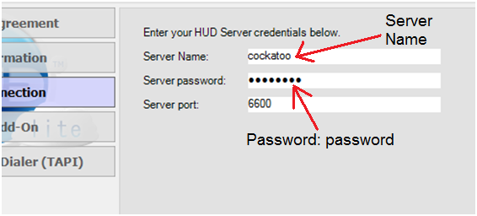

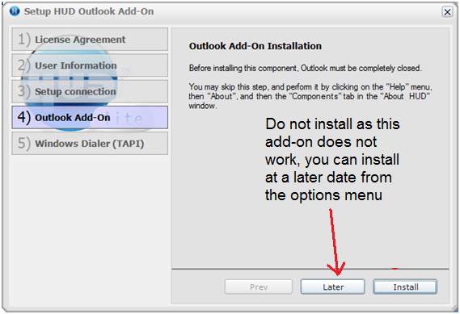

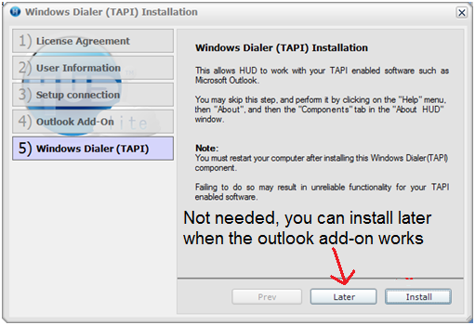

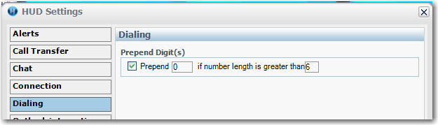

Figure 1: If you want to dial from HUD, you need to change the prepend digit to 0

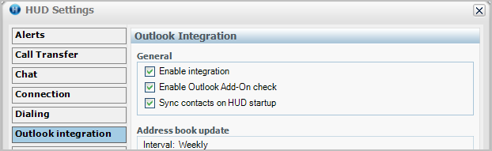

Figure 2: For proper Outlook integration make sure “Sync contacts on HUD startup” is ticked

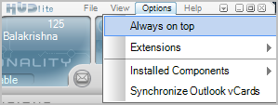

Figure 3: Click “Synchronize Outlook vCards” when you make changes to or add outlook contacts to sync with HUD

### Adding your name to Voice Mail

1. Settings | Advanced Options | Select Internal | Account | Change RFC-2833 to SIP INFO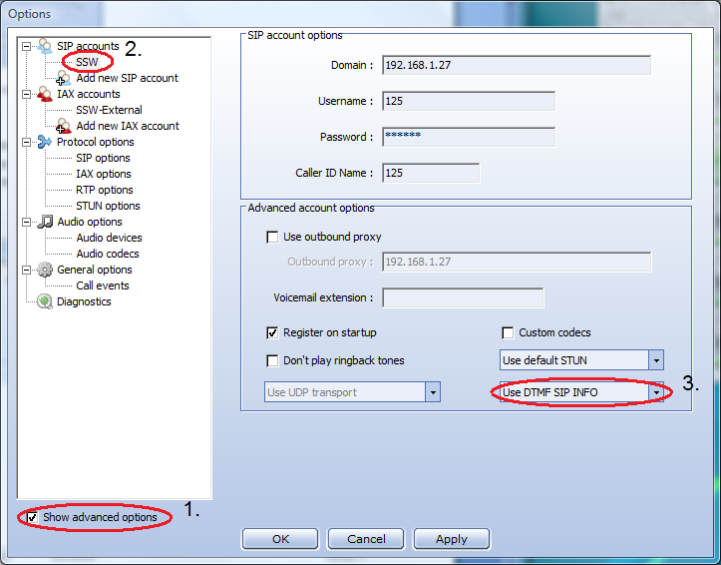
2. Dial *97
3. Enter in your password (2727)
4. Dial 0
5. Dial 3 to set your name and follow the prompts

# How to use the phone to

### Make a call

As we have many outbound rules for dialling, here are some hints about how to make a call.

(Beijing office)

1. For internal calls, dial the number directly.
2. For external calls
   1. Domestic: 9 + phone number
   2. International: 8 + phone number

(Sydney office)

Dial number directly.

### Transfer a call

To transfer calls you need to know the SIP extension of the person you are transferring to.

Refer to:

\\ant\ssw\StandardsInternal\GeneralPhone\PhoneList.xlsx (Sydney)

Or <http://cockatoo/xmlservices/LocalDirectory.php>

\\giraffe\datassw\phonesystem\BeijingOfficePhoneList.xlsx (Beijing)

Or <http://192.168.20.3/xmlservices/LocalDirectory.php>

Make the URL a favourite or print off the xlsx file and keep it near your phone.

**EyeBeam**

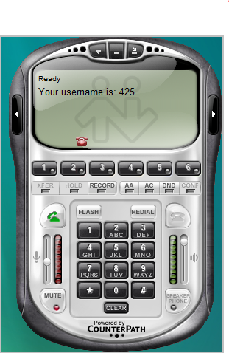

1. While you are in a call, press the **XFER** button

3. Press the **XFER** button again to complete transfer

2. Dial the **extension** of the person you want to transfer to

**Cisco 7940 (Non-Colour)**

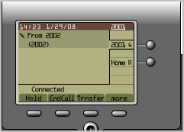

4. Hang up to end your participation in the call.

3. When you hear ringing, press **Trnsfer** again, or when the party answers, announce the call and press **Trnsfer**.

2. Press **Dial** and dial the **extension** of the phone you want to transfer to.

1. While in a call, click **more**, and then click **Trnsfer**.

**Cisco 7970 (Colour)**

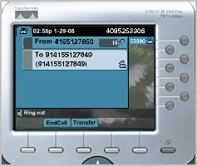

2. Press **Dial** and dial the **extension** of the phone you want to transfer to.

1. While in a call click the **Transfer** softkey.

**Note:** you cannot transfer a call that is on hold, take the call off hold before transferring.

3. When you hear ringing, press **Transfer** again; or when the party answers, announce the call and press **Transfer**.

### Hold a conference

You can hold a conference by calling other parties, or join the conference created by others.

|  |  |  |  |
| --- | --- | --- | --- |
| Action | 7940 | 7970 | EyeBeam |
| Hold a conference | **1.** From a connected call, press **Confrn**.  **2.** Enter the participant’s phone number.  **3.** Wait for the call to connect.  **4.** Press **Join** to add the other participant to your call. | **1.** From a connected call, press **Confrn.**  **2.** Enter the participant’s phone number.  **3.** Wait for the call to connect.  **4.** Press **Confrn** again to add the participant to your call.  **5.** Repeat to add additional participants. | 1. With one active call on one of the lines, select another line and dial a third party  2. To conference in all lines, click **CONF**. All lines will be part of the conference.  3. To suspend the conference, click **CONF** again. The other participants can’t speak to one another. To restart it, click **CONF** again. |
| Add another party to conference | Same as above | Same as above | **1.** From a connected call, press **Confrn**.  **2.** Enter the participant’s phone number.  **3.** Wait for the call to connect.  **4.** Press **Confrn** again to add the participant to your call.  **5.** Repeat to add additional participants. |
| View conference list | **1.** Highlight an active conference.  **2.** Press **ConfList**. Participants are listed in the order in which they join the conference with the most recent additions at the top. | No such function | Click **Confrn** to pause the conference. Every active line has an active party. |
| Remove a party (only for the conference creator) | In the conference list,  **1.** Highlight the participant’s name.  **2.** Press **Remove**. |  | 1. Suspend the conference by clicking **CONF**.  2. Select the line of the participant to remove.  3. Hang up the call.  4. Click **CONF** to re-establish the conference. |

Note: if you initiate the conference, you will close it if you hang up the call. If you want to keep the conference active after you end up the call, you should transfer the call to another party first.

### Switch between calls

You can switch between multiple calls on one or more lines.

**Cisco 7970/7940**

To switch calls on the same line:

**1.** Make sure the call that you want to switch to is highlighted.

**2.** Press **Resume**. Any active call is placed on hold and the selected call is resumed.

To switch between connected calls on different lines:

1. Press for the line that you are switching to. If a single call is holding on the line, the call automatically resumes. If multiple calls are holding, highlight the appropriate call and press **Resume**.

To switch from a connected call to answer a ringing call

1. Press **Answer**, or if the call is ringing on a different line, press the line button (flashing). Any active call is placed on hold and the selected call is resumed.

**Eyebeam**

Select another line, and then the previous one is on hold automatically.

### Forward a call to another number

**Cisco 7970/7940**

To set up call forwarding on your primary line, press **CFwdALL** and enter a target phone number exactly as you would dial it from your phone. To cancel call forwarding on your primary line, press **CFwdALL**.

**EyeBeam**

You can set the forward number in SIP account setting.

1. Right click on the soft phone, then click “SIP account setting”

2. Choose you current account, open the “Properties”

3. Go to “Voicemail” tab, complete the “forwarding” section

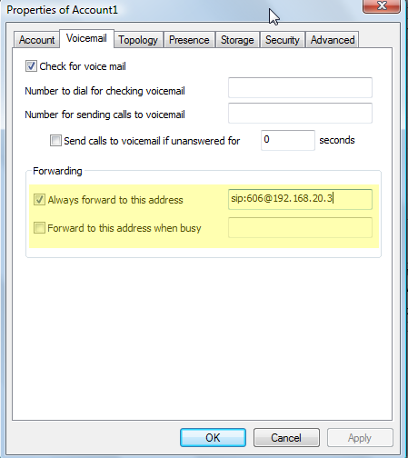

Note: If you set the call forward number on **Cisco 7940**, **all lines** of the phone will be forwarded. But for **Cisco 7970**, the call forward is **line specific**, so the line which forward is not enabled will ring still when a call is coming.

### DND (Do Not Disturb)

DND is a function to block any call to your phone. The caller will receive a busy tone.

**Cisco 7970/7940, Eyebeam**

To enable/disable DND, you just need to press the “DND” soft key.

Note: DND will apply to all the lines. If the “Call Forward” is enabled, the calls will be forwarded directly.

### Get your voice messages

IP phone/soft phone:

Press *97, then enter your password. Follow the instructions.

Email:

The voice message will be sent to the owner’s email box and deleted immediately. So be careful of some important messages, there is no backup in the system.

### Pick up any Extension from any Phone

When a call comes in on an extension which is not the phone you are currently at, you can type **[extension of phone you want to take call from] and dial. This will connect you to the call which is going to the extension you typed.

# Tips

### Hot keys

The hot keys of our phone are defined in “Feature Code” of Asterisk server.

Here are some common keys as default:

*43 – Echo test; *97 – Check voicemail; *98 – Dial voicemail; *99 – Check recording.