# VOIP Phone Instructions

|  |  |
| --- | --- |
|  |  |

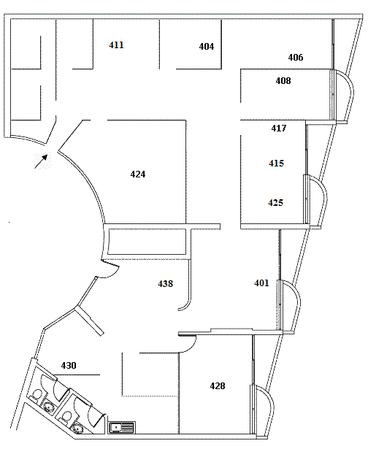

**Making an Internal Call**

**1.** Lift handset or (Press speaker)

**2.** Dial internal **extension #** e.g. 402

**Conference Call**

**1.** While speaking to **Mr Northwind**

**2.** Press **“More”** button (only applies to 7940 series phone)

**3.** Press **"Conference"** button. This will place **Mr Northwind** on hold

**4. Dial extension #** (or external number to connect to **“Person”.** You can speak to **“Person”** while **Mr Northwind** is still on hold.

**5.** Press **"Join"** button to join both **Mr Northwind** and **“Person”** to the conference call.

**Transferring a call**

**1.** While speaking to **Mr Northwind, press “More”** (only applies to 7940 series phone)

**2. Press "Transfer"**. This will place the **Mr Northwind** on hold

**3.** Dial the internal **extension #**   
(or external number)

**4.** Tell the staff member **“Mr Northwind for you”**

**5.** Press **"Transfer"** again

**6. Hang up** the phone.

### Cisco IP Phone 7970 Series

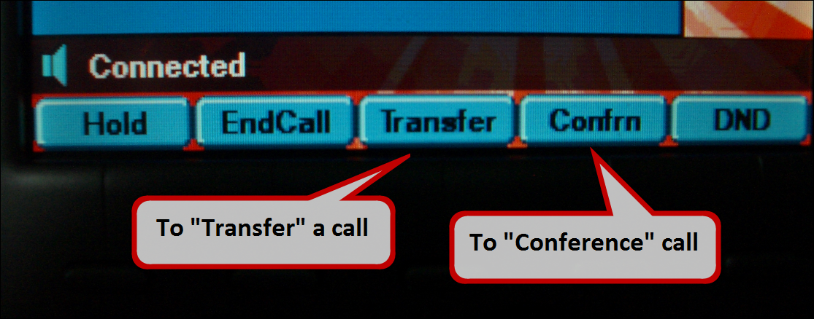

### Cisco IP Phone 7940 Series

