# How to truncate a large transaction log

1. Make sure the database’s recovery mode is “simple”. In this mode, the transaction log will be truncated after backup.

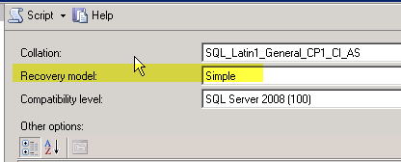

1. Adjust the initial size and autogrowth of transaction log and database, to make the file as small as possible

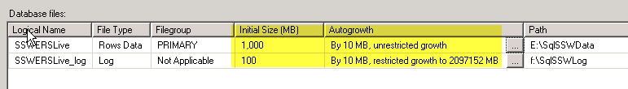

1. Do the backup
2. Setup a full backup schedule, so that the transaction log will be truncated after every backup and its size can be kept small.